Blockchain-Based Library Lending Tracker
Formative Assessment 2: Technical Report
Implementation and verification report | 1 October 2026

1. Overview
The tracker connects library lending events to token rewards while keeping unconfirmed events out of the permanent chain. Borrow and return commands create signed pending records. Mining establishes a proof-of-work hash, persists the confirmed chain, and only then settles return rewards into the selected token ledger.
Member IDs from members.txt are the ledger account identifiers. A return earns 10 gross tokens within the configured 14-day loan period and 5 gross tokens afterward. The fixed one-token transaction fee is deducted, yielding spendable credits of 9 or 4 tokens. An unreturned loan creates no reward transaction.

2. Lending, Rewards, and Confirmation
The pending pool includes both borrowing and returning events. Pending events participate in active-loan checks, preventing a second borrow before confirmation. A return is accepted only for the member who borrowed the book. The return reward transaction ID is SHA-256 over member ID, book ID, action, gross reward, fixed fee, and event timestamp.
Mining assigns the final block index and previous hash, re-signs lending fields with ECDSA P-256, and varies the nonce until the SHA-256 block hash has the configured leading-zero prefix. The chain is saved before balances are updated. Validation checks ordering, previous-hash links, signatures, reward fields, transaction IDs, and proof-of-work. Existing LIBCHAIN1 event blocks are re-signed and re-mined at difficulty 2 during migration; genesis is exempt from proof-of-work.

3. Transaction Models

UTXO model
Each confirmed return creates an unspent output for the member containing the net reward. A manual transfer gathers the sender's unspent outputs until amount plus the one-token fee is covered, marks those inputs spent, creates the recipient output, and returns any remainder as a change output. Spent outputs cannot be selected again. Balances are calculated by summing unspent outputs by member ID.

Account model
Each member account has an integer balance, outgoing nonce, and in-memory linked-list transaction history. Confirmed returns credit net rewards after chain persistence. A manual outgoing transfer must present the exact next sender nonce and enough balance to cover amount plus fee. Accepted transfers increment the sender nonce and append sender, recipient, amount, fee, and nonce records to both member histories.
Property | UTXO | Account-based
Balance source | Sum of unspent outputs | Stored account balance
Spend validation | Sufficient unspent inputs | Sufficient balance and exact nonce
Change | Explicit change output | Remaining balance after debit
History | In-memory member linked list | In-memory member linked list
Restart behavior | Confirmed return outputs replayed from chain | Confirmed return credits replayed from chain

4. Mining Simulations
Proof-of-work difficulty is configurable from 1 to 4 leading hexadecimal zeroes; the default is 2. The program reports attempts for each candidate block. The simulated mining reward is 2 coins per confirmed event, separately displayed from member return-token balances.
Solo mining performs all attempts and displays the full 2-coin payout. Pool mining assigns four simulated miners random attempt-rate weights, measures each miner's assigned attempts, deducts a 2% pool fee, and distributes the remaining block reward in proportion to attempts. Cloud mining runs 1 to 5 rental rounds. The sample rates are 2 coins gross reward, 2 coins rental, and 1 coin maintenance per round, so net profit is -1 coin per round and an unprofitable warning is expected.

5. Design Choices and Scope
- A 14-day loan period is the due-date assumption because the original registry has no due-date field.
- The token reward field stores gross reward; the one-token fee is deducted from the spendable credit.
- The pending pool and manual transfers are process-local demonstrations. Mine before exit; confirmed lending rewards are reconstructed from the chain after restart.
- Mining payouts are reported separately from member balances because simulated miner identities are not member registry accounts.
- The local ECDSA key and single-process chain demonstrate integrity and proof-of-work, not distributed consensus.

6. Verification Results
Scenario | Result
UTXO queue, on-time reward, pool/cloud mining and tamper detection | PASS
Account reward replay, valid/reused nonce, insufficient funds and histories | PASS
Insufficient UTXO input, spent-output reuse, unreturned loan and invalid rental duration | PASS
Difficulty 4 proof-of-work and validation | PASS
Invalid difficulty argument rejected | PASS
Legacy migration, re-mining, and late-return net reward | PASS
Build: MSYS2 UCRT64 GCC 16.2.0 with OpenSSL, C11, -Wall -Wextra -Wpedantic -Werror -O2. Build completed with exit code 0 and no warnings. Runtime scenarios used isolated temporary ledgers, leaving the workspace blockchain.dat and signing_key.pem untouched.

7. Evidence Captures
Figures are rendered captures of standard output collected directly from the test executable in isolated runs. They are output captures, not photographs of the desktop terminal.

Pending pool and solo mining
Borrow remains pending until solo mining confirms the block.
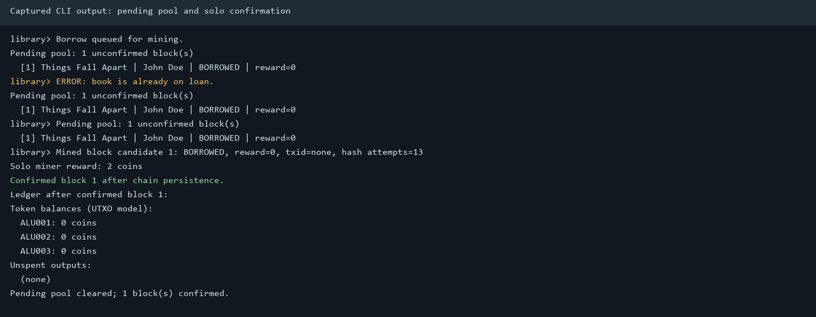

Pool mining and UTXO settlement
Pool attempt shares, return reward, and UTXO outputs.
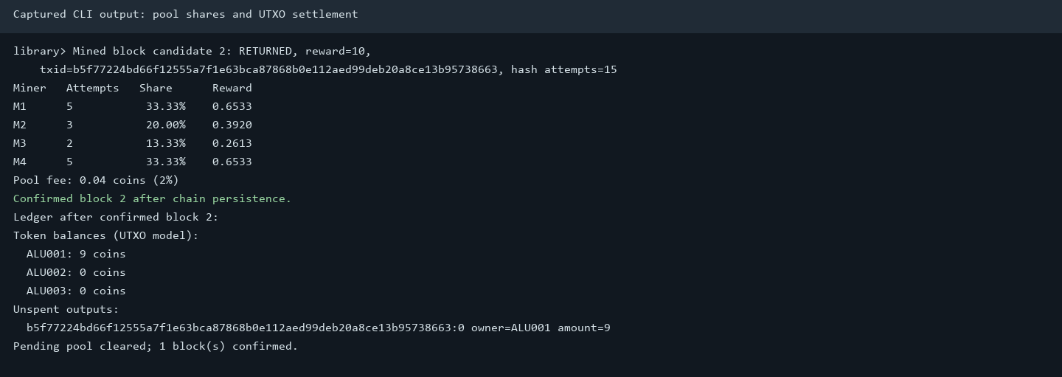

Account nonce and transaction history
Valid transfer, rejected nonce reuse/insufficient funds, and account histories.
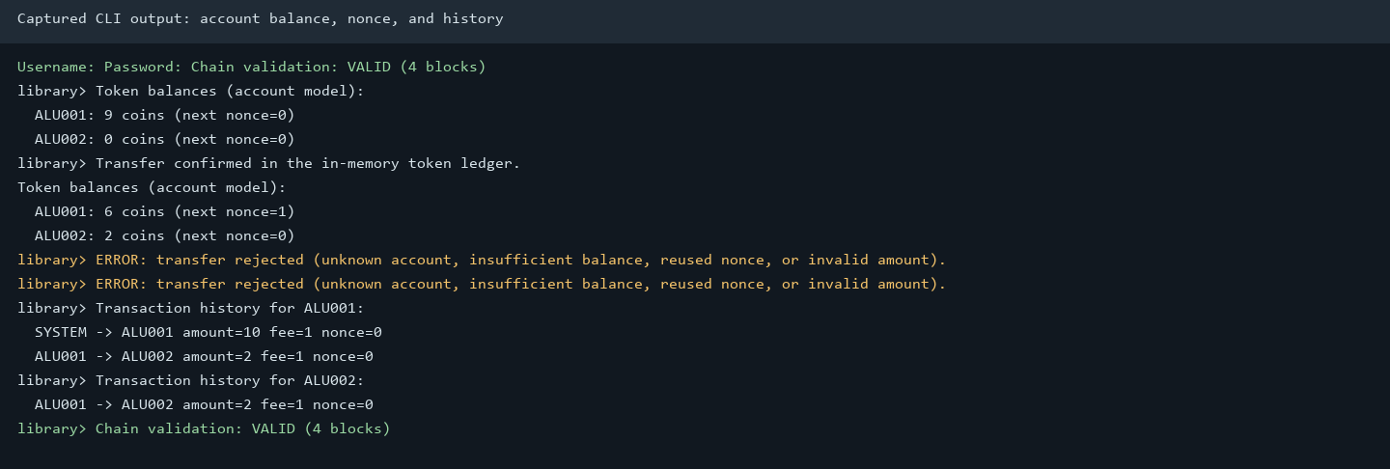

Cloud rental
Round earnings, rental and maintenance fees, cumulative net, and warnings.
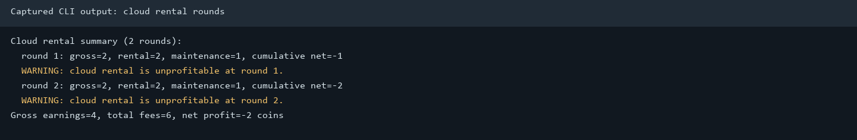

Late return and migration
Legacy migration followed by a late return credited at 4 net tokens.
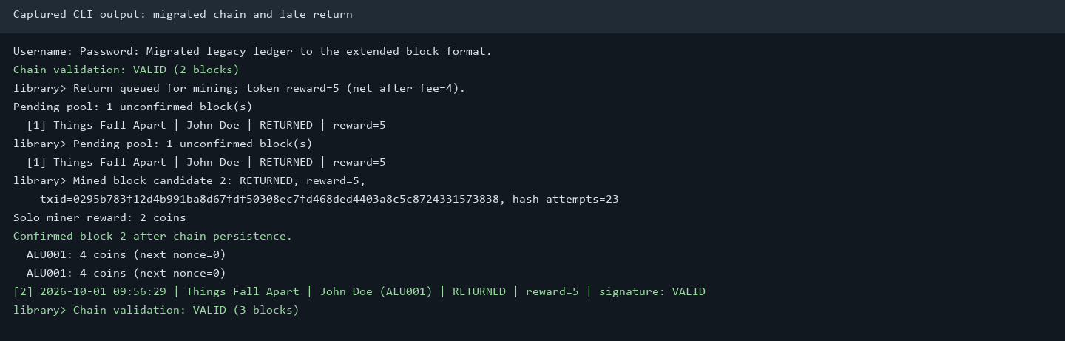

8. Limitations
Pending events and manual transfers are not persisted. Pool/cloud hash rates are simulations rather than concurrent workers or an external rental service. The 14-day threshold was tested using a migrated legacy borrow timestamp rather than waiting in real time. The reward and fee economics are fixed educational assumptions.

