### 

### 

# **Vital Club – Premium Fitness, Spa & Lifestyle**

## **🧭 Project Overview**

### **Vital Club is a responsive landing page for a premium fitness and wellness center that blends traditional training (strength, calisthenics, weight training) with modern performance techniques (boxing, functional workouts), while offering full wellness services including a sauna, spa, pool, and café lounge.**

### **Main Goal: This page is designed to increase customer sign-ups through a Free Trial booking form, helping us grow our community and club membership base.**

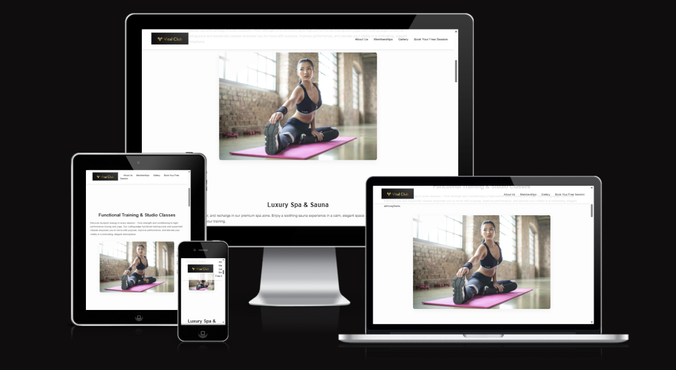

### 

## **🌟 Features**

### **Hero section with a clear call-to-action for Free Trial**

### **Sections for each key offering: Gym, Boxing, Spa, Pool, Café**

### **Functional and stylish Booking Form with validation**

### **Membership tier details**

### **Elegant, responsive layout for all devices (mobile, tablet, desktop)**

### **Future-ready for adding videos and gallery views**

### 

## **📸 Page Structure (Screenshots to**

### **🔝 Hero Section – *"Where Balance Meets Performance"***

### **Elegant full-screen banner with background image and CTA**

### **Messaging emphasizes personalized wellness and lifestyle**

### **💡 *Screenshot Placeholder: [Hero Section]***

### 

### **💪 Functional Training & Studio Classes**

### **Overview of all gym-related offerings: strength, conditioning, boxing, yoga**

### **Empowering text and image support**

### **💡 *Screenshot Placeholder: [Functional Training Section]***

### 

### **🧖 Luxury Spa & Sauna**

### **Visual and verbal emphasis on wellness and recovery**

### **Sauna, massages, and calming environment**

### **💡 *Screenshot Placeholder: [Spa & Sauna Section]***

### 

### **🏊 Heated Indoor Pool**

### **Features a tranquil indoor pool**

### **Highlights aqua classes and recovery-focused swimming**

### **💡 *Screenshot Placeholder: [Swimming Pool Section]***

### 

### **☕ Coffee & Lounge**

### **Post-workout social space**

### **Healthy drinks and snacks in a luxurious lounge**

### **💡 *Screenshot Placeholder: [Café Lounge Section]***

### 

### **💳 Membership Plans**

### **Three-tier membership structure:**

### **Essential: Gym + Classes (€79/month)**

### **Wellness: Gym + Spa + Pool (€99/month)**

### **Elite: All-inclusive + Personal Training (€129/month)**

### **💡 *Screenshot Placeholder: [Membership Section]***

### 

### **📝 Book Your Free Trial (Main CTA)**

### **Clean, responsive form with the following fields:**

### **Full Name**

### **Email Address *(with validation to avoid incorrect entries)***

### **Phone Number**

### **Fitness Goal**

### **Preferred Date/Time (Notes)**

### **Built-in required attributes to prevent blank submissions**

### **Future JavaScript validation layer recommended for deeper email/phone format checks**

### **💡 *Screenshot Placeholder: [Free Trial Form]***

### 

### **📱 Responsive Design**

### **The website is fully responsive across:**

### **Smartphones**

### **Tablets**

### **Desktops**

### **Layout adapts seamlessly to ensure an excellent user experience**

### **💡 *Screenshot Placeholders: [Mobile View], [Tablet View], [Desktop View]***

### 

## **🛠️ Technologies Used**

### **HTML5 – Semantic layout**

### **CSS3 – Custom styles, responsive design**

### **Google Fonts – Typography (Roboto)**

### **Embedded Video Support – HTML <video> element (with future optimization for web paths)**

### **Form Validation (HTML-level) – required, type="email" etc.**

### 

## **🚀 Future Improvements**

### **Full client-side and server-side form validation (email/phone/format)**

### **Backend integration for booking requests**

### **Image optimization for performance**

### **Live gallery page**

### **SEO and analytics integration**

### **Multilingual support**

### 

## **📬 Contact**

### **For partnership inquiries or technical issues, please reach out:**

### **📧 contact@vitalclub.com 📞 +49 123 456 789**

### 

## **📍 Location & Hours**

### **Vital Club Sample Street 123 🕐 Mon–Fri: 6am–11pm 🕐 Sat–Sun: 8am–10pm**

### 

## **🧾 License**

### **This project is for demo, portfolio, or commercial use under the Vital Club brand. Please request permission before reuse or redistribution.**

### 

## **✅ Testing**

### **Our project has been thoroughly tested to ensure high quality, accessibility, and responsiveness across all devices.**

### **🔍 HTML & CSS Validation**

### **Both HTML and CSS were successfully validated using the official** [**W3C HTML Validator**](https://validator.w3.org/) **and** [**W3C CSS Validator**](https://jigsaw.w3.org/css-validator/)**.**

### 

### **No critical errors or warnings were detected.**

### **The code follows semantic structure and accessibility best practices.**

### **💡 Lighthouse Testing**

### **We used Google Lighthouse to evaluate the website’s performance and quality.**

### 

### **These results confirm that the website meets the highest standards in terms of technical implementation, user experience, and search engine optimization.**

### 

### **Let me know if you'd like me to insert this directly into your README or adapt it for a specific layout.**

### 

### 