Universität zu Köln
WiSo Fakultät
Seminar Paper



Supervisor: Dr. Jay Doe
Second Examiner: Prof. Dr. Jane Doe
Submitted for the Bachelor/Master’s examination
in the study program Information Systems
at the Faculty of Management, Economics and Social Sciences
of the University of Cologne

Gabriel Witte,
Nataliia Korobkova,
Muhammad Saim,
Ali Areeb,
Alina Porschke

Contribution Statement

Team Members
1. Gabriel Witte,
2. Nataliia Korobkova,
3. Muhammad Saim,
4. Ali Areeb,
5. Alina Porschke

Contribution Statement

Team Member | Contribution Description
Gabriel Witte
Nataliia Korobkova
Muhammad Saim
Ali Areeb
Alina Porschke

Equal Contribution
If all members contributed equally, please indicate this in the table above.

Inhaltsverzeichnis
1. Executive Summary: Short-Term Rental Price Prediction in Chicago 3
2. Exploratory Data Analysis (EDA) 4
2.1 Dataset Overview 4
2.2 Data Cleaning and Transformation 4
2.3 Text-Based Feature Extraction 5
2.4 Geographic Features 5
2.5 Distribution Transformation and Outlier Treatment 5
1.6 Correlation Analysis 6
2.7 Visualisations of Preprocessed Variables 7
3. Predictive Modeling 9
3.1 Overview and Rationale 9
3.2 Model Selection 9
3.3 Model Development Workflow 10
3.4 XGBoost Model Tuning Process 10
3.5. Evaluation of Model Tuning Process 12
4. Training the Final Model and Generating Test Predictions 13

1. Executive Summary: Short-Term Rental Price Prediction in Chicago
We had to create a regression model designed to predict the nightly price of short-term rental listings in Chicago, utilizing provided data from the Airbnb platform. The primary objective was to build a robust and accurate predictive model with minimum RSME.
The analysis began with a dataset of 5118 listings, with the target variable being the rental price. Exploratory Data Analysis confirmed the initial hypothesis that "location" and "listing quality/type" are the most significant drivers of price.
To prepare the data for modeling, feature engineering was performed, resulting in 22 explanatory variables. This included:
1. Geographic features: calculating the "distance_from_center" (in km) and creating a binary "is_downtown" flag.
2. Text-Based features: extracting quantitative features from the listing titles, such as word count and the proportion of "luxury" and "suspicious" terms.
3. "Data Transformation: applying log-transformation to skewed variables (e.g., "number_of_reviews") and the target variable ("price") to stabilize the data and mitigate the influence of outliers.
Given the dataset's characteristics (non-linear relationships, right-skewed distributions, and multicollinearity) traditional linear models were deemed unsuitable. A comparative analysis of five different modeling approaches confirmed this assessment, with the XGBoost (Extreme Gradient Boosting) model demonstrating superior performance.
The XGBoost model achieved the lowest Root Mean Square Error (RMSE) of 64.5 on the validation set, confirming its status as the optimal model for this regression task.
The final XGBoost model was developed through a systematic, five-step hyperparameter tuning process using an 80/20 train-validation split. This process focused on optimizing key parameters (the number of trees, learning rate, tree depth, and regularization terms lambda and alpha).
The tuning process demonstrated stable learning curves and moderate, stable overfitting (validation-train gap approximately 21.7), indicating that the model generalizes well to unseen data. The low final regularization values for lambda and alpha suggest that the model was already well-regularized by the earlier steps.
The developed XGBoost model provides an accurate and robust solution for predicting short-term rental prices in Chicago. The final RMSE of 64.5 is a satisfactory result.

2. Exploratory Data Analysis (EDA)

2.1 Dataset Overview
The original training dataset contains 5,118 observations and 15 variables describing short-term rental listings in Chicago on the Airbnb platform, extracted as of September 21, 2020 (the date of the most recent review).
The variables in this dataset can be divided into several types:
- Text variables: "id", "host_id", "name" (listing description), "host_name"
- Location-related variables: "neighbourhood", "latitude, "longitude"
- Variables describing the quality of the listing: "room_type", "minimum_nights", "availability_365"
- Variables reflecting listing activity: "number_of_reviews", "reviews_per_month", "last_review", "calculated_host_listings_count"
The target variable is the rental price per night (in USD), which the final model should predict with the highest possible accuracy for the test dataset. In the training dataset, prices range from $10 to $10,000, with an mean of $154.34 and a median of $98.
We hypothesize that the key factors influencing short-term rental pricing are location and the quality of the listing, while the price may also be affected by seasonality or major events held in Chicago. Location is described by the precise geographic coordinates of each listing, while the quality of a listing (its size, number of beds, condition, type of property, provided amenities) can only be estimated indirectly based on the "room_type", variable. There is no information in the current dataset to account for seasonality.

2.2 Data Cleaning and Transformation
The following preprocessing steps were applied to the training dataset "df_train":
- Removal of unnecessary identifiers. The variables "id", "host_id", and "host_name" were removed, as they do not contribute predictive information for price modeling.
- Data type conversion. The variable "last_review" was converted to Date format, "neighbourhood" was converted to a categorical variable (factor).
- Data Validation and Quality Checks. Validation flags were constructed for key numeric variables ("latitude", "longitude", "price", "minimum_nights", "availability_365", "number_of_reviews", "reviews_per_month", "calculated_host_listings_count"). Logical consistency and valid ranges were checked (e.g., 0–365 for availability). No invalid observations were detected; thus, the issue dataset "df_issues" remained empty. All records with at least one error were collected in df_issues for manual review. No violations were found.
- Handling missing data. Missing "reviews_per_month" values were replaced with 0 (indicating no reviews). Missing "last_review" values were imputed with a placeholder date "2010-01-01" to preserve temporal consistency.
- Feature Engineering. A normalized availability variable was created "availability_365_rate" = (365 - availability_365) / 365. This represents the proportion of booked days during a year. The original variable "availability_365" was then removed to avoid redundancy.
- Categorical variables. The "room_type" variable was converted into dummy variables using "model.matrix" (one-hot encoding without intercept), resulting in binary dummy variables for each category.

2.3 Text-Based Feature Extraction
The variable "name" (listing title) contain valuable contextual and marketing information about the positioning of the property (e.g., “Luxury Downtown Apartment” or “Cozy Studio”). Longer descriptions may reflect hosts" efforts to emphasize the value of their listings. To leverage this information, a lexical analysis of the titles was performed, from which quantitative features were extracted:
- word count ("name_word_count")
- proportion of special characters (emojis, symbols),
- proportion of “luxury” words,
- “suspicious” word ratio (indicating low-quality or unclear descriptions).
These derived variables capturing owner effort, marketing intent, and perceived value of the listing.

2.4 Geographic Features
To account for spatial factors, two new features were added:
1. distance from city center ("distance_from_center") — the distance to downtown Chicago (in kilometers), calculated using the distHaversine() function from the "geosphere" package. The city center was approximated as a central point in Downtown between the Central train station and the Art Institute of Chicago (coordinates: −87.63, 41.88).
2. is_downtown — a binary feature indicating whether a listing belongs to central neighborhoods: Loop, Near North Side, Near West Side, Near South Side, Lower West Side.
These features are correlated with each other and with the original variables ("neighbourhood", "latitude", "longitude"), but they reflect different aspects of location—both quantitative and qualitative.

2.5 Distribution Transformation and Outlier Treatment
To stabilize the data (reduce the influence of extreme values) for better model training, several features were log-transformed using "log1p"(): "number_of_reviews", "reviews_per_month", "calculated_host_listings_count".
After that, the data were further cleaned of outliers using the "remove_outliers_iqr"() function — a modified interquartile range method using the 5th and 95th percentiles. This function was applied to remove outliers from: "minimum_nights", "number_of_reviews", "reviews_per_month", "calculated_host_listings_count", "name_word_count", and especially "price".
Usually, a single procedure is sufficient to mitigate the influence of extreme values, but here we demonstrated the possibility of applying both methods. As a result, the distributions became closer to normal, which facilitates the training of the final model.
Thus, within the framework of Exploratory Data Analysis, we described the original dataset, documented the transformations performed, identified and corrected features with outliers and missing values, and created new variables useful for the final model.

1.6 Correlation Analysis
On the processed dataset, we examined the relationships between the "price" variable and all quantitative and categorical features in the cleaned database. For numerical variables, we used Spearman"s correlation coefficient, as the distributions are far from normal. The strongest dependencies are summarized below.
Variable | Correlation with Price | Interpretation
room_typeEntire home/apt | +0.55 | Entire apartments are significantly more expensive
is_downtown | +0.20 | Central locations command higher prices
name_luxury_rate | +0.18 | “Luxury” words in titles correlate with higher prices
distance_from_center | −0.32 | Price decreases with distance from downtown
room_typePrivate room | −0.53 | Private rooms are cheaper than entire apartments
number_of_reviews, reviews_per_month | Negative | Cheaper listings attract more frequent bookings and reviews

We confirmed our initial hypotheses that price is most strongly influenced by the type of accommodation and location. We also found that marketing-related characteristics of the listing title are the factors affecting price. The number of reviews and availability in days are negatively correlated with price, likely indicating that these are features of cheaper, popular listings that turn over more frequently.
For categorical variables, we applied the Kruskal–Wallis test to determine statistically significant differences in prices between groups. We found that the most significant categorical variable is "neighbourhood" (p = 2.06e-159), indicating substantial price differences between city districts. Less significant features (if any) were excluded from the final model.
Thus, the type of accommodation, location, and marketing characteristics of the listing title are key predictors of price.

2.7 Visualisations of Preprocessed Variables
After preprocessing, the variables of our dataset were visualized to better understand their distributions, relationships, and potential patterns.
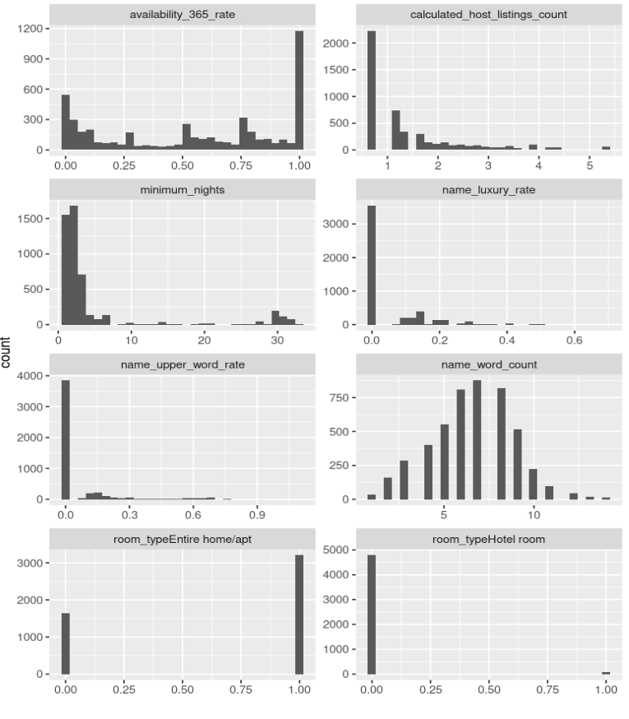

Figure: Log-Transformed Price vs. Locations
This scatter plot shows Airbnb listings in Chicago with latitude and longitude on the axes and log-transformed prices represented by the color scale. Higher-priced listings (yellow/green) are concentrated in central areas, while lower-priced listings (blue/purple) are more dispersed throughout the city. The visualization highlights spatial patterns in pricing, showing a relationship between location and rental price.
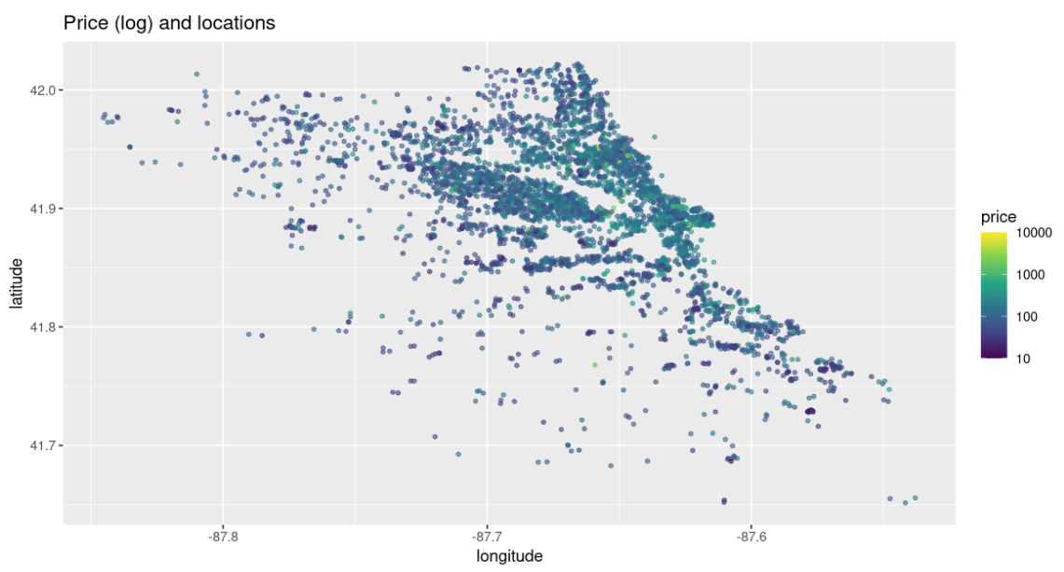
Figure: Word Concentration.
This gistogramm shows Airbnb listings in Chicago with keywords. Positive sentiment as well we Luxury terms words are the most frequently used, while sketchy terms are significantly rarer. This suggests a clear preference for positive and aspirational language in listings.
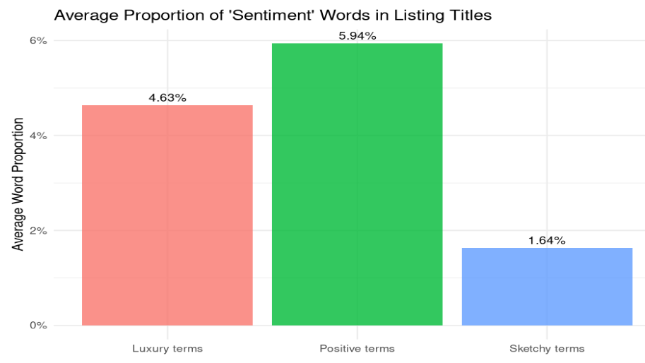

3. Predictive Modeling

3.1 Overview and Rationale
After preprocessing, the Airbnb Chicago dataset contains a large number of variables - 22 explanatory variables of various types (numeric, categorical, log-transformed, and text-based (derived from listing descriptions).
The relationship between the variables and the target variable price, especially with geographic features (coordinates, distance from the center) and text features derived from listing names (name considering word frequency), is not linear.
The dataset also exhibits:
- Right-skewed distributions (in "price", "reviews", "availability"),
- Presence of outliers,
- Multicollinearity (e.g., between "is_downtown" and "distance_from_center", as well as among "room_type" dummy variables).
These characteristics make our task at hand challenging for linear models, but well-suited for ensemble gradient boosting approaches that can capture complex non-linear relationships and handle outliers effectively.

3.2 Model Selection
The chosen method, XGBoost (Extreme Gradient Boosting), has several characteristics that make it particularly well-suited for our dataset:
- It can capture nonlinear relationships and is robust to outliers.
- It can handle missing values (NA) directly in trees without imputation.
- It performs dummy encoding and is partially robust to unbalanced classes.
- It trains quickly due to parallelization, which is important for large datasets.
We tested five alternative methods both theoretically and practically and concluded that all of them are less suitable for our dataset:
- Linear regression (OLS, Ridge, Lasso) requires linear relationships between variabels and the target variable, performs poorly with multicollinearity, and is highly sensitive to outliers.
- Random Forest (RF) is more robust than linear models and less sensitive to small changes in hyperparameters, but it loses accuracy when there are strong nonlinearities among predictors (it averages trees, losing flexibility) and offers less control over the bias/variance tradeoff.
- Support Vector Regression (SVR) scales poorly with a large number of observations and is unstable with respect to sigma/cost parameter selection.
The average RMSE results for these models are summarized below.

Model | RMSE
XGBoost (see sections below) | 64.5
Random Forest | 67.7–68.5
Ridge / Lasso / OLS | 72.6–73.7
SVR | 90.7

XGBoost model demonstrated the lowest RMSE, confirming it as the optimal model for our regression task.

3.3 Model Development Workflow
Model training was implemented through a systematic five-step tuning process, using an 80/20 train–validation split. All preprocessing steps were integrated into a recipe pipeline ensuring reproducibility and proper data hygiene.
Preprocessing Pipeline:
- Removal of zero-variance predictors.
- Median imputation of missing values (where necessary).
- Grouping of rare categories (step_other).
- One-hot encoding of categorical variables.
- Model evaluation metric fixed as RMSE.

3.4 XGBoost Model Tuning Process
The XGBoost hyperparameter optimization was conducted in five sequential stages in order to consistently improve the quality of the forecast and minimize overfitting.
Step | Parameter Group | Description
1 | trees, learn_rate | Tune the number of boosting rounds (trees) and learning rate. The aim is minimal validation RMSE with a small train–validation gap (avoiding overfitting). A lower learning rate compensated by more trees indicated stable convergence which is desirable.  In our case the optimal models are the upper two (1200 trees×0.01 rate and 1000 trees×0.01rate): min RMSE_val (64.73) + reasonable difference between train and val (gap: 17-19, acceptable level of overfitting) + SE stability (1.3–1.4)
2 | tree_depth, min_n | Adjusting tree complexity. Deeper trees capture more interactions, while min_n controls minimum observations per leaf.  The goal: to ensure that the trees are expressive enough and at the same time prevent overfitting. At this step, the parameters of the other steps were fixed to the previously selected values.  The best combination according to min RMSE_val (64.81) is min_n = 10, tree_depth = 6. At the same time, the retraining is moderate (gap: 21.8), which looks balanced.
3 | loss_reduction (gamma) | Regularization controlling minimum loss reduction for node splitting — reduces overfitting by pruning weak branches. loss_reduction (gamma) is the minimum quality gain required to split the node.  Here, the threshold for minimal improvement of the loss function for node partitioning was adjusted.  Gamma selection allows you to limit splits that give a slight improvement, which stabilizes the model and reduces the risk of overfitting.  Loss_reduction is 0.0245 by min RMSE_val = 64.664, gap: 21.68  All 15 best models show RMSE_val = 64.66 – 64.78 , meaning the quality is almost the same (the difference is < 0.12 RMSE, what is statistically insignificant). The gap is stable at = 21.6 – 21.9 in all cases. This means that the model is stable, and overfitting is stable and moderate. The improvement of RMSE_val compared to the previous steps confirms, that the final regularization is working correctly.
4 | sample_size, mtry | Subsampling parameters: proportion of observations and features used per tree. Helps improve diversity and generalization.  The use of random subsamples of data and features reduces the correlation of trees and reduces overfitting, increasing the stability of the model on new data.  mtry = 13 and sample_size = 0.9 are by min RMSE_val = 64.55, gap: 21.1  The optimal parameters identified in Step 4 are: 13 features are used for each tree split and 90% of a random subsample of observations.
5 | lambda, alpha  L2 (ridge) L1 (lasso) | Regularization on leaf weights to penalize overly complex models.  The aim: to additionally monitor retraining and stabilize model forecasts. In our case it turned out that the model was already well regularized in the previous steps, so the optimal values of lambda and alpha turned out to be very small, with virtually no effect on RMSE.  Lambda = 9.39e-06, alpha = 1.69e-08, min RMSE_val = 64.5717, gap: 21.73  The model has almost no L1/L2 penalties. This means that the model already generalizes well, strong regularization is not needed.

After tuning, the final model demonstrated:
- Stable learning curves,
- No significant overfitting,
- Best validation RMSE = 64.5,
- Interpretability through feature importance ranking (location, room_type, and luxury word ratio among top predictors).
Thus, XGBoost outperformed all alternative models in predictive accuracy and robustness. The RMSE of 64.5 indicates a satisfactory model fit given the inherent data noise and price variability.

3.5. Evaluation of Model Tuning Process
To consolidate the results of all previous steps of XGBoost hyperparameter tuning (Steps 1–5), we applied the "grab_step"() function to extract RMSE metrics from each tuning stage and then combined the results using the "all_results" function into a unified table. This allowed us to observe the model"s evolution and reaffirm the optimal parameter combinations that provide the lowest RMSE on cross-validation.
The best results are achieved with the following parameters:
- trees = 1200
- learn_rate = 0.01
- tree_depth = 6
- min_n = 10
- loss_reduction = 0.0245
- sample_size = 0.9
- mtry = 13
- lambda = 9.390095e-06
- alpha = 1.687474e-08
The optimal configurations were found in "step4_subsample_mtry" and "step5_lambda_alpha". These steps yield the lowest RMSE on validation, approximately 64.5 ± 1.5, indicating good consistency and stability of the model.
After Steps 3–5, the parameters hardly change — this indicates that the model has reached a stable optimal region, and further tuning does not provide noticeable improvement (plateau effect).
Tree depth (tree_depth = 6) and minimum samples per node (min_n = 10) strike a balance between underfitting and overfitting:
- tree_depth = 6 provides sufficient complexity,
- min_n = 10 prevents overfitting on small nodes.
Low learning rate (learn_rate = 0.01) requires more trees (1200), but makes the model more stable and smooth during training.
Loss reduction (loss_reduction = 0.0245) is the optimal regularization for splits, slightly constraining tree growth and improving generalization.
Subsampling (sample_size = 0.9) and feature sampling (mtry = 13) ensure that the model uses 90% of the data and 13 features per boosting iteration, increasing stability without adding excessive noise.
When optimizing the regularization parameters, improvements by Gamma and Alpha Regularization (Step 5) were minor. This suggests that the previously found structure is already sufficiently stable, and strong regularization is not required.
Thus, the final XGBoost model, after stepwise hyperparameter tuning, demonstrates:
- High resistance to overfitting
- Balanced complexity (depth/min_n)
- Optimal learning rate (learn_rate)
- Good generalization performance

4. Training the Final Model and Generating Test Predictions
Before evaluating the model on the test set, the data must be transformed to match the structure created for the training set. For this purpose, all preprocessing steps described in the "Exploratory Data Analysis" section were applied to the training set using the custom function "preprocess_abnb"(). As a result, a clean, stable, and training-consistent data frame (df_test_proc) was obtained.
The final XGBoost regression model ("final_spec"), with optimal parameters obtained after five tuning steps described above, was applied to this dataset. The model was configured for multi-threaded execution.
The recipe and model were combined into a workflow, and the model was trained on the full training set. Predictions on the test set were then generated using the "predict"() function, and results were saved to "submission.csv" for submission.
To evaluate model performance, the training data was split into train and validation subsets (80%/20%), preprocessed using "bake"(), and RMSE was calculated:
- Train RMSE = 44.16
- Validation RMSE = 61.88
Thus, the model is well-trained, shows moderate overfitting, and provides stable predictions on unseen data and is ready for use.

