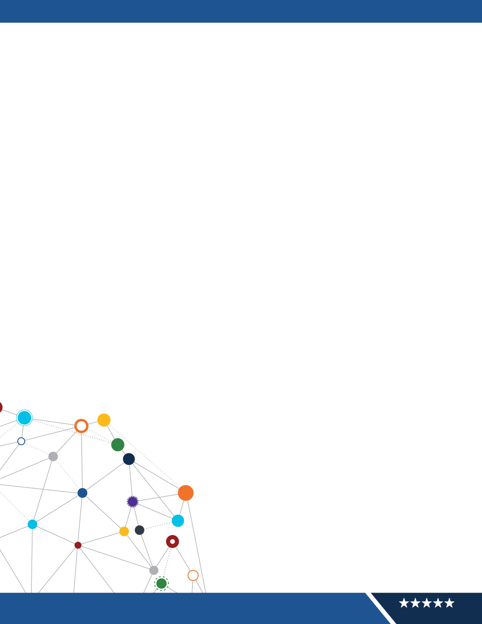


FOR INTERNAL USE ONLY

1

OFFICE OF

INFORMATION AND TECHNOLOGY

Production Operations Manual

{export_date}, | Veterans Affairs (VA) Product
Line Accountability & Reporting System (VA
PARS)

Version 1.5

Revision History

VersionDate Summary of Changes Reviewer Name/Title

1.0 | 09/10/2021 | Original draft; submitted to Information System Owner and Information System Security Officer for review / implementation | Jeremy Nobles/Program  Manager  Charlene Murray/IT  Specialist
1.1 | 02/01/2022 | Updated personnel and processes | Jeremy Nobles/Program  Manager  Charlene Murray/IT  Specialist
1.2 |  | Updated personnel and processes | Jeremy Nobles/Program  Manager  Charlene Murray/ IT  Specialist
1.3 | 11/16/2022 | Reviewed entire document for errors and resolved all comments | Derek Gerard/ACOE TSS Contractor Cyber Lead
1.4 | 05/12/2023 | Updated SOPs for System and Communications Protection (SC) (SC-7), Audit  and Accountability (AU) (AU-12) and System and Information Integrity (SI) (SI-3) | Gavin Brennan/ Contractor Project Lead
1.5 | 05/01/2024 | Updated following Controls resulting from VAEC inheritance changes and Overlay application:  - Access Control: AC-2(7), AC-2(9), AC-2(10), AC2(12), AC-4(21), AC-10, AC-11(1), AC-17(9)  - Audit and Accountability (AU): AU-3(1), AU-5,  AU-8(1), AU-9(4), AU-6.3, AU-8(1).1, AU-8(1).3, AU-8(1).4, AU-8(1).5, AU-9(4)  - Configuration Management: CM-2(2), CM-5(1), CM-5(3), CM-5(5), CM-6(1), CM-10(1)  - Contingency Planning: CP-2(2), CP-9(3)  - Identification and Authentication: IA-2(5), IA4(4), IA-5(4), | Jeremy Nobles/Product  Owner  Charlene Murray/IT  Specialist

Table of Contents

1 Access Control SOP 7
1.1 Access Control Purpose 7
1.2 Access Control Scope 7
1.3 Access Control Roles and Responsibilities 7
1.4 Access Control Procedures 8
1.5 Access Control References 15
2 Security Awareness and Training SOP 15
2.1 Security Awareness and Training Purpose 15
2.2 Security Awareness and Training Scope 16
2.3 Security Awareness and Training Policy 16
2.4 Security Awareness and Training Roles and Responsibilities 16
2.5 Security Awareness and Training Procedures 18
2.6 Security Awareness and Training References 21
3 Audit and Accountability SOP 21
3.1 Audit and Accountability Purpose 21
3.2 Audit and Accountability Scope 22
3.3 Audit and Accountability Policy 22
3.4 Audit and Accountability Roles and Responsibilities 22
3.5 Audit and Accountability Procedures 23
3.6 Audit and Accountability Definitions 28
3.7 Audit and Accountability References 29
4 Security Assessment and Authorization SOP 29
4.1 Security Assessment and Authorization Purpose 29
4.2 Security Assessment and Authorization Scope 29
4.3 Security Assessment and Authorization Policy 29
4.4 Security Assessment and Authorization Roles and Responsibilities 29
4.5 Security Assessment and Authorization Procedures 31
4.6 Security Assessment and Authorization References 34
5 Configuration Management SOP 35
5.1 Configuration Management Purpose 35
5.2 Configuration Management Scope 35
5.3 Configuration Management Policy 35
5.4 Configuration Management Roles and Responsibilities 36
5.5 Configuration Management Procedures 38
5.6 Configuration Management References 48
6 Contingency Planning SOP 49
6.1 Contingency Planning Purpose 49
6.2 Contingency Planning Scope 49
6.3 Contingency Planning Policy 49
6.4 Contingency Planning Roles and Responsibilities 49
6.5 Contingency Planning Procedures 50
6.6 Contingency Planning References 53
7 Identification and Authentication SOP 53
7.1 Identification and Authentication Purpose 53
7.2 Identification and Authentication Scope 53
7.3 Identification and Authentication Policy 54
7.4 Identification and Authentication Roles and Responsibilities 54
7.5 Identification and Authentication Procedures 54
7.6 Identification and Authentication References 57
8 Incident Response SOP 58
8.1 Incident Response Purpose 58
8.2 Incident Response Scope 58
8.3 Incident Response Roles and Responsibilities 58
8.4 Incident Response Procedures 63
8.5 Incident Response Team Members 67
8.6 Incident Response References 67
9 Maintenance SOP 68
9.1 Maintenance Purpose 68
9.2 Maintenance Policy 68
9.3 Maintenance Roles and Responsibilities 68
9.4 Maintenance Procedures 69
9.5 Maintenance References 70
10 Media Protection SOP 70
10.1 Media Protection Purpose 70
10.2 Media Protection Scope 70
10.3 Media Protection Roles and Responsibilities 70
10.4 Media Protection Procedures 72
11 Physical and Environmental Protection SOP 72
11.1 Physical and Environmental Protection Purpose 72
11.2 Physical and Environmental Protection Scope 72
11.3 Physical and Environmental Protection Roles and Responsibilities 73
11.4 Physical and Environmental Protection Procedures 73
12 Planning SOP 74
12.1 Planning Purpose 74
12.2 Planning Scope 74
12.3 Planning Policy 74
12.4 Planning Roles and Responsibilities 75
12.5 Planning Procedures 75
12.6 Planning References 78
13 Personnel Security SOP 78
13.1 Personnel Security Purpose 78
13.2 Personnel Security Scope 79
13.3 Personnel Security Policy 79
13.4 Personnel Security Roles and Responsibilities 79
13.5 Personnel Security Procedures 80
13.6 Personnel Security References 87
14 Risk Assessment SOP 88
14.1 Risk Assessment Purpose 88
14.2 Risk Assessment Scope 88
14.3 Risk Assessment Policy 88
14.4 Risk Assessment Roles and Responsibilities 88
14.5 Risk Assessment Procedures 89
14.6 Risk Assessment References 92
15 System and Services Acquisition SOP 93
15.1 System and Services Acquisition Purpose 93
15.2 System and Services Acquisition Scope 93
15.3 System and Services Acquisition Policy 93
15.4 System and Services Acquisition Roles and Responsibilities 93
15.5 System and Services Acquisition Procedures 95
15.6 System and Services Acquisition References 101
16 System and Communications Protections SOP 102
16.1 System and Communications Protections Purpose 102
16.2 System and Communications Protections Scope 102
16.3 System and Communications Protections Policy 102
16.4 System and Communications Protections Roles and Responsibilities 102
16.5 System and Communications Protections Procedures 103
16.6 System and Communications Protections References 108
17 System and Information Integrity SOP 109
17.1 System and Information Integrity Purpose 109
17.2 System and Information Integrity Scope 109
17.3 System and Information Integrity Policy 109
17.4 System and Information Integrity Roles and Responsibilities 110
17.5 System and Information Integrity Procedures 110
17.6 System and Information Integrity References 117
Appendix A: ServiceNow Process 118
Appendix B: VA PARS Authorized Roles 120
Appendix C: VA Product Line & Accountability Reporting System Enterprise Service Desk (ESD) Workflow 122
Appendix D: Acronyms 124

{#families}

{family_number} {family_name} SOP

{family_number}.{purpose_num} {family_name} Purpose
{purpose_text}
{#has_scope}

{family_number}.{scope_num} {family_name} Scope
{scope_text}
{/has_scope}
{#has_policy}

{family_number}.{policy_num} {family_name} Policy
{policy_text}
{/has_policy}

{family_number}.{roles_num} {family_name} Roles and Responsibilities
{#roles}

{role_number} {role_name}
{#responsibilities}
- {text}
{/responsibilities}
{/roles}

{family_number}.{procedures_num} {family_name} Procedures
{#base_controls}

{heading_number} {heading_text}
{#narrative}
- {bullet_text}
{#sub_bullets}
- {text}
{/sub_bullets}
{/narrative}
{#has_artifacts}
Evidence artifacts:
{#artifacts}
- {file_name}
{/artifacts}
{/has_artifacts}
{#enhancements}
{heading_number} {heading_text}
{#narrative}
- {bullet_text}
{#sub_bullets}
- {text}
{/sub_bullets}
{/narrative}
{#has_artifacts}
Evidence artifacts:
{#artifacts}
- {file_name}
{/artifacts}
{/has_artifacts}
{/enhancements}
{/base_controls}
{#has_references}

{family_number}.{references_num} {family_name} References
{#references}
- {text}
{/references}
{/has_references}
{/families}

Appendix A: ServiceNow Process
- All support and/or trouble tickets need to be submitted through https://yourit.va.gov/va
- Once in Your IT application, locate “Application Access” and click on the box. Any request for access, defect, information, data changes, etc. will be entered under Application Access for VA PARS. See Figure 1 below – Create your own issue:

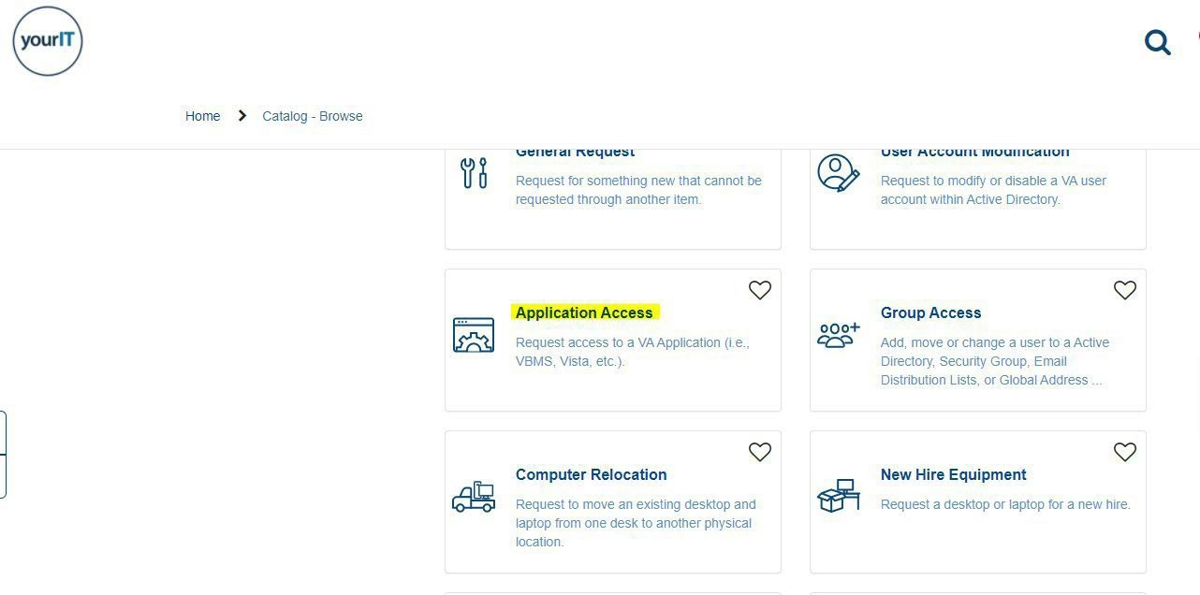

- Complete all the required USER INFORMATION fields.
- As you complete the REQUEST DETAILS section, select the following options (Figure 2 on the following page – Use Description Block for all VA PARS Issues):
  - Name of Requested Application: “Other Application”
  - Other Application: “VA PARS”
  - Describe the specifics: (Include all details pertaining to your request. If requesting access, describe access level/privileges. If requesting other assistance, please enter those details.)
  - DATE Needed By: Enter the date you need issue resolved by.

IRIEQUEST DETAILS

  - Name of Requested Application €)
Please select one of the options below_ If your specific application is no! listed, select other Application.
X

[ Other Application

  - other Application 0
Please provide the name of the application using 160 characters or less_
X

VA PARS

  - Please describe the specific access level, privileges, and if this is a new or existing user

  - Date Needed By

ii
5. Click on “Order” to submit ticket. The ticket will be routed to the VA PARS Help Desk.

Appendix B: VA PARS Authorized Roles
Security Group | Description
CIO Rating Editor | This group is a smaller subset of the Investments Team. Users in this group may add a new investment. Users may also update/edit the CIO rating
EPS Team | Add and modify all records in the EPS module. View and modify all hierarchical levels of the EPS Admin Console.
EPS Editor | Add/modify/copy EPS records
Investments Oversight | Modify ALL Investment Records but cannot create a new investment.  Membership grants access to text box within manage  Investment Section to override the investment CIO Rating. This group is a smaller subset of the Investments Team.
Investments Team | Modify their respective Investment Records.
Key Performance Indicators (KPI) Alerts Review Group | VA PARS Oversight Group for KPI Alerts
Code Sharing Review Group | VA PARS Oversight Group for Code Sharing
Product Scorecard Review Group | VA PARS Oversight Group for Product Scorecards
High Visibility Project Review Alert  Group | VA PARS Oversight Group for High Visibility Projects
OMB Oversight Group | Members of this group can view OMB project and its activities of the selected project from the Admin Module.
OMB Submission Team | Members of this group can submit JSON files for  Projects, Activities, Revisions, and CIO Ratings to OMB.
Portfolio Directors | Members in this group have edit access to their respective Portfolios.
Product Line Editors | Members in this group have edit access to their respective Product Lines.
Project Team | Members of this group can Edit their Project/Product.
Revise Approvers | Individuals or groups authorized to approve or reject revise requests; groups vary by investment.
Revise Record Creator | Members in this group can create or modify a Revise record.
Scorecard Editors | Users in this group will be able to add/edit data on Product Scorecards created in the last 3 months. This group also requires membership in VA PARS Product Scorecard Review Group.
Scorecard Oversight | Membership grants edit and delete permissions to all Scorecards.  This group also requires membership in VA PARS Product Scorecards Review Group.
VA PARS Read Only | Membership grants Read Only access for VA PARS.
VA PARS Oversight | Membership grants Overall Admin access for VA PARS.

Appendix C: VA Product Line & Accountability Reporting System Enterprise Service Desk (ESD) Workflow
The purpose of this workflow is to provide users with a step-by-step guide on how to successfully maintain the VA Product Line & Accountability Reporting System (VA PARS) Help Desk.

1 Prerequisites
- Access to VA PARS Security Groups for:
  - Production environment: https://vapars.prod.vaec.va.gov/
  - Pre-production environment: https://vapars- preprod.nprod.vaec.va.gov/
- Understand VA PARS tool functionality
- Assignment to VA PARS Assignment Group in ServiceNow

- Support or Trouble Tickets need to be submitted through ServiceNow via https://yourit.va.gov/va
- The ESD will assign the ticket to VA PARS assignment group in ServiceNow.
- VA PARS assignment group will triage the ticket as follows:

2 Triaging Help Desk Tickets
- Questions/VA PARS ServiceNow Assignment Group tickets can be answered by VA PARS support team (Tier 1) without additional input - Includes Access requests (Read Only and Edit), VA PARS tool functionality questions, Mentoring inquiries.
- Question/ VA PARS ServiceNow Assignment Group ticket will need to be investigated by the VA PARS development team (Tier 2) for technical help. Tickets will be assigned to one of the developers in the ServiceNow Assignment Group: VA PARS. Includes requests for:
  - Data changes for projects/products that cannot be done in the UI.
  - VA PARS functionality issues that are deemed defects.
  - DCBI Read only access to VA PARS database.

- Program Planning and Oversite (PPO) tickets (e.g., non-operations & maintenance [O&M] projects) that come in via VA PARS ServiceNow Assignment Group will need to be approved by the Investment Oversight & Reporting Branch (IORB) Investment Oversight & Reporting Branch organization.
» Includes requests for:
  - Deletions of data/records
  - Revise request questions/changes
  - EPS change request
  - VASI change request

Tier 2 PPO tickets will be assigned to the VA PARS ServiceNow Assignment Group ticket and emailed to the following:
OIT EPMO DMO PPO Management: OITEPMODMOPPOManagement@va.govmailto: VA PARS Support: vhasagvaparssupport@va.gov

- VA PARS ServiceNow Assignment Group Ticket requiring changes and/or information on metrics or dashboard reports need to be assigned to one of the listed ServiceNow Assignment Groups:
  - ACOE Metrics and Analytics
  - ACOE Business Intelligence and Reporting

ESO | Enterprise Security Operations
FIPS | Federal Information Processing Standards
FISMA | Federal Information Security Modernization Act

Appendix D: Acronyms
ACOE | Agile Center of Excellence
AD | Active Directory
ADFS | Active Directory Federation Services
AO | Accountability Officer
AOR | Area of Responsibility
ASAP | As Soon As Possible
AT | Awareness and Training
AU | Audit and Accountability
BAA | Business Associate Agreement
BCM | Baseline Configuration Management
CA | Security Assessment and Authorization?
CAB | Change Advisory Board
CAG | Citrix Access Gateway
CCI | Control Correlation Identifier
CFR | Code of Federal Regulations
CFT | Client First Technologies
CIA | Confidentiality, Integrity, and Availability
CMDB | Configuration Management Database
CMP | Configuration Management Plan
CNSS | Committee on National Security Systems
CO | Contracting Office (or Officer)
CONOPS | Concept of Operations
COR | Contracting Officer Representative
CRISP | Cybersecurity Risk Information System
CSOC | VA Cyber Security Operations Center
DCBI | Data Centralization and Business Intelligence Analytics
DISA | Defense Information Systems Agency
DMO | Demand Management Office
DRP | Disaster Recovery Plan
ECSO | Enterprise Cloud Solutions Office
eMASS | Enterprise Mission Assurance Support Services
ePAS | Electronic Permission Access System
EPMO | Enterprise Program Management Office
EPS | Enterprise Project Structure
ESD | Enterprise Service Desk
ESECC | Enterprise Secure External Connection Council
GRC Governance,Risk, and Compliance
HIPAA Health Insurance Portability & Accountability Act

HITECH Health Information Technology for Economic and Clinical Health Act
HR | Human Resources
HSPD 12 | Homeland Security Presidential Directive 12
HTTP | Hyper Text Transfer Protocol
I/O | Input/Output
IA | Identification and Authentication
ICAM | Improved Identity, Credential, and Access Management
ICAMP | VA Information Central Analytics and Metrics Platform
IRP | Incident Response Plan
ISA | Interconnection Security Agreement
ISCM | Information Security Continuous Monitoring
ISCP | Information System Contingency Plan
ISO | Information System Owner
ISSO | Information Security System Officer
IT | Information Technology
ITOPS | Information Technology Operations and Services
IORB | Investment Oversight & Reporting Branch
KPI | Key Performance Indicator
LEAF | Light Electronic Action Framework
MA | Maintenance
MIM | Microsoft Identity Management
MOU | Memorandum of Understanding
NARA | National Archive Records Administration
NCCIC | National Cybersecurity and Communications Integration Center
NEO | New Employee Orientation
NIST | National Institute of Standard and Technology
NMEA | Non-Mailbox-Enabled Accounts
O&M | Operations and Maintenance
OIS | Office of Information Security
OIT | Office of Information and Technology
OMB | Office of Management and Budget
OPM | Office of Personnel Management
OPS PR | Office of People Science People Readiness
OU | Organizational Unit
PaaS | Platform as a Service
PART | Privileged Access Review Team
PDAT Position Designation Application Tool
PE Physical and Environmental
Pen Test Penetration Test
PHI | Personal Health Identifiers
PII | Personally Identifiable Information

TBD | To Be Determined
TLS | Transport Layer Security
TMS | Talent Management System
PIN Personal Identification Number
PIV | Personal Identification Verification
PL | Planning
PO | Privacy Officer
POA&M | Plan of Action & Milestones
POC | Point of Contact
POM | Production Operations Manual
PPBE | Planning, Programming, Budgeting, and Execution
PPSM | Ports, Protocols, and Services Management
PSETS | Privacy and Security Event Tracking System
QA | Quality Assurance
RA | Risk Assessment
RAP | Remote Access Portal
RBT | Role-based Training
RCS | Records Control Schedule
RMF | Risk Management Framework
ROB | Rules of Behavior
SA | System and Service Acquisition
SAC | Special Agreement Check
SC | System and Communications
SCCD | System Configuration Compliance Data
SDLC | System Development Life Cycle
SI | System Integrity
SIC | Security and Investigations Center
SLA | Service Level Agreement
SME | Subject Matter Expert
SOP | Standard Operating Procedure
SOW | Statement of Work
SP | Special Publication
SPM | Software Product Management
SQL | Structured Query Language
SS | System Steward
SSP | System Security Plan
SUA | Standard User Account
TAG | Technical Advisory Group
TAPP | Threat Assessment & Analysis Portal

TRM Technical Reference Model
TS Technical Solutions

UAT User Acceptance Testing
UI | User Interface
VA | Department of Veterans Affairs
VA PARS | VA Product Line Accountability & Reporting System
VAEC | VA Enterprise Cloud
VASI | VA Systems Inventory
VPN | Virtual Private Network
WASA | Web Application Security Assessment

