1.Complete the following table:

654 | Rw-r-x r--
766 | Rwx rw- rw-
777 | Rwx rwx rwx
520 | R-x -w- ---
764 | Rwx rw-x r--
440 | r--r-----

2.Create the groups office1 and office2.

Sin permisos para crear grupos
- groupadd office1
- groupadd office2

3. Create the users gearoid and paul. These users must belong only to the group
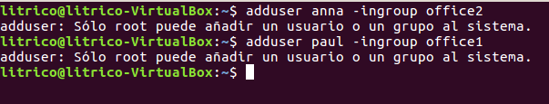
office1.

4. Create the users anna and emma. These users must belong only to the group office2.

- adduser anna –ingroup office2
- adduser emma –ingroup office2

5. As user gearoid, create a file named topsecret.txt in his home directory. Only
this user must have access to this file, both for reading and writing.

- su gearoid
- cd
- touch topsecret.txt
- chmod 600 topsecret.txt

6. Create another file named sales.txt, also as user gearoid,. All users in the same
group as gearoid must have access to this file, both for reading and writing. The
permissions for owner and the rest of users must remain as default. Check that you can
modify the file if you access it as user paul.

- Touch sales.txt
- chmod g+rw sales.txt

7. As user anna, create a file named employees.txt. Any user must have access to
read its content and any user in the same group must have access to read or write to it.

- exit
- su anna
- touch employees.txt
- chmod 064 employees.txt

8. Create the user student (if it is not yet created). Copy the file employees.txt to
the home directory of user student . Change the owner and the group of this file to
student.

- exit
- adduser student
- cd /home/anna
- sudo cp employees.txt /home/student
- cd /home/student
- sudo chown student employees.txt
- sudo chgrp office2 employees.txt

17. Supose a user has read access to a file, but this file is in a directory for which the user has
no read access. Could this user read this file? Try it.

Si, el usuario puede leer los archivos, ya que este usuario tiene prioridad sobre los demas directorios.

