1) In which directory are the configuration files of the system?

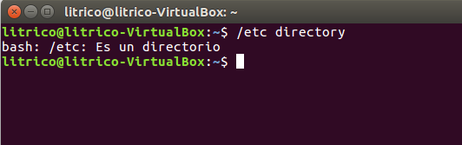

2)To login to a Linux system requires

a) user name, password and IP address,
b) username and password.
c) only a password.

3. Display the content of the current directory.

Ls

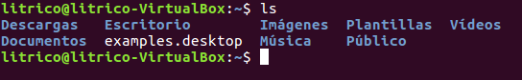

Archivos ocultos: la -a

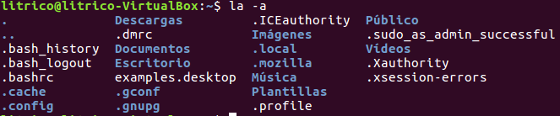

4)Display the contents of the directory which is just at an upper level.

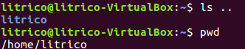

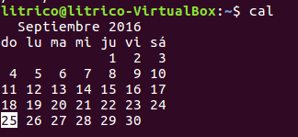
5) In wich day of the week you were born?, use the cal command to find it out.

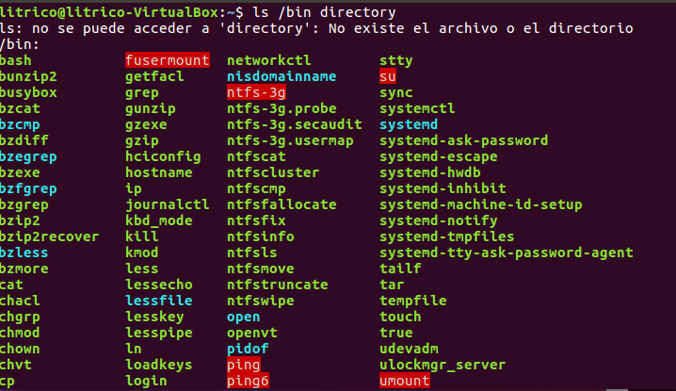
6) Display the files in the /bin directory.

7) Assuming you are in your home directory (/home/username), display the contents of
the /usr/bin directory
a) with just one command line, ls/usr/bin
b) moving step by step through the directory tree and
c) with two command lines.
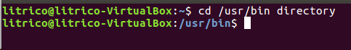
a

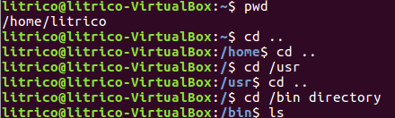

b

c

8) Display all the files in the /etc directory and all the files in the subdirectories
recursively (with just a one-line command).

Como yo creo
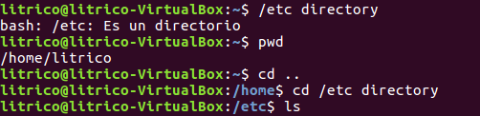

RESPUESTA

9) Display all the files in the /usr/bin/X11 directory ordered by size (from highest to
lowest). Only the name of each file must be shown, without any other additional information.

10)Show all the files in the /etc directory ordered by size (from highest to lowest)
together with other characteristics, i.e. permissions, size, date of last modification, etc. The
size of each file should appear in a "readable" format, expressed in Kb, Mb, etc.

ls -l -S -h -a /etc

11)Show all the files in the /bin directory ordered by size (from lowest to highest).
Only the name and the size of each file must be shown, without any other additional

ls -s -r -S /bin

12) ls /root

13) ls ../../../root

14) mkdir /home/alumno/expenses

15) acceso denegado

16) cat /etc/fstab

17) head /etc/bash.bashrc

18) mkdir multimedia
cd multimedia
mkdir music
mkdir pictures
mkdir videos
mkdir slides
cd pictures
mkdir personal
mkdir other

19) touch /home/alumno/music/favourite_styles.txt

20) nano favourite_styles.txt

21) cat favourite_styles.txt

22) head -n3 favourite_styles.txt

23) tail -n1 favourite_styles.txt

24) tail -n +2 favourite_styles.txt

