Java windows setup prepare document

1. To make an exe setup with mysql and jre, first we will use inno setup software. Inno setup uses yourapp.exe to make the final exe. So we need to create exe file from our jar file. For that we will use Launch4j Executable wrapper.

To download Launch4j, go to: http://launch4j.sourceforge.net/

Then in download section download launch-win32.exe as shown in screenshot

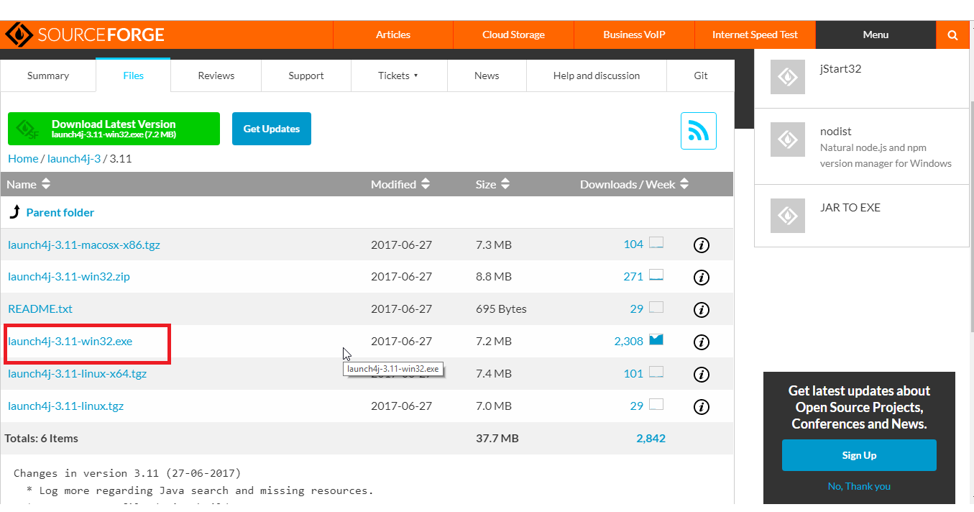

run this file and install Launch4j

2. Now copy your app’s dist folder’s data first and copy it in your setup making folder.

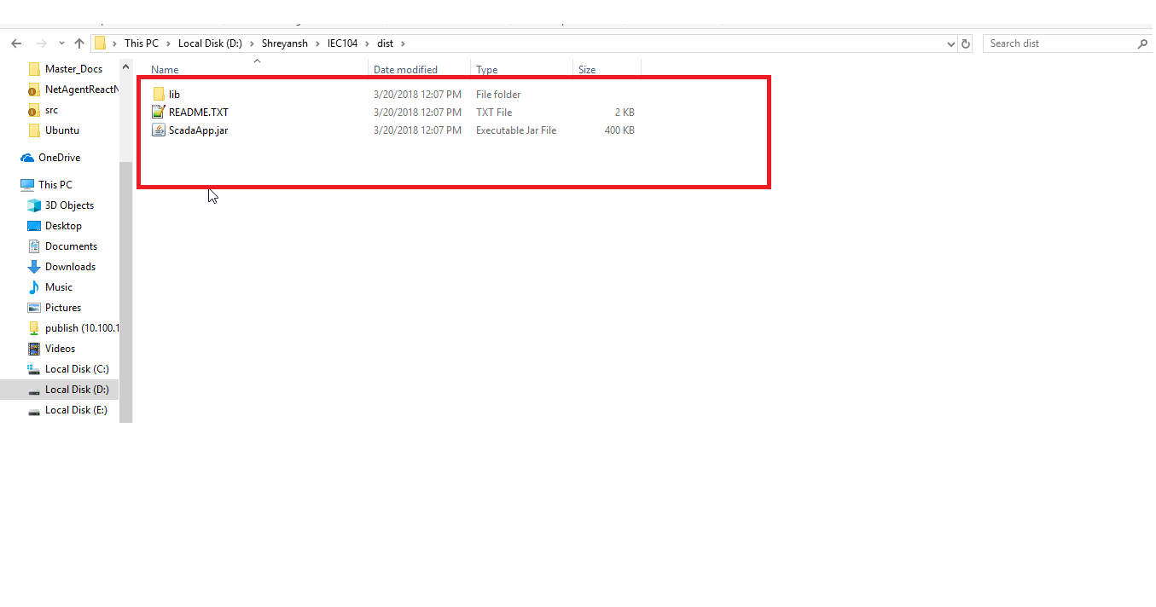
Now start Launch4j setup exe. And give path of your folder to prepare setup and your jar file that you just copied.
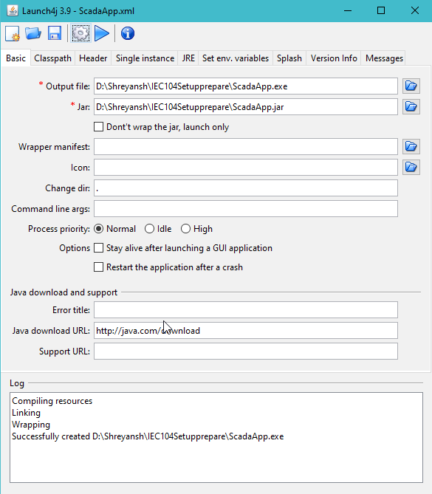

In jre section define minimum and maximum jre versions
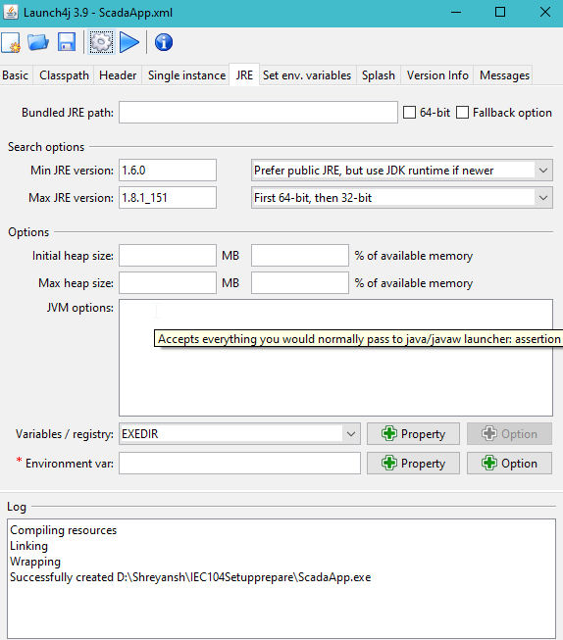

Now click on settings icon in top bar and save executable ScadaApp.exe file to your setup prepare folder. So, now the SetUpPrepare folder looks like this

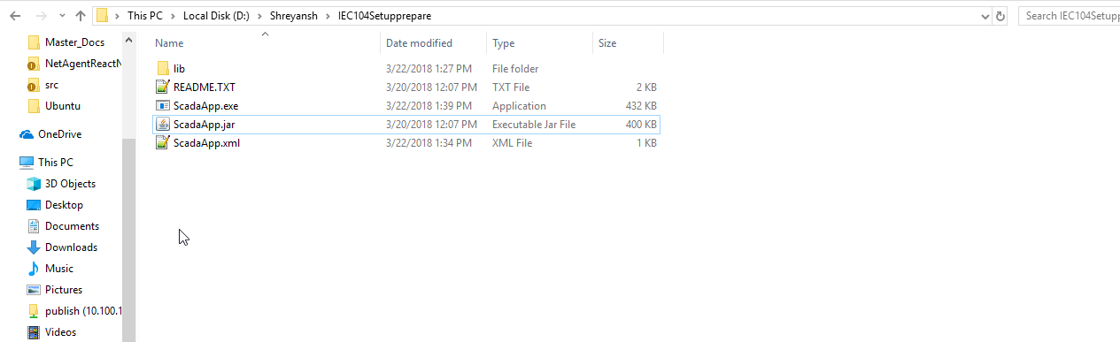

3. Now include jre which you are using in this folder to be shipped with this setup, copy the whole jre folder into our SetUpPrepare folder.cyou can find jre on : \\10.100.112.80\Publish\Java\Shreyansh\Downloads

So, now the SetUpPrepare folder looks like this

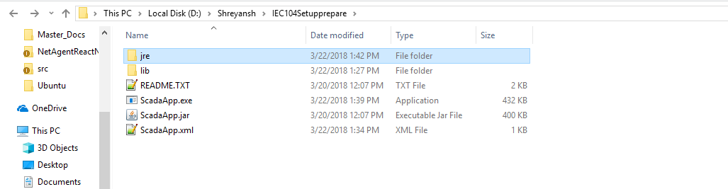

4. Now add mysql folder to our directory from: \\10.100.112.80\Publish\Java\Shreyansh\Downloads

Now put all this files in a single folder named your app’s name

So we have all these files now in: D:\Shreyansh\IEC104Setupprepare\ScadaApp folder’s

5. Download inno setup from: http://www.jrsoftware.org/isdl.php

Install inno setup and open it

6. now select create new file as shown in below Screen-shot:

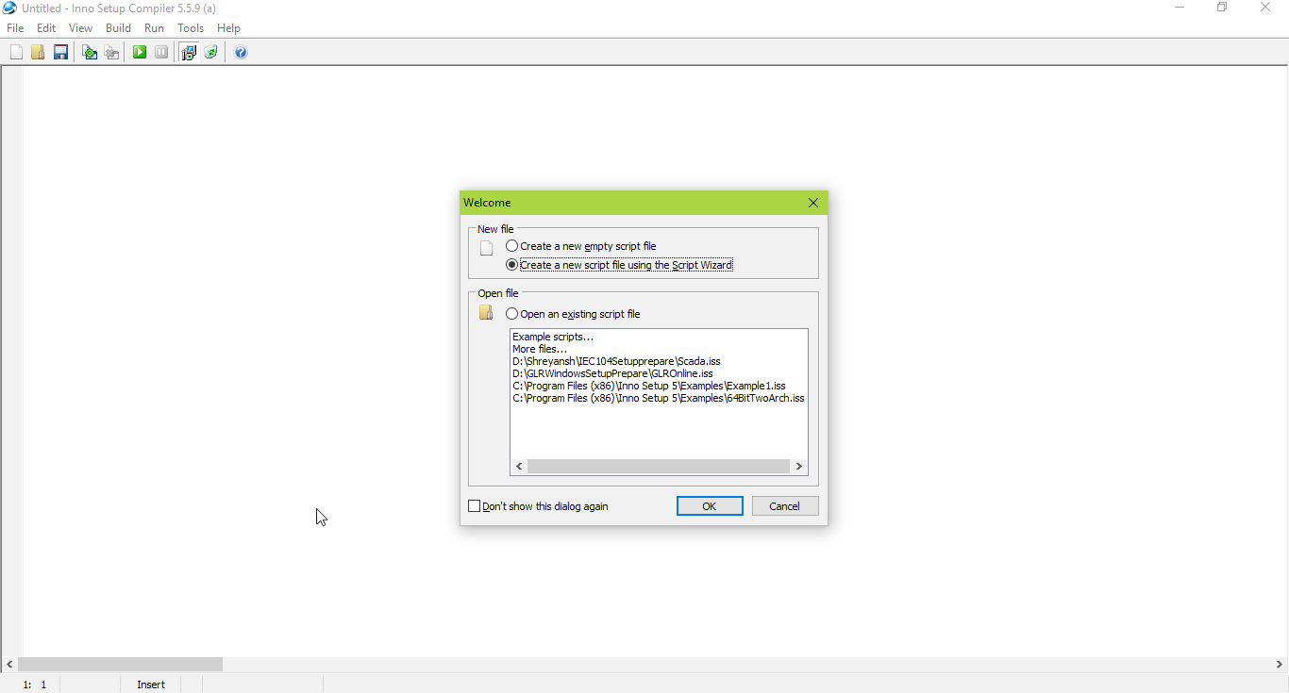

Now follow the dialogs along, add required information, give that exe file path which we created before using Launch4j and save the created script file along with our folder.

So, the folder structure now is,

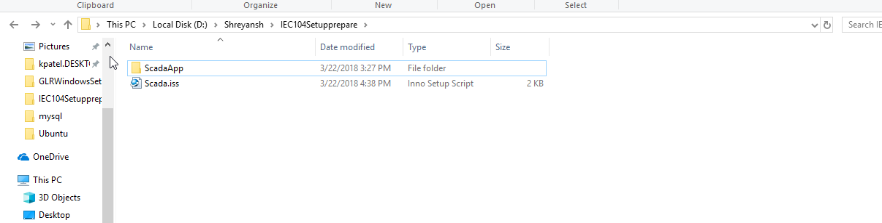

7. Now we can compile the setup using the iss file. So, run the file and press compile icon as show in below screen-shot

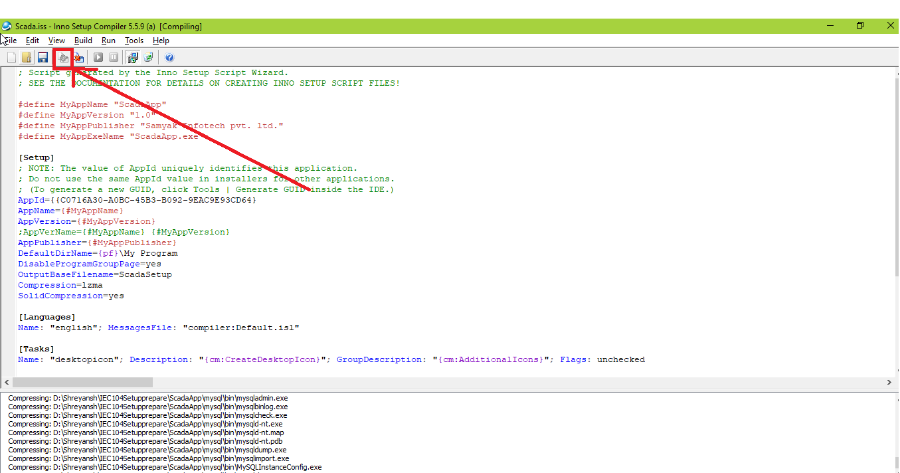

When the compile is done, you can find your exe In Output folder of your SetupPrepare folder’s

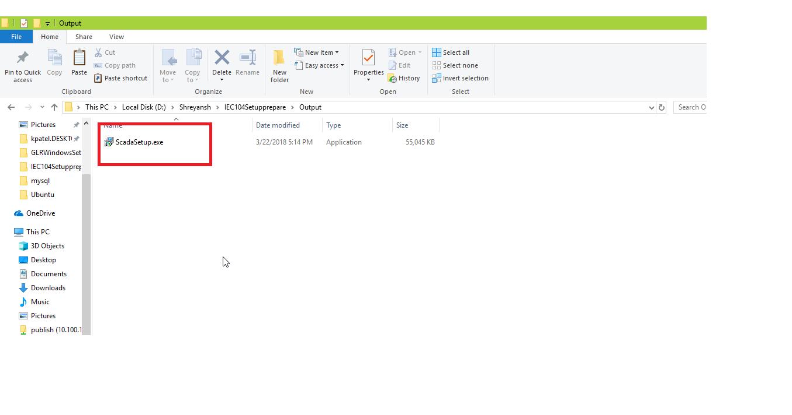

8. To run mysql in start of your desktop application, we need to write below code in java:

try {

Process proc = new ProcessBuilder(".\\mysql\\bin\\mysqld-nt.exe", "--defaults- file=\".\\mysql\\my.ini\"").start();

} catch (IOException ex) {
Logger.getLogger(GLROnlineApp.class.getName()).log(Level.SEVERE, null, ex);
}

To start on specific portt, you can change port number in mysql’s my.ini file

