Mobile Application Flow

Surya-CFL Mobile Applcation
Prepared and Submitted By
Samyak Infotech Pvt. Ltd.
905-908, Abhijeet, Mithakhali Six Roads,
Ellisbridge, Ahmedabad - 380 006, INDIA
Tel 91-79-26465758, Fax 91-79-26466804
URL www.samyak.com, E-mail info@samyak.com

Made by | Shreyansh Doshi
Approved by
Issue Date | 8th March, 2017

Screen: 1

Screen Name: Splash Screen

Discription :

Start Point:
Surya CFL Mobile Applcation

Screen Shot:

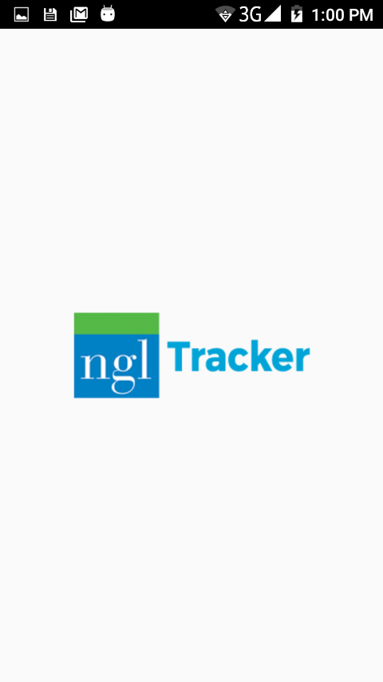

Screen: 2

Screen Name: WiFi List

Discription :

The objective of this screen is to detect all Wifi Connections and show them with their strengths

Start Point:

Tracking Mobile Applcation >> Splash >> WiFi List

Screen Shots:
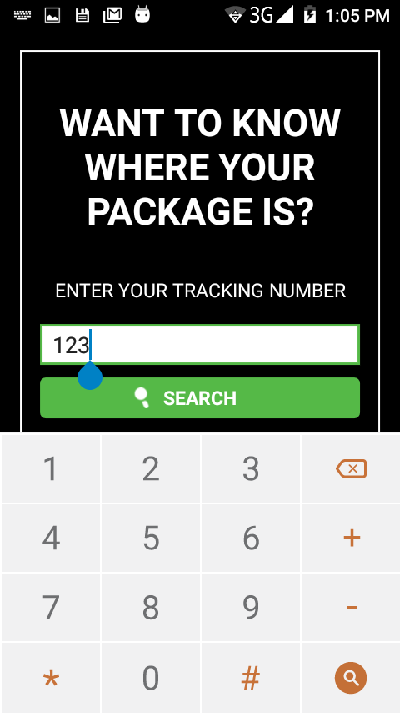
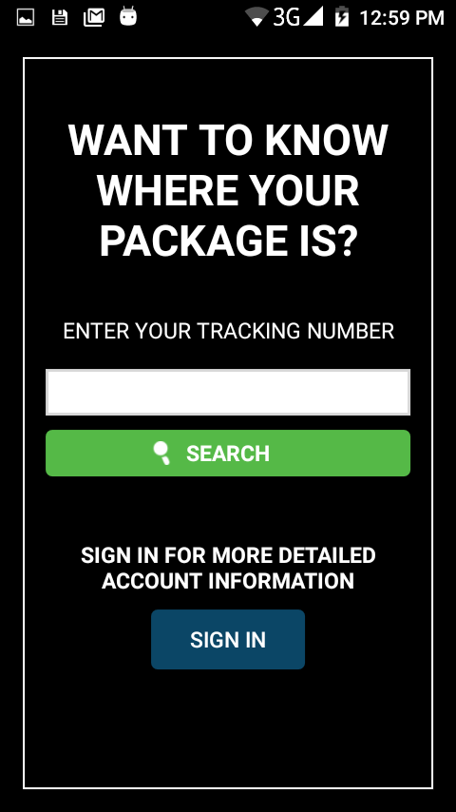

Functionalities:

- User will be asked to switch on wifi if it is disabled
- After enabling wifi list of all wifi available will be shown with wifi strengths.
- If User click on any of the Wi-fi according to security type of Wi-fi he/she will be connected to it. If it is open, then directly connected to Wi-fi and if WPA then it will ask for a Security Key.

Screen: 3

Screen Name: Dash Board

Discription :

There are two tabs in this screen, One for get and set data and the other for View Log

Start Point:

Tracking Mobile Applcation >> Splash >> WiFI List >> Dash Board

Screen Shots:

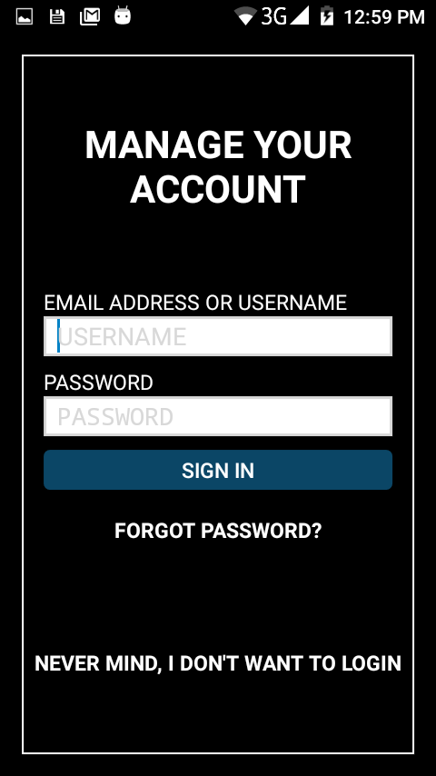

Functionalities:

- By pressing on the floating action button which is placed at the bottom of the screen all the data from the connected wifi of the bulb will be got and shown on the screen
- User can enter data or select option and set data by pressing a button below the edittexts
- Validations for all edittexts
- Connected WiFi name and its status will be shown in the actionbar
- Voltage is refreshed every 5 seconds automatically if connected to WiFi
- User can set on/off cycle, Default Email, Admin Passwor and Change WiFi connection by clicking on the settings menu present in the action bar

View Log Screen:
- There are some advance options, user has to enter admin password to see those options
- User can download all Periodic and alarm log data in CSV File format and generate a graph by clicking on the button ‘Trendz’

