**Mobile Application and Admin Panel Flow**

**WishList Mobile Applcation**

Prepared and Submitted By

**Samyak Infotech Pvt. Ltd.**

905-908, Abhijeet, Mithakhali Six Roads,

Ellisbridge, Ahmedabad - 380 006, **INDIA**

Tel 91-79-26465758, Fax 91-79-26466804

URL [www.samyak.com](http://www.samyak.com/), E-mail [info@samyak.com](mailto:info@samyak.com)

|  |  |
| --- | --- |
| **Made by** | **Shreyansh Doshi** |
| **Approved by** |  |
| **Issue Date** | **06/07/17** |

**Mobile Application Flow**

**Screen: 1**

**Screen Name: Splash Screen**

**Description :**

Splash screen will be shown for 2-3 seconds as app starts. After that Login screen for the user will be displayed.

**Screen: 2**

**Screen Name: Login**

**Mock-up:**

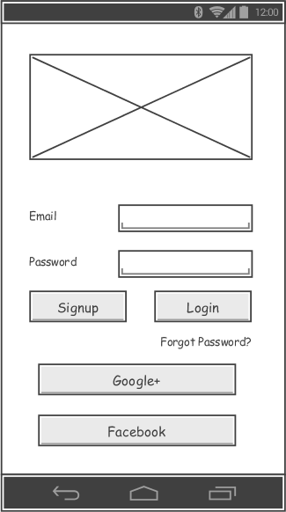

**Description :**

**1.** This screen will open after Splash screen. This screen has different fields like.

**Fields:**

Email Edit-Text

PassWord Edit-Text

Sign Up Button

Login Button

Google+ Button

Facebook Button

Forgot Password Link

1. If user is already registered he/she will enter email and password in textfield and click on login button it will redirect to **dashboard** of our app.
2. If user is not registered, he/she can click on signup button to register the App.

4.If user have Google+ and Facebook account ,Click on any of this button

it will directly Login by this button.

5. Validations for Email and password fields

6. There is a link for forgot Password on this screen. User will be redirected to Forgot Password screen.

**Screen: 3**

**Screen Name: Forgot Password**

**Mock-up:**

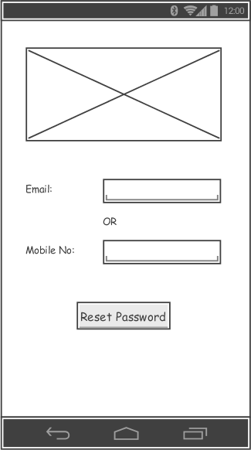

**Description :**

1. This screen will open after clicking on the ‘Forgot Password’ link on Login Screen. There are three fields in this screen.

Email Edittext

Mobile Number Edittext

Forgot Password Button

2. User can add email or Mobile number and click on Button. Email or message will be sent to registered Email or Mobile Number.

3. There will be a toast after pressing a button suggesting that New Password is sent to registered email or phone and user will be redirected to Login Screen

**Screen: 4**

**Screen Name: Sign Up**

**Mock-up:**

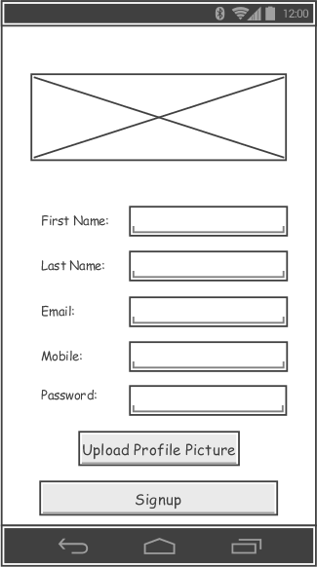

**.**

**Description :**

**1.** This screen will open after clicking on the ‘SignUp’ Button on Login Screen. There are Five Fields in this screen like

**Fields:**  First Name Edit-Text

Last Name Edit-Text

Email Edit-Text

Mobile Edit-Text

Password Edit-Text

Confirm Password Edit-Text

Profile Picture Button(File Selection)

Sign Up Button

2. User will enter these fields with proper format if not enter any field properly validation message will be shown.

3. Then After click on Sign up button user will be Redirected to **Login** page.

**Screen: 5**

**Screen Name: DashBoard**

**Mock-up:**

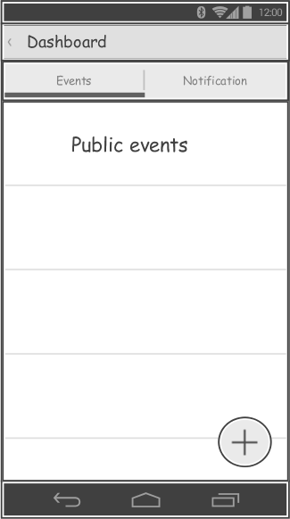

**Description :**

1.This screen will open after Successful login to the app

2. There are 2 tabs on Dashboard. Events and Notifications

3. In Events tab different public events will be showed and user can join any of the event shown here

4. In Second tab notifications will be displayed if any user uploads photos of the completed events

5. There is an action button on this page. User can create event by clicking on the button. User will be redirected to **create event** page by clicking on this button.

6. On click of any of the card in first or second **event details** page will be opened, user can press photo button and see photos uploaded or he can upload new photos by clicking on the button in the action bar

**Screen: 6**

**Screen Name: Create Event**

**Mock-up:**

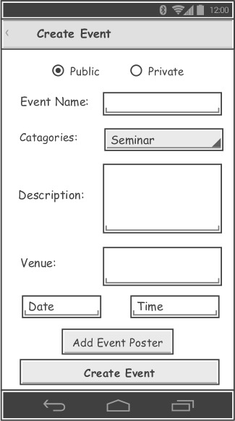

**Description :**

1. User will come here after clicking on the action button on the dashboard

2. In this we will give different fields to create an event

Fields: select event type: private or public Radio Buttons

Event name Edittext

Catagories Spinner(Drop-down)

Description Edittext

Venue Edittext

Date Select from Date-picker

Time Select from Time-Picker

Add Event Poster Button

Create Event Button

3. User will first select event type, then enters event name. We will show a dropdown list of event Catagories according to event type. Then user will enter Description, venue and Date-time of an event

4. Validations for all fields if not selected or entered values. Events which are happening after 24 hours can only be created

5. After entering all valid values user will press a button to create event and the event will be created.

6. Event Creator can upload photo/poster/Banner of the event

7. Creator will be redirected to **MyEvents** page after clicking the button ‘Create Event’. An Event code will be generated while posting an event and will be shared while sharing an event

**Screen: 7**

**Screen Name: My Events**

**Mock-up:**

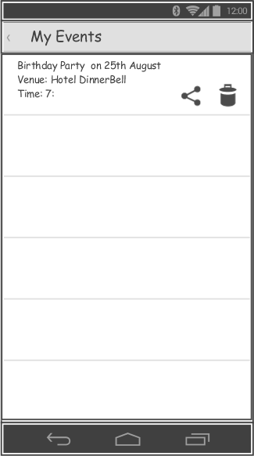

**Description :**

1. In this page we will show a list of events which are posted by user and which are currently active.

2. The cards will have date-time, venue and event name and cards will also have an option to directly share or delete an event

3. Events in this page will be disappear after one week of completion

4. On click of a card user will be redirected to **Event Details** Screen

**Screen: 8**

**Screen Name: Event Details**

**Mock-up:**

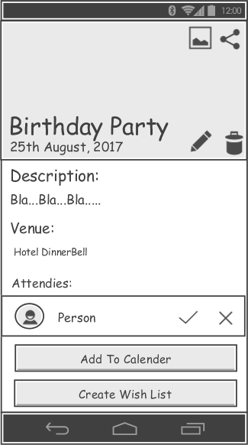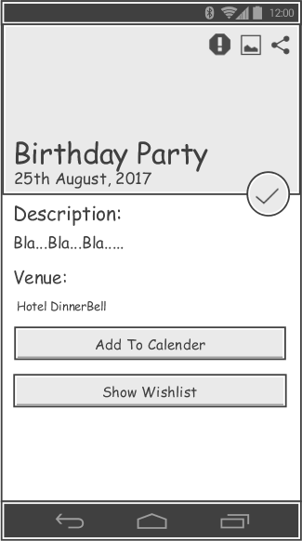

Event Creator End User

**Description :**

1. On this page we will show a predefined image for a particular event. On that name of the event and date will be shown.

2. Description and venue will also be displayed as entered before

3. There will be buttons to update,share and delete event for the event Creator.

On sharing event code will be shared to users. If the event is public anybody

can share the event

4. No fields are editable for the End User. End users can see only Share(only displayed for the public event) and upload photos button after the date-time of event is passed

5. A list of interested People will also be shown to the creator if the event previously selected was private. Event Creator can approve or reject any of the interested people

6. Here, a button for upload photos of events is also available. Creator and friends can upload photos after event completion. This button will only be displayed after the event date and time is passed

7. There will also be a button for creating a wish list or show wishlist for the End User, on click of that button user will be redirected to Create/Show **WishList** screen

8. User and Creator both can add events to the calendar

9.There is also a button for join an event for the End User, on click of that button we will show a dialogue to join an event if the user is already logged in otherwise he will be redirected to Login Screen

10. End Users can report if he/she finds the event inappropriate by clicking on report abuse button. A dialogue will open and user will enter description and submits the abuse report.

**Screen: 9**

**Screen Name: Event Photos**

**Mock-up:**

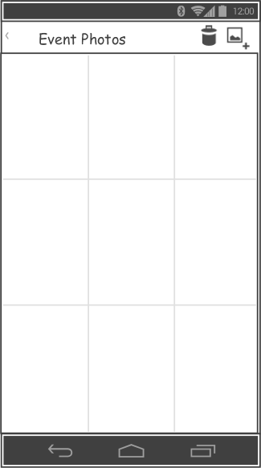

**Description :**

1. User will come to this screen after clicking on Photos option in Event Details screen.

2. User can see photos already uploaded by other users or can add new photos of completed events using a button present in the actionbar.

3. On click of upload photos button user will be redirected to Gallery of the mobile phone

4. Event Creator can delete photos uploaded by him or other End Users.

**Screen: 10**

**Screen Name: WishList**

**Mock-up:**

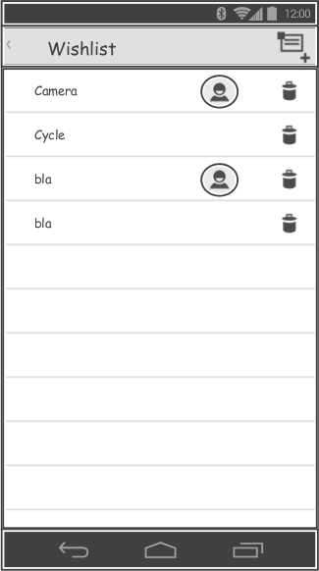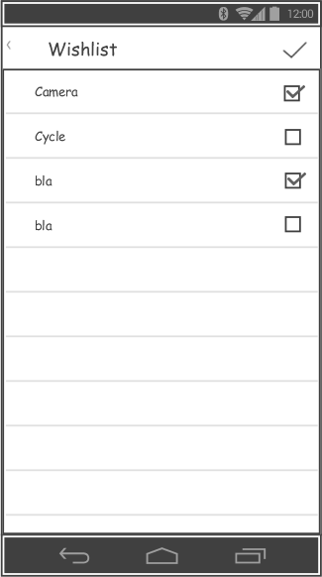

**Description :**

1. On click of a button to create a wishlist on Event Details screen, User will come to this screen.

2. On this screen there will be a plus button in the action bar. User can add item by clicking on the button. On click of button, a dialogue will be shown with edittext and a button. User can enter a name of an item of his wish and click on add item button to add his wish to the list.

3. If any of the friends are bringing a particular gifts to the user then in cards their names or profile picture will also be displayed

4. Event Creator can also delete his wish from this page

5. End Users will have check-boxes against every item, they can select which gifts they are gifting to the creator and click on the true button in action bar to save data.

6.Here only those gifts which are left to be selected will be displayed to the End User.

**Screen: 11**

**Screen Name: Attending Events**

**Mock-up:**

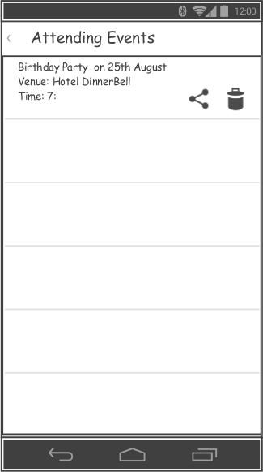

**Description :**

1. Here the list of events user is attending will be displayed. User can come to this screen through Navigation Drawer.

2. There will be two buttons in card, Share and Delete for the Public events and only Delete button for the private events

3. Clicking of card will redirect user to **Event Details** screen

4. Events in this page will be disappear after **one week** of completion

**Screen: 12**

**Screen Name: Profile**

**Mock-up:**

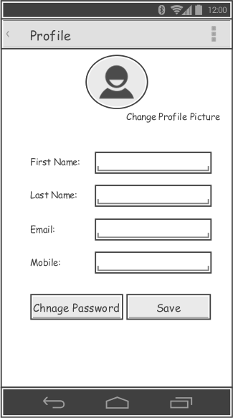

**Description :**

1. User can come to this screen through navigation drawer

2. The fields in this screens are:

Firstname Edittext

Lastname Edittext

Email(change for local registered user only) Label

Mobile Edittext

Save Button

Change Password Button

Save Profile Picture link

3. All details previously saved will be shown to the user when this screen is opened.

4. User can edit this details and click on save button to save all details

5. User can change password by clicking on the ‘Change Password’ button. There will be a dialogue having 3 fields

Current Password Edittext

New Password Edittext

Re-type New Password Edittext

Save Button

Cancel Button

6. User can change profile picture by clicking on the link and he will be redirected to Gallery to select the profile picture

**Future Implementation:**

1. A messenger for the end users to chat in between

2. User can generate invitation cards (We will have 4-5 HTML formats and set data)

3. Event ratings module

**Admin Panel Flow**

**Screen: 1**

**Screen Name: Log In Page**

**Mock-up:**

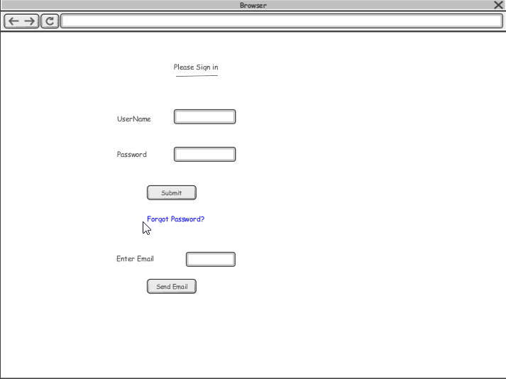

**Description :** Log in to the admin Panel

1. This screen will have User-name and Password field. It also has a Login button and ‘Forgot Password’ link.

2. User will enter required data and if the data is proper then logged in into the admin panel.

3. If User clicks on the link a textbox to enter Email and a button named ‘Send Email’ will appear. User can type an Email and a password will be sent to him via Email if the account exists.

**Screen: 2**

**Screen Name: View All Users**

**Mock-up:**

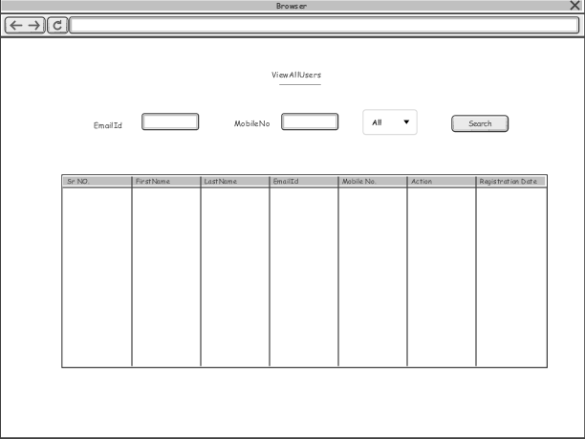

**Description:**

1. This Screen have below Columns:

Serial No. Label

Firstname Label

Lastname Label

Email Label

Mobile No. Label

Registration date Label

Action(Activate/Deactivate) Link

2. This screen will also have different filters to filter data. User can filter data using Email and Mobile number and according to user status(active/deactive).

3. In action column there will be a link to activate or deactivate a user account.

**Screen: 3**

**Screen Name: Show Events**

**Mock-up:**

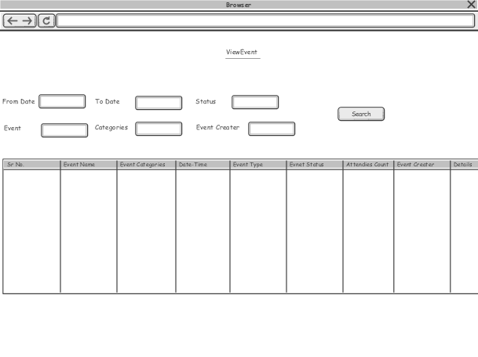

**Description:**

1. This page will have all the events list posted by all application users.

The columns on this screen are:

Serial No.

Event Name

Event Category

Event Date-Time

Event type(Private/Public)

Event Status(Active/Closed)

Attendees Count

Event Creator

Details

2. Details column will have a link clicking on which a pop-up will be opened with Event Details Screen.

3. The events will be disappeared on this page after a week of completion.

4. Filters: from date, to date, category, status, event type, Event Creator

**Screen: 4**

**Screen Name: Add Event Catagories**

**Mock-up:**

**Screen: 5**

**Screen Name: Events Details**

**Mock-up:**

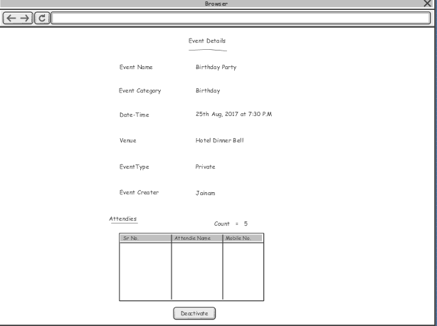

**Description:**

1.User will come to this screen by clicking on the links: ‘Details’ on **Show Events** Screen and ‘Go to Event’ on **Event Abuse** Screen

2. This page will have these fields:

Event Name Label

Event Category Label

Event Date-Time Label

Venue Label

Event type(Private/Public) Label

Event Creator Label

Attendees table(Name and Mobile number and no of attendees count at top of table)

Activate/Deactivate button Button

Here admin can see all details of an event and if found inappropriate then deactivate the event

3.This screen will be opened in a pop-up window

**Screen: 6**

**Screen Name: Event Abuse**

**Mock-up:**

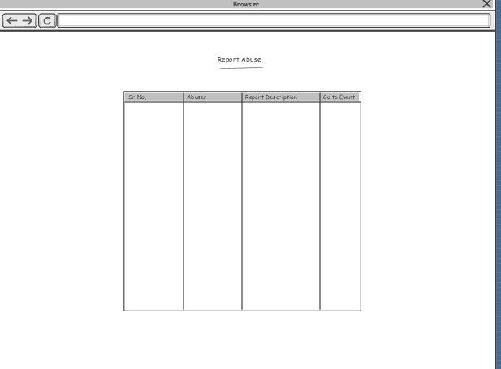

**Description:**

1. This screen will have abuse reports that are posted for the specific events.

Fields in the table:

Serial No Label

Abuser Label

Report Description Label

Go to Event Link

2. Go to event will have a link clicking on which a pop-up with Event Details screen will be opened where he/she can check all details and if the event is found inappropriate admin can deactivate the event

**Screen: 7**

**Screen Name: Edit Profile**

**Mock-up:**

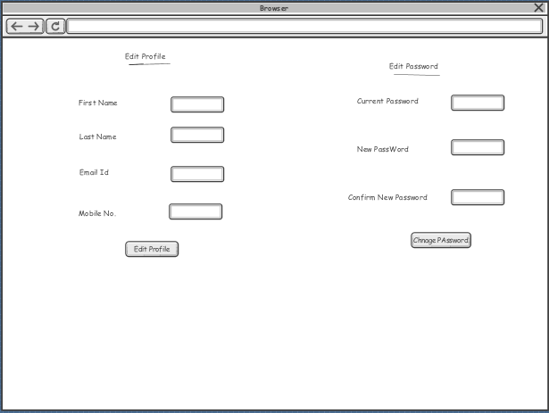

**Description:**

1. This screen has two features: Edit Profile and Change Password

2. Edit Profile fields:

Firstname Textbox

Lastname Textbox

Email Textbox

Mobile No. Textbox

Edit Profile Button

All fields are editable

3. Change Password fields:

Current Password Textbox type: password

New Password Textbox type: password

Retype New Password Textbox type: password

Change Password Button

4. All the fields will have validations.

**Screen: 8**

**Screen Name: Admin List**

**Mock-up:**

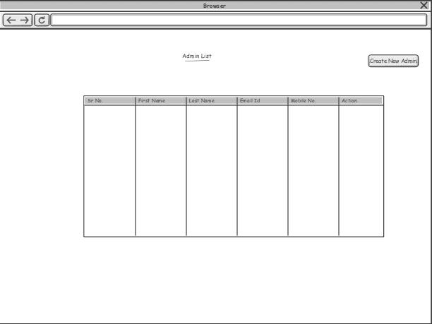

**Description:**

1. This screen will show all registered admin list. Fields in this screen are:

Serial No. Label

Firstname Label

Lastname Label

Email Label

Mobile No. Label

Action Link

Create New Admin Button

2. In action column there will be a link to activate or deactivate a user account.

3. All the fields will have validations

4. On click of button ‘Create New Admin’ a new screen for creating an admin will be opened.

**Screen: 9**

**Screen Name: Create New Admin**

**Mock-up:**

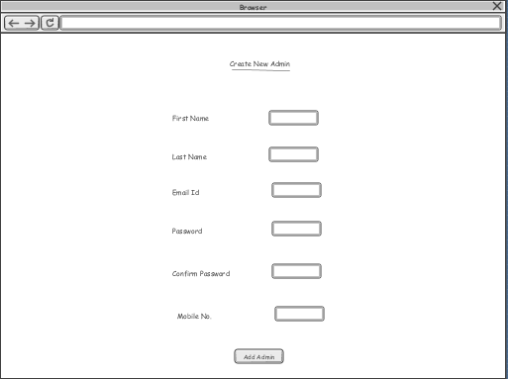

**Description:**

1. This screen will be used to create a new admin account. Fields in this screen are:

Firstname Textbox

Lastname Textbox

Email Textbox

Password Textbox type: password

Confirm Password Textbox type: password

Mobile No. Textbox

Add User Button

2. All the fields will have validations

3. User can create a new admin account by clicking on the button after entering all valid details

4. This screen will be opened in a pop-up window

**Database Structure**

**Summery of Mobile Application Flow**

Event Creator Flow:

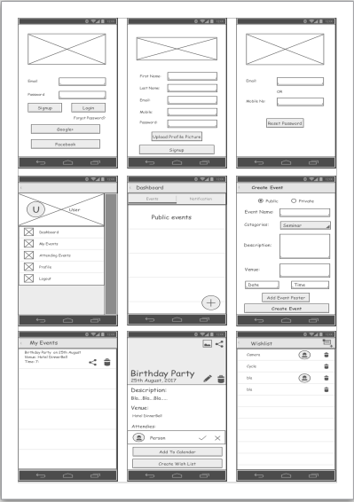

End User Flow:

