AppSmartHome

Requerimientos

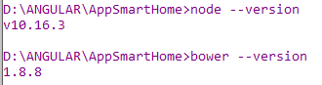

* Node 10.16.3
  + https://nodejs.org/es/
* Bower 1.8.8
  + npm install -g bower
* Angular Cli
  + npm install -g @angular/cli
* Angular 8.2.11
  + ng --version

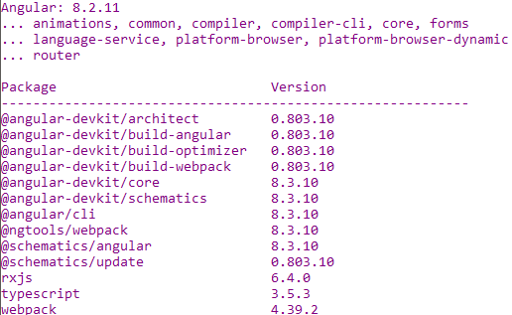

CREANDO PROYECTO

ng new AppSmartHome

router yes

css

LEVANTAR PROYETO

ng serve

MANEJADOR DE PAQUETES

bower init

LIBRERIAS INSTALADAS CON BOWER

"bootstrap": "^4.3.1",

"popper.js": "^1.16.0",

"jquery": "^3.4.1",

"bootswatch": "^4.3.1",

"components-font-awesome": "^5.9.0",

"datatables.net": "^1.10.20",

"datatables.net-dt": "^3.2.2"

LIBRERIAS INSTALADAS CON NPM

npm install firebase @angular/fire –save

npm install firebase ngx-toastr –sabe

<http://l-lin.github.io/angular-datatables/#/getting-started>

npm install datatables.net --save

npm install datatables.net-dt --save

npm install angular-datatables --save

npm install @types/jquery --save-dev

npm install @types/datatables.net --save-dev

npm install d3 --save

npm install @types/d3 –sabe

npm install file-saver –save

npm install xlsx --save

"angular-datatables": "^8.0.0",

"firebase": "^7.2.2",

"ngx-toastr": "^11.1.2",

"d3": "^5.12.0",

GENERANDO COMPONENTES

ng g component view/login

ng g component view/not-found

ng g component view/gestion-sensores

ng g component view/line-chart

ng g component view/listar-sensores

ng g component view/main-sensores

ng g component view/time-chart

ng g component view/data-sensores

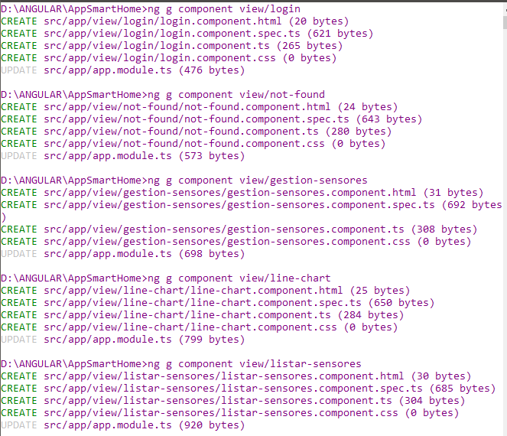

ng g guard guards/auth

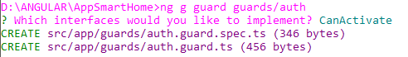

ng g class models/dth

ng g class models/sensores

ng g class models/actuadores

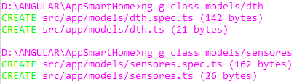

ng g class models/dth

ng g class models/sensores

ng g service services/auth

ng g service services/excel

ng g service services/sensores

ng g service services/actuadores

