The user login, in the first time must validate in mysql and store credentials on device database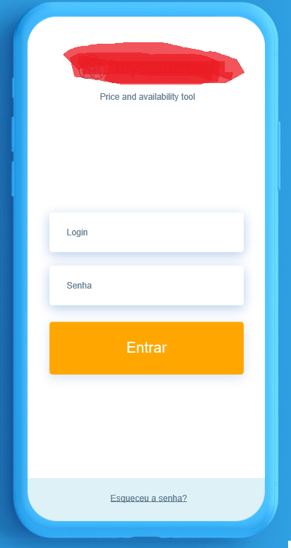

The user (technician) must update your local database, the app connects and downloads the list of items to the device, only for his country

Create the update screen

The user select search type ( cod or descr )

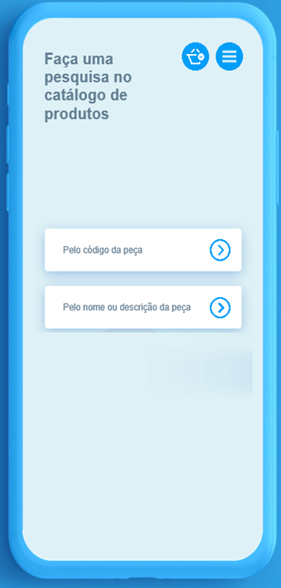

The user search for an item by code or Description.

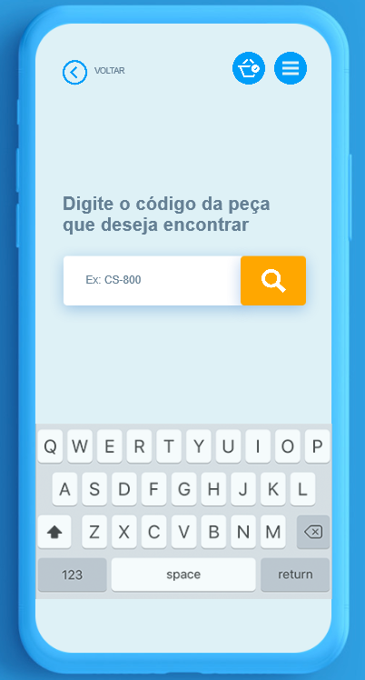

The App lists the items

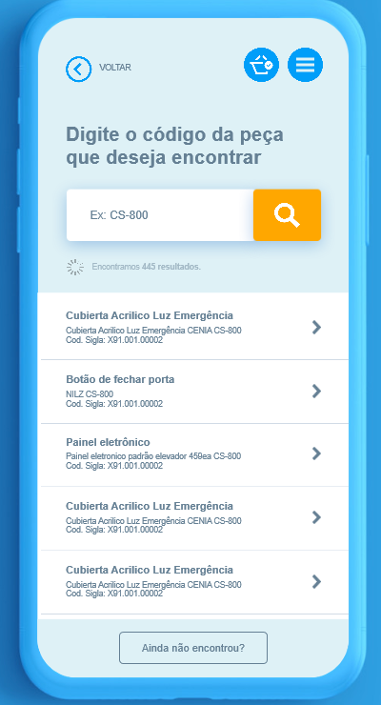

The user can view the item detail

The user can add this item to the shop Cart (Orange Button)

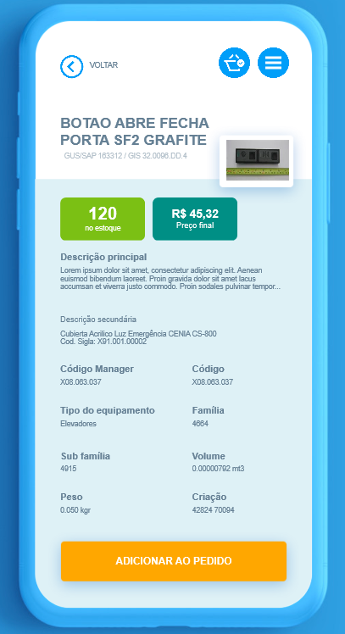

And then the app asks to the user whether to search another item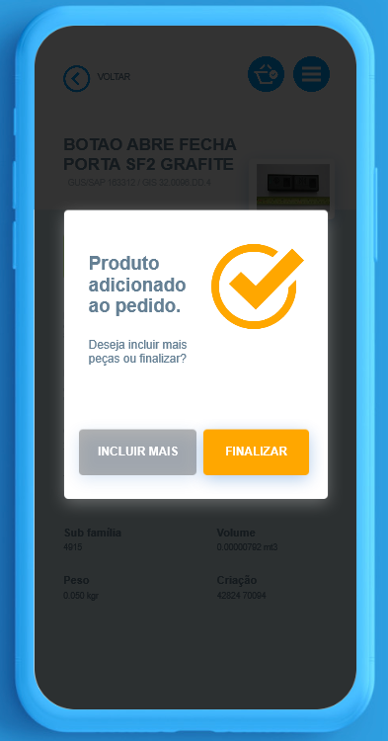

FInish ( Orange button ) go to Checkout

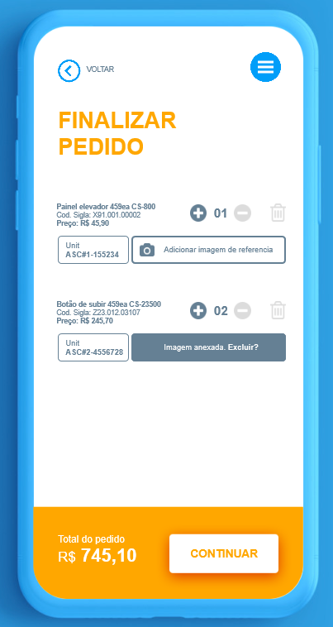

For each item the user can add up to 3 photos

For each item in the shop cart the user must have inform the unit serial number .

The user can change the quantity, which affects the total price value.

When the user wants to continue, the app must request customer information

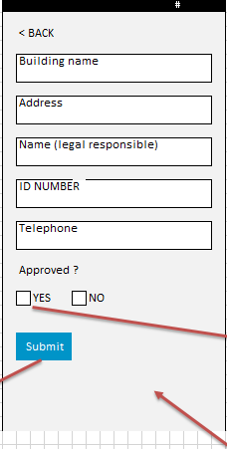

When Technician set the request as approved by customer, the app must request the signature of the client.

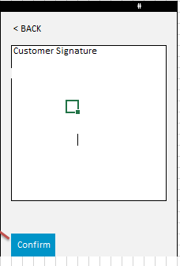

Confirm and submit

The user can´t insert new products in the database