Lab3_Part1

Output

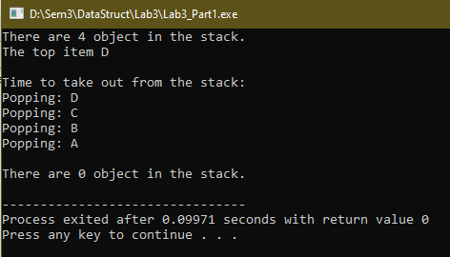

Lab3_Part1_Exercise1

Output

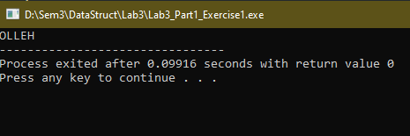

Lab3_Part1_Exercise2

Output

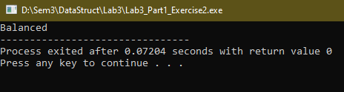

Lab3_Part2

Output

