Lab5_Part1_Exercise1

Output

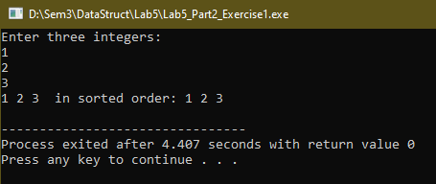

Lab5_Part2_Exercise2

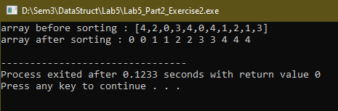Output