Candidates:
Planetary nebulae:

-) 50014-1475 (149.08, 68.83)

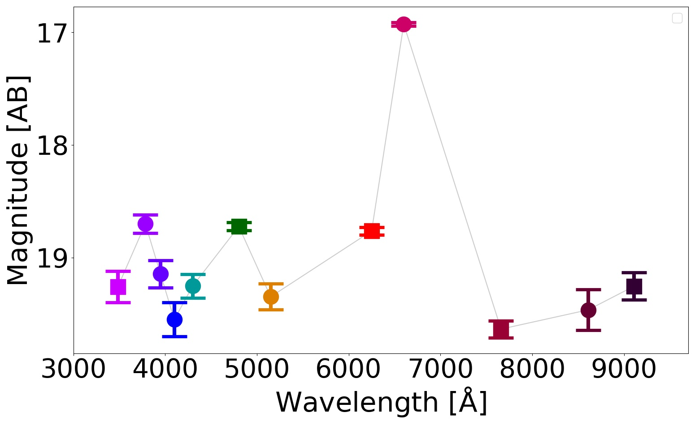
SDSS
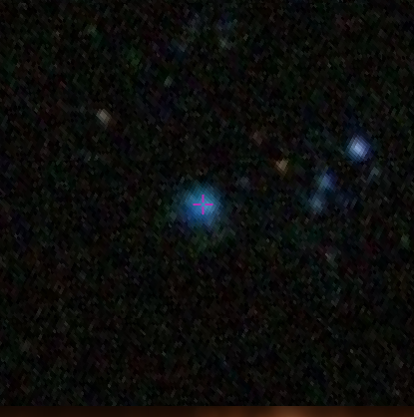

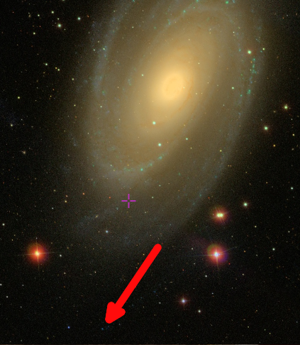
[GTK91b] 63, Globular Cluster candidate (1993BSAO...36...43G ), of the galaxy M81

Symbiotic stars:

-) 45677-49903 (276.97, 40.89)
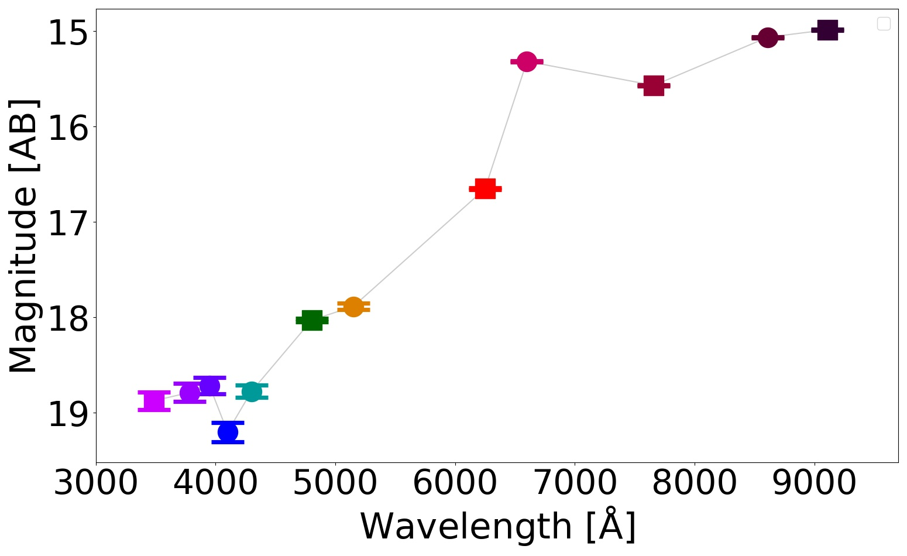
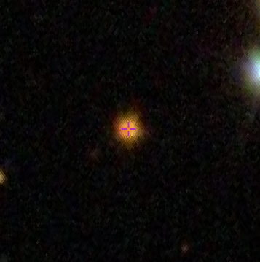

2mass: J – H = 0.65
H – K = 0.32

A First Catalog of Variable Stars Measured by the Asteroid Terrestrial-impact Last Alert System (ATLAS) (Heinze+, 2018)

