SimbadName | RA | DEC | RAx | DECx | Dimension (HST) | Morpho
SMP_SMC_2 | 8.16179 | -71.69986 | 00:32:38.83 | -71:41:59.5 | 0.54” | R
SMP_SMC_3 | 8.59137 | -73.22264 | 00:34:21.93 | -73:13:21.5 | 0.59” x 0.48” | E(bc)
SMP_SMC_15 | 12.78071 | -73.96047 | 00:51:07.37 | -73:57:37.7 | 0.32” | R
SMP_SMC_28 | 21.04921 | -74.04239 | 01:24:11.81 | -74:02:32.6 | 0.31” | R

REF: Shaw, Stanghellini, Villaver & Mutchler, 2006 (2006ApJS..167..201S)

All figures are: HST image; [OIII], [NII], Ha and [NII] STIS spectra. Box sizes: 3x3arcsec². The orientation for each image is indicated on the figure, with north lying in the direction of the arrow and east to the left.

SMC-SMP 2. This round nebula has an asymmetric bright-ness profile in broadband light and in the high-ionization lines of H and [Oiii], with higher emission on the south side. The low-ionization lines such as [Nii] show emission in an elliptical ring, again with somewhat brighter emission on the south edge. No CS is evident in the broadband image. (See Fig. 18.)

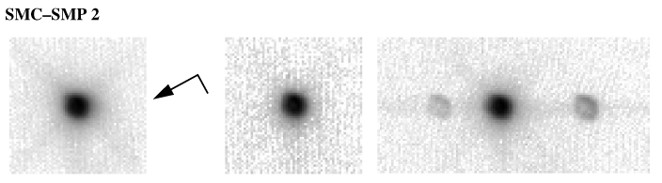
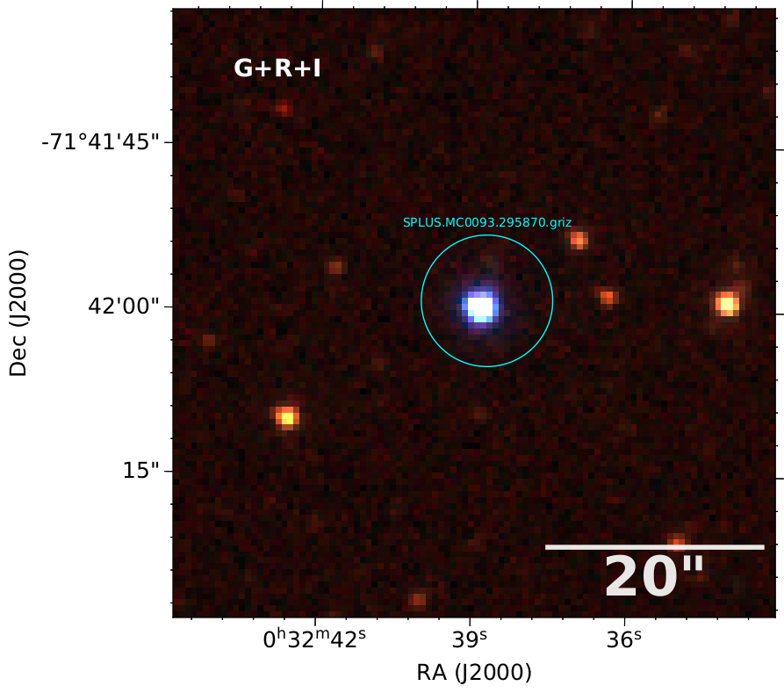

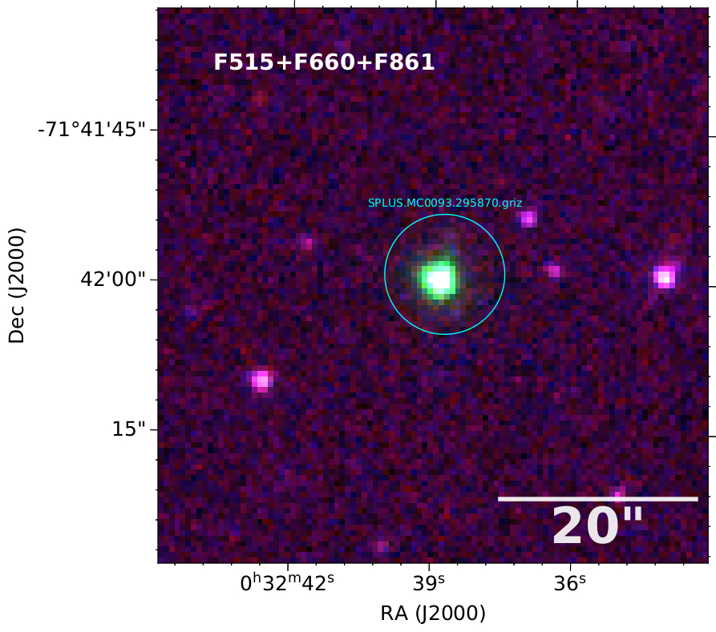

Dimension of the images below: 6”x6”

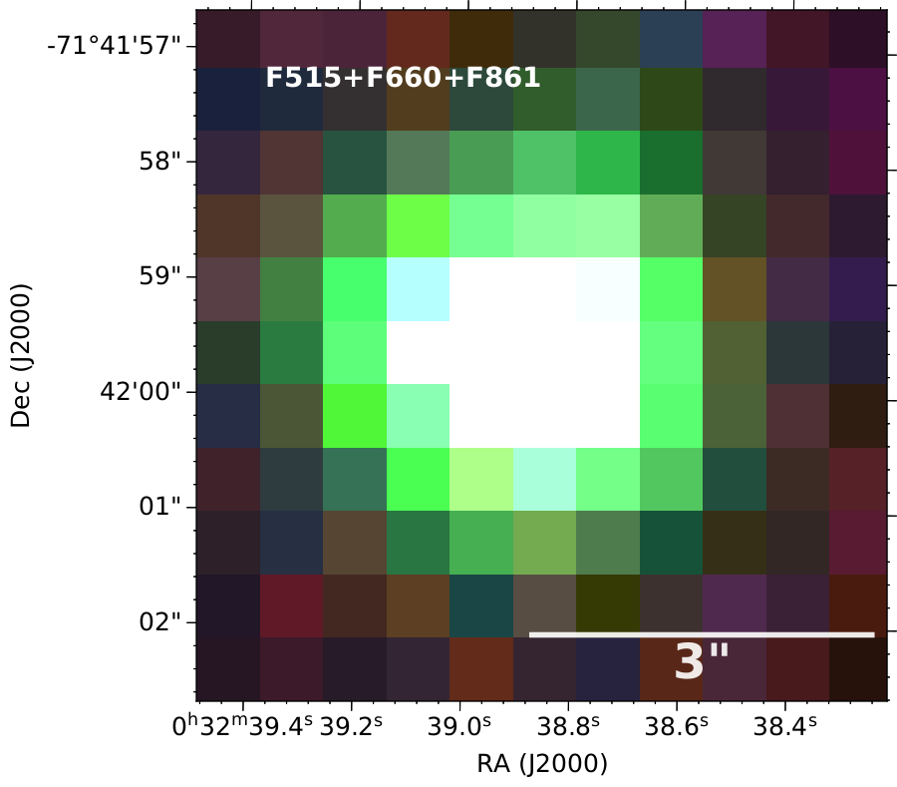
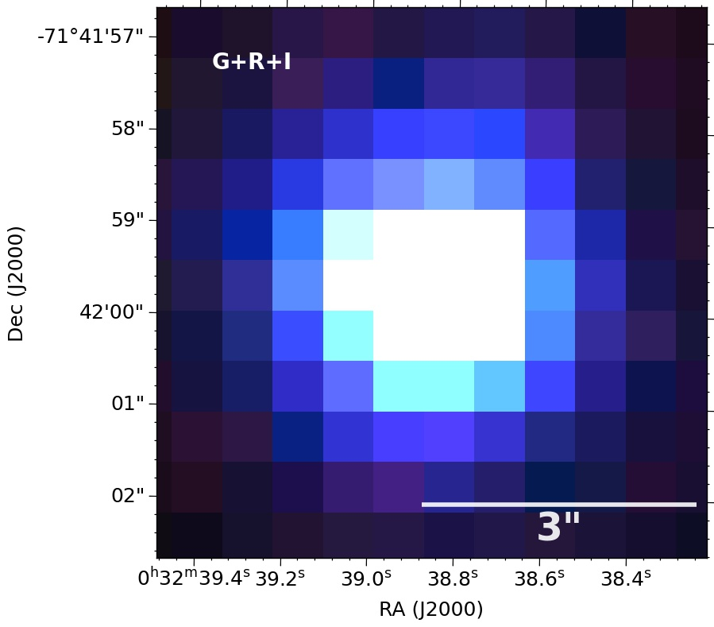

SMC-SMP 3. This elliptical nebula has a very distinct bi-polar core. Interestingly, only the lobes can be seen in the [Nii] emission. The CS is very apparent in the broadband image.
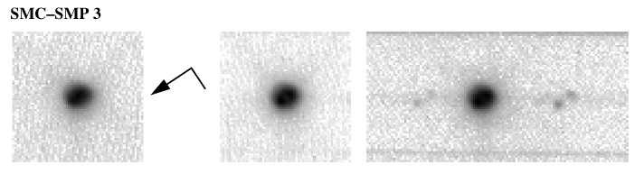
(SeeFig. 18.)
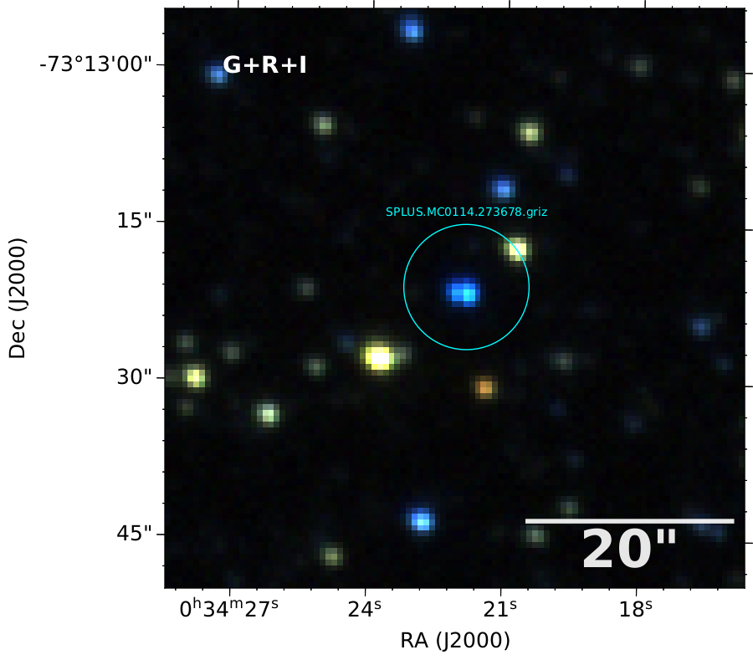

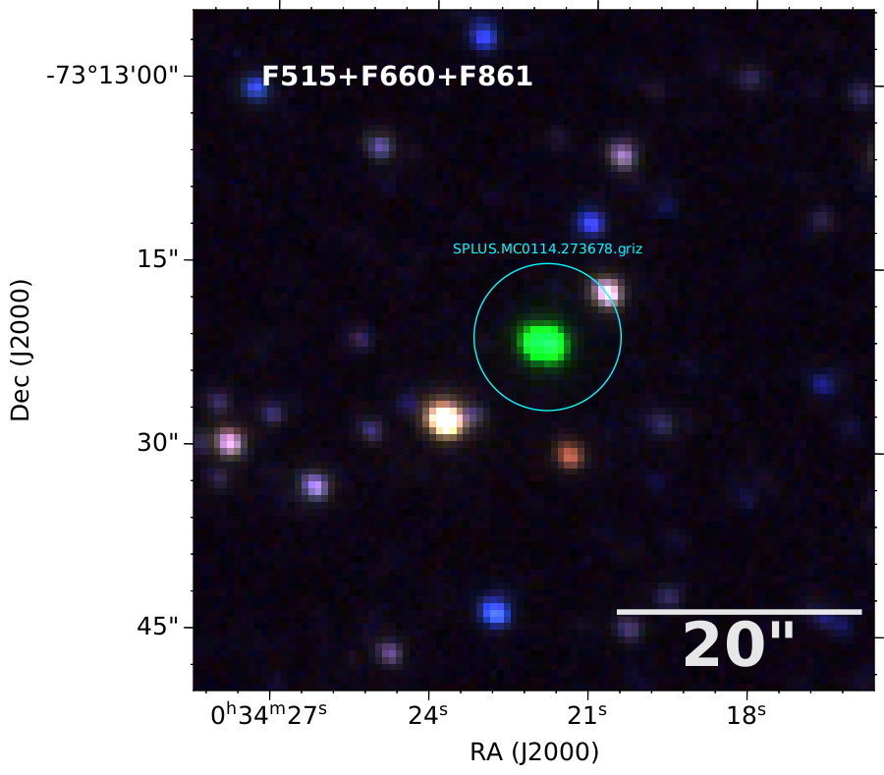

Please pay attention to the orientation of the bi-polar lobes in the [NII] spectra.

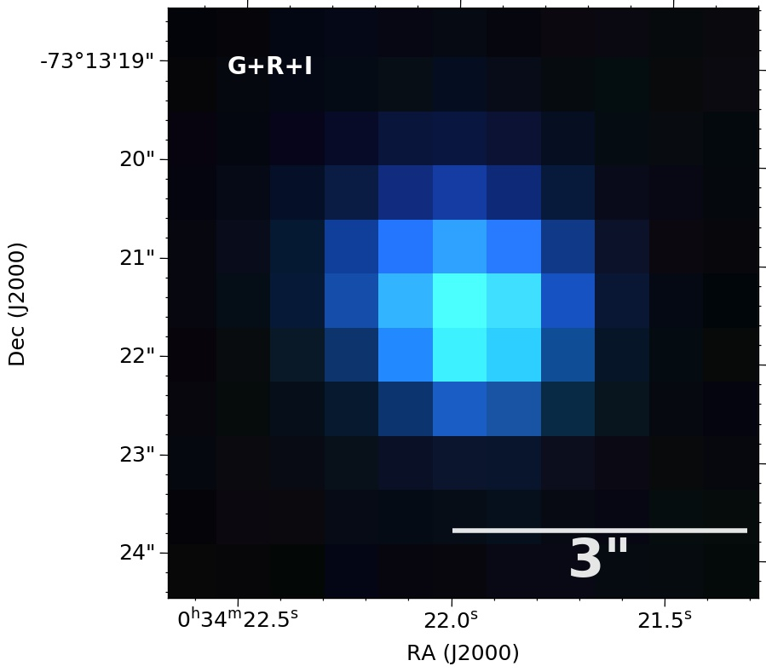
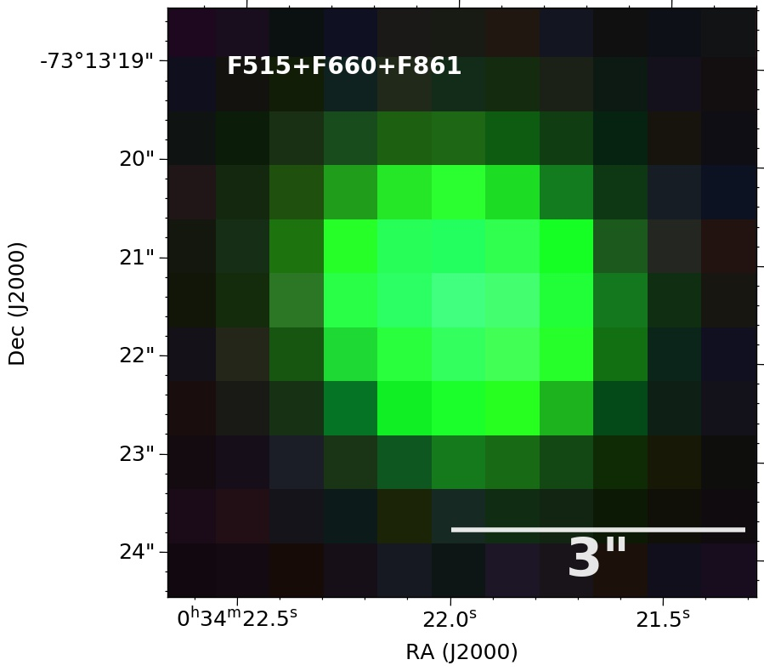

SMC-SMP 15. The emission from this nebula is strongly peaked in both the broadband image, as well as the high-ionization lines of H and [Oiii]. The emission in [Nii] is not as stronglypeaked, and from the 6583 line it is possible to make an improved estimate of the nebular size, which is slightly broader than a pointsource. The CS might have been detected had it not saturated in thebroadband image. (See Fig. 18.)

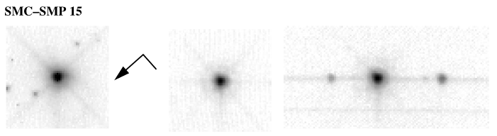
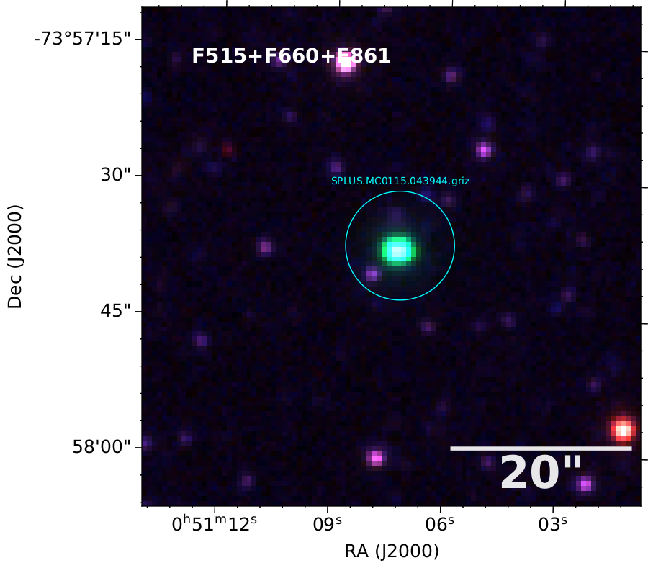
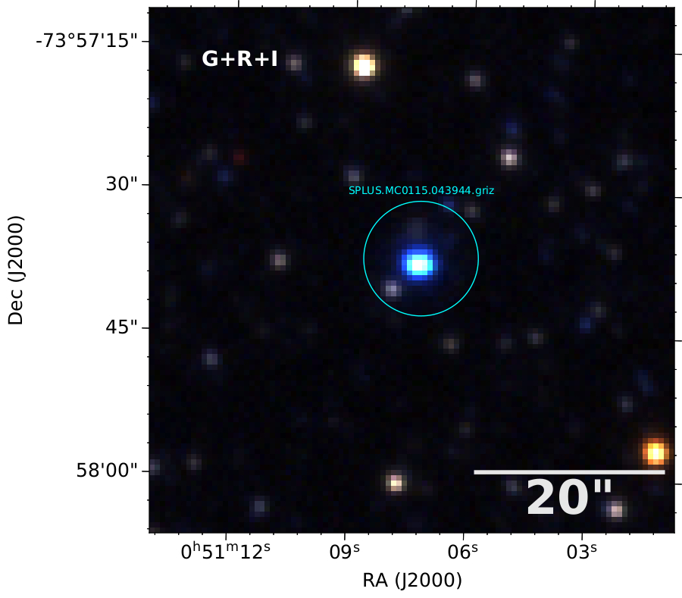

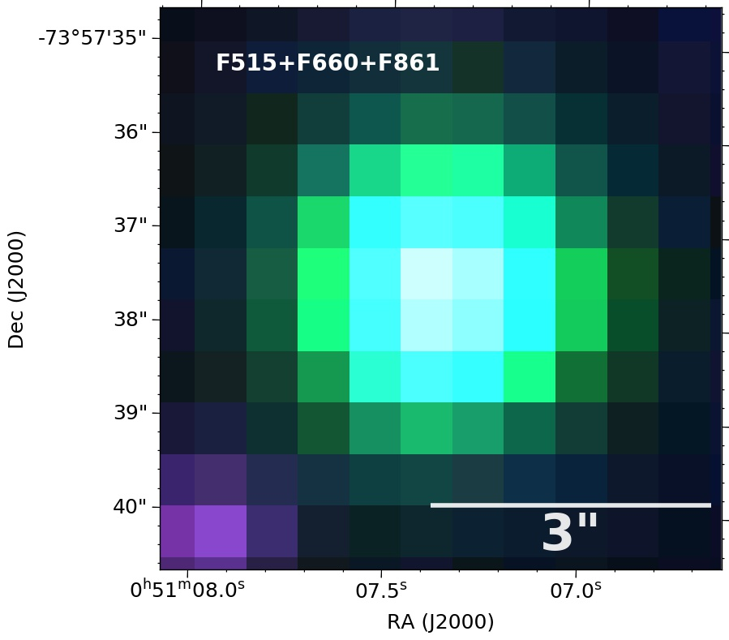
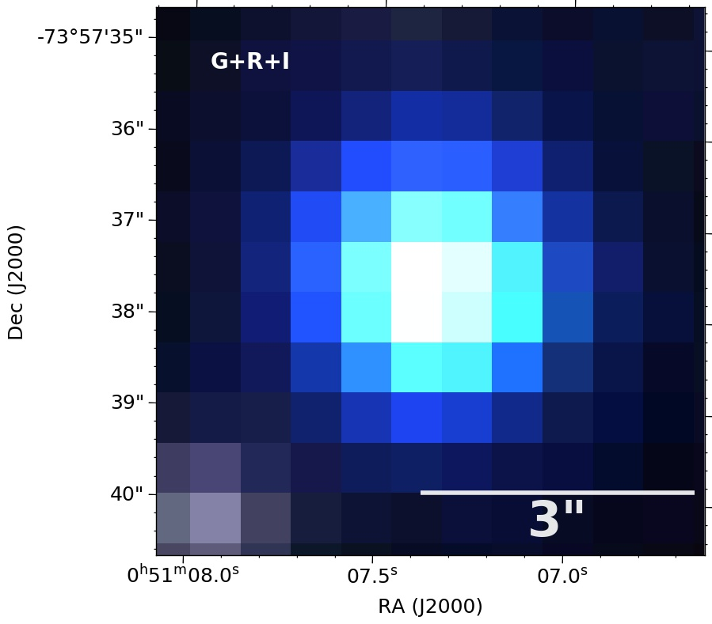

SMC-SMP 28. This bright, compact nebula is round but appears to have a faint, diffuse tail of emission extending about 0,9” to the northwest from the central star. No G750M spectrum isavailable. (See Fig. 18.)


