MODULE – 4

BACKUP, ARCHIVE, AND REPLICATION

# INTRODUCTION TO BUSINESSCONTINUITY

### Business Continuity (BC):

**Business continuity (BC)** is an integrated and enterprise wide process that includes all activities (internal and external to IT) that a business must perform to mitigate the impact of planned and unplanned downtime.

BC entails preparing for, responding to, and recovering from a system outage that adversely affects business operations. It involves proactive measures, such as business impact analysis, risk assessments, deployment of BC technology solutions (backup and replication), and reactive measures, such as disaster recovery and restart, to be invoked in the event of a failure.

The goal of a BC solution is to ensure the **“information availability”** required to conduct vital business operations.

* + 1. **InformationAvailability:**

**Information availability (IA)** refers to the ability of the infrastructure to function according to business expectations during its specified time of operation. Information availability ensures that people (employees, customers, suppliers, and partners) can access information whenever they need it. Information availability can be defined in terms of:

1. Reliability,
2. Accessibility
3. Timeliness.
4. **Reliability:** This reflects a component’s ability to function without failure, understated conditions, for a specified amount oftime.
5. **Accessibility:** This is the state within which the required information is accessible at the right place, to the right user. The period of time during which the system is in an accessiblestateistermed**systemuptime;**whenitisnotaccessibleitistermed**system**

### downtime.

1. **Timeliness:** Defines the exact moment or the time window (a particular time of the day, week, month, and/or year as specified) during which information must be accessible. For example, if online access to an application is required between 8:00 am and 10:00 pm each day, any disruptions to data availability outside of this time slot are not considered to affecttimeliness.

### Causes of InformationUnavailability

Various planned and unplanned incidents result in data unavailability.

* + - * + **Planned outages** include installation/integration/maintenance of new hardware, software upgrades or patches, taking backups, application and data restores, facility operations (renovation and construction), and refresh/migration of the testing to the productionenvironment.
        + **Unplanned outages** include failure caused by database corruption, component failure, and humanerrors.
        + 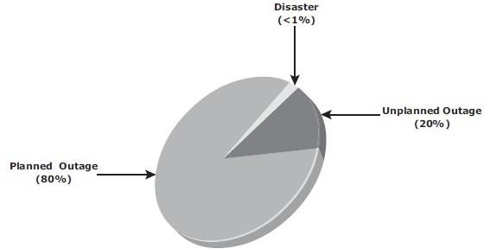**Disasters (natural or man-made)** such as flood, fire, earthquake, and contamination are another type of incident that may cause dataunavailability.

Fig 3.1: Disruptors of Information Availability

As illustrated in Fig 3.1 above, the majority of outages are planned. Planned outages are expected and scheduled, but still cause data to be unavailable.

### Consequences of Downtime

* Information unavailability or downtime results in loss of productivity, loss ofrevenue, poor financial performance, and damage toreputation.
* Loss of productivity includes reduced output per unit of labor, equipment, andcapital.
* Loss of revenue includes direct loss, compensatory payments, future revenue loss,billing loss, and investment loss.
* Poor financial performance affects revenue recognition, cash flow, discounts, payment guarantees, credit rating, and stockprice.
* Damages to reputations may result in a loss of confidence or credibility withcustomers, suppliers, financial markets, banks, and business partners.
* An important metric, *average cost of downtime per hour*, provides a key estimatein determining the appropriate BC solutions. It is calculated asfollows:Average cost of downtime per hour = average productivity loss per hour + average revenue loss per hour

Where:

Productivity loss per hour = (total salaries and benefits of all employees per week)

/(average number of working hours per week)

Average revenue loss per hour = (total revenue of an organization per week)

/(average number of hours per week that an organization is open for business)

### Measuring InformationAvailability

* Information availability (IA) relies on the availability of physical and virtual components of a data center. Failure of these components might disrupt IA.A failure is the termination of a component’s capability to perform a required function. The component’s capability can be restored by performing an external corrective action, such as a manual reboot, a repair, or replacement of the failedcomponent(s).
* Proactive risk analysis performed as part of the BC planning process considers the component failure rate and average repair time, which are measured by MTBF and MTTR:

**Mean Time Between Failure (MTBF):** It is the average time available for a system or component to perform its normal operations between failures.

**Mean Time To Repair (MTTR):** It is the average time required to repair a failed component. MTTR includes the total time required to do the following activities: Detect the fault, mobilize the maintenance team, diagnose the fault, obtain the spare parts, repair, test, and restore thedata.

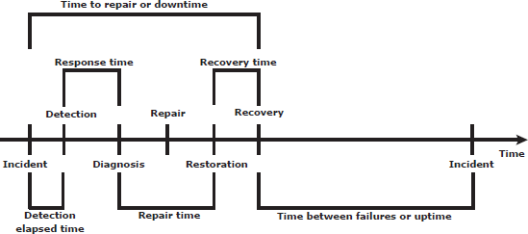Fig 3.2 illustrates the various information availability metrics that represent system uptime and downtime.

Fig 3-2: Information availability metrics

IA is the time period that a system is in a condition to perform its intended function upon demand. It can be expressed in terms of system uptime and downtime and measured as the amount or percentage of system uptime:

### IA = system uptime / (system uptime + system downtime)

In terms of MTBF and MTTR, IA could also be expressed as

### IA = MTBF / (MTBF + MTTR)

Uptime per year is based on the exact timeliness requirements of the service, this calculation leads to the number of “9s” representation for availability metrics.

Table 3-1 lists the approximate amount of downtime allowed for a service to achieve certain levels of 9s availability. For example, a service that is said to be “five 9s available” is available for 99.999 percent of the scheduled time in a year (24 × 365).

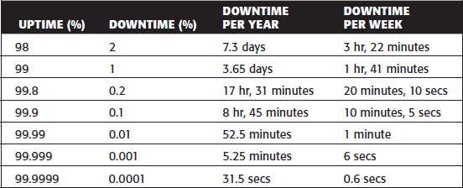

Table 3-1: Availability percentage and Allowable downtime

## BC Terminology

This section defines common terms related to BC operations which are used in this module to explain advanced concepts:

* **Disaster recovery:** This is the coordinated process of restoring systems, data, and the infrastructure required to support key ongoing business operations in the event of a disaster. It is the process of restoring a previous copy of the data and applying logs or other necessary processes to that copy to bring it to a known point of consistency. Once all recoveries are completed, the data is validated to ensure that it iscorrect.
* **Disaster restart:** This is the process of restarting business operations with mirrored consistent copies of data andapplications.
* **Recovery-Point Objective (RPO):** This is the point in time to which systems and data must be recovered after an outage. It defines the amount of data loss that a business can endure. A large RPO signifies high tolerance to information loss in a business. Based on the RPO, organizations plan for the minimum frequency with which a backup or replica must be made. For example, if the RPO is six hours, backups or replicas must be made at least once in 6 hours. Fig 3.3 (a) shows various RPOs and their corresponding ideal recovery strategies. An organization can plan for an appropriate BC technology solution on the basis of the RPO it sets. Forexample:

** RPO of 24 hours:** This ensures that backups are created on an offsite tape drive every midnight. The corresponding recovery strategy is to restore data from the set of last

backup tapes.

** RPO of 1 hour:** Shipping database logs to the remote site every hour. The corresponding recovery strategy is to recover the database at the point of the last log shipment.

** RPO in the order of minutes:** Mirroring data asynchronously to a remote site

** Near zero RPO:** This mirrors mission-critical data synchronously to a remote site.

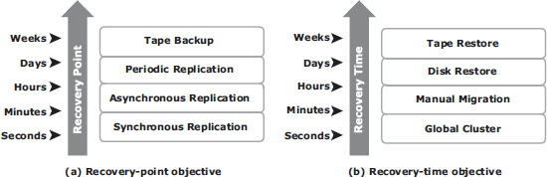

Fig 3.3: Strategies to meet RPO and RTO targets

* **Recovery-Time Objective (RTO):** The time within which systems and applications must be recovered after an outage. It defines the amount of downtime that a business can endure and survive. Businesses can optimize disaster recovery plans after defining the RTO for a given system. For example, if the RTO is two hours, then use a disk backup because it enables a faster restore than a tape backup. However, for an RTO of one week, tape backup will likely meet requirements. Some examples of RTOs and the recovery strategies to ensure data availability are listed below (refer to Fig 3.3(b)):

**RTO of 72 hours:** Restore from backup tapes at a cold site.

**RTO of 12 hours:** Restore from tapes at a hot site.

**RTO of few hours:** Use a data vault to a hot site.

** RTO of a few seconds:** Cluster production servers with bidirectional mirroring, enabling the applications to run at both sites simultaneously.

## BC Planning LifeCycle

BC planning must follow a disciplined approach like any other planning process. Organizations today dedicate specialized resources to develop and maintain BC plans. From the conceptualization to the realization of the BC plan, a life cycle of activities can be defined for the BC process.

The BC planning lifecycle includes five stages shown below (Fig 3.4):

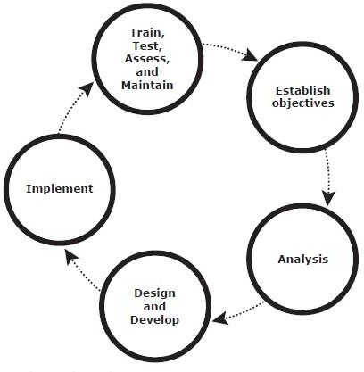

Fig 3.4: BC Planning Lifecycle

Several activities are performed at each stage of the BC planning lifecycle, including the following key activities:

### Establishingobjectives

→ Determine BC requirements.

→ Estimate the scope and budget to achieve requirements.

→ Select a BC team by considering subject matter experts from all areas of the business, whether internal or external.

→ Create BC policies.

### Analyzing

→ Collect information on data profiles, business processes, infrastructure support, dependencies, and frequency of using business infrastructure.

→ Identify critical business needs and assign recovery priorities.

→ Create a risk analysis for critical areas and mitigation strategies.

→ Conduct a Business Impact Analysis (BIA).

→ Create a cost and benefit analysis based on the consequences of data unavailability.

### Designing anddeveloping

→ Define the team structure and assign individual roles and responsibilities. For example, different teams are formed for activities such as emergency response, damage assessment, and infrastructure and application recovery.

→ Design data protection strategies and develop infrastructure.

→ Develop contingency scenarios.

→ Develop emergency response procedures.

→ Detail recovery and restart procedures.

### Implementing

→ Implement risk management and mitigation procedures that include backup, replication, and management of resources.

→ Prepare the disaster recovery sites that can be utilized if a disaster affects the primary data center.

→ Implement redundancy for every resource in a data center to avoid single points of failure.

### Training, testing, assessing, andmaintaining

→ Train the employees who are responsible for backup and replication of business-critical data on a regular basis or whenever there is a modification in the BC plan

→ Train employees on emergency response procedures when disasters aredeclared.

→ Train the recovery team on recovery procedures based on contingencyscenarios.

→ Perform damage assessment processes and review recovery plans.

→ Test the BC plan regularly to evaluate its performance and identify its limitations.

→ Assess the performance reports and identify limitations.

→ Update the BC plans and recovery/restart procedures to reflect regular changes within the data center.

## FailureAnalysis

### Single Point ofFailure

* + A **single point of failure** refers to the failure of a component that can terminate the availability of the entire system or ITservice.
  + Fig 3.5 depicts a system setup in which an application, running on a VM, provides an interface to the client and performs I/Ooperations.
  + The client is connected to the server through an IPnetwork, the server is connected tothe storage array through a FC connection, an HBA installed at the server sends or receives data to and from a storage array, and an FC switch connects the HBA to the storageport
  + In a setup where **each component must function as required to ensure data availability**, the failure of a single physical or virtual component causes the failure of the entire data center or an application, resulting in disruption of businessoperations.
  + In this example, failure of a hypervisor can affect all the running VMs and the virtual network, which are hosted on it.
  + The can be several similar single points of failure identified in this example. A VM, a hypervisor, an HBA/NIC on the server, the physical server, the IP network, the FC switch, the storage array ports, or even the storage array could be a potential single point of failure. To avoid single points of failure, it is essential to implement a fault-tolerant mechanism.

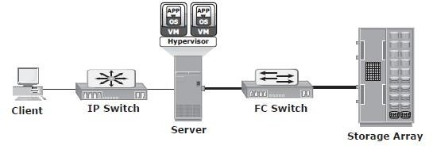

Fig 3.5: Single Point of Failure

### Resolving Single Points ofFailure

* + To mitigate a single point of failure, systems are designed with redundancy, such that the system will fail only if all the components in the redundancy group fail. This ensures that the failure of a single component does not affect dataavailability.
  + Data centers follow stringent guidelines to implement fault tolerance for uninterrupted information availability. Careful analysis is performed to eliminate every single point of failure.
  + The example shown in Fig 3.6 represents all enhancements of the system shown in Fig 3.5 in the infrastructure to mitigate single points offailure:
    - Configuration of redundant HBAs at a server to mitigate single HBAfailure
    - Configuration of NIC (network interface card) teaming at a server allows protection against single physical NIC failure. It allows grouping of two or more physical NICs and treating them as a single logical device. NIC teaming eliminates the single point of failure associated with a single physicalNIC.
    - Configuration of redundant switches to account for a switchfailure
    - Configuration of multiple storage array ports to mitigate a portfailure
    - RAID and hot spare configuration to ensure continuous operation in the event of disk failure
    - Implementation of a redundant storage array at a remote site to mitigate local site failure
    - Implementing server (or compute) clustering, a fault-tolerance mechanism whereby two or more servers in a cluster access the same set of data volumes. Clustered servers exchange a heartbeat to inform each other about their health. If one of the servers or hypervisors fails, the other server or hypervisor can take up theworkload.
    - Implementing a VM Fault Tolerance mechanism ensures BC in the event of a server failure. This technique creates duplicate copies of each VM on another server so that when a VM failure is detected, the duplicate VM can be used for failover. The two VMs are kept in synchronization with each other in order to perform successful failover.

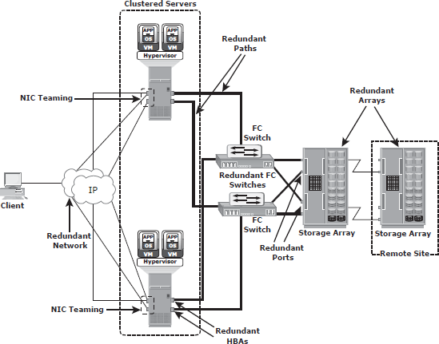

Fig 3.6: Resolving single points of failure

### MultipathingSoftware

* + Configuration of multiple paths increases the data availability through path failover. If servers are configured with one I/O path to the data there will be no access to the dataif that path fails. Redundant paths eliminate the path to become single points offailure.
  + Multiple paths to data also improve I/O performance through load sharing and maximize server, storage, and data path utilization.
  + In practice, merely configuring multiple paths does not serve the purpose. Even with multiple paths, if one path fails, I/O will not reroute unless the system recognizes thatit has an alternatepath.
  + Multipathing software provides the functionality to recognize and utilize alternate I/O path to data. Multipathing software also manages the load balancing by distributing I/Os to all available, activepaths.
  + In a virtual environment, multipathing is enabled either by using the hypervisor’s built-in capability or by running a third-party software module, added to thehypervisor.

**Business Impact Analysis**

A business impact analysis (BIA) identiﬁes which business units, operations, and processes are essential to the survival of the business. It evaluates the ﬁnancial, operational, and service impacts of a disruption to essential business processes. Selected functional areas are evaluated to determine resilience of the infra- structure to support information availability.

The BIA process leads to a report detailing the incidents and their impact over business functions. The impact may be speciﬁed in terms of money or in terms of time. Based on the potential impacts associated with downtime, businesses can prioritize and implement countermeasures to mitigate the likelihood of such disruptions. These are detailed in the BC plan.

A BIA includes the following set of tasks:

* Determine the business areas.
* For each business area, identify the key business processes critical to its operation.
* Determine the attributes of the business process in terms of applications, databases, and hardware and software requirements.
* Estimate the costs of failure for each business process.
* Calculate the maximum tolerable outage and deﬁne RTO and RPO for each business process.
* Establish the minimum resources required for the operation of business processes.
* Determine recovery strategies and the cost for implementing them.
* Optimize the backup and business recovery strategy based on business priorities.
* Analyze the current state of BC readiness and optimize future BC planning.

## BC TechnologySolutions

After analyzing the business impact of an outage, designing appropriate solutions to recover from a failure is the next important activity. One or more copies of the original data are maintained using any of the following strategies, so that data can be recovered and business operations can be restarted using an alternate copy:

1. **Backup:** Data backup is a predominant method of ensuring data availability. The frequency of backup is determined based on RPO, RTO, and the frequency of data changes.
2. **Storage array-based replication (local):** Data can be replicated to a separate location within the same storage array. The replica is used independently for other business operations. Replicas can also be used for restoring operations if data corruptionoccurs.
3. **Storage array-based replication (remote):** Data in a storage array can be replicated to another storage array located at a remote site. If the storage array is lost due to a disaster, business operations can be started from the remote storagearray.

1. A system has three components and requires all three components to be operational 24 hours, Monday through Friday. Failure of component 1 occurs as follows:

o Monday = No failure.

o Tuesday = 5 a.m. to 7 a.m.

o Wednesday = No failure.

o Thursday = 4 p.m. to 8 p.m.

o Friday = 8 a.m. to 11 a.m.

Calculate the MTBF and MTTR of component 1.

Solution

The formula for MTBF is

(total operational time/number of failure)

Therefore,

MTBF=(24 hrs * 5 days) /3 = 120 Hrs/3 = 40 Hrs

The formula for MTTR is

(total downtime/ number of failure)

Therefore

Total down time=2 hrs on Tuesday + 4 hrs on Thursday + 3 hrs on Friday

= 9 Hrs/3 = 3 Hrs

2. A system has three components and requires all three components to be operational during 8 a.m. through 5 p.m. business hours, Monday through Friday. Failure of component 2 occurs as follows:

o Monday = 8 a.m. to 11 a.m.

o Tuesday = No failure.

o Wednesday = 4 p.m. to 7 p.m.

o Thursday = 5 p.m. to 8 p.m.

o Friday = 1 p.m. to 2 p.m.

Calculate the availability of component 2.

Solution:

Availability(%) = system uptime + (system downtime)

System downtime= 3 Hours on Monday + 1 hour on Wednesday + 1 hour on Friday

= 5 Hours

System uptime = total operational time - system downtime

= 45 hours - 5 hours = 40 hours

Availability (%) = 40/45=88.9 %

# Backup andRecovery

* **Data Backup** is a copy of production data, created and retained for the sole purpose of recovering lost or corrupteddata.
* Evaluating the various backup methods along with their recovery considerations and retention requirements is an essential step to implement a successful backup and recoverysolution.
* Organizations generate and maintain large volumes of data, and most of the data is fixed content. This fixed content is rarely accessed after a period of time. Still, this data needs to be retained for several years to meet regulatory compliance.
* **Data archiving** is the process of moving data that is no longer actively used, from primary storage to a low-cost secondary storage. This data is retained in the secondary storage for a long term to meet regulatory requirements. This reduces the amount of data to be backed up and the time required to back up thedata.

## Backup Purpose

Backups are performed to serve three purposes: ***disaster recovery, operational recovery, and archival***. These are discussed in the following sections.

### DisasterRecovery

* + Backups are performed to address disaster recoveryneeds.
  + The backup copies are used for restoring data at an alternate site when the primary site is incapacitated due to a disaster. Based on RPO and RTO requirements, organizations use different backup strategies for disasterrecovery.
  + When a tape-based backup method is used as a disaster recovery strategy, the backup tape media is shipped and stored at an offsite location. These tapes can be recalled for restoration at the disaster recoverysite.
  + Organizations with stringent RPO and RTO requirements use remote replication technology to replicate data to a disaster recovery site. Organizations can bring production systems online in a relatively short period of time if a disasteroccurs.

### OperationalRecovery

* + Data in the production environment changes with every business transaction and operation.
  + Operational recovery is the use of backups to restore data if data loss orlogical

corruption occurs during routine processing.

* + For example, it is common for a user to accidentally delete an important email or for a file to become corrupted, which can be restored from operationalbackup.

### Archival

* + Backups are also performed to address archivalrequirements.
  + Traditional backups are still used by small and medium enterprises for long-term preservation of transaction records, e‑ mail messages, and other business records required for regulatorycompliance.

Apart from addressing disaster recovery, archival, and operational requirements, backups serve as a protection against data loss due to physical damage of a storage device, software failures, or virus attacks. Backups can also be used to protect against accidents such as a deletion or intentional datadestruction.

Backup Considerations

* The amount of data loss and downtime that a business can endure in terms of RTO and RPO are theprimary considerations in selecting and implementing a specific backup strategy. Another consideration isthe retention period, which defines the duration for which a business needs to retain the backup copies.
* Some data is retained for years and some only for a few days. For example, data backed up for archival isretained for a longer period than data backed up for operational recovery.
* It is also important to consider the backup media type, based on the retention period and data accessibility. Organizations must also consider the granularity of backups
* The development of a backup strategy must include a decision about the most appropriate time forperforming a backup in order to minimize any disruption to production operations. Similarly, the locationand time of the restore operation must be considered, along with file characteristics and data compressionthat influences the backup process.
* Location, size, and number of files should also be considered, as they may affect the backupprocess. Location is an important consideration for the data to be backed up. Many organizations havedozens of heterogeneous platforms supporting complex solutions. Consider a data warehouseenvironment that uses backup data from many sources. The backup process must address these sources interms of transactional and content integrity. This process must be coordinated with all heterogeneousplatforms on which the data resides.
* File size also influences the backup process. Backing up large-size files (example: ten 1 MB files)may use less system resources than backing up an equal amount of data comprising a large number ofsmall-size files (example: ten thousand 1 KB files). The backup and restore operation takes more timewhen a file system contains many small files.
* Like file size, the number of files to be backed up also influences the backup process. Forexample, in incremental backup, a file system containing one million files with a 10 percent daily changerate will have to create 100,000 entries in the backup catalog, which contains the table of contents for thebacked up data set and information about the backup session. This large number of entries in the filesystem affects the performance of the backup and restore process because it takes a long time to searchthrough a file system.
* Backup performance also depends on the media used for the backup. The time-consuming

operation of starting and stopping in a tape-based system affects backup performance, especially whilebacking up a large number of small files.

* Data compression is widely used in backup systems because compression saves space on themedia. Many backup devices, such as tape drives, have built-in support for hardware-based datacompression. To effectively use this, it is important to understand the characteristics of the data.

**Backup Granularity**

* Backup granularity depends on business needs and required RTO/RPO. Based on granularity, backups
* can be categorized as full, cumulative, and incremental.
* Most organizations use a combination of these three backup types to meet their backup and recovery
* requirements. Figure 12-1 depicts the categories of backup granularity.

1. Full backup is a backup of the complete data on the production volumes at a certain point in

time. A full backup copy is created by copying the data on the production volumes to a secondary

storage device. Synthetic (or constructed) full backup is another type of backup that is used in

implementations where the production volume resources cannot be exclusively reserved for a

backup process for extended periods to perform a full backup.It is usually created from the most

recent full backup and all the incremental backups performed after that full backup. A synthetic

full backup enables a full backup copy to be created offline without disrupting the I/O operation

on the production volume. This also frees up network resources from the backup process, making

them available for other production uses.

2. Incremental backup copies the data that has changed since the last full or incremental backup,

whichever has occurred more recently. This is much faster (because the volume of data backed up

is restricted to changed data), but it takes longer to restore.

3. Cumulative (or differential) backup copies the data that has changed since the last full backup.

This method takes longer than incremental backup but is faster to restore

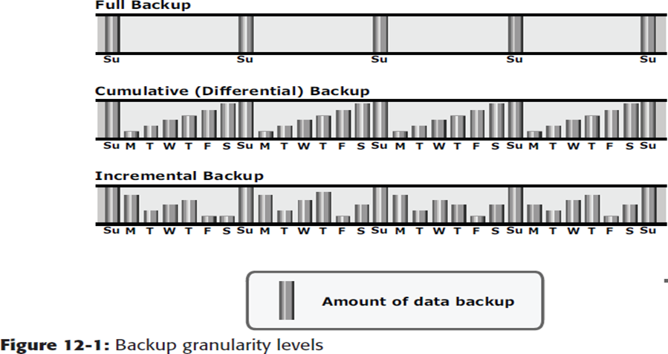

Restore operations vary with the granularity of the backup. A full backup provides a single repository

from which data can be easily restored. The process of restoration from an incremental backup requires

the last full backup and all the incremental backups available until the point of restoration. A restore from

a cumulative backup requires the last full backup and the most recent cumulative backup.

**Restoring from an incremental backup**

Figure 12-2 illustrates an example of an incremental backup and restoration.

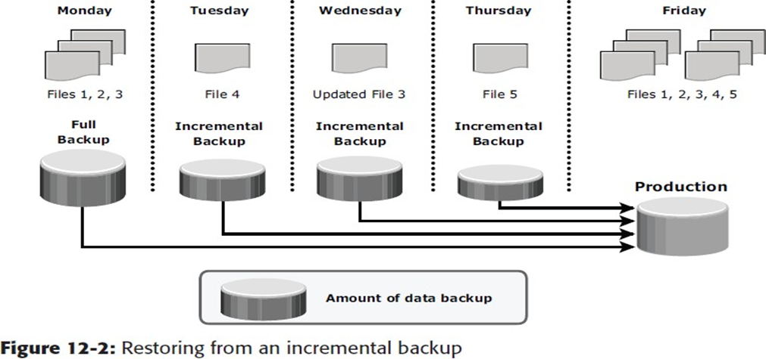

In this example, a full backup is performed on Monday evening. Each day after that, an incremental

backup is performed. On Tuesday, a new file (File 4 in the figure) is added, and no other files havechanged. Consequently, only File 4 is copied during the incremental backup performed on Tuesday

evening. On Wednesday, no new files are added, but File 3 has been modified. Therefore, only the

modified File 3 is copied during the incremental backup on Wednesday evening. Similarly, the

incremental backup on Thursday copies only File 5. On Friday morning, there is data corruption, which

requires data restoration from the backup. The first step toward data restoration is restoring all data from

the full backup of Monday evening. The next step is applying the incremental backups of Tuesday,

Wednesday, and Thursday. In this manner, data can be successfully restored to its previous state, as it

existed on Thursday evening.

**Restoring a cumulative backup**

Figure 12-3 illustrates an example of cumulative backup and restoration.

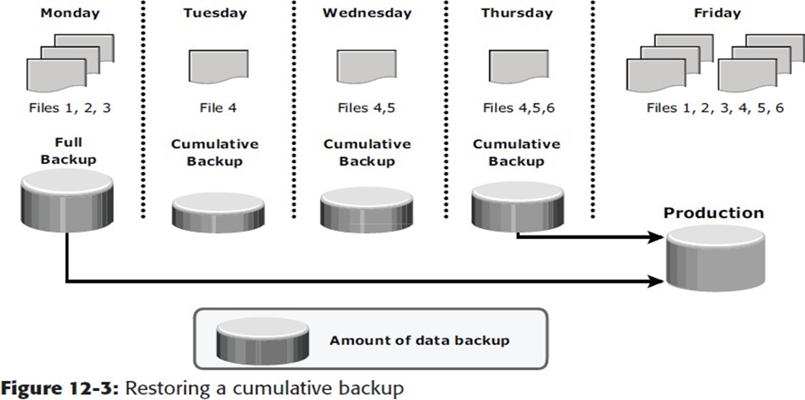

In this example, a full backup of the business data is taken on Monday evening. Each day after that, a cumulative backup is taken. On Tuesday, File 4 is added and no other data is modified since the previous full backup of Monday evening. Consequently, the cumulative backup on Tuesday evening copies only File 4. On Wednesday, File 5 is added. The cumulative backup taking place on Wednesday evening copies both File 4 and File 5 because these files have been added or modified since the last full backup. Similarly, on Thursday, File 6 is added. Therefore, the cumulative backup on Thursday evening copies all three files: File 4, File 5, and File 6.

On Friday morning, data corruption occurs that requires data restoration using backup copies. The first step in restoring data from a cumulative backup is restoring all data from the full backup of Monday evening. The next step is to apply only the latest cumulative backup — Thursday evening.

**Recovery Considerations**

RPO and RTO are major considerations when planning a backup strategy. RPO defines the tolerable limit

of data loss for a business and specifies the time interval between two backups. In other words, the RPO

determines backup frequency.

For example, if application A requires an RPO of one day, it would needthe data to be backed up at least once every day.

The retention period for a backup is also derived from anRPO specified for operational recovery. For example, users of application “A” may request to restore the application data from its operational backup copy, which was created a month ago. This determines the retention period for the backup.

The RPO for application A can therefore range from one day to one month based on operational recovery needs. However, the organization may choose to retain the backup for a longer period of time because of internal policies or external factors, such as regulatory directives.

If short retention periods are specified for backups, it may not be possible to recover all the data needed for the requested recovery point, as some data may be older than the retention period. Long retention periods can be defined for all backups, making it possible to meet any RPO within the defined retention periods. However, this requires a large storage space, which translates into higher cost. Therefore, it is important to define the retention period based on an analysis of all the restore requests in the past and the allocated budget.

RTO relates to the time taken by the recovery process. To meet the defined RTO, the business may choose to use a combination of different backup solutions to minimize recovery time. In a backup environment, RTO influences the type of backup media that should be used.

For example, recovery from data streams multiplexed in tape takes longer to complete than recovery from tapes with no multiplexing.

Organizations perform more full backups than they actually need because of recovery constraints. Cumulative and incremental backups depend on a previous full backup. When restoring from tape media, several tapes are needed to fully recover the system. With a full backup, recovery can be achieved with a lower RTO and fewer tapes.

## BackupMethods

* **Hot backup and cold backup** are the two methods deployed for backup. They are based on the state of the application when the backup isperformed.
* In a **hot backup**, the application is up and running, with users accessing their data during the backup process. This method of backup is also referred to as an *online backup***.**
* In a **cold backup**, the application is not active or shutdown during the backup process and is also called as *offlinebackup*.
* The hot backup of online production data becomes more challenging because data is actively used andchanged.
* An open file is locked by the operating system and is not backed up during the backup process. In such situations, an *open file agent* is required to back up the openfile.
* In database environments, the use of open file agents is not enough, because the agent should also support a consistent backup of all the databasecomponents.
* For example, a database is composed of many files of varying sizes occupying several file systems. To ensure a consistent database backup, all files need to be backed up in the same state. That does not necessarily mean that all files need to be backed up at the same time, but they all must be synchronized so that the database can be restored with consistency.
* The disadvantage associated with a hot backup is that the agents usually affect the overall applicationperformance.
* Consistent backups of databases can also be done by using a cold backup. This requires the database to remain inactive during the backup. Of course, the disadvantage of a cold backup is that the database is inaccessible to users during the backupprocess.
* Hot backup is used in situations where it is not possible to shut down the database. This is facilitated by database backup agents that can perform a backup while the database is active. The disadvantage associated with a hot backup is that the agents usually affect overall applicationperformance.
* A **point-in-time (PIT)** copy method is deployed in environments where the impact of downtime from a cold backup or the performance resulting from a hot backup is unacceptable. The PIT copy is created from the production volume and used as the source for the backup. This reduces the impact on the productionvolume.
* Certain attributes and properties attached to a file, such as permissions, owner, and other metadata, also need to be backed up. These attributes are as important as the data itself and must be backed up forconsistency.
* Backup of boot sector and partition layout information is also critical for successful recovery.
* In a disaster recovery environment, **bare-metal recovery (BMR)** refers to a backup in which all metadata, system information, and application configurations are appropriately backed up for a full system recovery. BMR builds the base system, which includes partitioning, the file system layout, the operating system, the applications, and all the relevant configurations. BMR recovers the base system first, before starting the recovery of data files. Some BMR technologies can recover a server onto dissimilar hardware.

Backup Architecture

* A backup system commonly uses the client-server architecture with a backup server and multiple backup clients. Figure 10-4 illustrates the backup archi- tecture.
* The backup server manages the backup operations and maintains the backup catalog, which contains information about the backup conﬁguration and backup metadata. Backup conﬁguration contains information about when to run backups, which client data to be backed up, and so on, and the backup metadata contains information about the backed up data.
* The role of a backup client is to gather the data that is to be backed up and send it to the storage node. It also sends the tracking information to the backup server.
* The storage node is responsible for writing the data to the backup device. (In a backup environment, a storage node is a host that controls backup devices.) The storage node also sends tracking information to the backup server. In many cases, the storage node is integrated with the backup server, and both are hosted on the same physical platform.
* A backup device is attached directly or through a network to the storage node’s host platform. Some backup archi- tecture refers to the storage node as the media server because it manages the storage device.

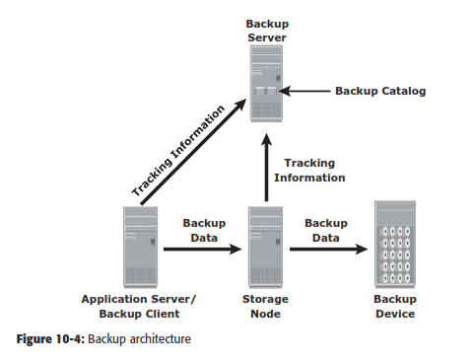

* Backup software provides reporting capabilities based on the backup catalog and the log ﬁles.
* These reports include information, such as the amount of data backed up, the number of completed and incomplete backups, and the types of errors that might have occurred. Reports can be customized depending on the speciﬁc backup software used.

**Backup and Restore Operations**

* The backup server coordinates the backup process with all the components in a backup environment (see Figure 10-5).
* The backup server maintains the information about backup clients to be backed up and storage nodes to be used in a backup operation.
* The backup server retrieves the backup-related infor- mation from the backup catalog and, based on this information, instructs the storage node to load the appropriate backup media into the backup devices. Simultaneously, it instructs the backup clients to gather the data to be backed up and send it over the network to the assigned storage node.
* After the backup data is sent to the storage node, the client sends some backup metadata (the number of ﬁles, name of the ﬁles, storage node details, and so on) to the backup server.
* The storage node receives the client data, organizes it, and sends it to the backup device. The storage node then sends additional backup metadata (loca- tion of the data on the backup device, time of backup, and so on) to the backup server. The backup server updates the backup catalog with this information.
* After the data is backed up, it can be restored when required.
* A restore process must be manually initiated from the client. Some backup software has a separate application for restore operations. These restore applications are usually accessible only to the administrators or backup operators. Figure 10-6 shows a restore operation.

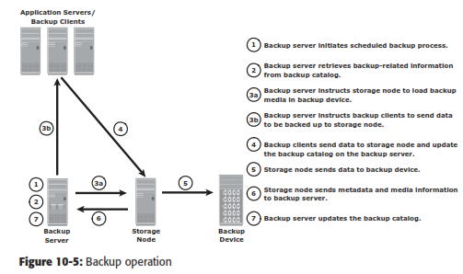

* Upon receiving a restore request, an administrator opens the restore application to view the list of clients that have been backed up.
* While selecting the client for which a restore request has been made, the administrator also needs to identify the client that will receive the restored data.
* Data can be restored on the same client for whom the restore request has been made or on any other client. The administrator then selects the data to be restored and the speciﬁed point in time to which the data has to be restored based on the RPO.
* Because all this information comes from the backup catalog, the restore application needs to communicate with the backup server.

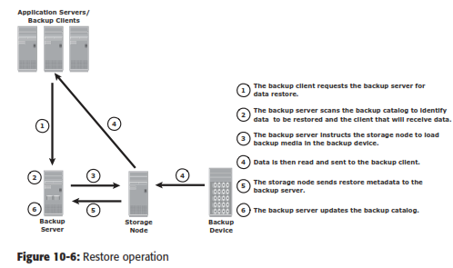

The backup server instructs the appropriate storage node to mount the speciﬁc backup media onto the backup device. Data is then read and sent to the client that has been identiﬁed to receive the restored data.

## BackupTopologies

* Three basic topologies are used in a backupenvironment:

1. Direct attachedbackup
2. LAN based backup,and
3. SAN basedbackup.

* A **mixed topology** is also used by combining LAN based and SAN basedtopologies.
* In a **direct-attached backup**, a backup device is attached directly to the client. Only the metadata is sent to the backup server through the LAN. This configuration frees the LAN from backuptraffic.
* 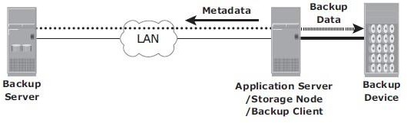The example shown in Fig 3.7 device is directly attached and dedicated to the backup client. As the environment grows, however, there will be a need for central management of all backup devices and to share the resources to optimize costs. An appropriate solution is to share the backup devices among multiple servers. Network- based topologies (LAN-based and SAN-based) provide the solution to optimize the utilization of backup devices.

Fig 3.7: Direct-attached backup topology

* In **LAN-based backup**, the clients, backup server, storage node, and backup device are connected to the LAN (see Fig 3.8). The data to be backed up is transferred from the backup client (source), to the backup device (destination) over the LAN, which may affect networkperformance.
* This impact can be minimized by adopting a number of measures, such as configuring separate networks for backup and installing dedicated storage nodes for some applicationservers.

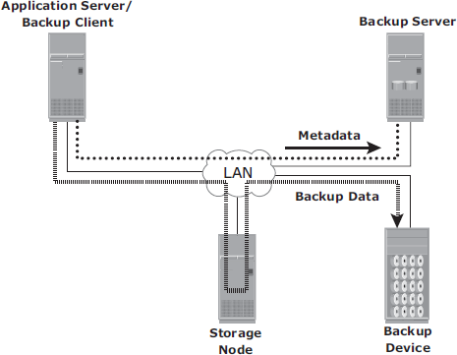

Fig 3.8: LAN-based backup topology

* The **SAN-based backup** is also known as the *LAN-free backup*. Fig 3.9 illustrates a SAN-based backup. The SAN-based backup topology is the most appropriate solution when a backup device needs to be shared among the clients. In this case the backup device and clients are attached to theSAN.
* 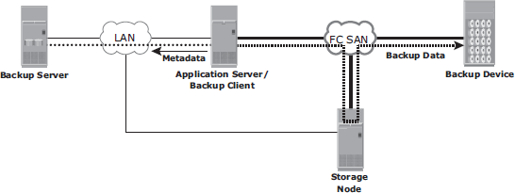In the example from Fig 3.9, a client sends the data to be backed up to the backup device over the SAN. Therefore, the backup data traffic is restricted to the SAN, and only the backup metadata is transported over the LAN. The volume of metadata is insignificant when compared to the production data; the LAN performance is not degraded in this configuration.

Fig 3.9: SAN-based backup topology

* The emergence of low-cost disks as a backup medium has enabled disk arrays to be attached to the SAN and used as backup devices. A tape backup of these data backups on the disks can be created and shipped offsite for disaster recovery and long-termretention.
* The mixed topology uses both the LAN-based and SAN-based topologies, as shown in Fig 3.10. This topology might be implemented for several reasons, including cost, server location, reduction in administrative overhead, and performanceconsiderations.

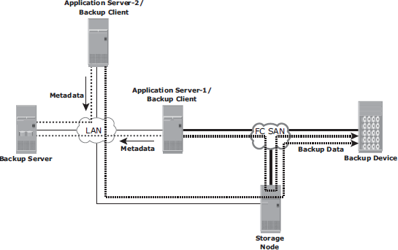

Fig 3.10: Mixed backup topology

## BackupTargets

* A wide range of technology solutions are currently available for backuptargets.
* Tapes and disks are the two most commonly used backup media. Virtual tape libraries use disks as backup medium emulating tapes, providing enhanced backup and recovery capabilities.

### Backup toTape

* + Tapes, a low-cost technology, are used extensively for backup. Tape drives are used to read/write data from/to a tape cartridge. Tape drives are referred to as sequential, or linear, access devices because the data is written or readsequentially.
  + A tape cartridge is composed of magnetic tapes in a plasticenclosure.
  + Tape Mounting is the process of inserting a tape cartridge into a tape drive. The tape drive has motorized controls to move the magnetic tape around, enabling the head to read or writedata.
  + Several types of tape cartridges are available. They vary in size, capacity, shape, number of reels, density, tape length, tape thickness, tape tracks, and supportedspeed.

### Physical Tape Library

* + The physical tape library provides housing and power for a number of tape drives and tape cartridges, along with a robotic arm or pickermechanism.
  + The backup software has intelligence to manage the robotic arm and entire backup process. Fig 3-14 shows a physical tapelibrary.
  + 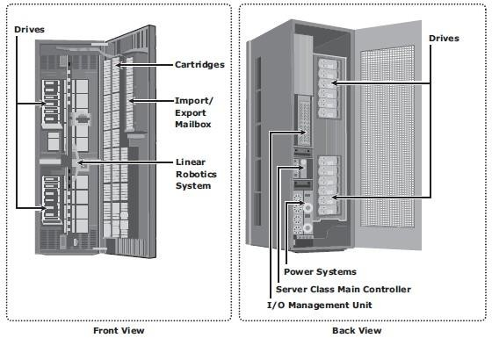*Tape drives* read and write data from and to a tape. Tape cartridges are placed in the slots when not in use by a tape drive. *Robotic arms* are used to move tapes around the library, such as moving a tape drive into aslot.

Fig 3.11: Physical tape library

* Another type of slot called a *mail or import/export* slot is used to add or remove tapes from the library without opening the access doors (Fig 3.11 Front View) because opening the access doors causes a library to gooffline.
* In addition, each physical component in a tape library has an individual element address that is used as an addressing mechanism for moving tapes around thelibrary.
* When a backup process starts, the robotic arm is instructed to load a tape to a tape drive. This process adds to the delay to a degree depending on the type of hardware used, but it generally takes 5 to 10 seconds to mount a tape. After the tape is mounted, additional time is spent to position the heads and validate header information. This total time is called *load to ready time*, and it can vary from several seconds tominutes.
* The tape drive receives backup data and stores the data in its internal buffer. This backup data is then written to the tape in blocks. During this process, it is best to ensure that the tape drive is kept busy continuously to prevent gaps between the blocks. Thisis

accomplished by buffering the data on tape drives.

* The speed of the tape drives can also be adjusted to match data transferrates.
* Tape drive *streaming or multiple streaming* writes data from multiple streams on a single tape to keep the drive busy. Shown in Fig 3.12, multiple streaming improves media performance, but it has an associated disadvantage. The backup data is interleaved because data from multiple streams is written onit.

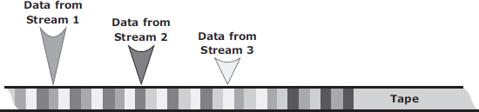

Fig 3.12: Physical tape library

* Many times, even the buffering and speed adjustment features of a tape drive fail to prevent the gaps, causing the *“shoe shining effect” or “backhitching.”* This is the repeated back and forth motion a tape drive makes when there is an interruption in the backup data stream. This repeated back-and-forth motion not only causes a degradation of service, but also excessive wear and tear totapes.
* When the tape operation finishes, the tape rewinds to the starting position and it is unmounted. The robotic arm is then instructed to move the unmounted tape back to the slot. *Rewind time* can range from several seconds tominutes.
* When a *restore* is initiated, the backup software identifies which tapes are required. The robotic arm is instructed to move the tape from its slot to a tape drive. If the required tape is not found in the tape library, the backup software displays a message, instructing the operator to manually insert the required tape in the tapelibrary.
* When a file or a group of files require restores, the tape must move sequentially to the beginning of the data before it can start reading. This process can take a significant amount of time, especially if the required files are recorded at the end of thetape.
* Modern tape devices have an indexing mechanism that enables a tape to be fast forwarded to a location near the requireddata.

### Limitations of Tape

* Tapes must be stored in locations with a controlled environment to ensure preservation of the media and prevent datacorruption.
* Data access in a tape is sequential, which can slow backup and recoveryoperations.
* Physical transportation of the tapes to offsite locations also adds managementoverhead.

### Backup toDisk

* + Because of *increased availability*, low cost **disks** have now replaced tapes as the primary device for storing backup data because of their *performance advantages*. Backup-to-disk systems offer *ease of implementation*, *reduced TCO* (Total cost of ownership), and *improved quality of service*. Disks also offer *faster recovery* when compared totapes.
  + Backing up to disk storage systems offers clear advantages due to their inherent random access and RAID-protectioncapabilities.
  + Fig 3.13 illustrates a recovery scenario comparing tape versus disk in a Microsoft Exchange environment that supports 800 users with a 75 MB mailbox size and a 60 GB database. As shown, a restore from disk took 24 minutes compared to the restore from a tape, which took 108 minutes for the sameenvironment.
  + Recovering from a full backup copy stored on disk and kept onsite provides the fastest recovery solution. Using a disk enables the creation of full backups more frequently, which in turn improves RPO and RTO.
  + Backup to disk does not offer any inherent offsite capability, and is dependent on other technologies such as local and remotereplication.
  + 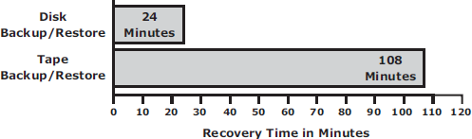Some backup products also require additional modules and licenses to support backup to disk, which may also require additional configuration steps, including creation of RAID groups and file system tuning. These activities are not usually performed by a backupadministrator.

Fig 3.13: Tape versus Disk restore

### Backup to VirtualTape

* + Virtual tapes are disk drives emulated and presented as tapes to the backupsoftware.
  + The key benefit of using a virtual tape is that it does not require any additional modules, configuration, or changes in the legacy backup software. This preserves the investment made in the backupsoftware.

### Virtual Tape Library

* A virtual tape library (VTL) has the same components as that of a physical tape library except that the majority of the components are presented as virtualresources.
* For the backup software, there is no difference between a physical tape library and a virtual tapelibrary.
* Fig 3.14 shows a virtual tape library that uses disks as backup media. Emulation software has a database with a list of virtual tapes, and each virtual tape is assigned a portion of a LUN on the disk. A virtual tape can span multiple LUNs ifrequired.
* File system awareness is not required while backing up because virtual tape solutions use rawdevices.
* Similar to a physical tape library, a robot mount is performed when a backup process starts in a virtual tape library. However, unlike a physical tape library, where this process involves some mechanical delays, in a virtual tape library it is almost instantaneous. Even the *load to ready* time is much less than in a physical tapelibrary.
* After the virtual tape is mounted and the tape drive is positioned, the virtual tape is ready to be used, and backup data can be written to it. Unlike a physical tape library, the virtual tape library is not constrained by the shoe shiningeffect.
* When the operation is complete, the backup software issues a rewind command and then the tape can be unmounted. This rewind is alsoinstantaneous.
* The virtual tape is then unmounted, and the virtual robotic arm is instructed to move it back to a virtualslot.
* The steps to restore data are similar to those in a physical tape library, but the restore operation is instantaneous. Even though virtual tapes are based on disks, which provide random access, they still emulate the tapebehavior.
* Virtual tape library appliances offer a number of features that are not available with physical tapelibraries.
* Some virtual tape libraries offer *multiple emulation engines* configured in an active cluster configuration. An engine is a dedicated server with a customized operating system that makes physical disks in the VTL appear as tapes to the backup application. With this feature, one engine can pick up the virtual resources from another engine in the event of anyfailure.Replication over IP is available with most of the virtual tape library appliances. This feature enables virtual tapes to be replicated over an inexpensive IP network to aremote site.
* Connecting the engines of a virtual tape library appliance to a physical tape library enables the virtual tapes to be copied onto the physical tapes, which can then be sent to a vault or shipped to an offsitelocation.
* Using virtual tapes offers several advantages over both physical tapes anddisks.
* Compared to physical tapes, virtual tapes offer better single stream performance, better reliability, and random disk accesscharacteristics.
* Backup and restore operations benefit from the disk’s random access characteristics because they are always online and provide faster backup andrecovery.
* A virtual tape drive does not require the usual maintenance tasks associated with a physical tape drive, such as periodic cleaning and drivecalibration.
* Compared to backup-to-disk devices, a virtual tape library offers easy installation and administration because it is preconfigured by themanufacturer.
* However, a virtual tape library is generally used only for backup purposes. In a backup- to-disk environment, the disk systems are used for both production and backupdata.

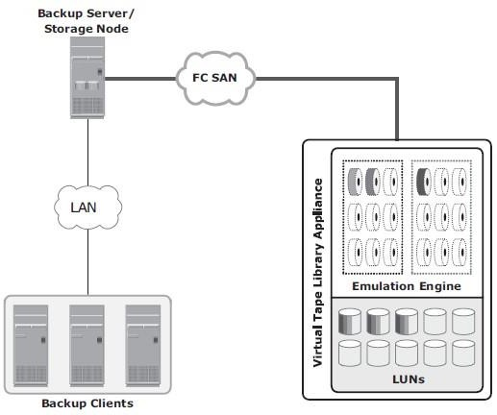

Fig 3.14: Virtual Tape Library

### Backup Targets Comparison

Table 3.2 shows a comparison between various backup targets.

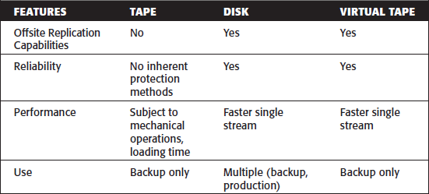

Table 3.2: Backup targets comparison

## Data Deduplication for Backup

* **Data deduplication** is the process of identifying and eliminating redundant data. When duplicate data is detected during backup, the data is discarded and only the pointer is created to refer the copy of the data that is already backedup.
* Data deduplication helps to reduce the storage requirement for backup, shorten the backup window, and remove the network burden. It also helps to store more backups on the disk and retain the data on the disk for a longertime.

### Data DeduplicationMethods

* + There are two methods of deduplication: *file level* and *subfile*level.
  + The differences exist in the amount of data reduction each method produces and the time each approach takes to determine the unique content.
  + ***File-level deduplication*** (also called single-instance storage) detects and removes redundant copies of identical files. It enables storing only one copy of the file; the subsequent copies are replaced with a pointer that points to the originalfile.
  + File-level deduplication is simple and fast but does not address the problem of duplicate content inside the files. For example, two 10-MB PowerPoint presentations with a difference in just the title page are not considered as duplicate files, and each file will be storedseparately.
  + ***Subfile deduplication*** breaks the file into smaller chunks and then uses a specialized algorithm to detect redundant data within and across the file. As a result, subfile deduplication eliminates duplicate data across files.
  + There are two forms of subfile deduplication: fixed-length block and variable-length segment.
  + *The fixed-length block deduplication* divides the files into fixed length blocks and uses a hash algorithm to find the duplicatedata.
  + Although simple in design, fixed-length blocks might miss many opportunities to discover redundant data because the block boundary of similar data might be different. Consider the addition of a person’s name to a document’s title page. This shifts the whole document, and all the blocks appear to have changed, causing the failure of the deduplication method to detect equivalencies.
  + In *variable-length segment deduplication*, if there is a change in the segment, the boundary for only that segment is adjusted, leaving the remaining segments unchanged. This method vastly improves the ability to find duplicate data segments compared tofixed-block.

### Data DeduplicationImplementation

Deduplication for backup can happen at the data source or the backup target.

### Source-Based Data Deduplication

* + *Source-based data deduplication* eliminates redundant data at the source before it transmits to the backup device.
  + Source-based data deduplication can dramatically reduce the amount of backup data sent over the network during backup processes. It provides the benefits of a shorter backup window and requires less network bandwidth. There is also a substantial reduction in the capacity required to store the backupimages.
  + Fig 3.15 shows source-based datadeduplication.
  + Source-based deduplication increases the overhead on the backup client, which impacts the performance of the backup and application running on theclient.
  + Source-based deduplication might also require a change of backup software if it is not supported by backupsoftware.

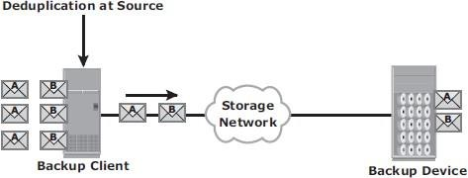

Fig 3.15: Source-based data deduplication

### Target-Based Data Deduplication

* + Target-based data deduplication is an alternative to source-based datadeduplication.
  + Target-based data deduplication occurs at the backup device, which offloads the backup client from the deduplicationprocess.
  + Fig 3.16 shows target-based datadeduplication.
  + In this case, the backup client sends the data to the backup device and the data is deduplicated at the backup device, either *immediately (inline)* or at a *scheduled time (post-process).*
  + Because deduplication occurs at the target, all the backup data needs to be transferred over the network, which increases network bandwidth requirements. Target-based data deduplication does not require any changes in the existing backupsoftware.
  + *Inline deduplication* performs deduplication on the backup data before it is stored on the backup device. Hence, this method reduces the storage capacity needed for the backup.
  + Inline deduplication introduces overhead in the form of the time required to identify and remove duplication in the data. So, this method is best suited for an environment with a large backupwindow.
  + *Post-process deduplication* enables the backup data to be stored or written on the backup device first and then deduplicatedlater.
  + This method is suitable for situations with tighter backup windows. However, post- process deduplication requires more storage capacity to store the backup images before they arededuplicated.

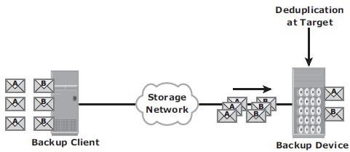

Fig 3.16: Target-based data deduplication

## Backup in VirtualizedEnvironments

* Therearetwoapproachesforperformingabackupinavirtualizedenvironment:the

*traditional backup* approach and the *image-based* backup approach.

* In *the traditional backup* approach, a backup agent is installed either on the virtual machine (VM) or on thehypervisor.
* Fig 3.17 shows the traditional VM backupapproach.
* If the backup agent is installed on a VM, the VM appears as a physical server to the agent. The backup agent installed on the VM backs up the VM data to the backup device. The agent does not capture VM files, such as the virtual BIOS file, VM swap file, logs, and configuration fi les. Therefore, for a VM restore, a user needs to manually re-create the VM and then restore data ontoit.
* If the backup agent is installed on the hypervisor, the VMs appear as a set of files to the agent. So, VM files can be backed up by performing a file system backup from a hypervisor. This approach is relatively simple because it requires having the agent just on the hypervisor instead of all theVMs.
* The traditional backup method can cause high CPU utilization on the server being backedup.
* So the backup should be performed when the server resources are idle or during a low activity period on thenetwork.
* And also allocate enough resources to manage the backup on each server when a large number of VMs are in theenvironment.

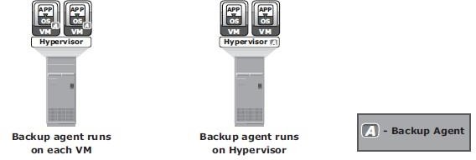

Fig 3.17: Traditional VM backup

* *Image-based backup* operates at the hypervisor level and essentially takes a snapshot of the VM.
* It creates a copy of the guest OS and all the data associated with it (snapshot of VM disk files), including the VM state and application configurations. The backup is saved as a single file called an *“image,”* and this image is mounted on the separate physical machine–proxy server, which acts as a backupclient.
* The backup software then backs up these image files normally. (see Fig3.18).
* This effectively offloads the backup processing from the hypervisor and transfers the load on the proxy server, thereby reducing the impact to VMs running on the hypervisor.
* Image-based backup enables quick restoration of aVM.

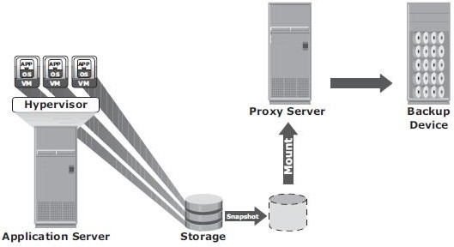Fig 3.18: Image-based backup

**Data Archive**

* In the life cycle of information, data is actively created, accessed, and changed.
* As data ages, it is less likely to be changed and eventually becomes “ﬁxed” but continues to be accessed by applications and users.
* This data is called ﬁxed content. X-rays, e-mails, and multimedia ﬁles are examples of ﬁxed content. Figure 10-23 shows some examples of ﬁxed content.

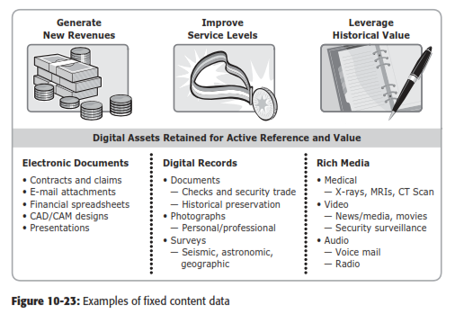

* All organizations may require retention of their data for an extended period of time due to government regulations and legal/contractual obligations.
* Organizations also make use of this ﬁxed content to generate new revenue strategies and improve service levels. A repository where ﬁxed content is stored is known as an archive.

An archive can be implemented as an online, nearline, or ofﬂine solution:

* Online archive: A storage device directly connected to a host that makes the data immediately accessible.
* Nearline archive: A storage device connected to a host, but the device where the data is stored must be mounted or loaded to access the data.
* Ofﬂine archive: A storage device that is not ready to use. Manual inter- vention is required to connect, mount, or load the storage device before data can be accessed.