2.2 Disk Drive Components
A disk drive uses a rapidly moving arm to read and write data across a flat platter coated with magnetic particles. Data is transferred from the magnetic platter through the R/W head to the computer. Several platters are assembled together with the R/W head and controller, most commonly referred to as a hard disk drive (HDD). Data can be recorded and erased on a magnetic disk any number of times.Key components of a disk drive are platter, spindle, read/write head, actuator arm assembly, and controller is as shown in Figure 2-2

2.2.1 Platter
A typical HDD consists of one or more flat circular disks called platters shown below Figure 2-3. The data is recorded on these platters in binary codes (0s and1s). The set of rotating platters is sealed in a case, called a Head Disk Assembly (HDA). The data is encoded by polarizing the magneticarea, or domains, of the disk surface. Data can be written to or read from bothsurfaces of the platter.

2.2.2 Spindle
A spindle connects all the platters, as shown in Figure 2-3, and is connected to a motor. The motor of the spindle rotates with a constant speed. The disk platter spins at a speed of several thousands of revolutions per minute (rpm). Disk drives have spindle speeds of 7,200 rpm, 10,000 rpm, or 15,000 rpm. Disks used on current storage systems have a platter diameter of 3.5” (90 mm).

2.2.3 Read/Write Head
Read/Write (R/W) heads, shown in Figure 2-4, read and write data from or to a platter. Drives have two R/W heads per platter, one for each surface of the platter. The R/W head changes the magnetic polarization on the surface of the platter when writing data. While reading data, this head detects magnetic polarization on the surface of the platter. During reads and writes, the R/W head senses the magnetic polarization and never touches the surface of the platter.
The logic on the disk drive ensures that heads are moved to the landing zone before they touch the surface. If the drive malfunctions and the R/W head accidentally touches the surface of the platter outside the landing zone, a head crash occurs. In a head crash, the magnetic coating on the platter is scratched and may cause damage to the R/W head. A head crash generally results in data loss.

2.2.4 Actuator Arm Assembly
The R/W heads are mounted on the actuator arm assembly, which positions the R/W head at the location on the platter where the data needs to be written or read. The R/W heads for all platters on a drive are attached to one actuator arm assembly and move across the platters simultaneously.

2.2.5 Controller
The controller is a printed circuit board, mounted at the bottom of a disk drive. It consists of a microprocessor, internal memory, circuitry, and firmware. The firmware controls power to the spindle motor and the speed of the motor. It also manages communication between the drive and the host.

2.2.6 Physical Disk Structure
Data on the disk is recorded on tracks, which are concentric rings on the platter around the spindle, as shown in Figure 2-5. The tracks are numbered, starting from zero, from the outer edge of the platter. The number of tracks per inch (TPI) on the platter (or the track density) measures how tightly the tracks are packed on a platter. Each track is divided into smaller units called sectors. A sector is the smallest, individually addressable unit of storage.
2.2.7 Zoned Bit Recording
Zone bit recording utilizes the disk efficiently. As shown in Figure 2-6 (b), this mechanism groups tracks into zones based on their distance from the center of the disk. The zones are numbered, with the outermost zone being zone 0. An appropriate number of sectors per track are assigned to each zone, so a zone near the center of the platter has fewer sectors per track than a zone on the outer edge.
2.2.8 Logical Block Addressing
Earlier drives used physical addresses consisting of the cylinder, head, and sector (CHS) number to refer to specific locations on the disk, as shown in Figure 2-7(a), and the host operating system had to be aware of the geometry of each diskbeing used. Logical block addressing (LBA), shown in Figure 2-7 (b), simplifiesaddressing by using a linear address to access physical blocks of data. The diskcontroller translates LBA to a CHS address, and the host only needs to knowthe size of the disk drive in terms of the number of blocks.
In Figure 2-7 (b), the drive shows eight sectors per track, eight heads, and four cylinders. This means a total of 8 × 8 × 4 = 256 blocks, so the block number ranges from 0 to 255. Each block has its own unique address. Assuming that the sector holds 512 bytes, a 500 GB drive with a formatted capacity of 465.7 GB will have in excess of 976,000,000 blocks.

2.3 Disk Drive Performance
A disk drive is an electromechanical device that governs the overall performance of the storage system environment.
The various factors that affect the performance of disk drives are discussed in this section.

2.3.1 Disk Service Time
Disk service time is the time taken by a disk to complete an I/O request. Components that contribute to service time on a disk drive are seek time, rotationallatency, and data transfer rate.
- Seek Time:-The seek time (also called access time) describes the time taken to position the R/W heads across the platter with a radial movement (moving along the radius of the platter). In other words, it is the time taken to reposition and settle the arm and the head over the correct track. The lower the seek time, the faster the I/O operation. Disk vendors publish the following seek time specifications:
- Full Stroke: The time taken by the R/W head to move across the entire width of the disk, from the innermost track to the outermost track.
- Average: The average time taken by the R/W head to move from one random track to another, normally listed as the time for one-third of a full stroke.
- Track-to-Track: The time taken by the R/W head to move between adjacent tracks.

- Rotational Latency
To access data, the actuator arm moves the R/W head over the platter to a particular track while the platter spins to position the requested sector under the R/W head. The time taken by the platter to rotate and position the data under the R/W head is called rotational latency. This latency depends on the rotation speed of the spindle and is measured in milliseconds.

- Data Transfer Rate
The data transfer rate (also called transfer rate) refers to the average amount of data per unit time that the drive can deliver to the HBA. In a read operation, the data first moves from disk platters to R/W heads, and then it moves to the drive’s internal buffer. Finally, data moves from the buffer through the interface to the host HBA. In a write operation, the data moves from the HBA to the internal buffer of the disk drive through the drive’s interface. The data then moves from the buffer to the R/W heads. Finally, it moves from the R/W heads to the platters.
Internal transfer rateis the speed at which data moves from a single track of a platter’s surface to internal buffer (cache) of the disk. Internal transfer rate takes into account factors such as the seek time.
External transfer rateis the rate at which data can be moved through the interface to the HBA. External transfer rate is generally the advertised speed of the interface, such as 133 MB/s for ATA.

Storage Design Based on Application Requirements and Disk Performance
Disk Service time (Ts) for an I/O is a key measure of disk performance along with disk utilization rate (U) determines the I/O response time for an application
The total disk service time (Ts) is the sum of the seek Time (T) rotational latency and internal transfer time(X)
Ts=T+L+X

Direct-Attached Storage (DAS)
Stands for “Direct Attached Storage.” DAS refers to any storage device connected directly to a computer. Examples include HDDs, SSDs, and optical drives. While DAS can refer to internal storage devices, it is most often describes external devices, such as an external hard drive.

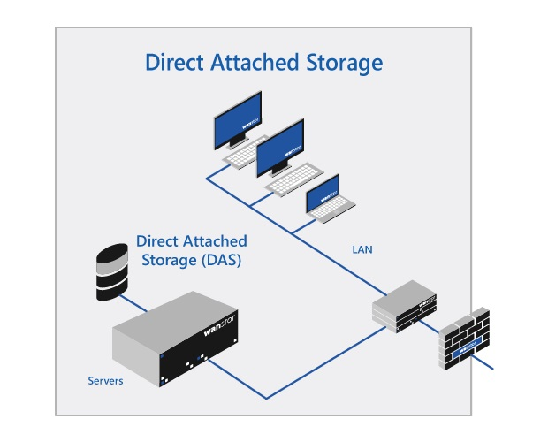
The term “DAS” was created to differentiate between network-attached storage (NAS) and direct-attached storage. Before NAS and storage area networks (SANs) were available, direct-attached storage was the the only option. While DAS is still the most common type of storage used in personal computing, network and server administrators often need to choose between DAS and NAS for a storage solution.
The primary benefit of DAS vs NAS is the simplicity of the setup. You can simply connect a device to a computer and, as long as the necessary drivers are available, it will show up as an additional storage device. There is no need to configure network settings or set up permissions for individual computers. The main drawback of DAS is that a direct-attached device is only accessible via the computer to which it is attached. Therefore, a computer must be configured as a file server in order for other systems to access any connected DAS devices.

Direct Attached Storage: Two Types internal DAS and External DAS
Hosts H1, H2, and H3 connected directly to storage array
Benefits
1) Relatively lower initial investment than storage networking architectures
2) Configuration simple and easily deployable
3) Setup managed using host based tools which makes storage management tasks easy for small environments
4) Requires fewer management tasks and less hardware and software elements to setup and operate
Limitations
1) Does not scale well
2) Has limited number of hosts which restricts the number of hosts that can be directly connected to storage
3) Service availability compromised on reaching capacities
4) Does not make optimal use of resources
5) Unused resources cannot be easily allocated which results in overused and under used storage pools

