**Protocol:** RNA-extraction-v2.py

# Assumptions/Limitations:

1. I assume samples are already in a 96 deep welled plate.

2. We only use half of the plate, that is, 48 samples.

3. We use 5.5 tipracks

4. Initial plate has 140 ul

5. We are using pipette tips with filter, which reduce max volume in pipette. Therefore, we only transfer volumes of 180 ul, with a previous step of aspiring 20ul of air. (Inherited behaviour, I am unsure about exactly why. I think it is to avoid liquid touching the filter)

# Constraints when writing the script

1. Sample plates must stay away from the trash

2. The robot should avoid hovering over other wells/ pipette tips after being in contact with samples

# Labware:

1. magnetic module with 96 deep wells plate in pos 7

2. NEST 12 15 ml reservoir for Reagents in pos 5 (A1: Proteinase K/LBF, A2: Beads, A3: Wash WBE, A4: Ethanol 70%, A5:RNAse free water)

3. NEST 12 15 ml reservoir for liquid waste in pos 11

4. Eppendorf 96 well 150 ul plate in pos 4. Output plate.

5. 300ul tipracks in pos 1,2,3,6,8,9

6. Multichannel P300 Generation 1

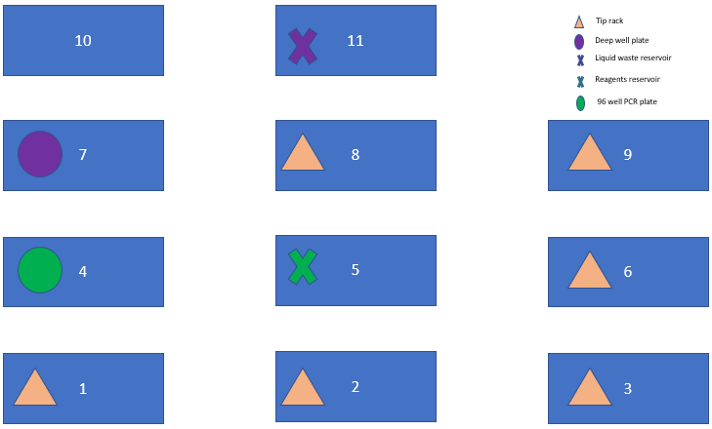

# Step-by-Step:

1. Add 112 ul of proteinase K/LBF and incubate 10 min

2. Add 144 ul of bead solution to each well and mix 5 times using 40 ul.

3. Incubate for 5 min without magnet and then 5 more with the magnet on

4. With the magnet on, remove 396 ul of supernatant

5. Add 280 ul of Wash WBE and mix 5 times with 70 ul. Incubate for 3 min

6. With the magnet on, remove 280 ul of supernatant

7. FIRST TIME: Add 280 ul of Ethanol 70% and mix 5 times with 70 ul. Incubate for 3 min

8. FIRST TIME: With the magnet on, remove 280 ul of supernatant

9. SECOND TIME: Add 280 ul of Ethanol 70% and mix 5 times with 70 ul. Incubate for 3 min

10. SECOND TIME: With the magnet on, remove 280 ul of supernatant

11. With magnet on, allow beads to dry for 5 min

12. Turn off magnet and add 80 ul of RNAse free water

13. Incubate with magnet for 1 min

14. Transfer 80 ul from deep well to output eppendorf 96 well plate.

# In-detail Behaviour:

1. Whenever a tip touches a sample, I try to avoid hovering over any other wells. As such, when mixing/removing supernatant the first thing the robot does is to move on the Y axis to pos 10 and then from there it goes to the liquid waste/trash

2. Before picking up any liquid, the pipette always aspires 20 ul of air. I copied this behaviour from a similar protocol Pedro showed me. I think is related to the filter, but I am not sure.

3. Maximum capacity is 180 ul (Excluding the previous 20ul). If any transference is bigger than that, the robot does more than one trip and pours the liquid from the top of the well, to avoid getting in contact with the sample and spread it during the trips. When all liquid is there, it mixes normally.

4. For mixing, the pipette takes liquid from the bottom, and pours it from a height of 6 mm from the bottom

5. When removing supernatant, aspiration rate is reduced to 20 ul/sec (50 ul/sec in other situations)

6. This magnetic module places magnets between pairs of consecutive columns. This means that the pellet is going to precipitate on one side of the tube. To avoid aspiring pellet, when the robot is removing supernatant, it always moves 1mm off-center to the side opposite of the magnet. As seen in the next figure.

