===========================================================================
https://github.com/AngelP00/UADER_IS2_Angel_Palacios_2023/blob/main/src/factorial/factorial1.py
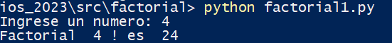

===========================================================================
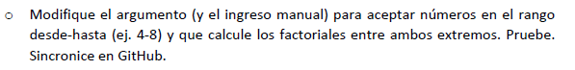
https://github.com/AngelP00/UADER_IS2_Angel_Palacios_2023/blob/main/src/factorial/factorial2.py
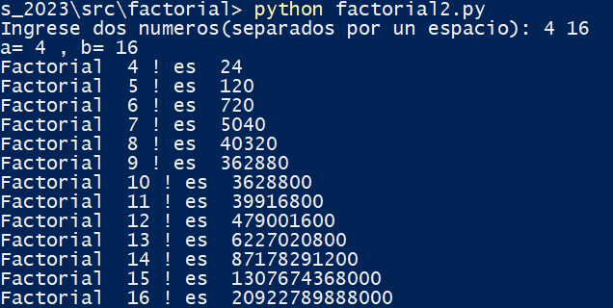

===========================================================================
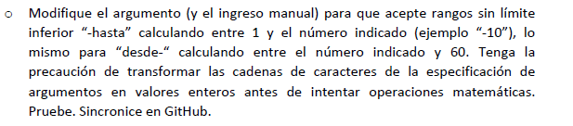
https://github.com/AngelP00/UADER_IS2_Angel_Palacios_2023/blob/main/src/factorial/factorial3.py
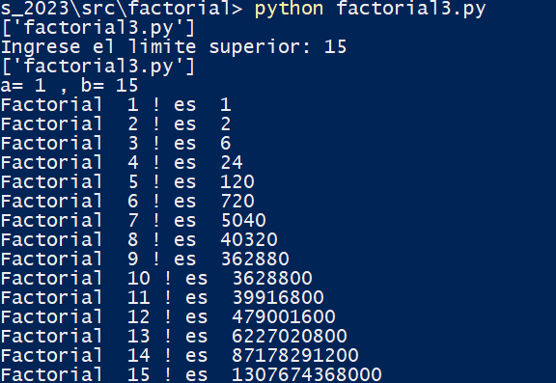
https://github.com/AngelP00/UADER_IS2_Angel_Palacios_2023/blob/main/src/factorial/factorial4.py
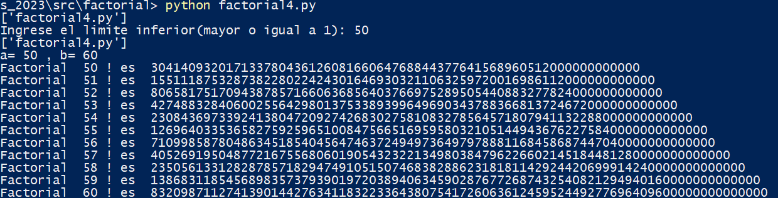

===========================================================================
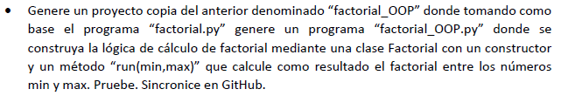
https://github.com/AngelP00/UADER_IS2_Angel_Palacios_2023/blob/main/src/factorial/factorial_OOP/factorial_OOP.py
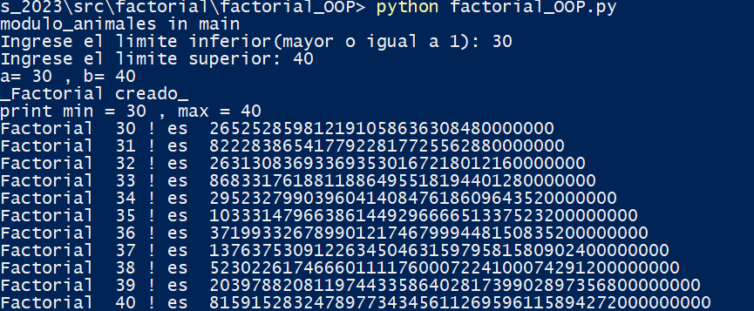
===========================================================================
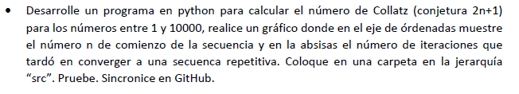
https://github.com/AngelP00/UADER_IS2_Angel_Palacios_2023/blob/main/src/conjetura/conjetura.py
