Parcial Bases de Datos Ángel Quintero:  
  
Link Github: <https://github.com/AngelQuinteroDev/ParcialSerio>  
  
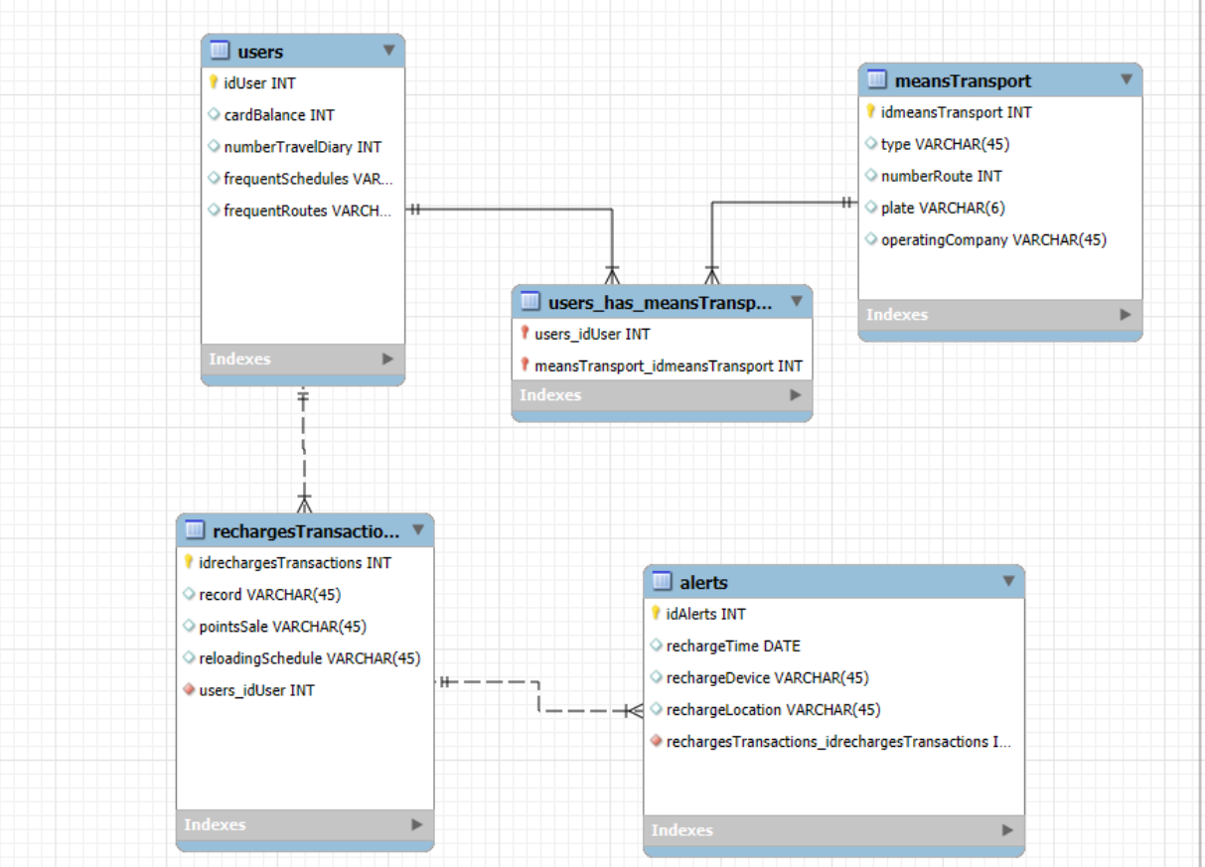

Código SQL:

CREATE SCHEMA IF NOT EXISTS `mintransp` DEFAULT CHARACTER SET utf8 ;

USE `mintransp` ;

-- -----------------------------------------------------

-- Table `minTransporte`.`users`

-- -----------------------------------------------------

CREATE TABLE IF NOT EXISTS `mintransp`.`users` (

`idUser` INT NOT NULL,

`cardBalance` INT NULL,

`numberTravelDiary` INT NULL,

`frequentSchedules` VARCHAR(45) NULL,

`frequentRoutes` VARCHAR(45) NULL,

PRIMARY KEY (`idUser`))

ENGINE = InnoDB;

-- -----------------------------------------------------

-- Table `minTransporte`.`meansTransport`

-- -----------------------------------------------------

CREATE TABLE IF NOT EXISTS `mintransp`.`meansTransport` (

`idmeansTransport` INT NOT NULL,

`type` VARCHAR(45) NULL,

`numberRoute` INT NULL,

`plate` VARCHAR(6) NULL,

`operatingCompany` VARCHAR(45) NULL,

PRIMARY KEY (`idmeansTransport`))

ENGINE = InnoDB;

-- -----------------------------------------------------

-- Table `minTransporte`.`rechargesTransactions`

-- -----------------------------------------------------

CREATE TABLE IF NOT EXISTS `mintransp`.`rechargesTransactions` (

`idrechargesTransactions` INT NOT NULL,

`record` VARCHAR(45) NULL,

`pointsSale` VARCHAR(45) NULL,

`reloadingSchedule` VARCHAR(45) NULL,

`users_idUser` INT NOT NULL,

PRIMARY KEY (`idrechargesTransactions`),

INDEX `fk_rechargesTransactions_users_idx` (`users_idUser` ASC) VISIBLE,

CONSTRAINT `fk_rechargesTransactiomeanstransportmeanstransportns_users`

FOREIGN KEY (`users_idUser`)

REFERENCES `mintransp`.`users` (`idUser`)

ON DELETE NO ACTION

ON UPDATE NO ACTION)

ENGINE = InnoDB;

-- -----------------------------------------------------

-- Table `minTransporte`.`alerts`

-- -----------------------------------------------------

CREATE TABLE IF NOT EXISTS `mintransp`.`alerts` (

`idAlerts` INT NOT NULL,

`rechargeTime` DATE NULL,

`rechargeDevice` VARCHAR(45) NULL,

`rechargeLocation` VARCHAR(45) NULL,

`rechargesTransactions_idrechargesTransactions` INT NOT NULL,

PRIMARY KEY (`idAlerts`),

INDEX `fk_alerts_rechargesTransactions1_idx` (`rechargesTransactions_idrechargesTransactions` ASC) VISIBLE,

CONSTRAINT `fk_alerts_rechargesTransactions1`

FOREIGN KEY (`rechargesTransactions_idrechargesTransactions`)

REFERENCES `mintransp`.`rechargesTransactions` (`idrechargesTransactions`)

ON DELETE NO ACTION

ON UPDATE NO ACTION)

ENGINE = InnoDB;

-- -----------------------------------------------------

-- Table `minTransporte`.`users_has_meansTransport`

-- -----------------------------------------------------

CREATE TABLE IF NOT EXISTS `mintransp`.`users_has_meansTransport` (

`users_idUser` INT NOT NULL,

`meansTransport_idmeansTransport` INT NOT NULL,

PRIMARY KEY (`users_idUser`, `meansTransport_idmeansTransport`),

INDEX `fk_users_has_meansTransport_meansTransport1_idx` (`meansTransport_idmeansTransport` ASC) VISIBLE,

INDEX `fk_users_has_meansTransport_users1_idx` (`users_idUser` ASC) VISIBLE,

CONSTRAINT `fk_users_has_meansTransport_users1`

FOREIGN KEY (`users_idUser`)

REFERENCES `mintransp`.`users` (`idUser`)

ON DELETE NO ACTION

ON UPDATE NO ACTION,

CONSTRAINT `fk_users_has_meansTransport_meansTransport1`

FOREIGN KEY (`meansTransport_idmeansTransport`)

REFERENCES `mintransp`.`meansTransport` (`idmeansTransport`)

ON DELETE NO ACTION

ON UPDATE NO ACTION)

ENGINE = InnoDB;