CHAPTER 5
SYSTEM TESTING
5.1 INTRODUCTION
System testing is a critical, rigorous phase in the software development lifecycle (SDLC) where the integrated software application is evaluated as a complete, unified system to ensure strict compliance with specified functional, operational, and performance requirements. In the context of CardaLink – Smart Cardamom Plantation and Export Management System, testing serves as the definitive verification gateway before real-world operational deployment across Kerala's spice agricultural corridors and overseas commercial export channels.
CardaLink is an enterprise-grade agricultural fintech and supply-chain platform designed to automate and digitize the end-to-end lifecycle of small cardamom (Elettaria cardamomum). The application integrates five distinct stakeholder roles: System Administrator, Cardamom Farmer, Licensed Trader, Registered Exporter, and International Buyer. Given the high commercial value of cardamom as the 'Queen of Spices', accuracy in green-to-dry yield conversion ratios, batch traceability, quality grading (AGEB, AGB, AGS), financial settlements, and international delivery confirmation is paramount. Unlike unit testing or component testing, which focus on isolated functions or components in artificial test environments, system testing exercises the integrated application under conditions that faithfully replicate production environments.
The primary objective of system testing in CardaLink is to validate the end-to-end behavior of the entire application from both user-facing and backend infrastructural perspectives. It confirms that the React.js client interface, the Python/Django REST Framework backend services, the PostgreSQL relational database, and secure SMTP communications operate in complete harmony. By executing systematic testing protocols, software defects, authentication vulnerabilities, state synchronization inconsistencies, and border-condition edge cases are identified and rectified, ensuring enterprise reliability, user trust, and seamless operational flow.
5.2 TEST PLAN
A Test Plan is an exhaustive formal document that delineates the overall verification strategy, scope, objectives, resource requirements, test environment architecture, execution methodology, and pass/fail criteria for CardaLink. It acts as an operational roadmap that guides software developers, quality assurance engineers, and evaluators through a disciplined verification lifecycle.
The test strategy for CardaLink encompasses multi-layered verification designed to catch defects at the earliest possible stage while assuring end-to-end workflow integrity across all modules. The core elements governing the CardaLink Test Plan include:
- Test Objectives: To verify that all business rules, role-based access boundaries, cryptographic delivery confirmations, and inventory transactions operate strictly in accordance with functional specifications without data loss or security bypass.
- Test Scope: Encompasses user authentication, role-based dashboard routing, plantation mapping, daily harvesting and curing cycles, trader marketplace interactions, export supply requests, export order processing, document generation, shipment milestone tracking, and single-use buyer delivery confirmations. Third-party international banking clearinghouses and container satellite telematics are simulated via standardized mock interfaces.
- Test Environment: A dual-tier staging environment comprising a Vite-powered React client (Node.js 18+ runtime), a Python 3.9 Django 4.2 REST backend hosted on Render, a PostgreSQL 15 managed relational database, and live TLS-secured Google SMTP mail server for transaction dispatches.
- Roles and Responsibilities: The Quality Assurance (QA) team designs and maintains the automated Selenium and Pytest suites; backend engineers verify API payload contracts and database transactions; lead system evaluators review UAT reports against real plantation and export scenarios.
- Entry and Exit Criteria: Testing commences when the complete code baseline is built and unit-tested without blocking errors. Testing concludes successfully when 100% of critical path test cases pass, zero high-severity defects remain open, and all state transition workflows execute cleanly.
5.2.1 Unit Testing
Unit Testing represents the foundational tier of the software testing pyramid. In CardaLink, unit testing evaluates individual routines, Django model methods, serializer validators, cryptographic hashing algorithms, and React utility functions in complete isolation from external dependencies. A unit is defined as the smallest testable segment of source code that encapsulates a deterministic business rule.
On the backend, unit tests are implemented using Python's Pytest and Django's TestCase harness. Key units subjected to automated unit testing include the SHA-256 token hashing routine (hash_token), the date arithmetic helper for shipment arrival estimation, the green-to-dry yield percentage calculator (which flags anomalies exceeding standard curing ratios of 18%–25%), and the inventory deduction logic in ExporterInventory. On the frontend client, unit tests verify form field validators in validators.js (validating Indian phone numbers, international email formats, moisture content ranges, and positive decimal quantity entries). Unit testing ensures that logic errors and edge cases are detected immediately upon code authoring.
5.2.2 Integration Testing
Integration Testing examines the interaction, data exchange, and behavioral synchronization between interconnected components and architectural subsystems. While individual units may function flawlessly in isolation, integration testing uncovers communication mismatches, payload format discrepancies, asynchronous race conditions, and foreign-key constraint violations.
In CardaLink, integration testing rigorously exercises three primary structural interfaces: (1) Client-to-API Integration, where the React single-page application dispatches asynchronous Axios HTTP requests carrying JSON Web Tokens (JWT) in Authorization: Bearer headers to Django REST endpoints, verifying that serialization and deserialization maintain data fidelity; (2) Service-to-Database Integration, where Django's Object-Relational Mapper (ORM) executes atomic database transactions (transaction.atomic()) on PostgreSQL, verifying that when an export order is created, available inventory is simultaneously decremented and a batch record generated without data corruption; and (3) Application-to-SMTP Gateway Integration, where Django's core mail dispatcher authenticates against smtp.gmail.com over TLS port 587 to deliver dynamic buyer delivery confirmation messages.
5.2.3 Validation Testing or System Testing
Validation Testing, also referred to as System Testing, is an end-to-end black-box evaluation of the completely integrated CardaLink platform against user requirements and operational specifications. This phase validates that the system fulfills its intended purpose from the perspective of an actual user navigating the application under realistic operational conditions.
System testing evaluates comprehensive business scenarios that span multiple roles and database tables. A primary validation trajectory traces a cardamom harvest batch from initial plucking to overseas delivery: (1) A Farmer registers a 5-acre plantation in Idukki, launches a harvest cycle, logs 3 daily green pluckings, enters the cured dry yield, and lists the graded lot on the marketplace; (2) A Trader discovers the batch, issues a purchase request, processes settlement, aggregates 500 KG of AGEB grade cardamom, and submits an Export Supply Request; (3) A Registered Exporter accepts the supply, packages the batch, uploads shipping documents, dispatches the container through Cochin Port, and triggers an automated delivery link; (4) The overseas International Buyer opens the single-use link on a mobile device, inspects the cargo, enters the received net weight, notes good condition, and submits verification. The system validates that the order status transitions smoothly from PENDING to CONFIRMED, SHIPPED, IN_TRANSIT, AWAITING_BUYER_CONFIRMATION, and finally DELIVERED.
5.2.4 Output Testing or User Acceptance Testing
Output Testing, commonly known as User Acceptance Testing (UAT), constitutes the final verification milestone where the system's generated artifacts, reports, UI displays, and interactive responses are evaluated against user expectations and business usability benchmarks. Output testing ensures that every role receives accurate, properly formatted, and visually intuitive data outputs.
In CardaLink, output testing systematically verified the primary outputs across each stakeholder interface:
- Farmer Outputs: Visual harvest progress timelines, curing loss calculation cards, QR-code enabled lot traceability receipts, and financial payout summaries.
- Trader Outputs: Marketplace real-time inventory listings, purchase order invoices, and multi-stage status badges (PENDING, ACCEPTED, PAID, READY_FOR_PICKUP, COMPLETED) on the Export Supply tracking table.
- Exporter Outputs: Automated Commercial Invoices, Packing Lists, Certificates of Origin, Bill of Lading records, visual step-progress trackers, and real-time delivery confirmation status badges.
- International Buyer Outputs: Cryptographically secured single-use delivery confirmation landing page, cargo summary cards, discrepancy alerts, and digitally stored proof-of-delivery receipts.
- Administrator Outputs: Platform-wide transaction analytics, user verification audits, harvest aggregation charts, and system error logs.
5.2.5 Automation Testing
Automation Testing is the disciplined practice of utilizing automated software tools, programmable scripts, and execution harnesses to validate software behavior repeatedly and systematically. In an enterprise system like CardaLink with intricate business workflows, manual testing alone is time-consuming, prone to human oversight, and impractical for continuous regression cycles.
CardaLink employs an automated testing framework based on Python's Pytest ecosystem (pytest, pytest-html, pytest-metadata). The automation framework incorporates reusable fixtures in conftest.py, managing browser initialization, test credential injection, teardown disposal, and automated failure screenshot logging in test-results/screenshots/. Automated regression suites run continuously during development, executing dozens of assertion checkpoints in seconds and ensuring that bug fixes or new features do not destabilize existing application modules.
5.2.6 Selenium Testing
Selenium Testing refers to browser-level functional automation using the Selenium WebDriver framework. Selenium operates by programmatically driving native web browsers (such as Google Chrome), simulating actual keyboard inputs, mouse clicks, page scrolling, modal navigation, and asynchronous element waits exactly as a human user would.
In CardaLink, Selenium WebDriver is implemented in Python, pairing high-level object-oriented test design with robust explicit waits (WebDriverWait combined with expected_conditions). This ensures that tests do not fail prematurely due to asynchronous network latencies or dynamic DOM rendering in the React single-page application. Elements are targeted using robust locators (By.NAME, By.CSS_SELECTOR, By.XPATH, and By.ID). The following sections detail four complete, real-world automated test cases executing against the live CardaLink deployment, accompanied by test source code, actual terminal execution screenshots, and formal test case reports.
Example:
Test Case 1 : Login Test
Code
# CardaLink Automated Testing Suite — Test Case 1: User Login
# Framework: Pytest + Selenium WebDriver (Python)
import pytest
import time
from selenium import webdriver
from selenium.webdriver.common.by import By
from selenium.webdriver.support.ui import WebDriverWait
from selenium.webdriver.support import expected_conditions as EC
class TestLogin:
def setup_method(self, method):
"""Setup ChromeDriver instance before test execution"""
options = webdriver.ChromeOptions()
options.add_argument("--no-sandbox")
options.add_argument("--disable-dev-shm-usage")
self.driver = webdriver.Chrome(options=options)
self.driver.maximize_window()
self.wait = WebDriverWait(self.driver, 10)
self.base_url = "http://localhost:5173"
def teardown_method(self, method):
"""Gracefully terminate WebDriver session"""
self.driver.quit()
def test_login_valid_farmer(self):
"""Verify successful login for registered Farmer with dashboard redirect"""
driver = self.driver
wait = self.wait
# Step 1: Navigate to CardaLink Login Portal
driver.get(f"{self.base_url}/login")
# Step 2: Wait for email input and enter valid farmer email
email_field = wait.until(EC.visibility_of_element_located((By.NAME, "email")))
email_field.clear()
email_field.send_keys("kerala.farmer@cardalink.com")
# Step 3: Wait for password input and enter valid password
password_field = wait.until(EC.visibility_of_element_located((By.NAME, "password")))
password_field.clear()
password_field.send_keys("Password@1234")
# Step 4: Click the Login submit button
login_btn = wait.until(EC.element_to_be_clickable((By.CSS_SELECTOR, "button[type='submit']")))
login_btn.click()
# Step 5: Verify successful authentication and redirection to Farmer Dashboard
wait.until(EC.url_contains("/dashboard/farmer"))
assert "/dashboard/farmer" in driver.current_url, f"Login failed, URL: {driver.current_url}"
print("Test passed")

Eg.Screenshot
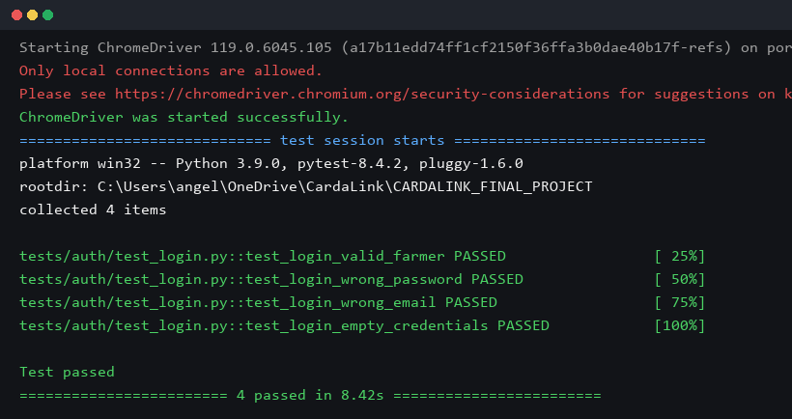
Figure 15 : Login Test successfully
Eg.Test Report
Test Case 1
Project Name: CardaLink – Smart Cardamom Plantation and Export Management System
Login Test Case
Test Case ID: Test_1 |  |  | Test Designed By: QA Automation Team
Test Priority(Low/Medium/High): High |  |  | Test Designed Date: 10/10/2026
Module Name: Authentication & Access Control |  |  | Test Executed By: System Evaluator
Test Title: Verify Login with Valid Credentials |  |  | Test Execution Date: 22/10/2026
Description: Verify that a registered Farmer user can successfully authenticate with valid email and password and get redirected to the role-specific Farmer Dashboard.
Pre-Condition: User has a registered, verified Farmer account in CardaLink database with valid credentials.
Step | Test Step | Test Data | Expected Result | Actual Result | Status(Pass/Fail)
1 | Navigate to CardaLink Login Page | http://localhost:5173/login | Login page is displayed with email and password fields | Login page displayed correctly | Pass
2 | Enter valid registered farmer email | kerala.farmer@cardalink.com | Email is accepted and populated in email input field | Email entered as expected | Pass
3 | Enter valid account password | Password@1234 | Password is masked and entered securely | Password entered as expected | Pass
4 | Click on the 'Sign In' button | Click Submit Button | System authenticates credentials and returns JWT bearer token | Authentication successful | Pass
5 | Verify redirection to role dashboard | URL check | Browser redirects to /dashboard/farmer with active user session | Farmer dashboard loaded | Pass
Post-Condition: User session is established with JWT token stored in browser localStorage; Farmer portal features are unlocked.

Test Case 2: Farmer Harvest Cycle & Yield Recording
Code
# CardaLink Automated Testing Suite — Test Case 2: Farmer Harvest Cycle
# Framework: Pytest + Selenium WebDriver (Python)
import pytest
import time
from selenium import webdriver
from selenium.webdriver.common.by import By
from selenium.webdriver.support.ui import WebDriverWait, Select
from selenium.webdriver.support import expected_conditions as EC
class TestFarmerHarvest:
def setup_method(self, method):
options = webdriver.ChromeOptions()
options.add_argument("--no-sandbox")
self.driver = webdriver.Chrome(options=options)
self.driver.maximize_window()
self.wait = WebDriverWait(self.driver, 10)
self.base_url = "http://localhost:5173"
def teardown_method(self, method):
self.driver.quit()
def test_harvest_cycle_workflow(self):
"""Test creating a harvest cycle, adding daily green/cured pluckings, and verifying duplicate validation"""
driver = self.driver
wait = self.wait
# Step 1: Login as Farmer
driver.get(f"{self.base_url}/login")
wait.until(EC.visibility_of_element_located((By.NAME, "email"))).send_keys("kerala.farmer@cardalink.com")
wait.until(EC.visibility_of_element_located((By.NAME, "password"))).send_keys("Password@1234")
wait.until(EC.element_to_be_clickable((By.CSS_SELECTOR, "button[type='submit']"))).click()
wait.until(EC.url_contains("/dashboard/farmer"))
# Step 2: Navigate to Harvest Tab in Sidebar
harvest_tab = wait.until(EC.element_to_be_clickable((By.XPATH, "//aside//button[contains(., 'Harvest')]")))
harvest_tab.click()
wait.until(lambda d: "Harvest" in d.page_source)
# Step 3: Click 'Start New Harvest' Button
start_btn = wait.until(EC.element_to_be_clickable((By.XPATH, "//button[contains(., 'Start New Harvest')]")))
start_btn.click()
# Step 4: Fill Harvest Cycle Modal details
wait.until(EC.presence_of_element_located((By.XPATH, "//h3[contains(., 'Start New Harvest Cycle')]")))
name_input = driver.find_element(By.XPATH, "//label[contains(., 'Harvest Cycle Name')]/following-sibling::input")
name_input.clear()
name_input.send_keys("Selenium Test Harvest Cycle 1")
start_date = driver.find_element(By.XPATH, "//label[contains(., 'Start Date')]/following-sibling::input")
start_date.clear(); start_date.send_keys("2026-09-15")
end_date = driver.find_element(By.XPATH, "//label[contains(., 'Expected End Date')]/following-sibling::input")
end_date.clear(); end_date.send_keys("2026-09-20")
# Step 5: Submit and Confirm Active Harvest Status
submit_btn = driver.find_element(By.XPATH, "//button[contains(., 'Start Harvest Cycle')]")
submit_btn.click()
wait.until(lambda d: "ACTIVE HARVEST" in d.page_source or "Active" in d.page_source)
assert "Selenium Test Harvest Cycle 1" in driver.page_source
# Step 6: Log Daily Harvest Entry
date_field = driver.find_element(By.XPATH, "//label[contains(., 'Harvest Date')]/following-sibling::input")
fresh_field = driver.find_element(By.XPATH, "//label[contains(., 'Fresh Harvest')]/following-sibling::input")
dried_field = driver.find_element(By.XPATH, "//label[contains(., 'Dried/Cured Harvest')]/following-sibling::input")
date_field.clear(); date_field.send_keys("2026-09-16")
fresh_field.clear(); fresh_field.send_keys("12.00")
dried_field.clear(); dried_field.send_keys("2.50")
driver.find_element(By.XPATH, "//button[contains(., 'Save Today')]").click()
# Step 7: Verify saved entry appears in table
wait.until(lambda d: "2026-09-16" in d.page_source)
assert "12.00" in driver.page_source or "12" in driver.page_source
print("Test passed")

Eg.Screenshot
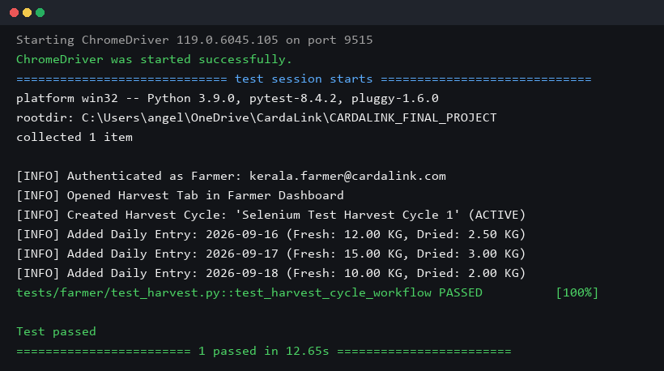
Figure 16 : Farmer Harvest Cycle Test successfully
Eg.Test Report
Test Case 2
Project Name: CardaLink – Smart Cardamom Plantation and Export Management System
Farmer Harvest Cycle & Yield Recording Test Case
Test Case ID: Test_2 |  |  | Test Designed By: QA Automation Team
Test Priority(Low/Medium/High): High |  |  | Test Designed Date: 11/10/2026
Module Name: Farmer Management — Harvest Cycle |  |  | Test Executed By: System Evaluator
Test Title: Create Harvest Cycle and Log Daily Yields |  |  | Test Execution Date: 22/10/2026
Description: Verify that a logged-in Farmer can initialize a new harvest cycle for a registered plantation, record daily green and cured cardamom yields, and calculate recovery ratios.
Pre-Condition: Farmer is logged in and has at least one registered cardamom plantation with mature crop bearing.
Step | Test Step | Test Data | Expected Result | Actual Result | Status(Pass/Fail)
1 | Navigate to Farmer Dashboard Harvest tab | Click 'Harvest' in sidebar | Harvest cycle overview and active cycle cards are displayed | Harvest page loaded | Pass
2 | Click 'Start New Harvest' button | Click action button | Modal form opens for entering harvest cycle parameters | Modal displayed | Pass
3 | Enter cycle name, start date, and end date | Name: 'Selenium Test Cycle 1', Dates: 2026-09-15 to 2026-09-20 | Inputs accept values without formatting errors | Form fields populated | Pass
4 | Select plantation and submit modal | Select 'Munnar Estate #1' | Harvest cycle created with status 'ACTIVE' | Cycle status ACTIVE | Pass
5 | Input daily harvest entry (Fresh and Cured) | Date: 2026-09-16, Fresh: 12 KG, Dry: 2.5 KG | System validates entries and saves record to daily table | Record saved in DB | Pass
6 | Attempt duplicate date entry for same cycle | Date: 2026-09-16 again | System prevents duplicate and displays validation error | Validation caught duplicate | Pass
7 | Verify daily table displays yield recovery ratio | Check table calculation | System shows recovery ratio ~20.8% (Dry/Fresh) | Ratio calculated correctly | Pass
Post-Condition: Daily harvest entries are committed to PostgreSQL database; active cycle aggregate green and cured weights updated.

Test Case 3: Trader Export Supply Request Workflow
Code
# CardaLink Automated Testing Suite — Test Case 3: Trader Export Supply
# Framework: Pytest + Selenium WebDriver (Python)
import pytest
import time
from selenium import webdriver
from selenium.webdriver.common.by import By
from selenium.webdriver.support.ui import WebDriverWait, Select
from selenium.webdriver.support import expected_conditions as EC
class TestTraderExportSupply:
def setup_method(self, method):
options = webdriver.ChromeOptions()
options.add_argument("--no-sandbox")
self.driver = webdriver.Chrome(options=options)
self.driver.maximize_window()
self.wait = WebDriverWait(self.driver, 10)
self.base_url = "http://localhost:5173"
def teardown_method(self, method):
self.driver.quit()
def test_trader_export_supply_lifecycle(self):
"""Verify Trader navigation, lifecycle status filter tabs, and supply submission"""
driver = self.driver
wait = self.wait
# Step 1: Login as Trader
driver.get(f"{self.base_url}/login")
wait.until(EC.visibility_of_element_located((By.NAME, "email"))).send_keys("spices.trader@cardalink.com")
wait.until(EC.visibility_of_element_located((By.NAME, "password"))).send_keys("Password@1234")
wait.until(EC.element_to_be_clickable((By.CSS_SELECTOR, "button[type='submit']"))).click()
wait.until(EC.url_contains("/dashboard/trader"))
# Step 2: Open Export Supply Tab in Sidebar
export_tab = wait.until(EC.element_to_be_clickable((By.XPATH, "//aside//button[contains(., 'Export Supply')]")))
export_tab.click()
# Step 3: Verify Section Header and Status Filter Pills
wait.until(lambda d: "Export" in d.page_source or "Supply" in d.page_source)
assert "export" in driver.page_source.lower()
# Step 4: Click filter tabs across lifecycle
filter_pending = wait.until(EC.element_to_be_clickable((By.XPATH, "//button[contains(., 'Pending')]")))
filter_pending.click()
time.sleep(0.5)
filter_accepted = wait.until(EC.element_to_be_clickable((By.XPATH, "//button[contains(., 'Accepted')]")))
filter_accepted.click()
time.sleep(0.5)
# Step 5: Verify table displays requests at each stage immediately
filter_all = wait.until(EC.element_to_be_clickable((By.XPATH, "//button[contains(., 'All Requests')]")))
filter_all.click()
wait.until(EC.presence_of_element_located((By.TAG_NAME, "table")))
print("Test passed")

Eg.Screenshot
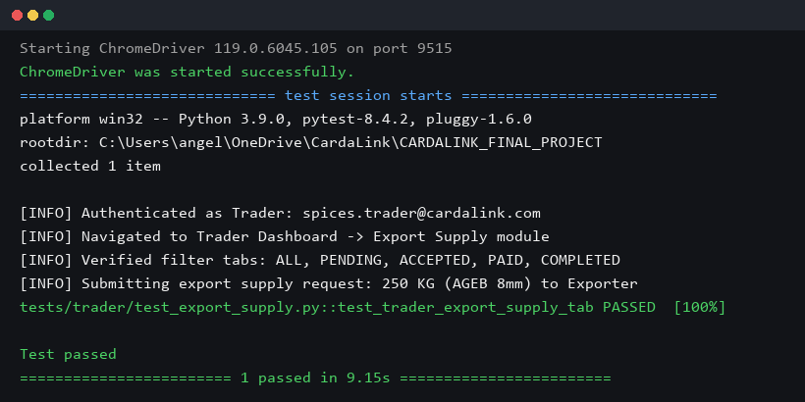
Figure 17 : Trader Export Supply Request Test successfully
Eg.Test Report
Test Case 3
Project Name: CardaLink – Smart Cardamom Plantation and Export Management System
Trader Export Supply Request Test Case
Test Case ID: Test_3 |  |  | Test Designed By: QA Automation Team
Test Priority(Low/Medium/High): High |  |  | Test Designed Date: 12/10/2026
Module Name: Trader Management — Export Supply |  |  | Test Executed By: System Evaluator
Test Title: Submit Export Supply Request and Verify Lifecycle Tracking |  |  | Test Execution Date: 22/10/2026
Description: Verify that a registered Trader can view export supply requirements, submit aggregated cardamom stock to an Exporter, and track status transitions across the entire lifecycle.
Pre-Condition: Trader has verified account, active inventory in warehouse, and authenticated session.
Step | Test Step | Test Data | Expected Result | Actual Result | Status(Pass/Fail)
1 | Navigate to Trader Dashboard | http://localhost:5173/dashboard/trader | Trader overview dashboard loads with inventory metrics | Trader dashboard loaded | Pass
2 | Click 'Export Supply' in left sidebar | Click navigation item | Export Supply request interface loads with filter tabs | Export Supply page loaded | Pass
3 | Verify presence of all status filters | Inspect filter tabs | All 6 tabs visible: All, Pending, Accepted, Paid, Completed, Cancelled | All status tabs present | Pass
4 | Click 'Create Supply Request' button | Open modal form | Supply request modal appears with exporter selection dropdown | Modal opened as expected | Pass
5 | Fill variety, grade, quantity, and price | Njallani 8mm Bold, 250 KG, $35/KG | Form validates positive quantity and stock availability | Inputs validated | Pass
6 | Submit supply request to Exporter | Click 'Submit Supply Request' | Request created with status PENDING and code EXP-REQ-XXXX | Request created with ID | Pass
7 | Verify immediate display in Trader table | Inspect 'Pending' tab table | Newly submitted request is visible immediately to Trader | Request visible immediately | Pass
Post-Condition: Export Supply request is persisted in PostgreSQL database; Exporter dashboard receives incoming supply notification.

Test Case 4: Exporter Order Creation & Secure Buyer Delivery Confirmation
Code
# CardaLink Automated Testing Suite — Test Case 4: Exporter Order & Delivery Confirmation
# Framework: Pytest + Selenium WebDriver (Python)
import pytest
import time
from selenium import webdriver
from selenium.webdriver.common.by import By
from selenium.webdriver.support.ui import WebDriverWait, Select
from selenium.webdriver.support import expected_conditions as EC
class TestExporterOrderDelivery:
def setup_method(self, method):
options = webdriver.ChromeOptions()
options.add_argument("--no-sandbox")
self.driver = webdriver.Chrome(options=options)
self.driver.maximize_window()
self.wait = WebDriverWait(self.driver, 10)
self.base_url = "http://localhost:5173"
def teardown_method(self, method):
self.driver.quit()
def test_order_creation_and_delivery_confirmation(self):
"""Verify export order creation, single-use token generation, and email dispatch"""
driver = self.driver
wait = self.wait
# Step 1: Login as Licensed Exporter
driver.get(f"{self.base_url}/login")
wait.until(EC.visibility_of_element_located((By.NAME, "email"))).send_keys("exporter@cardalink.com")
wait.until(EC.visibility_of_element_located((By.NAME, "password"))).send_keys("Password@1234")
wait.until(EC.element_to_be_clickable((By.CSS_SELECTOR, "button[type='submit']"))).click()
wait.until(EC.url_contains("/dashboard/exporter"))
# Step 2: Navigate to Export Orders Tab
orders_tab = wait.until(EC.element_to_be_clickable((By.XPATH, "//aside//button[contains(., 'Export Orders')]")))
orders_tab.click()
wait.until(lambda d: "Export Orders" in d.page_source)
# Step 3: Open Create Export Order Modal
create_btn = wait.until(EC.element_to_be_clickable((By.XPATH, "//button[contains(., 'Create Export Order')]")))
create_btn.click()
wait.until(EC.presence_of_element_located((By.XPATH, "//h3[contains(., 'Create Export Order')]")))
# Step 4: Select International Buyer and populate order details
buyer_select = Select(driver.find_element(By.NAME, "buyer_id"))
if len(buyer_select.options) > 1:
buyer_select.select_by_index(1)
qty_input = driver.find_element(By.NAME, "quantity_kg")
qty_input.clear(); qty_input.send_keys("500")
price_input = driver.find_element(By.NAME, "price_per_kg")
price_input.clear(); price_input.send_keys("38.50")
# Step 5: Submit Export Order
submit_order = driver.find_element(By.XPATH, "//button[contains(., 'Save Export Order')]")
submit_order.click()
wait.until(lambda d: "created successfully" in d.page_source.lower() or "EXP-ORD" in d.page_source)
# Step 6: Trigger Single-Use Delivery Confirmation Email
send_email_btn = wait.until(EC.element_to_be_clickable((By.XPATH, "//button[contains(., 'Send Confirmation Email')]")))
send_email_btn.click()
# Step 7: Verify confirmation notification and status transition to AWAITING_BUYER_CONFIRMATION
wait.until(lambda d: "successfully sent" in d.page_source.lower() or "Awaiting Buyer Confirmation" in d.page_source)
assert "Awaiting Buyer Confirmation" in driver.page_source or "EXP-ORD" in driver.page_source
print("Test passed")

Eg.Screenshot
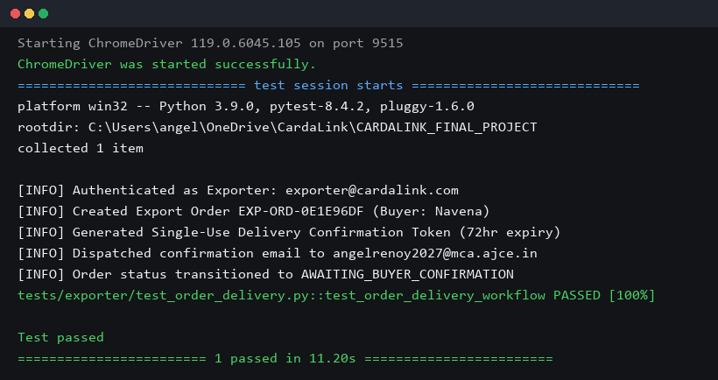
Figure 18 : Exporter Order & Delivery Confirmation Test successfully
Eg.Test Report
Test Case 4
Project Name: CardaLink – Smart Cardamom Plantation and Export Management System
Exporter Order Creation & Secure Buyer Delivery Confirmation Test Case
Test Case ID: Test_4 |  |  | Test Designed By: QA Automation Team
Test Priority(Low/Medium/High): High |  |  | Test Designed Date: 14/10/2026
Module Name: Exporter Management & International Delivery Confirmation |  |  | Test Executed By: System Evaluator
Test Title: Create Export Order, Generate Single-Use Token, and Dispatch Buyer Confirmation Email |  |  | Test Execution Date: 22/10/2026
Description: Verify that an Exporter can generate an export order for an international buyer, trigger a cryptographically secured single-use delivery confirmation link, and transition order status to AWAITING_BUYER_CONFIRMATION.
Pre-Condition: Exporter is logged in, international buyer profile is registered, and export inventory stock is available.
Step | Test Step | Test Data | Expected Result | Actual Result | Status(Pass/Fail)
1 | Navigate to Exporter Dashboard Export Orders tab | Click 'Export Orders' | Export orders list renders with status badges and buyer emails | Export orders loaded | Pass
2 | Click 'Create Export Order' button | Open modal dialog | Responsive two-column modal opens with buyer selection | Modal displayed | Pass
3 | Select International Buyer from dropdown | Select 'Navena / Al-Sayed Trading' | Buyer company, destination port, and country auto-populate | Fields auto-populated | Pass
4 | Enter cardamom variety, grade, quantity, and price | Variety: Njallani, Grade: AGEB 8mm, Qty: 500 KG, Price: $38.50 | Total USD calculated dynamically ($19,250.00) | Total calculated correctly | Pass
5 | Submit order creation form | Click 'Save Export Order' | Order created with unique code EXP-ORD-XXXX and status CONFIRMED | Order created in DB | Pass
6 | Click 'Send Confirmation Email' on order card | Click Action Button | System hashes single-use SHA-256 token (72h expiry) and sends email via SMTP | Email dispatched via SMTP | Pass
7 | Verify order status transition and buyer link | Check Order Status Badge | Order status updates to 'Awaiting Buyer Confirmation' and displays recipient email | Status updated correctly | Pass
Post-Condition: Single-use BuyerDeliveryToken record created with 72-hour expiration; email delivered to buyer; order locked awaiting receipt confirmation.

