CHAPTER 4
SYSTEM DESIGN
4.1 INTRODUCTION
The design phase is a crucial stage in the development of the CardaLink – Smart Cardamom Plantation and Export Management System, as it lays the foundation for an efficient, traceable, and user-friendly platform. A well-structured design ensures smooth functionality, optimized performance, and a seamless user experience across the agricultural, procurement, and international export supply chain. This phase involves defining the system architecture, database structure, user interface, and integration of various components, such as plantation management, harvest tracking, agrochemical usage logs, domestic marketplace trading, purchase requests, international export contracts, laboratory quality grading, packaging records, regulatory documentation, freight logistics, and secure delivery confirmation. The design process translates user requirements into a detailed technical blueprint, enabling developers to implement a robust, secure, and scalable solution. By prioritizing usability, traceability, and responsiveness, the system is crafted to enhance both farmer livelihoods and export efficiency, making spice trading transparent and reliable.
4.2 UML DIAGRAM
A standardized language called Unified Modeling Language (UML) is utilized to conceptualize, characterize, plan, and depict software-intensive system architectures. The Object Management Group (OMG) was responsible for creating UML, establishing an international industry standard for software visualization. UML provides a nonexclusive visual modeling syntax utilized for computer software systems and a pictorial language utilized for software outlines. It enables developers, business stakeholders, and system architects to analyze both structural and behavioral views of an enterprise application. The eight UML diagrams modeled for CardaLink are:
- Class diagram
- Object diagram
- Use case diagram
- Sequence diagram
- Activity diagram
- State chart diagram
- Component diagram
- Deployment diagram

4.2.1 Use Case Diagram
A use case diagram is a graphical representation that illustrates how users and external entities interact with a system. It helps identify, outline, and organize the system's functional requirements from a user’s perspective. Built using the Unified Modeling Language (UML), use case diagrams define system boundaries, actors (users or external systems), use cases (specific actions or functionalities), and their relationships. They are essential for understanding system behavior, verifying requirements, testing, and providing customer support. To create an effective use case diagram, it is important to use clear naming conventions, accurately depict actor roles, highlight essential functionalities, and avoid unnecessary complexity. Following these principles ensures a well-structured diagram that effectively communicates the system's core functionalities.
In CardaLink, the system boundary encompasses five primary actors who interact with the dedicated subsystems:
- • Farmer: Registers plantations, logs agrochemical applications and irrigation operations, records daily fresh and cured dry yields, lists lots on the domestic marketplace, and confirms physical stock handover.
- • Trader: Browses domestic marketplace listings, submits purchase procurement requests, settles payments (Razorpay or direct cash), confirms pickup, manages warehouse inventory, and fulfills exporter supply requests.
- • Exporter: Manages international buyer profiles (CRM), creates export contracts, allocates stock batches, initiates laboratory quality testing, oversees vacuum packaging, uploads export clearance documents, dispatches freight shipments, and sends delivery confirmation tokens.
- • International Buyer: Receives automated tokenized email links, accesses the delivery portal, reviews order details, and submits digital delivery condition confirmations or disputes.
- • Admin: Oversees user account verification and role approvals, audits system transaction ledgers, and configures standard cardamom varieties and grades.
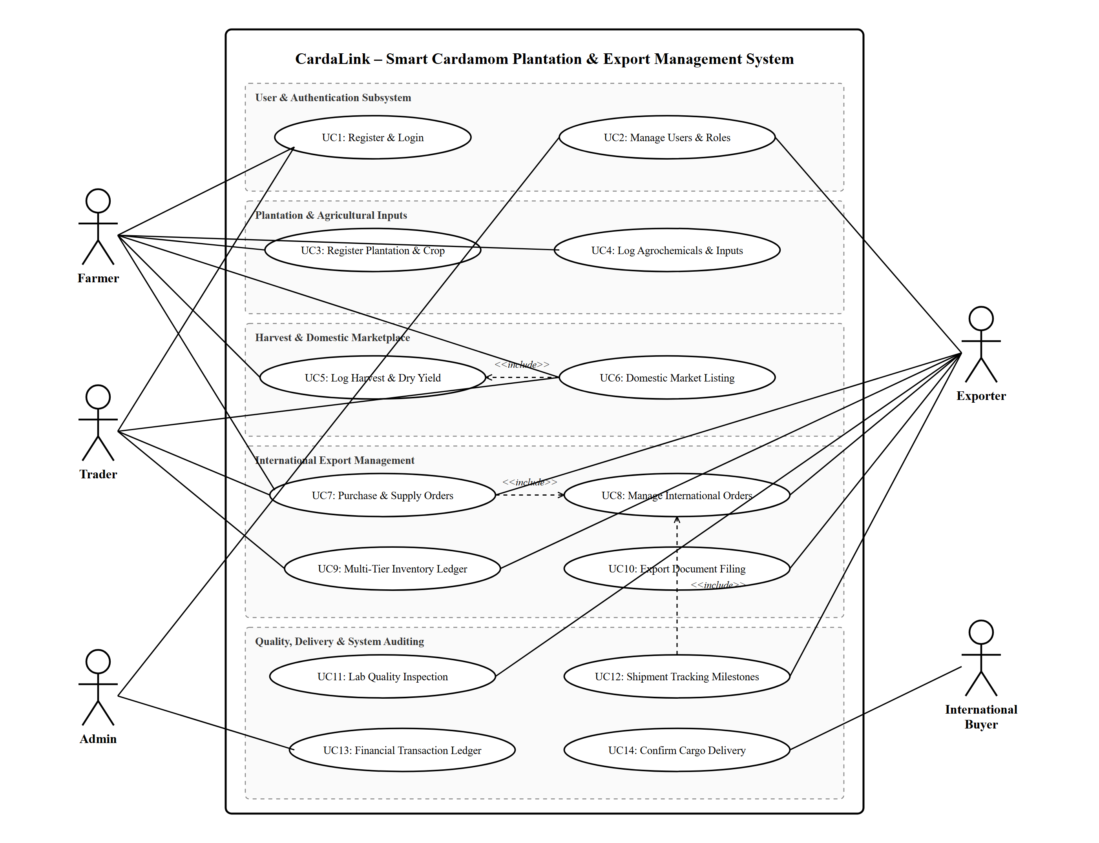
Figure 1 : Use case diagram for CardaLink

4.2.2 Sequence Diagram
A sequence diagram is a type of interaction diagram that depicts the chronological flow of messages between system components. It helps visualize object interactions, understand system requirements, and detect potential issues. Key elements include actors (external users or systems), lifelines (vertical dashed lines representing an object’s lifespan), messages (interactions between objects), and guards (conditions that control message flow). Sequence diagrams are used to model complex processes, illustrate use case details, and analyze system functionality. They aid both developers and business professionals in understanding and refining system behavior effectively.
Uses of sequence diagram:
- Modeling and visualizing the logic of complex functions, operations, or procedures.
- Showing details of UML use case diagrams across multi-tier application layers.
- Understanding the detailed functionality of current or future systems.
- Visualizing how messages and tasks move between objects or components in a system.
- Overall, sequence diagrams are useful for representing the flow of interactions.
In CardaLink, the sequence diagram models the end-to-end lifecycle across four distinct operational phases: (1) Harvest logging and marketplace listing by the Farmer; (2) Domestic procurement, payment settlement, and physical handover by the Trader; (3) International export order execution, lab quality certification, and document filing by the Exporter; and (4) Freight shipment tracking and tokenized digital delivery confirmation by the International Buyer.
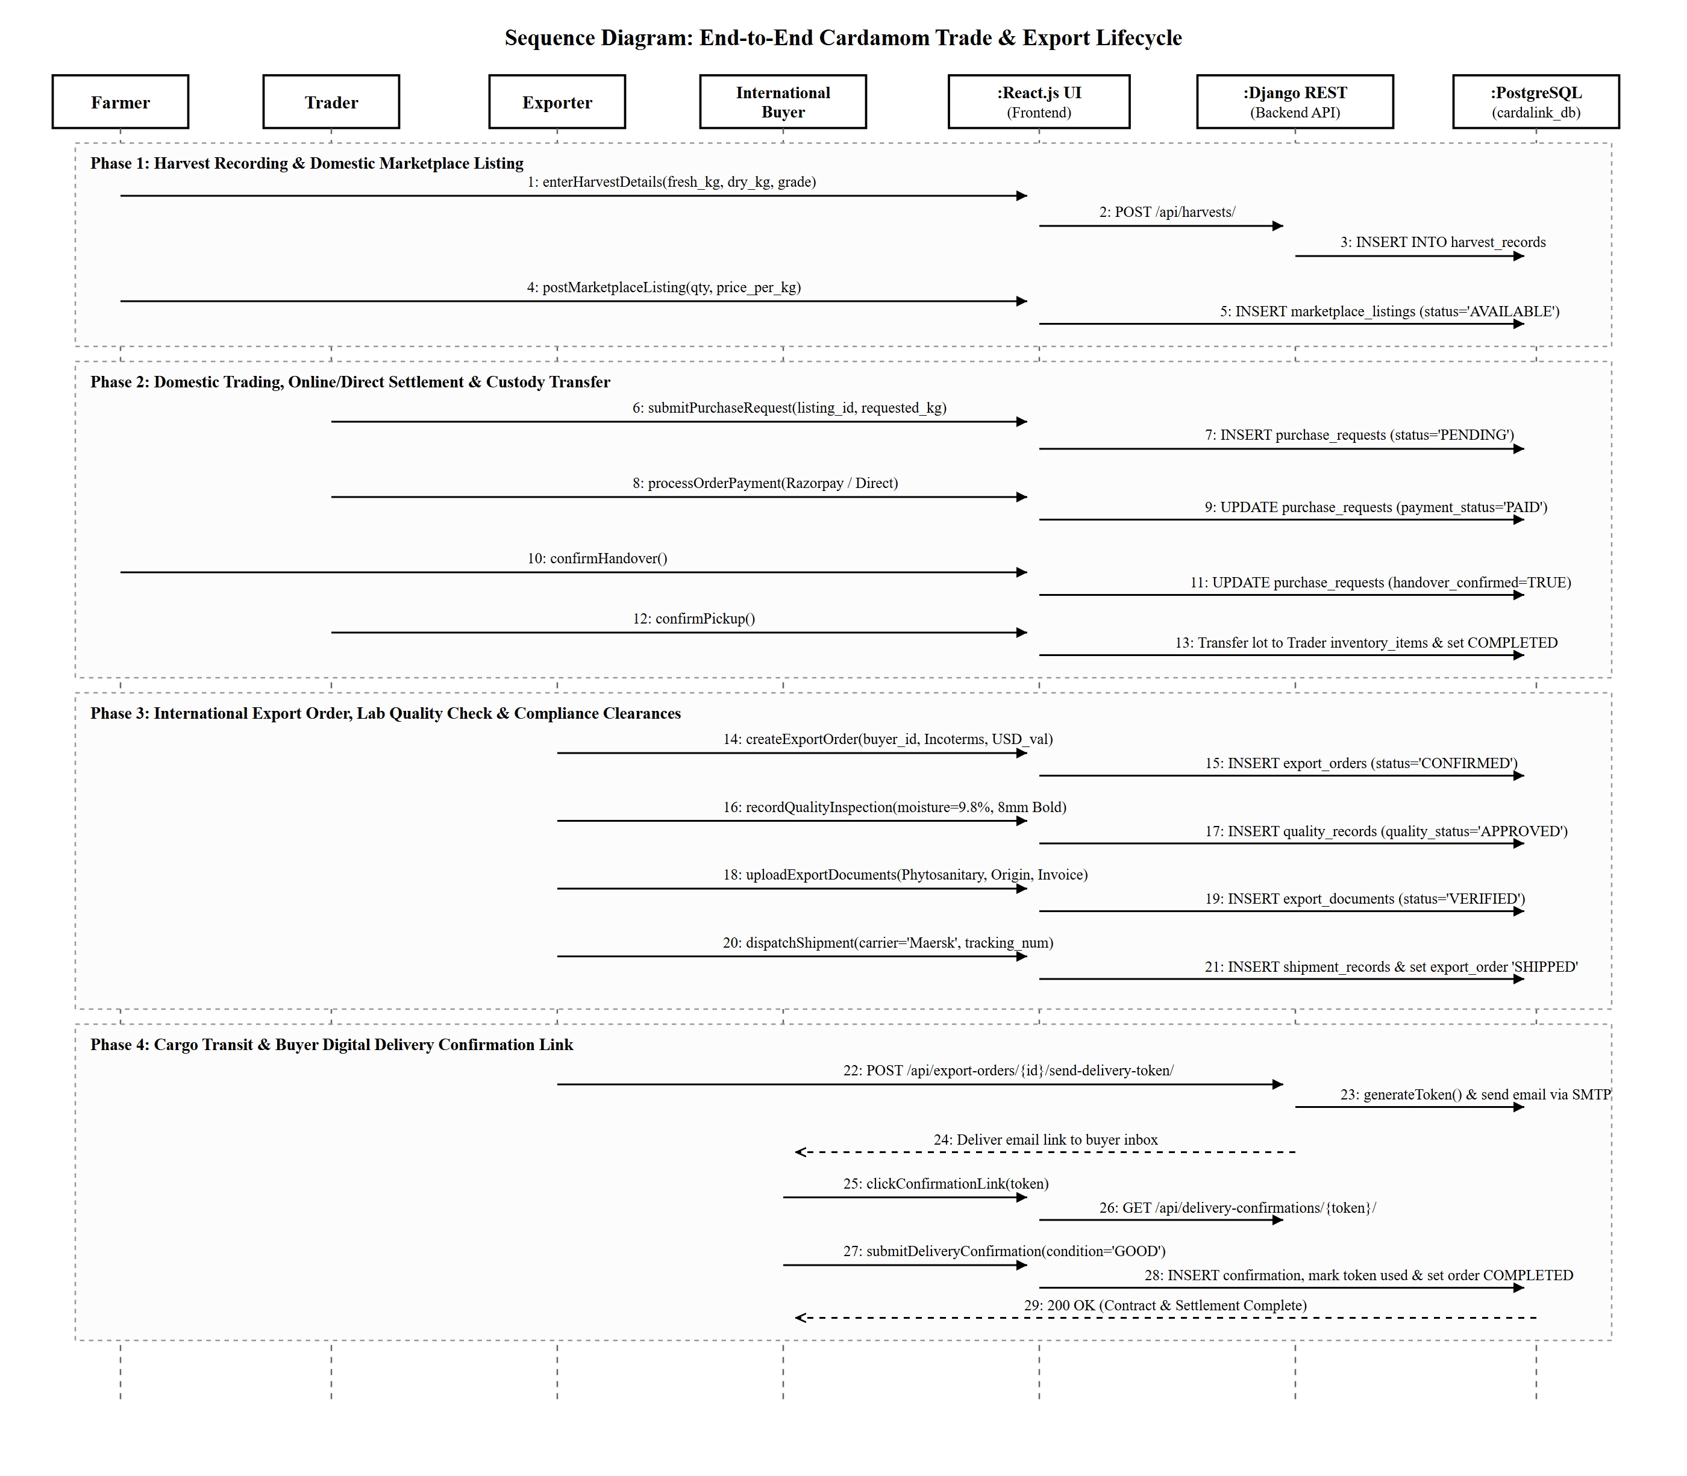
Figure 2 : Sequence diagram for CardaLink

4.2.3 State Chart Diagram
A State Chart Diagram is a UML behavioral diagram that represents the various states an object or system can be in and how it transitions between them. It consists of key elements like the Initial State (starting point), State (current condition of an object), Transition (movement between states), Event and Action (triggers and responses), Signal (messages causing transitions), and the Final State (end of the process). State diagrams help visualize system behavior over time, making them useful for modeling dynamic systems and workflow processes.
In CardaLink, the State Chart Diagram models the lifecycle of an Export Order (tbl_export_orders), strictly capturing the verified statuses supported by the Django backend and UI:
- • DRAFT: Initial contract entered by the exporter with target buyer, cardamom variety, quantity, Incoterms, and destination port.
- • CONFIRMED: Export contract legally finalized and linked with an allocated inventory batch.
- • QUALITY_CHECK: Laboratory testing in progress evaluating moisture percentage (<= 11%) and pod diameter (>= 8mm Bold).
- • QUALITY_APPROVED / QUALITY_REJECTED: Official determination outcome based on statutory Spices Board standards.
- • PACKAGING: Vacuum sealing into aroma-retentive food-grade packages with tamper-evident seals.
- • DOCUMENTS_PENDING: Preparation and verification of Phytosanitary, Origin, and Shipping documentation.
- • READY_FOR_SHIPMENT: Cargo cleared and staged at the departure port terminal.
- • SHIPPED & IN_TRANSIT: Freight vessel or flight departed with active tracking number and carrier logistics.
- • ARRIVED: Consignment docked at destination port terminal undergoing import customs clearance.
- • AWAITING_BUYER_CONFIRMATION: Automated 72-hour secure token link dispatched to buyer's verified email.
- • DELIVERED & COMPLETED: Buyer acknowledges cargo receipt in good condition (or resolves dispute), finalizing the financial ledger.
- • CANCELLED: Terminal cancellation state resulting from irrecoverable quality failures or mutual agreement.
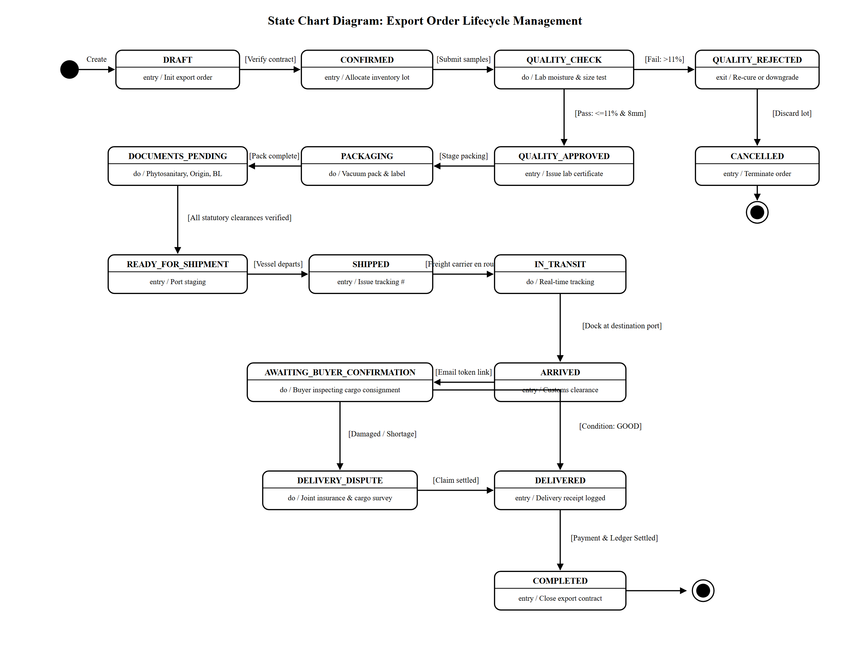
Figure 3 : State Chart diagram for CardaLink

4.2.4 Activity Diagram
An activity diagram is a visual representation of a workflow that shows how one activity leads to another. An activity is referred to as a system operation, and one operation leads to another in the control flow. A flow can be parallel, concurrent, or branched, and activity diagrams use various functions such as branching, joining, etc., to manage all types of flow control. Activity diagrams are a type of behavior diagram that shows the behavior of a system. They show the flow of control from the start point to the end point and show the different decision paths that exist during the execution of the activity.
The key components of an activity diagram are:
- Initial node: A starting point of the activity diagram, denoted by a black circle.
- Activity: A task or action performed by the system or entity, represented by a rectangle with rounded corners.
- Control flow: It represents the sequence of activities or actions performed by the system or entity, represented by an arrow.
- Decision node: A decision or branching point in the activity flow, denoted by a diamond shape.
- Merge node: Used to merge multiple branches of the activity flow into a single flow, represented by a diamond shape with a plus sign inside.
- Fork node: Used to split the activity flow into multiple parallel flows, represented by a solid black circle with multiple arrows.
- Join node: Used to join multiple parallel flows back into a single flow, represented by a solid black circle with multiple arrows pointing towards it.
- Final node: The end point of the activity diagram, denoted by a black circle with a dot inside.
- Object flow: Represents the flow of objects or data between activities, represented by a dashed arrow.
In CardaLink, the activity diagram is structured across five swimlanes: Farmer (Production), Trader (Procurement), Exporter (Contracts), Quality & Compliance, and Logistics & Overseas Buyer, illustrating the entire supply chain from capsule picking to final delivery settlement.
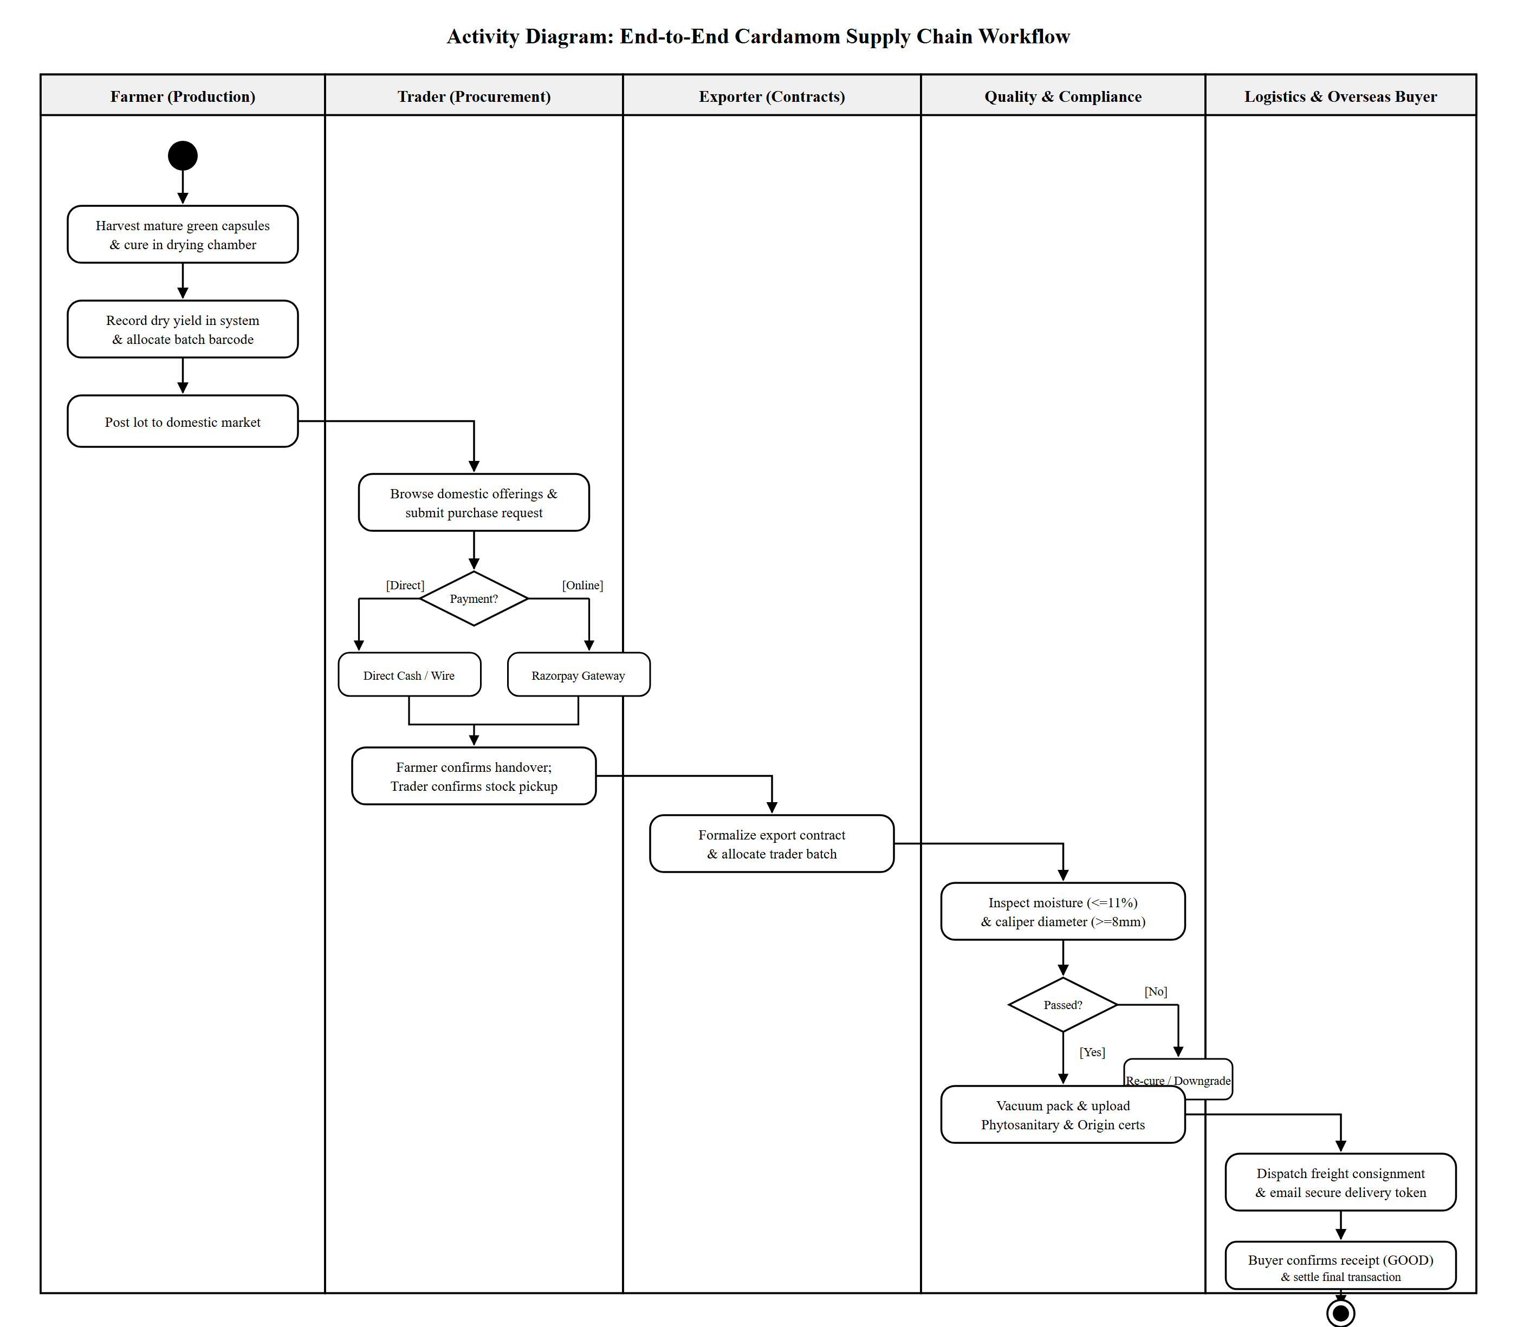
Figure 4 : Activity diagram for CardaLink

4.2.5 Class Diagram
A Class Diagram is a key UML component used in object-oriented modeling to represent the structure of an application. It defines classes, objects, interfaces, and relationships such as association, aggregation, composition, inheritance, dependency, and multiplicity. Classes are depicted as rectangles containing attributes and methods, while interfaces define abstract methods. Relationships like aggregation (whole-part), composition (stronger whole-part), and inheritance (is-a hierarchy) establish connections between classes. Class diagrams provide a conceptual and detailed view of system structure, making them essential for both software development and data modeling.
Important Components of a Class Diagram:
- Class: A blueprint for objects, represented as a rectangle with a class name, attributes, and methods.
- Interface: Defines abstract methods, represented as a circle with the interface name.
- Object: An instance of a class with state and behavior, shown as a rectangle.
- Association: A link between two classes, depicted as a line with optional direction and multiplicity.
- Aggregation: A part-whole relationship, shown with a hollow diamond at the whole side.
- Composition: A stronger part-whole relationship, represented with a filled diamond.
- Inheritance: An 'is-a' relationship between superclass and subclass, marked by an open arrow.
- Dependency: One class depends on another, shown with a dashed arrow.
In CardaLink, the class diagram represents the core Django ORM models from backend/iam/models.py, detailing entity attributes, primary/foreign key constraints, methods, and multiplicities connecting users, plantations, harvests, inventory items, marketplace listings, procurement orders, international buyers, export contracts, quality test records, regulatory documents, shipment tracking, and digital delivery confirmations.
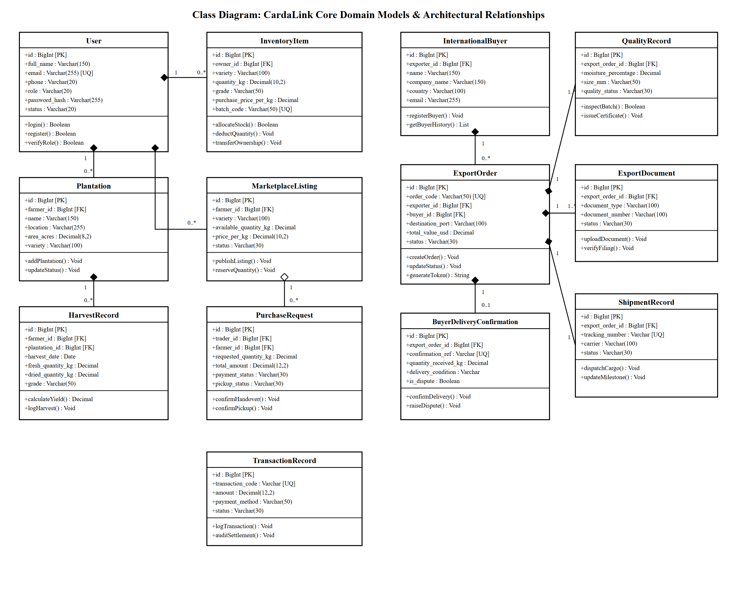
Figure 5 : Class diagram for CardaLink

4.2.6 Object Diagram
Class diagrams and object diagrams are closely related in object-oriented modeling. Object diagrams are instances of class diagrams, which represent a snapshot of the system at a given moment in time. Both types of diagrams use the same concepts and notation to represent the structure of a system. While class diagrams are used to model the structure of the system, including its classes, attributes, and methods, object diagrams represent a group of objects and their connections at a specific point in time. An object diagram is a type of structural diagram in UML that shows instances of classes and their relationships.
Key Components of an Object Diagram:
- Object: An instance of a class representing a specific entity, shown as a rectangle with an underlined name:Type.
- Class: A template for objects with attributes and methods, represented as a three-part rectangle.
- Link: A relationship between objects, depicted as a line connecting instance boxes.
- Attribute: A property defining an object's state, shown as a name-value pair.
- Value: A specific instance of an attribute assigned during runtime execution.
- Operation: An action an object can perform, listed inside the class rectangle.
- Multiplicity: Defines the number of instances in a relationship.
In CardaLink, the object diagram captures a concrete execution snapshot using realistic, fictional sample data: farmer Ramesh Kumar harvesting 250 KG of fresh cardamom from Highland Green Valley Estate, listing 50 KG of cured 8mm Bold cardamom on the marketplace, which is purchased and verified by trader Suresh V., transferred to exporter George Thomas, allocated to an international contract for Dubai-based buyer Gulf Spices Trading LLC, certified by quality inspector Dr. K. S. Nair, and transported aboard Maersk Sealand vessel MAEU-98214710.
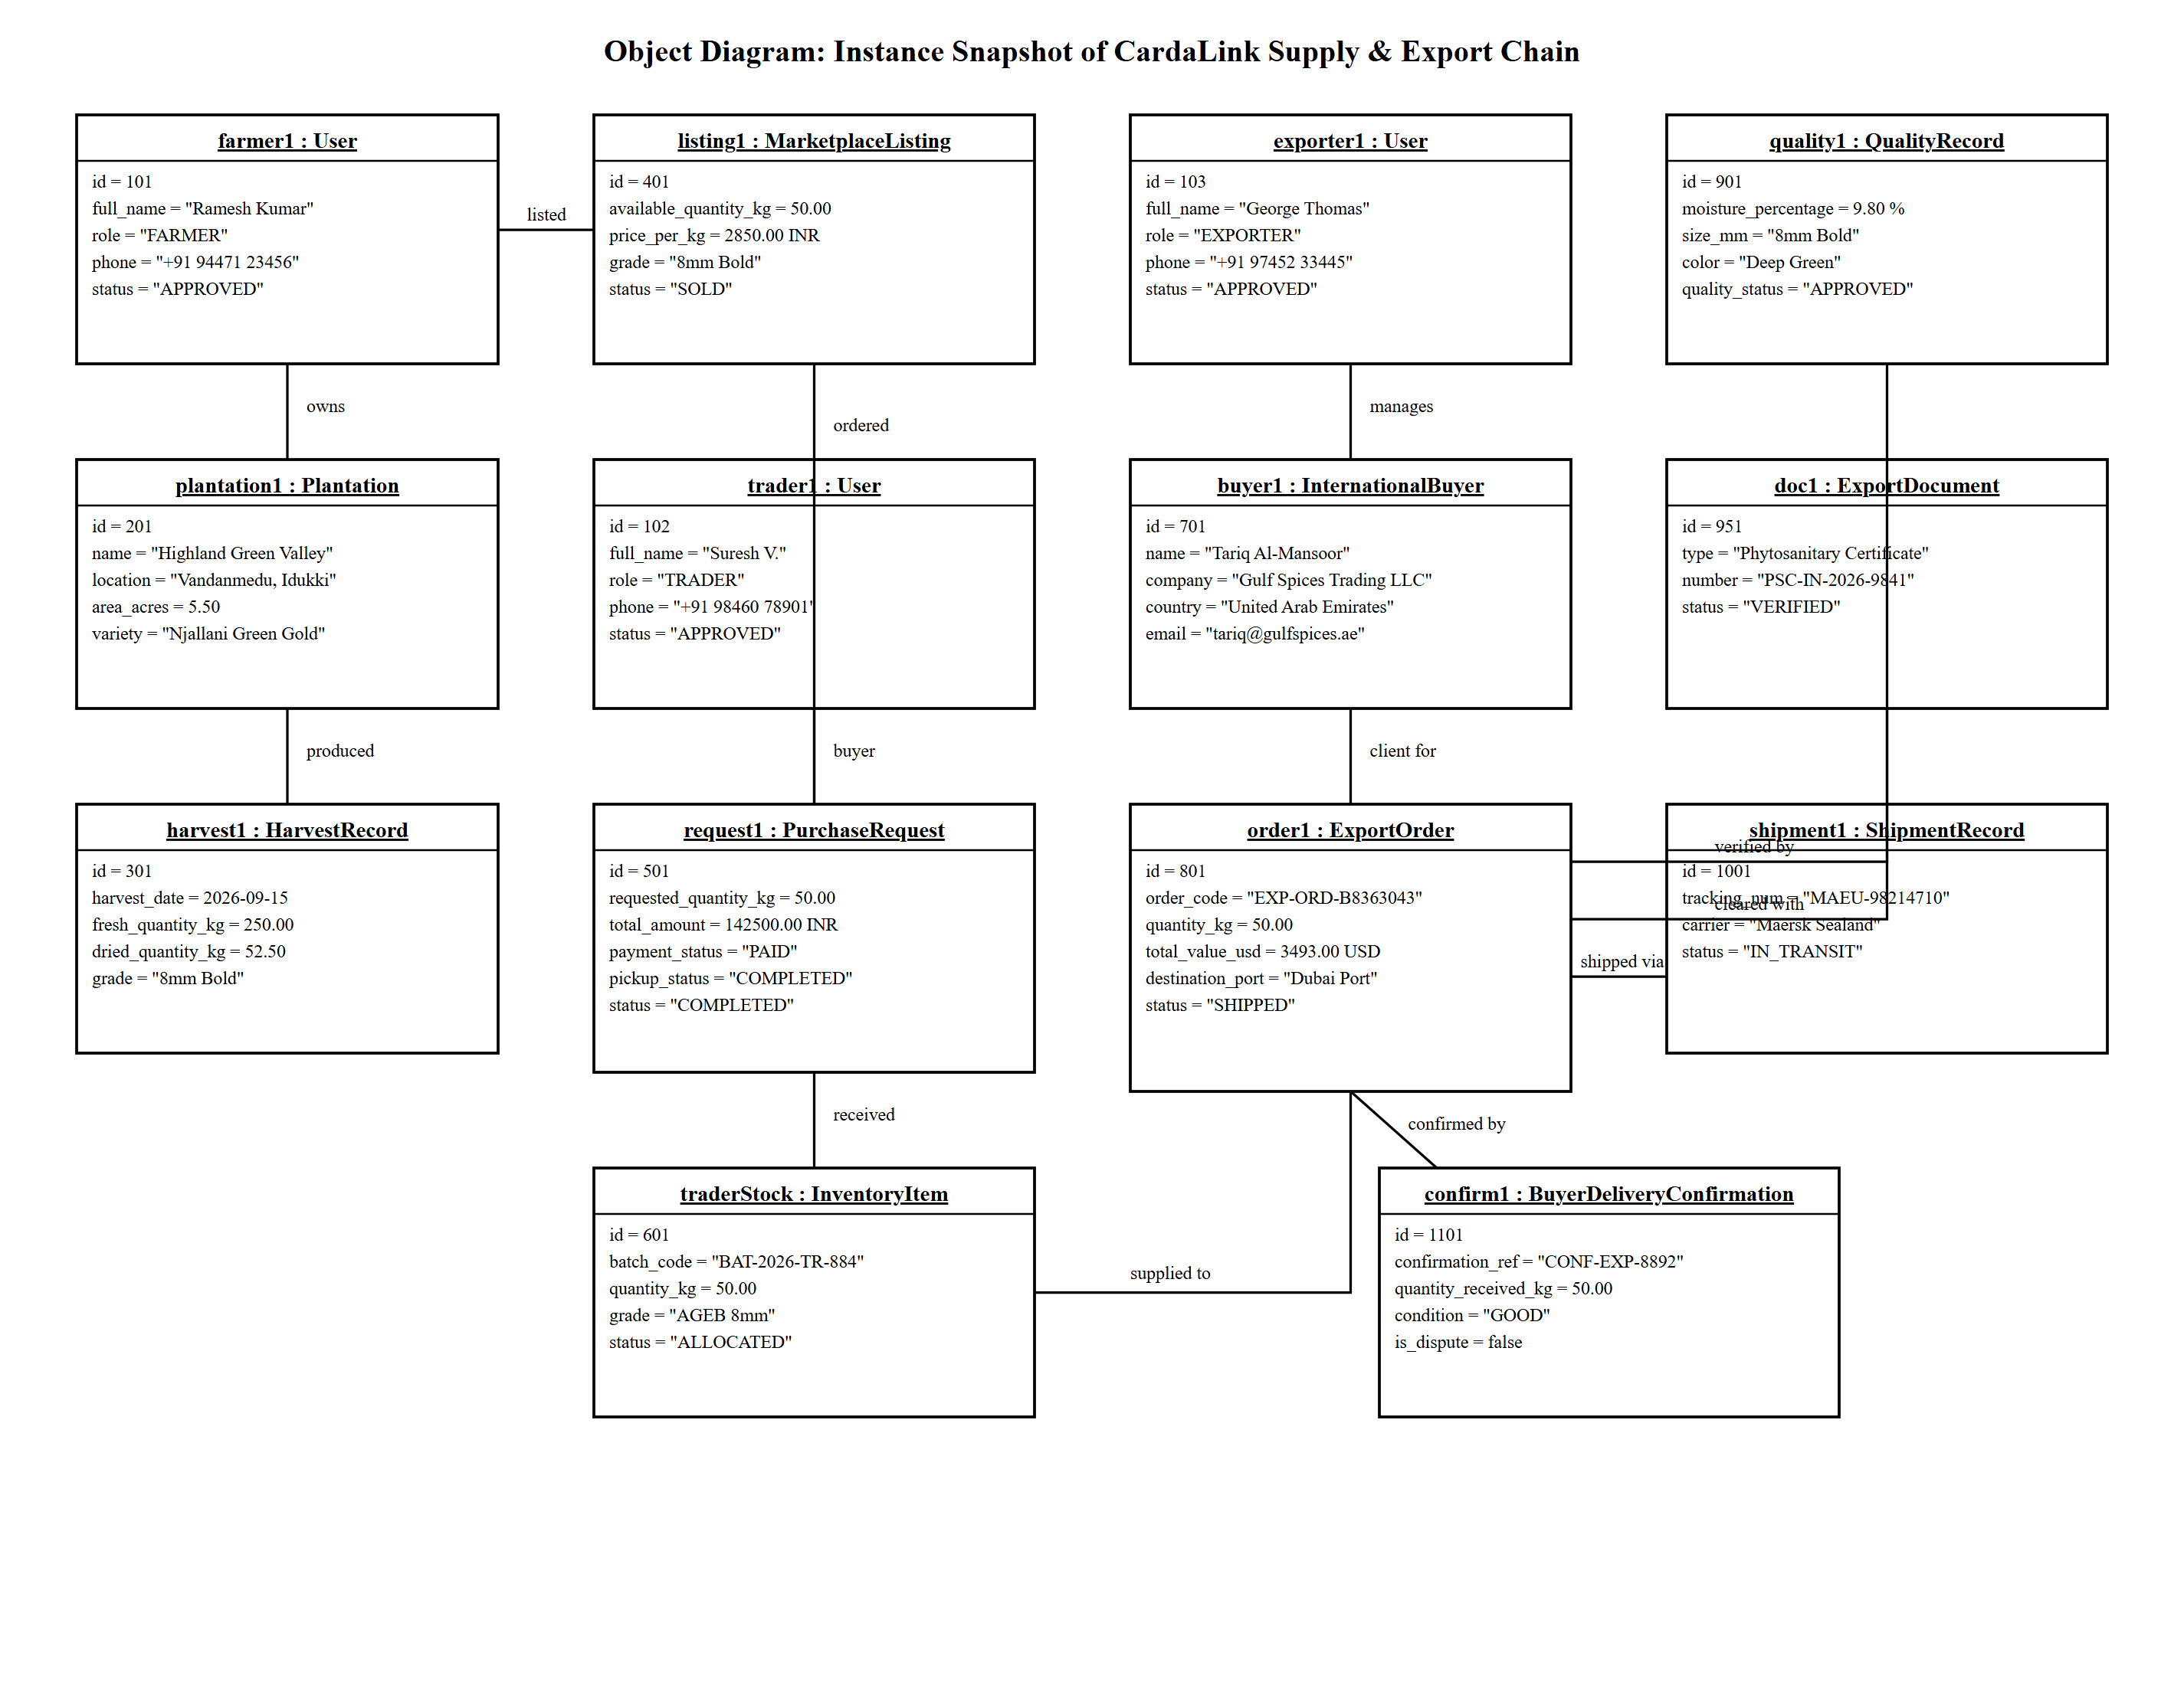
Figure 6 : Object diagram for CardaLink

4.2.7 Component Diagram
A component diagram in UML illustrates how various components are interconnected to create larger components or software systems. It is an effective tool for representing the structure of complex systems with multiple components. By using component diagrams, developers can easily visualize the internal structure of a software system and understand how different components work together to accomplish a specific task.
Key Components of a Component Diagram:
- Component: A modular unit with defined functionality, shown as a rectangle with the component icon or stereotype.
- Interface: A set of accessible methods, represented as a circle or formal interface port.
- Port: A connection point for interactions, shown as a small square.
- Connector: A link enabling communication, depicted as a solid line.
- Dependency: A relationship where one component relies on another, shown as a dashed arrow.
- Association: A connection between components, represented as a line.
In CardaLink, the component diagram illustrates the three-tier software architecture: the React.js client presentation tier (Role Dashboards, Router, and Buyer Confirmation UI communicating via Axios), the Django REST Framework backend application tier (API Gateway, JWT Middleware, Controllers, Serializers, and Delivery Engine), the PostgreSQL relational database store (cardalink_db), and external integrations (Google OAuth 2.0, Razorpay Gateway, and SMTP Mail Relay).
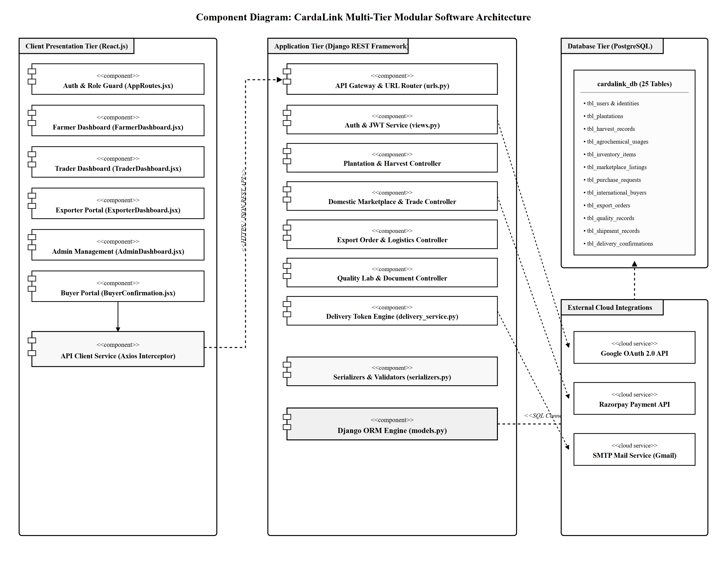
Figure 7 : Component diagram for CardaLink

4.2.8 Deployment Diagram
A deployment diagram is a type of UML diagram that focuses on the physical hardware used to deploy software. It provides a static view of a system's deployment and involves nodes and their relationships. The deployment diagram maps the software architecture to the physical system architecture, showing how the software will be executed on nodes. Communication paths are used to illustrate the relationships between the nodes. Unlike other UML diagram types, which focus on the logical components of a system, the deployment diagram emphasizes the hardware topology.
Key Components of a Deployment Diagram:
- Node: A physical or virtual machine hosting components, shown as a 3D box.
- Component: A software element providing functionality, represented as a rectangle.
- Artifact: A physical data piece used or produced by a component (e.g., build bundle, schema file).
- Deployment Specification: Details how a component or artifact is deployed, including location and configuration.
- Association: A relationship between nodes and components, shown as a connecting line.
- Communication Path: A network or communication link between nodes, represented by a labeled line indicating protocol and port.
In CardaLink, the deployment diagram models the production hosting topology: Client Web Browsers accessing the React.js SPA hosted on the Vercel Global Edge Network via HTTPS (Port 443), connecting to the Python/Django REST API hosted in an Ubuntu Linux container on the Render Cloud Platform, which queries the Render Managed PostgreSQL Database over an SSL-encrypted connection (TCP Port 5432), with external cloud connections to Google Identity Services, Razorpay Cloud API, and SMTP Mail Gateway.
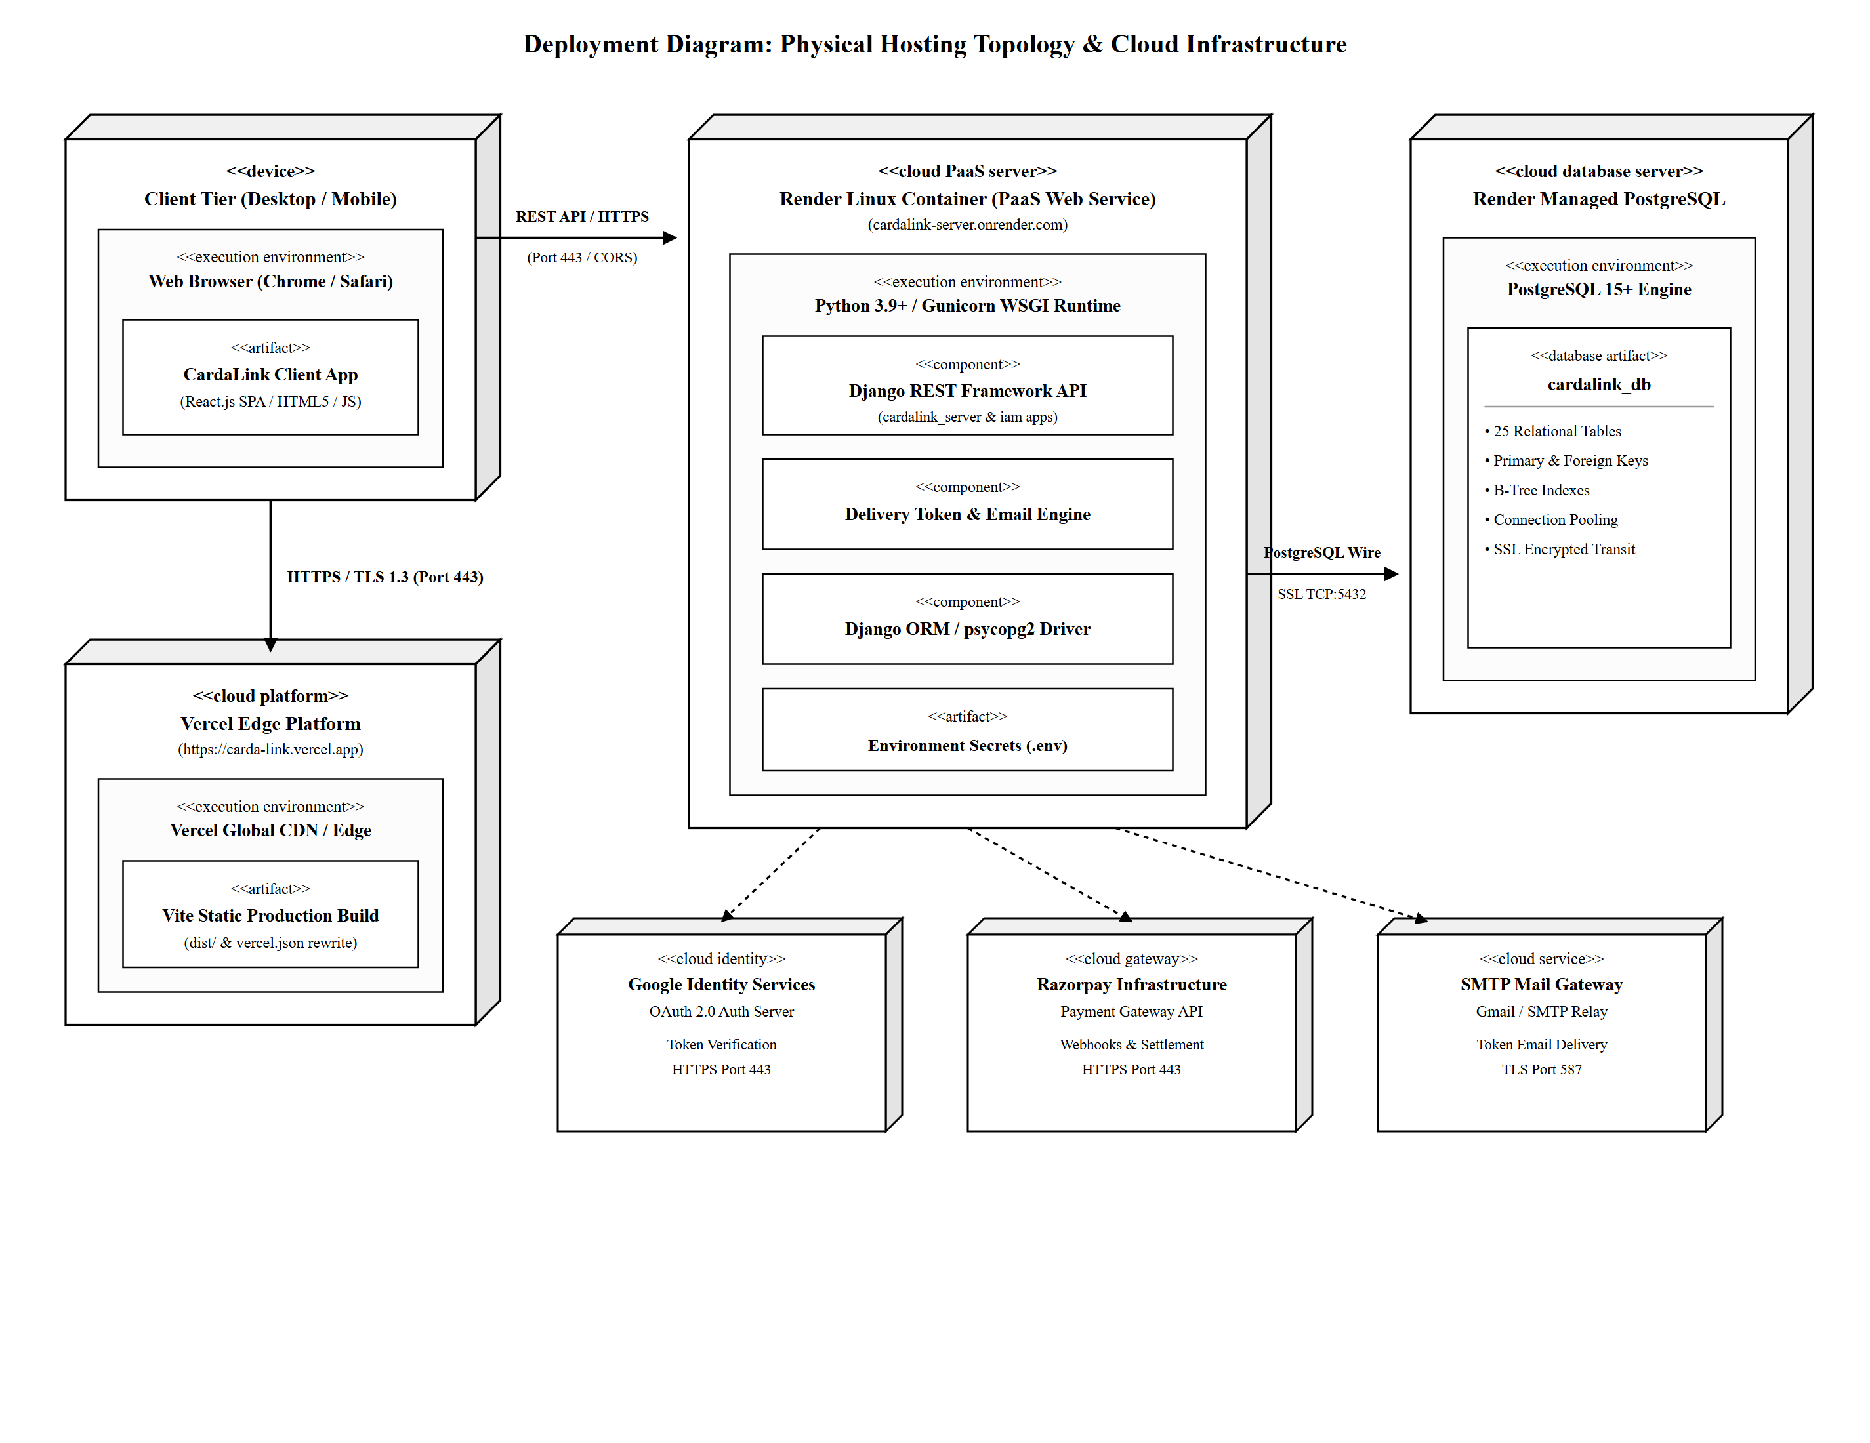
Figure 8 : Deployment diagram for CardaLink

