AWS IAM PROJECT

Title: Design and Implement AWS IAM for a Medium-Sized Organization
Organization: AdescoTechHub Ltd.
Submitted By: Angel
Course: AWS IAM
Date: June 2026

“AdescoTechHub Ltd. is migrating its infrastructure to AWS”.

In AdescoTechHub, we have various departments which are:
Management
Developers
Network Administrators
Security Team
Interns

The IAM Users and the departments they belong to:
USERS | DEPARTMENTS
OJO | Management
MARIAN | Developer
OMA | Network Administrator
Angel | Security Team
Chinaza | Interns

TASK 1: Creation of IAM Groups
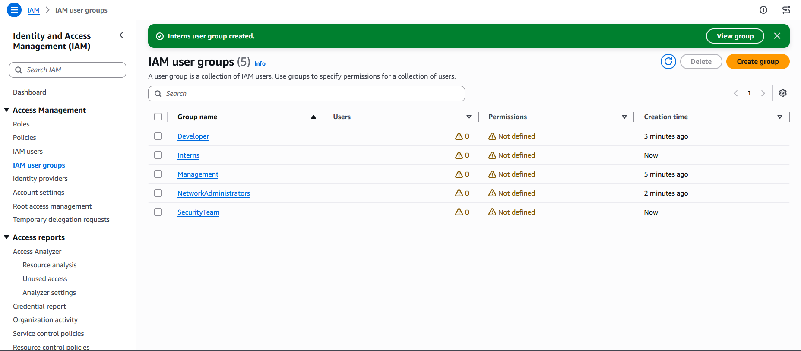

TASK 2: Creation of IAM Users and their respective groups
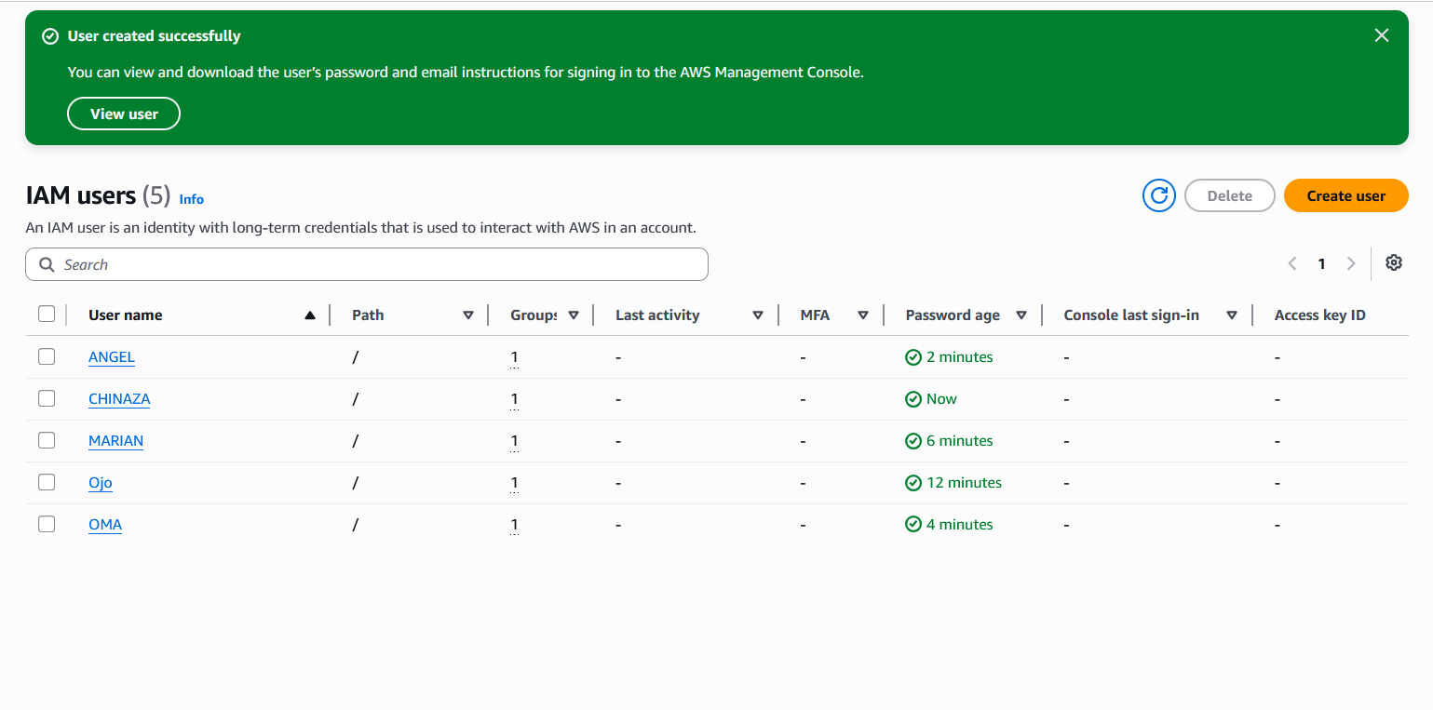

Task 3: Creation of IAM Policy
(EC2AccessPolicy)

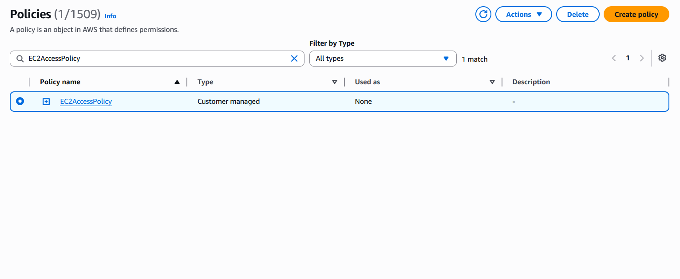
(S3FullAccessPolicy)
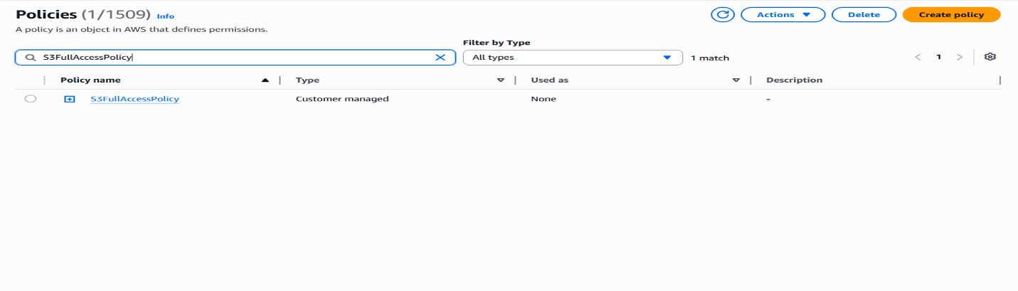

The two policies
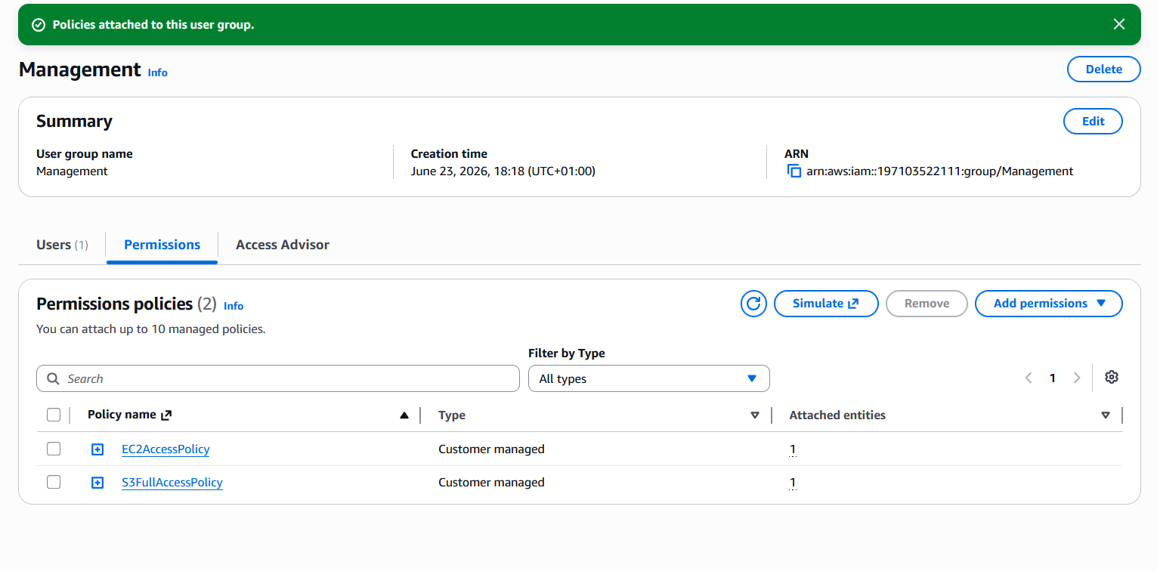

These policies were attached to the appropriate groups based on their responsibilities

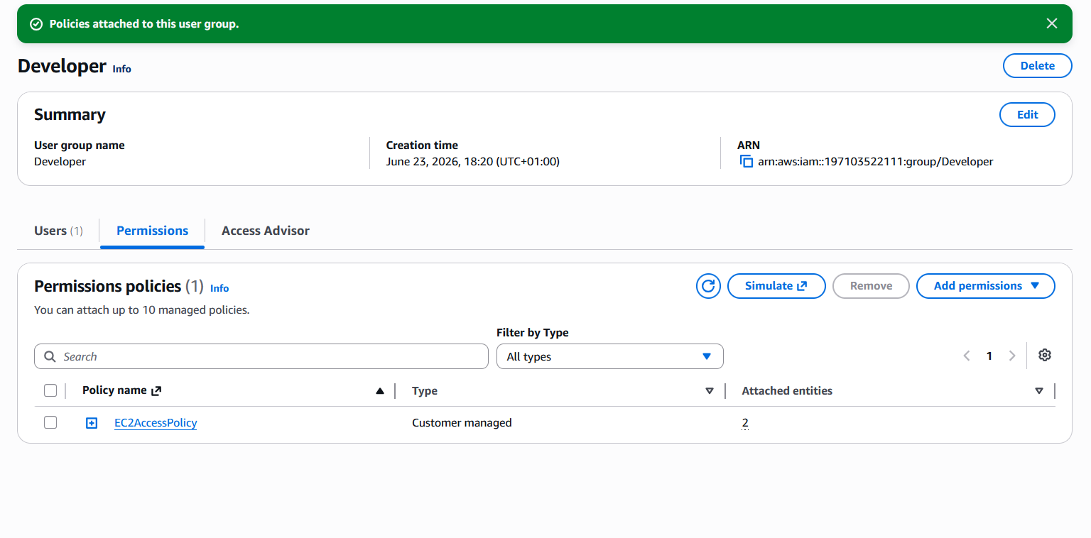
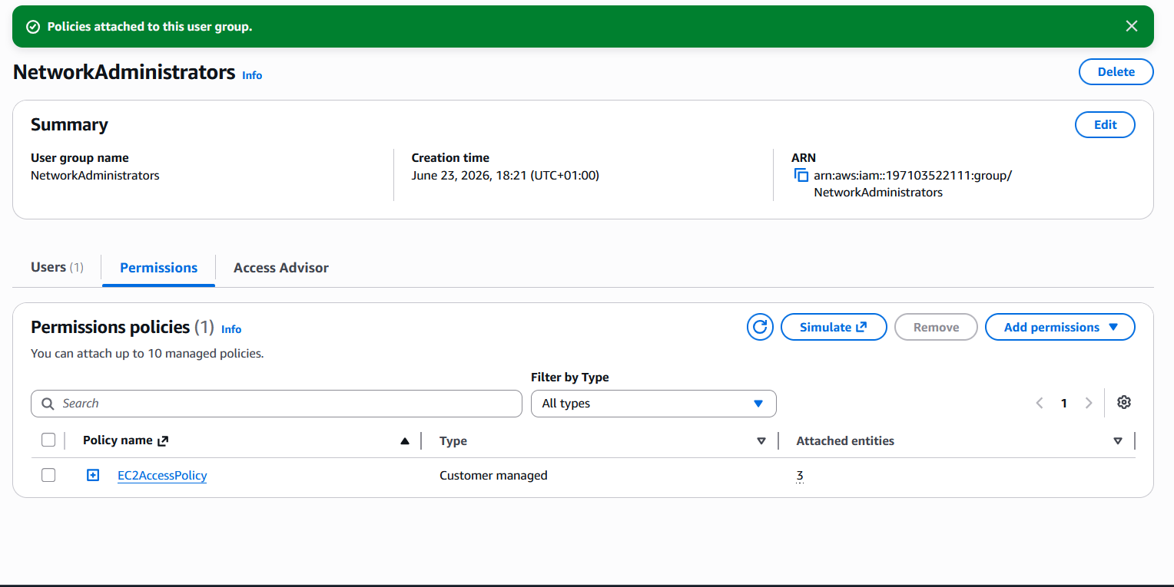

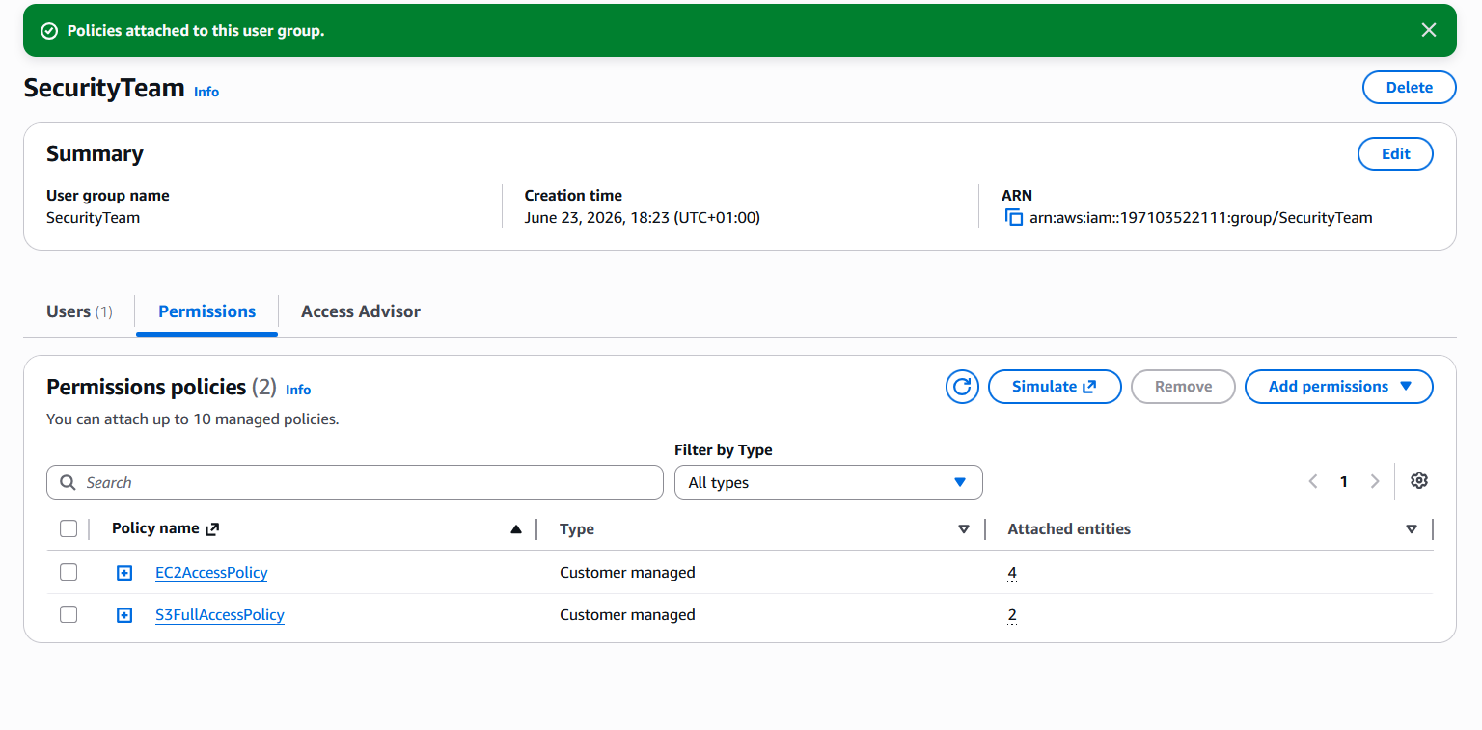

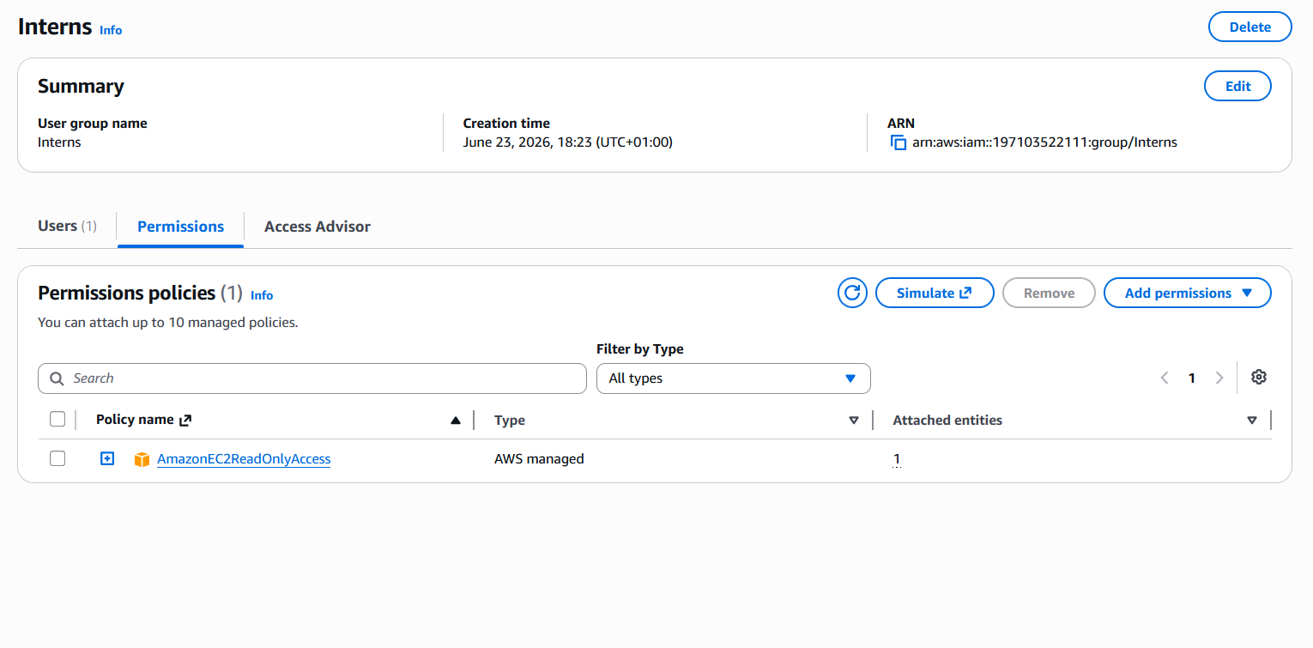

TASK 4: Multi – Factor Authentication (MFA)
MFA was enabled for the users to improve account security
ANGEL MFA
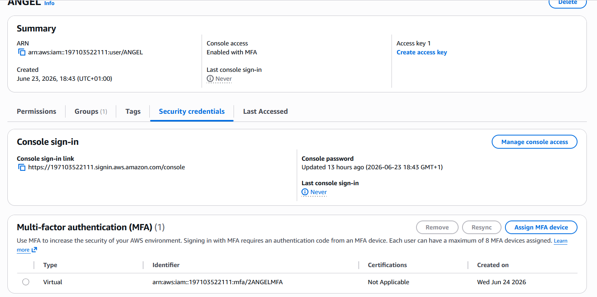

CHINAZA MFA
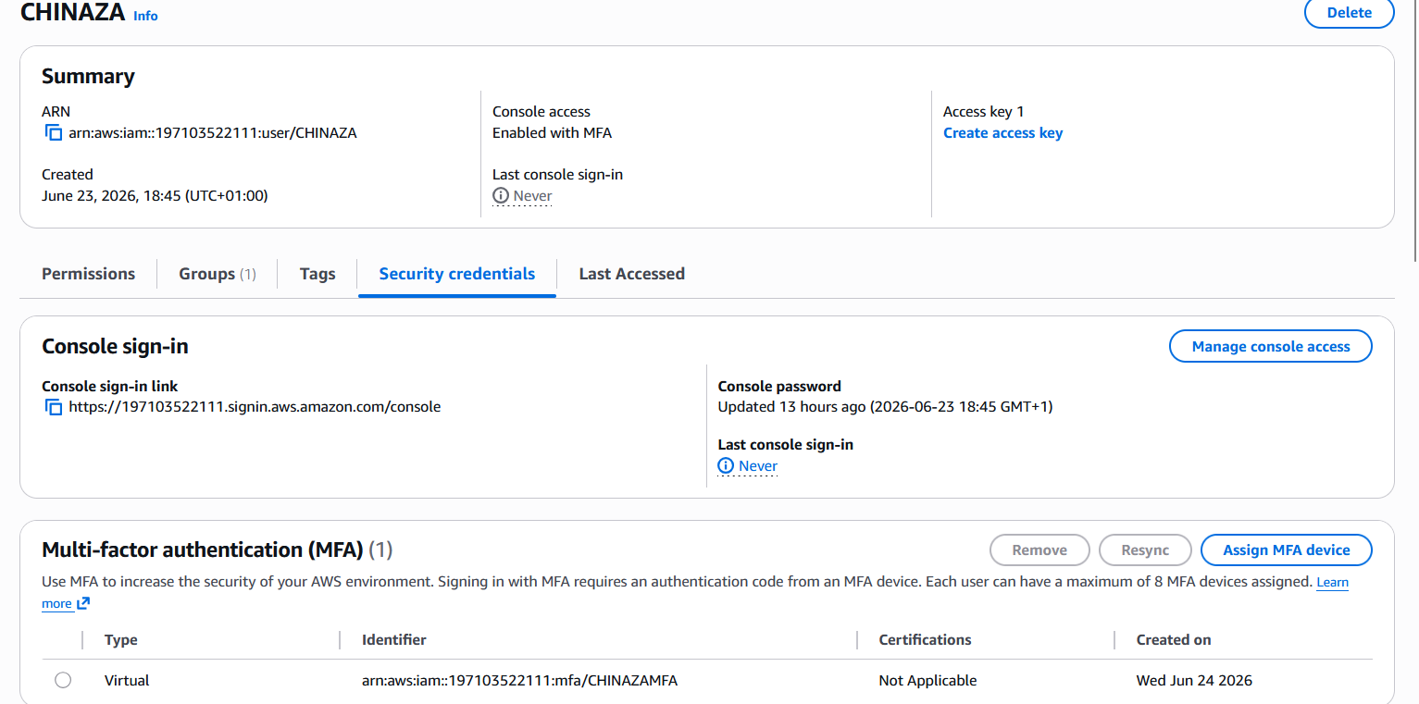

MARIAN MFA
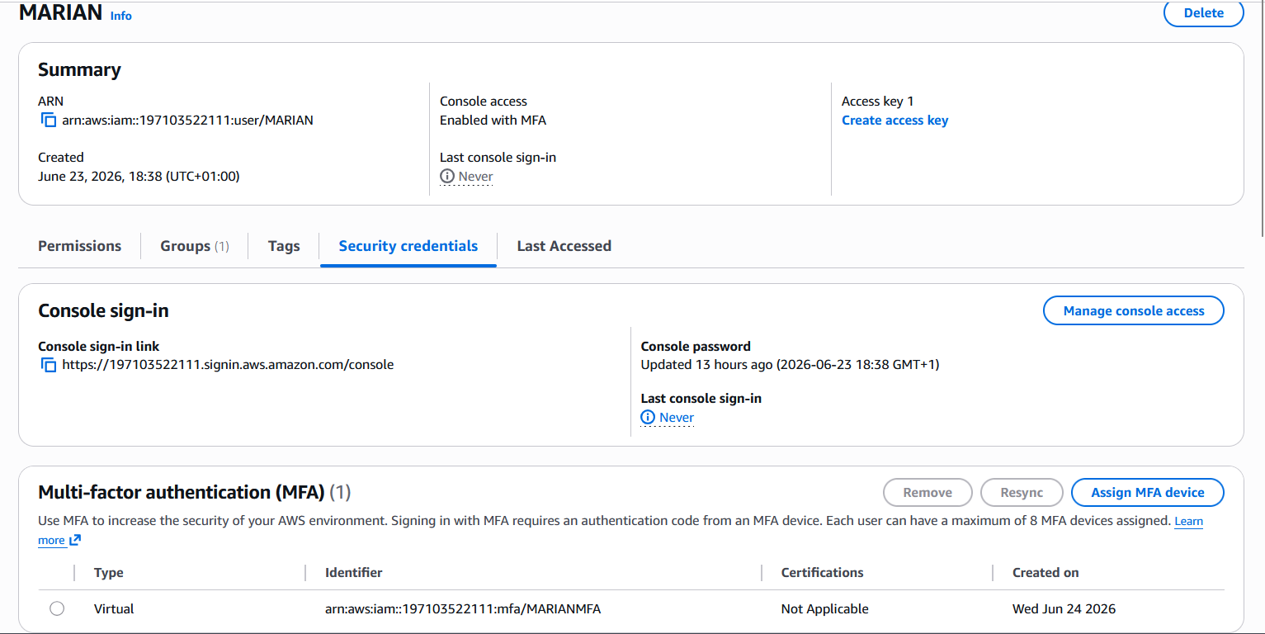

OJO MFA
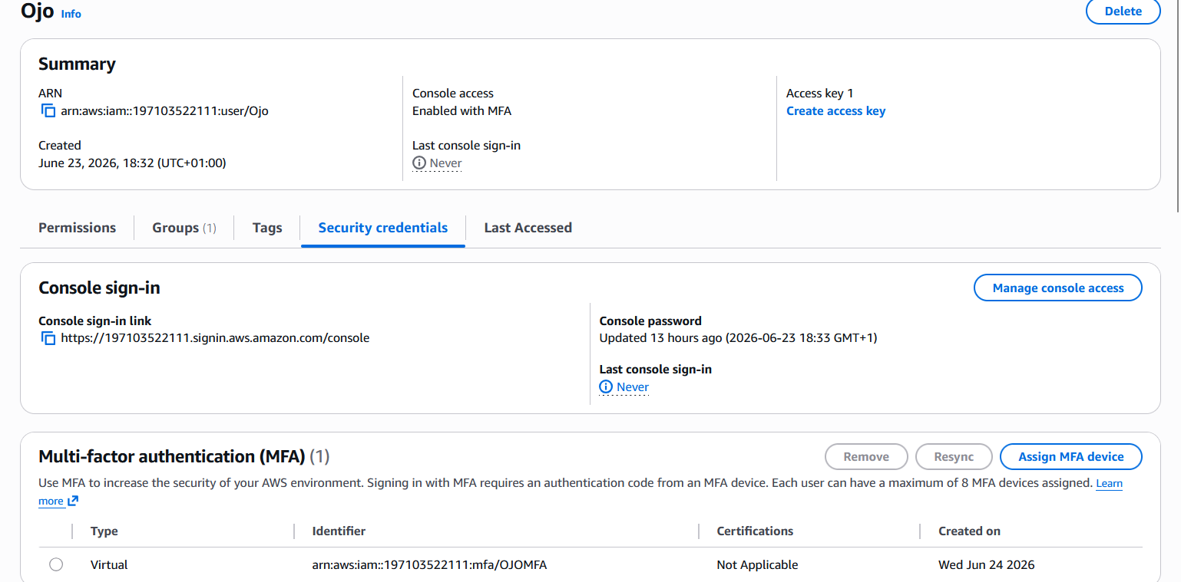

OMA MFA
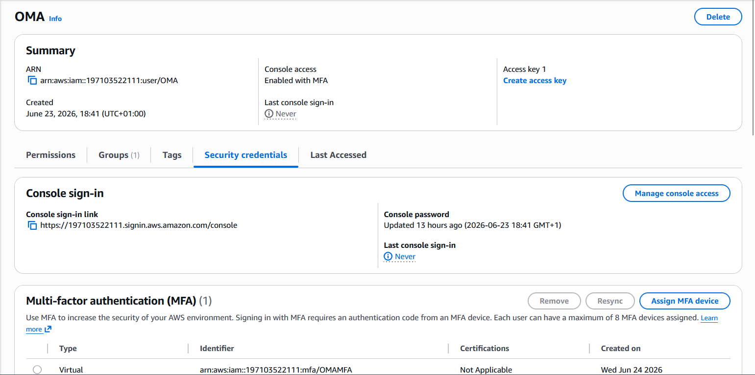

All IAM Users MFA
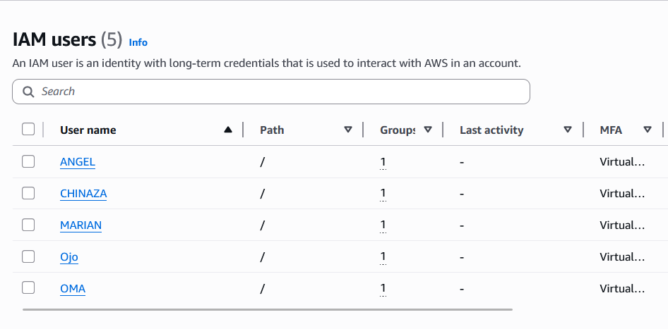

TASK 5: IAM Roles
EC2 ROLES AND LAMBDA ROLE
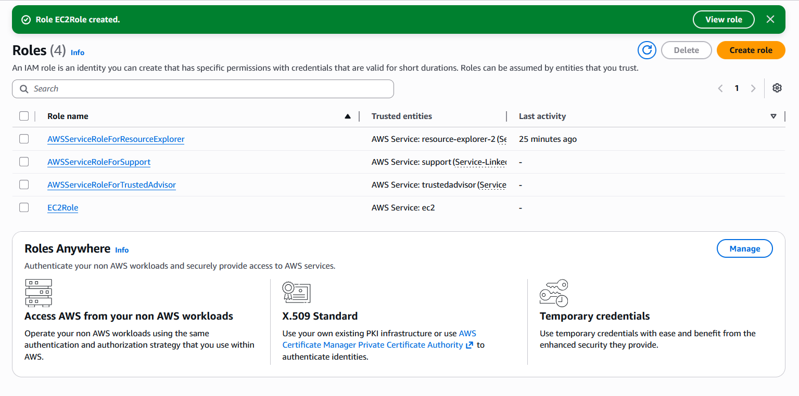

LambdaRole
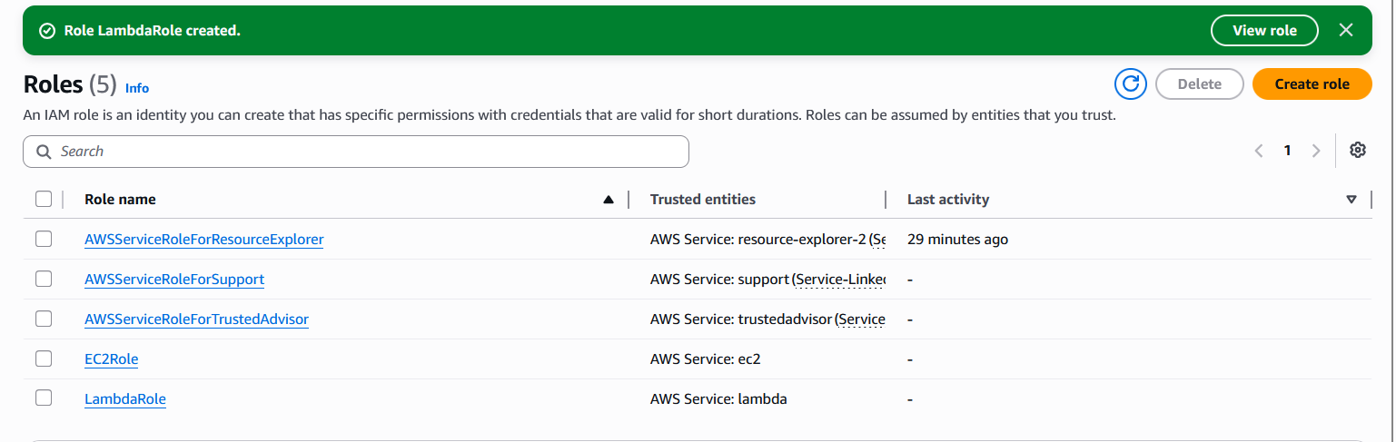

TASK 6: Security Best Practices
- MFA was enabled for IAM users.
- IAM Roles were created.
- IAM Groups were used for permission management.
- Custom IAM Policies were created.

Credential Report
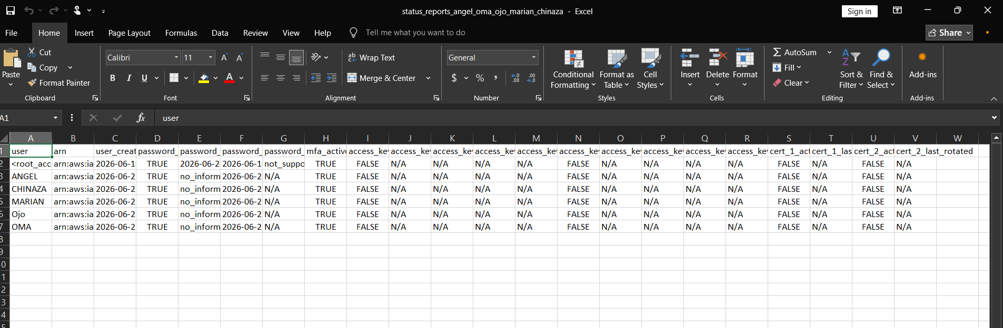

In conclusion, this project successfully implemented AWSIAM for AdescoTechHub Ltd. by creating users, groups, policies, roles, and MFA configurations.

