ADESCO TECH ONLINE ACADEMY PROJECT
BY
ANGEL

Task 1: Create an S3 Bucket
Bucket Name: adesco-company-documents-angel
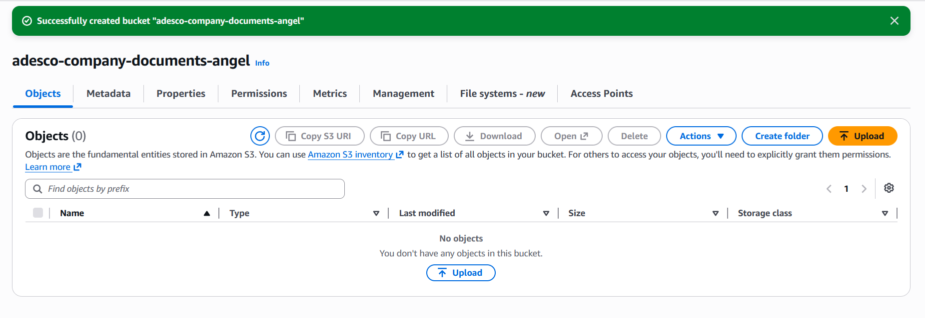

Task 2 – Upload Company Documents
Three company documents were uploaded into the Amazon S3 bucket.
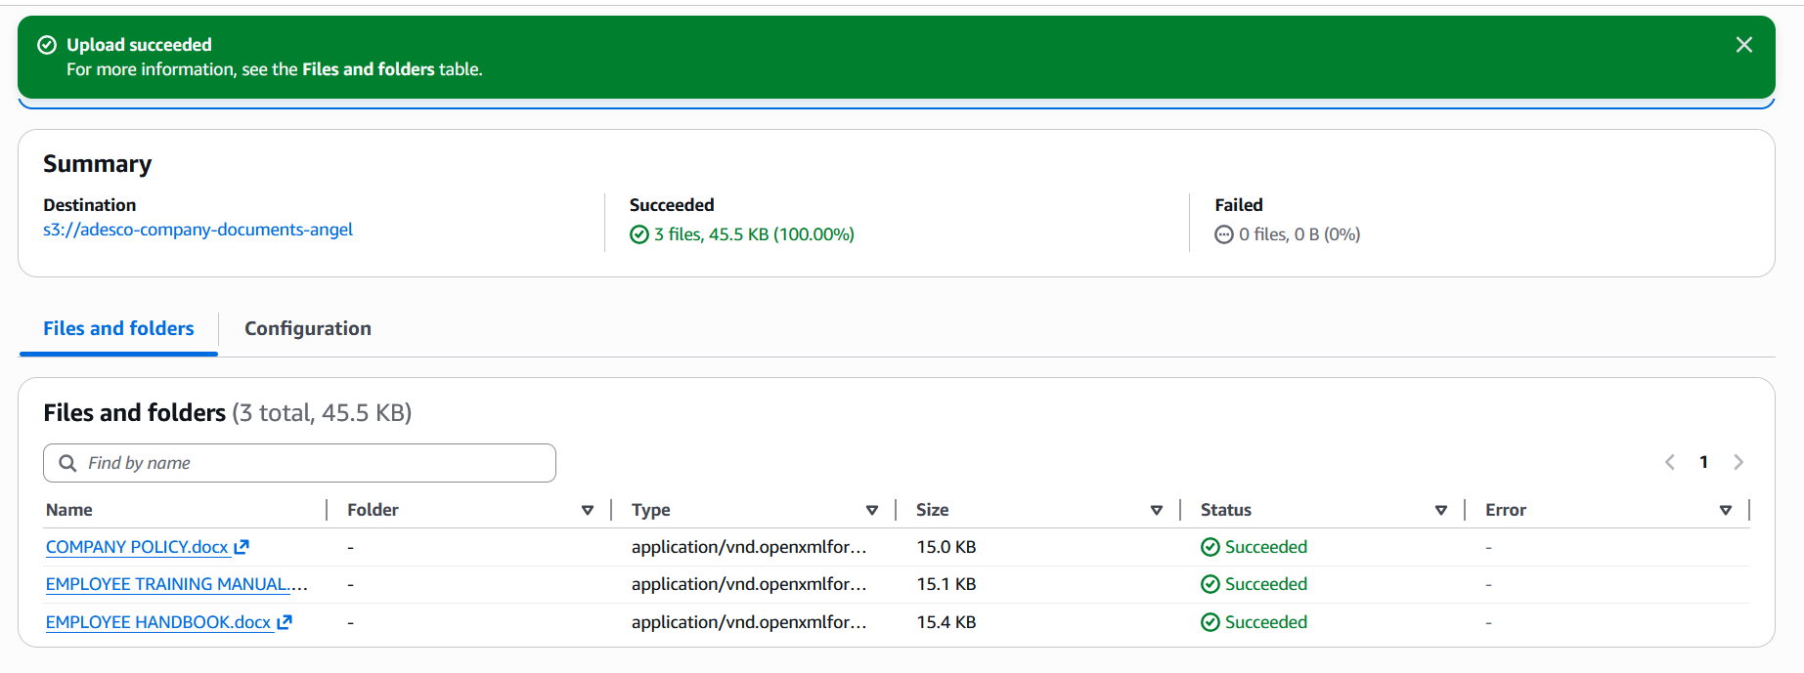

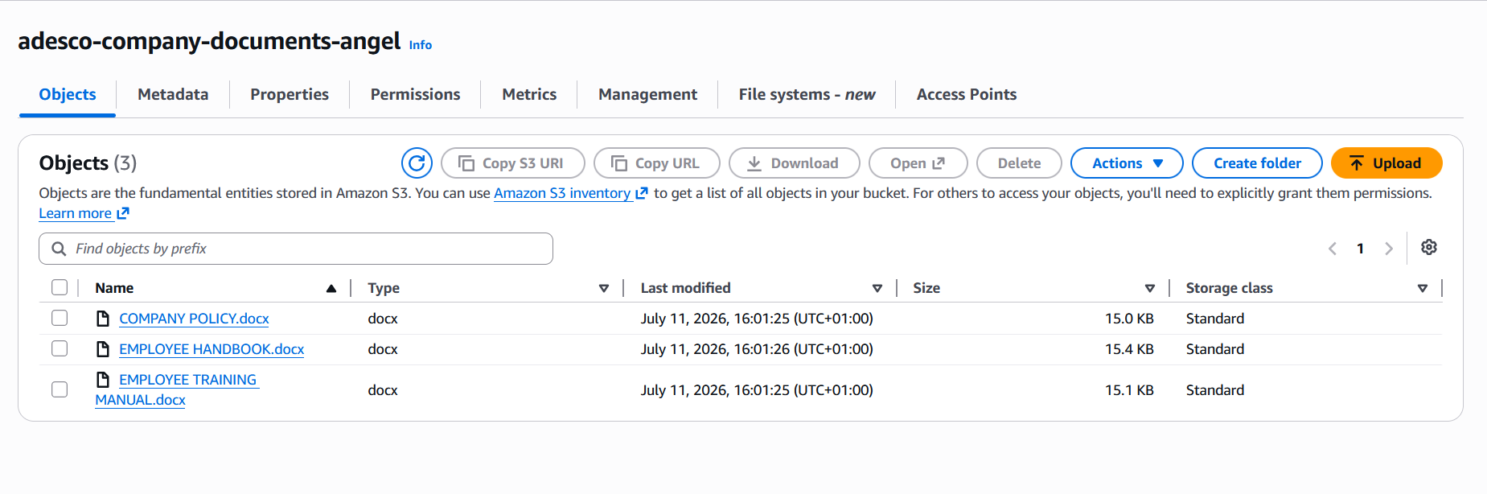

Task 3 – Enable Versioning
Bucket Versioning was enabled on the S3 bucket to protect company files.
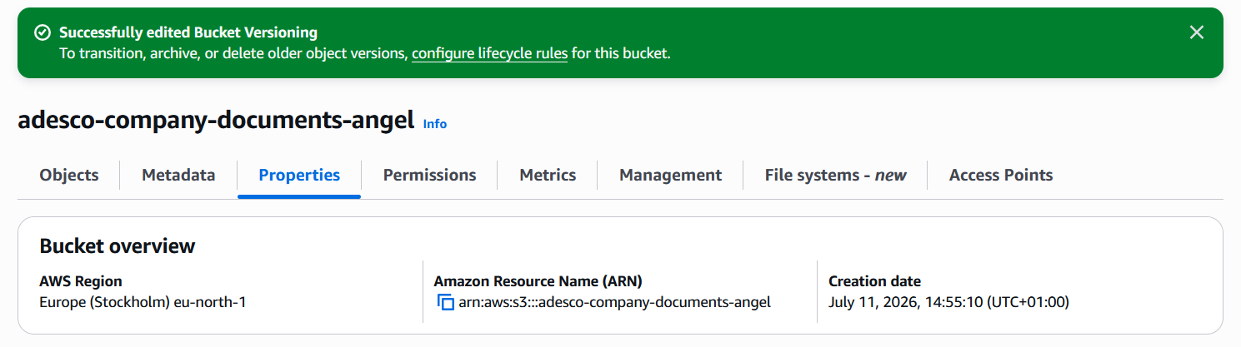

Task 4 – Configure Bucket Policy
The S3 bucket was configured to remain private by keeping Block Public Access enabled.
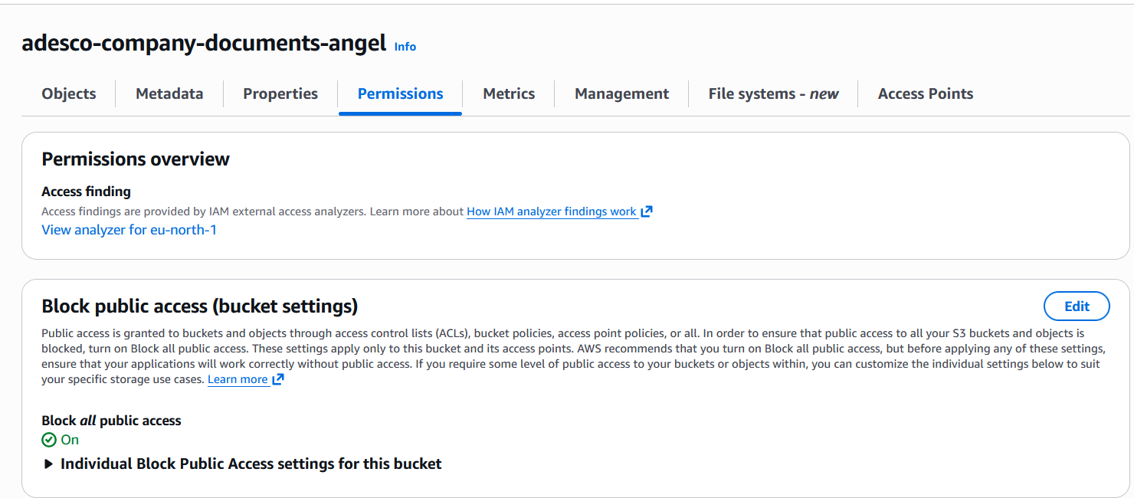

Task 5 – Configure Lifecycle Policy
A lifecycle policy was configured on the S3 bucket to automatically optimize storage costs.
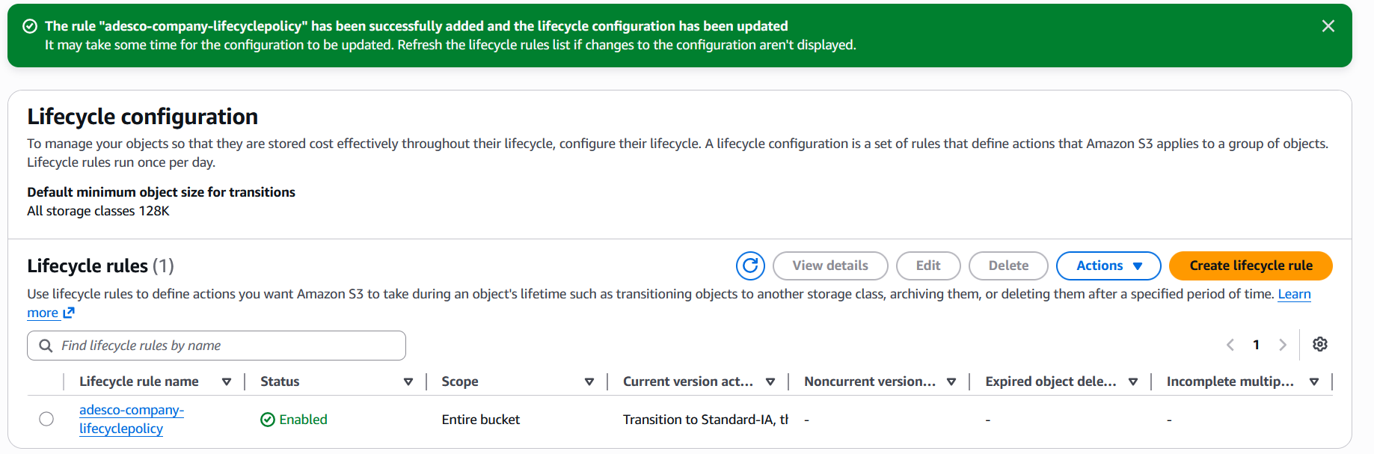

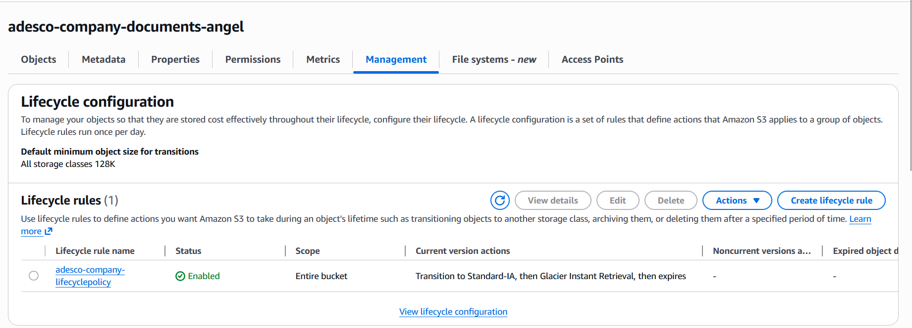

Task 6 – Host a Static Website
A separate Amazon S3 bucket was created specifically for hosting the company's static website.
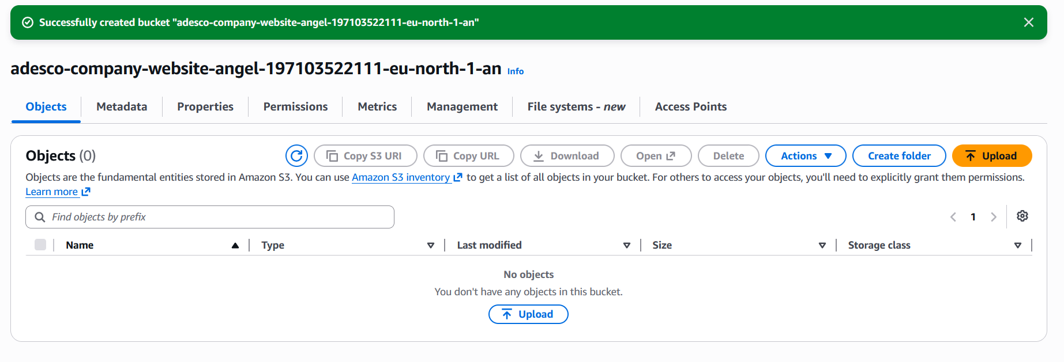

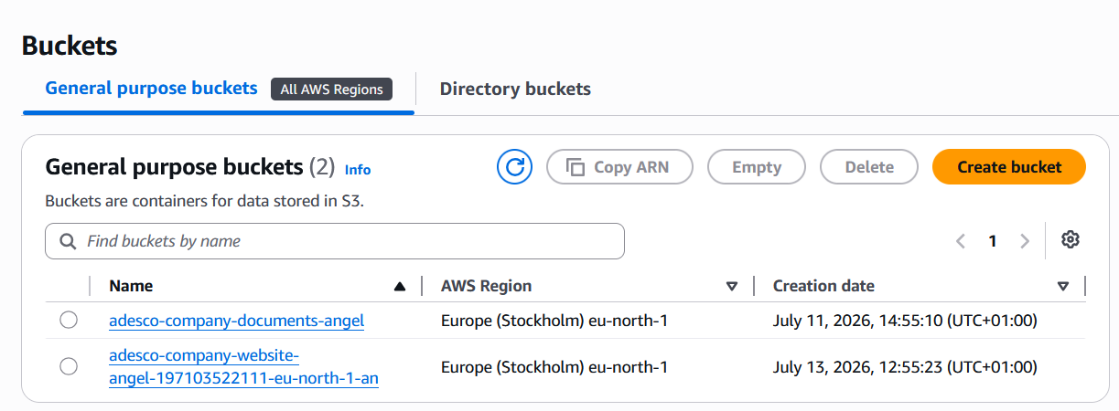

Successfully uploaded files (index.html)
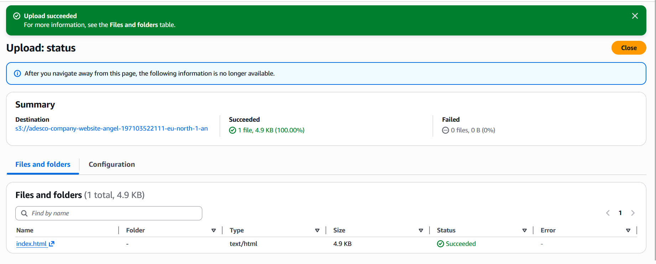

Task 7 – Configure Bucket Policy for Website
Static Website Hosting was enabled on the website bucket, with index.html to allow public read
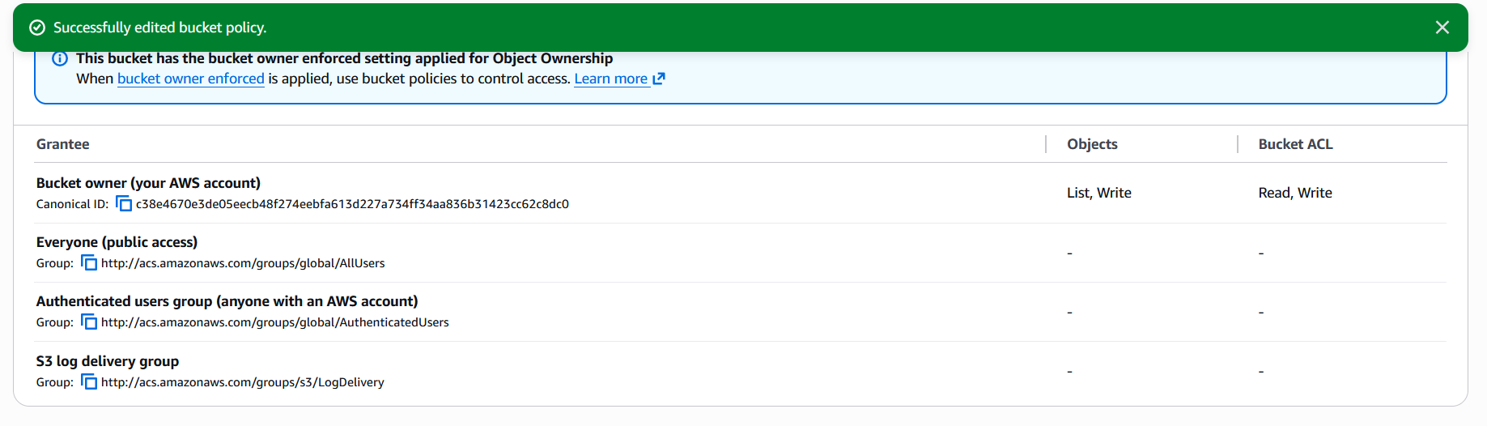

TASK 8: Test the Website
Website displayed in the browser
