ADESCOTECHHUB ACADEMY PROJECT
BY
ANGEL

Deployment of AdescoTechHub Academy Student Portal Using AWS EC2 and Amazon EBS

- Launch Ubuntu EC2 Instance
I launched an Ubuntu EC2 instance named AdescoTechHubAcademy using the Ubuntu Server Amazon Machine Image and I also selected the t3. micro instance type. I also created a new Key Pair for secure access to the server.
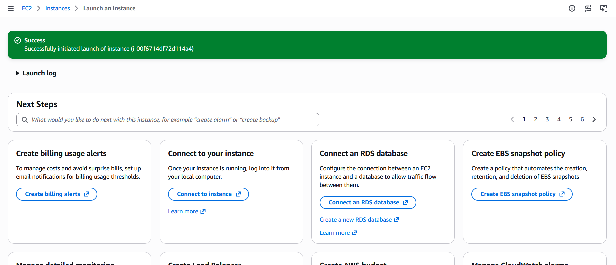

- EC2 Instance Details

After launching the instance, I verified that it was running successfully. I confirmed the following details:
    - Instance ID
    - Ubuntu AMI
    - Instance Type (t3. micro)
    - Public IPv4 Address
    - Instance State (Running)

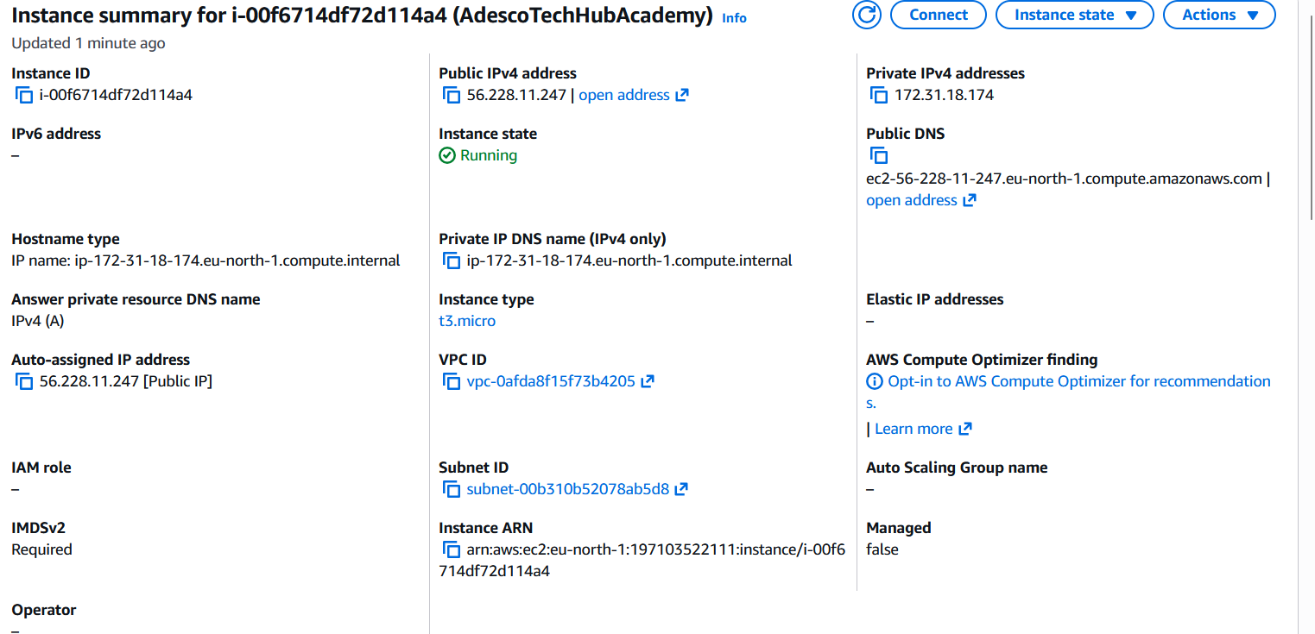

- Deploy Student Portal Using EC2 User Data
I used the EC2 User Data script provided to automatically:
- Update Ubuntu.
- Install Apache Web Server.
- Start the Apache service.
After deployment, I accessed the Student Portal
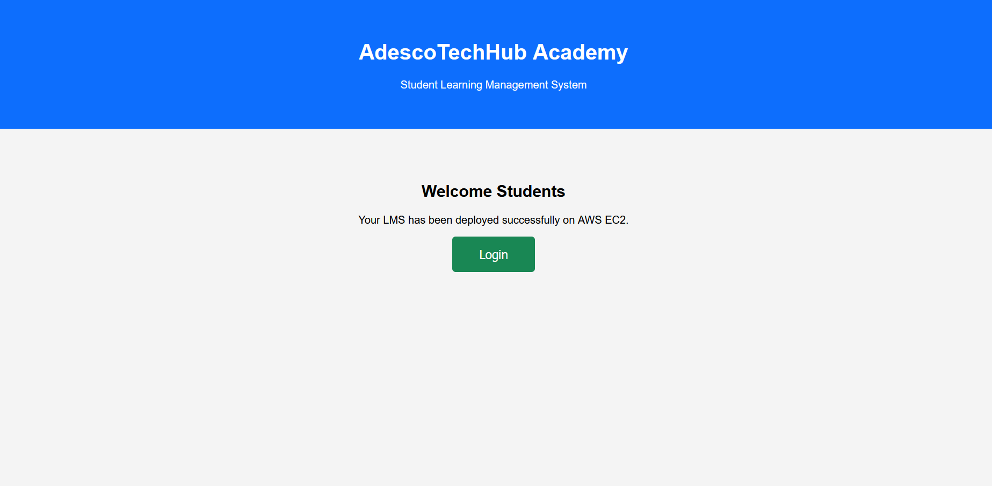

- Create and Attach Amazon EBS Volume
I created a 10 GiB SSD Amazon EBS volume in the same Availability Zone as the EC2 instance (eu-north-1a). I then attached the volume to the EC2 instance.
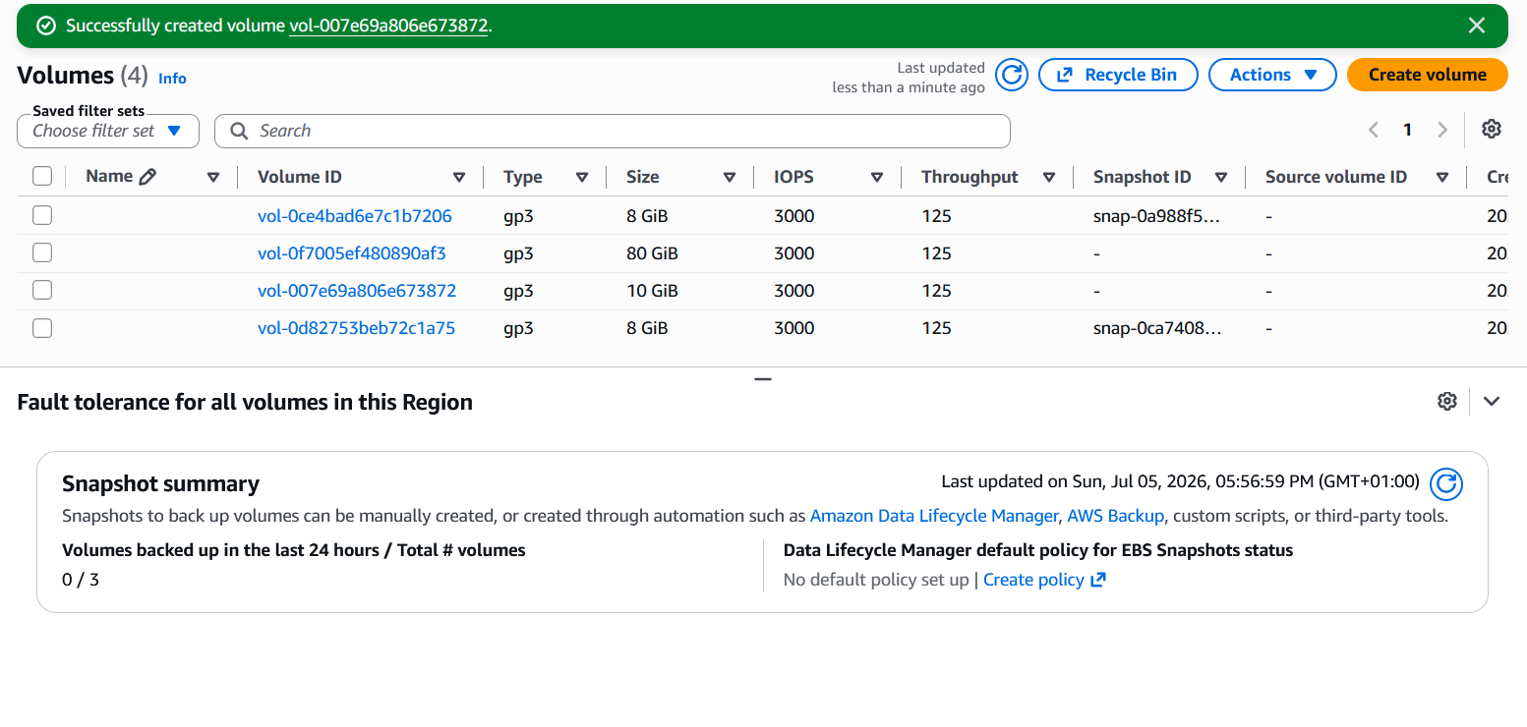

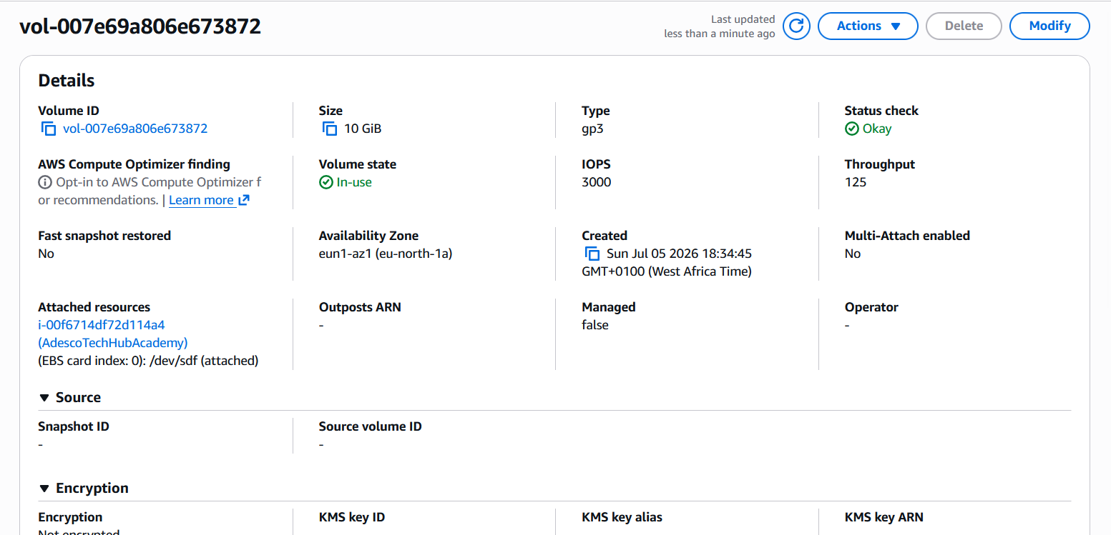
- SNAPSHOT

I created an EBS Snapshot. As a backup that can be used to restore the EBS volume if necessary.

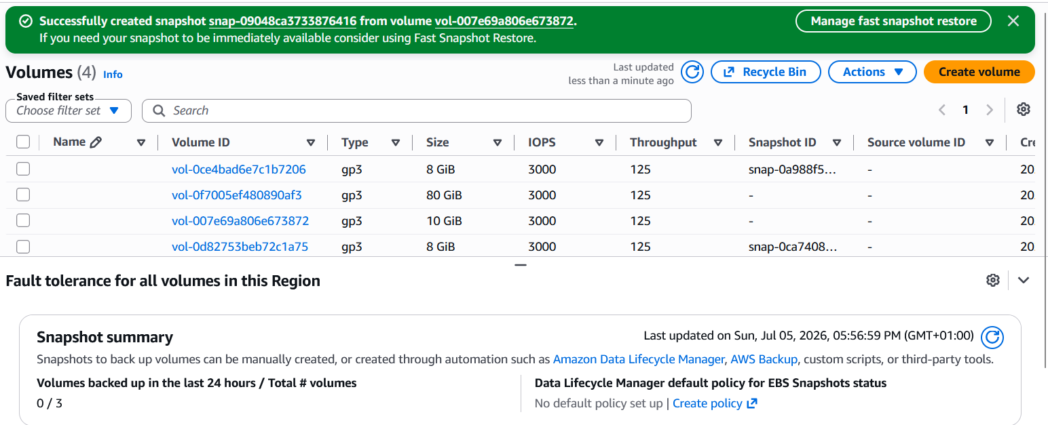

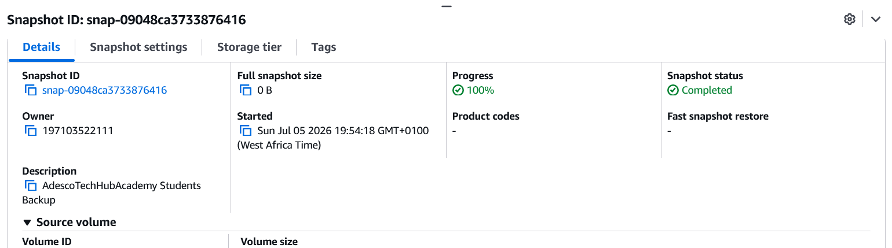
CHALLENGES I ENCOUNTERED
Understanding the difference between EC2, EBS, and Snapshots.

Learning how to configure Security Groups correctly.

Understanding the purpose of EC2 User Data.
Attaching the EBS volume to the EC2 instance.

