Name: Zarin Khan

Roll No: 18CO05

Exp 9: Hosting the website with domain registration process

Step 1: Register in profreehost.com as new applicant



Step 2: Click on Create new Account



Step 3: We can choose our domain type and domain name

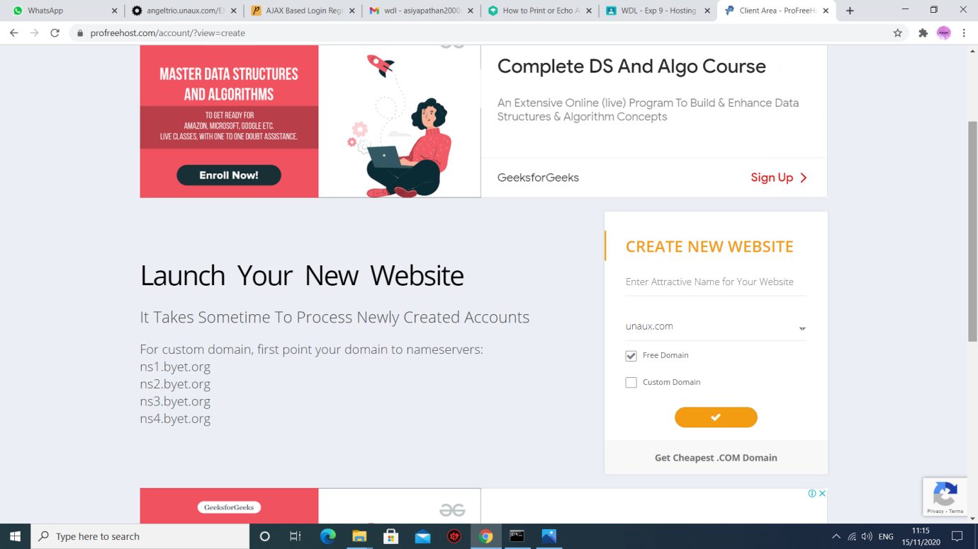

Step 4: After accepting the agreement a control panel will generate where we get our credentials regarding hosting.

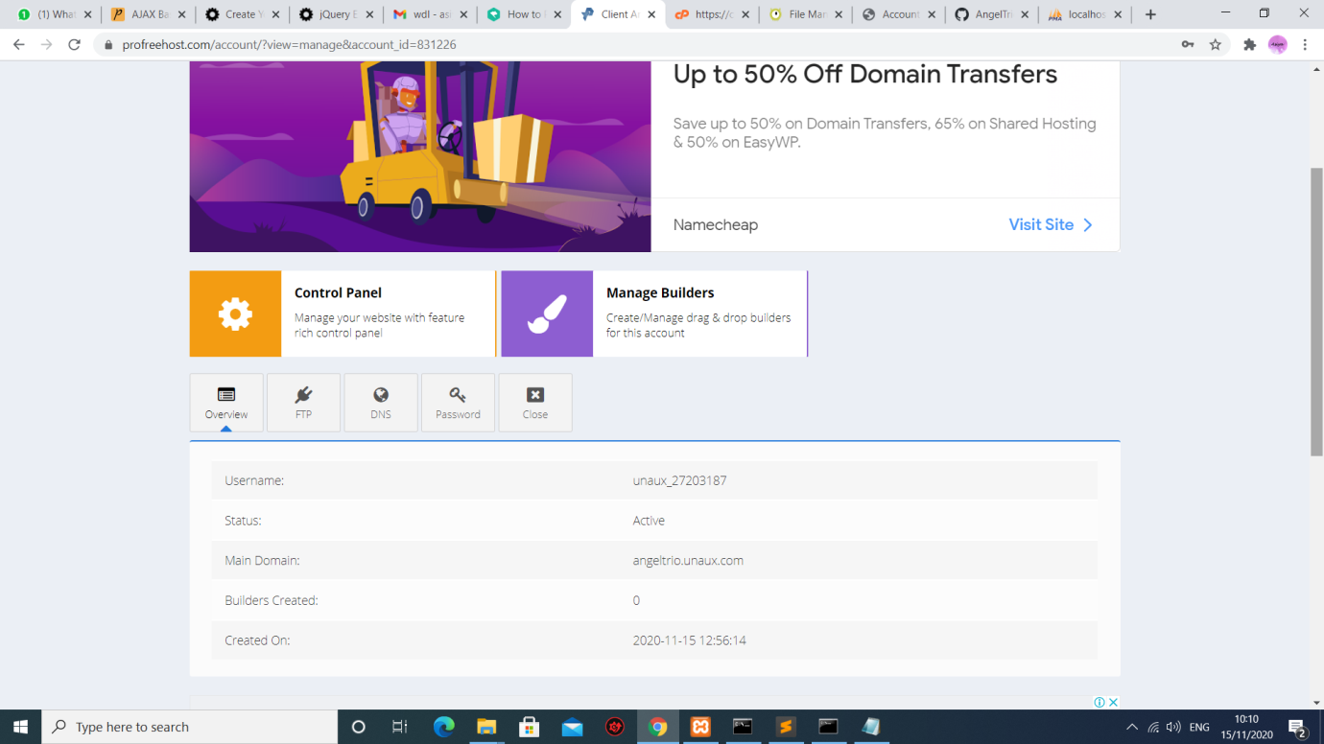

Step 5: Click on the control panel where we can upload our folder and database files.

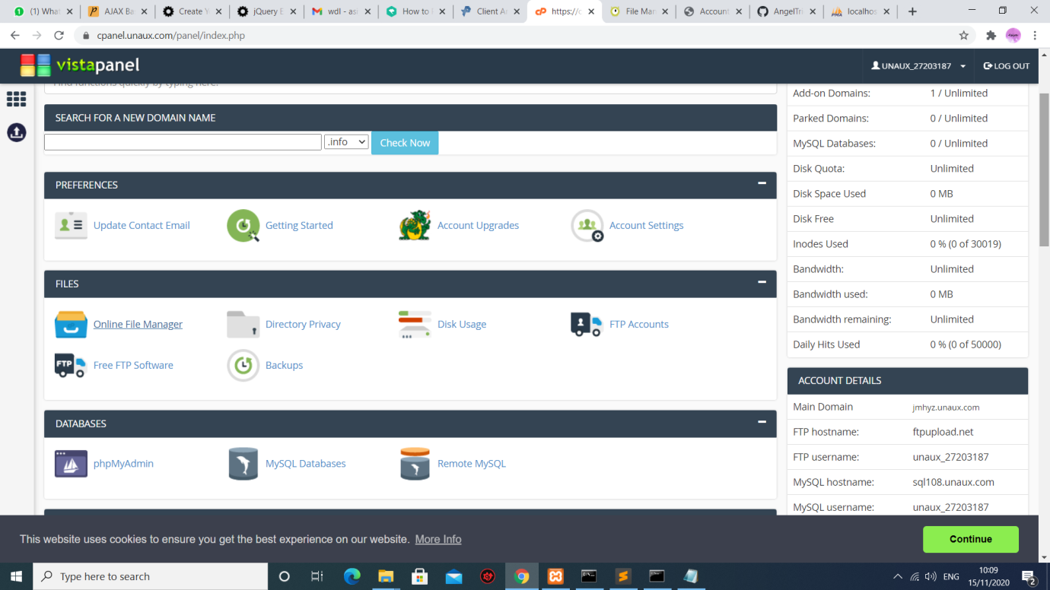

Step 6: Go to MySQL Databases and create a database.

Database credentials are generated. Replace the previous localhost credentials in the files with Current Databses.

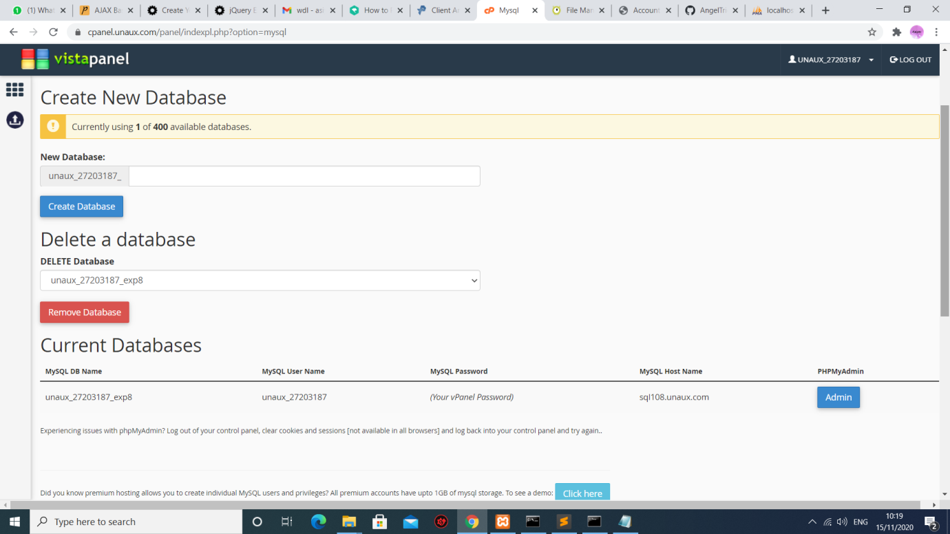

Step 7: Go to phpMyAdmin



Step 8: Here we will connect our current database

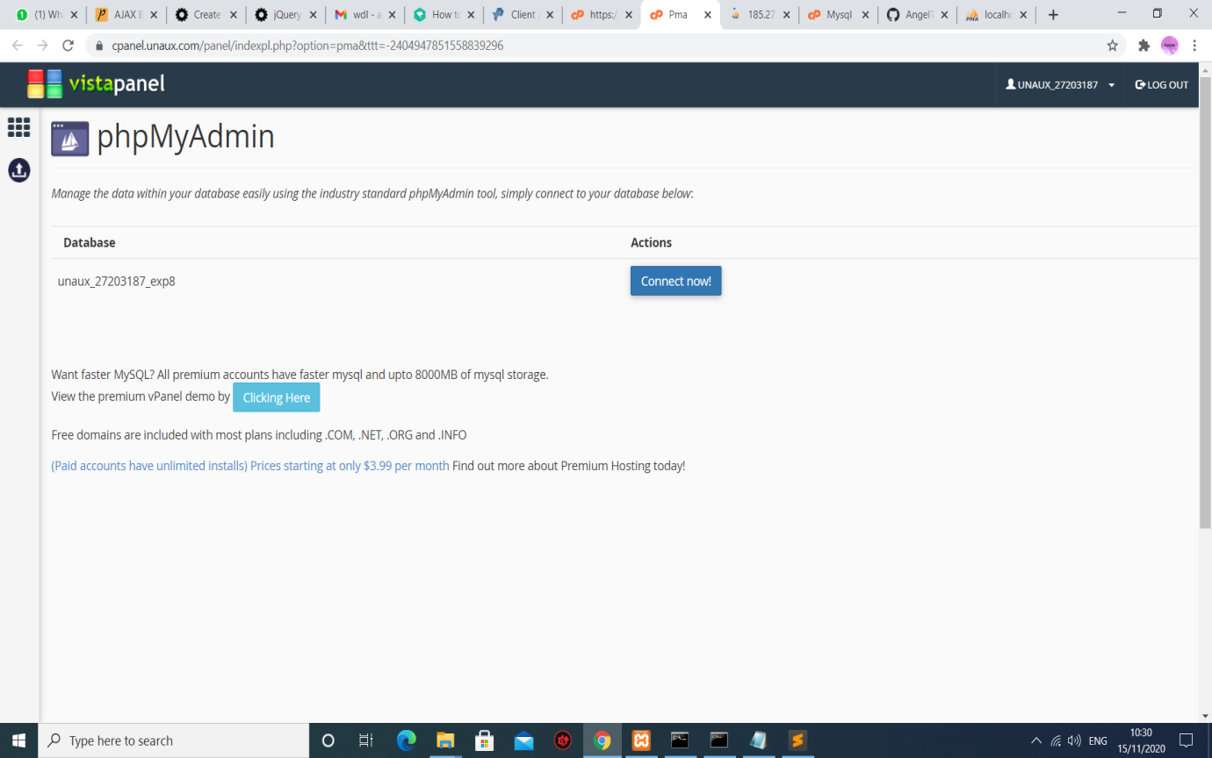

Step 9: We will be redirected to the admin panel. Import the sql file from the system.

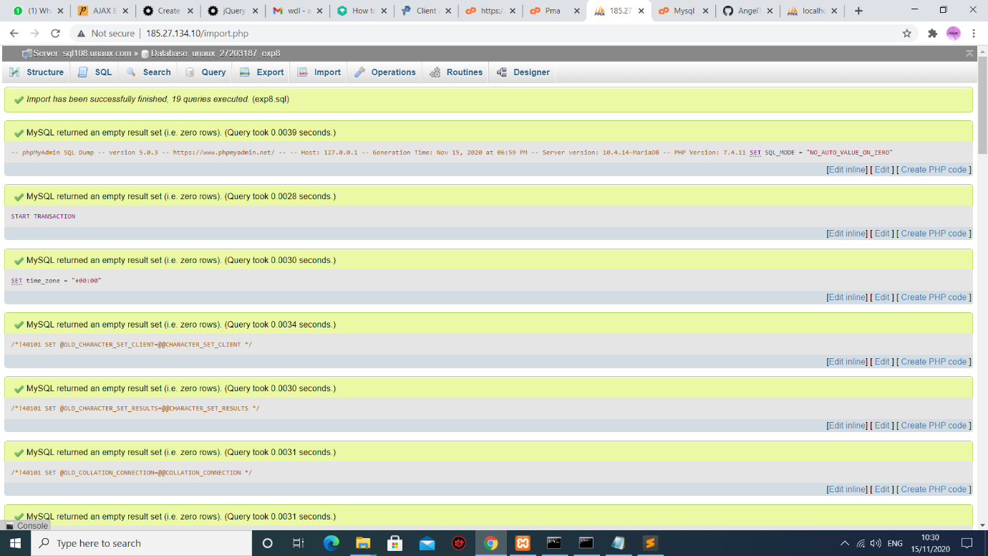

Step 10: Database imported

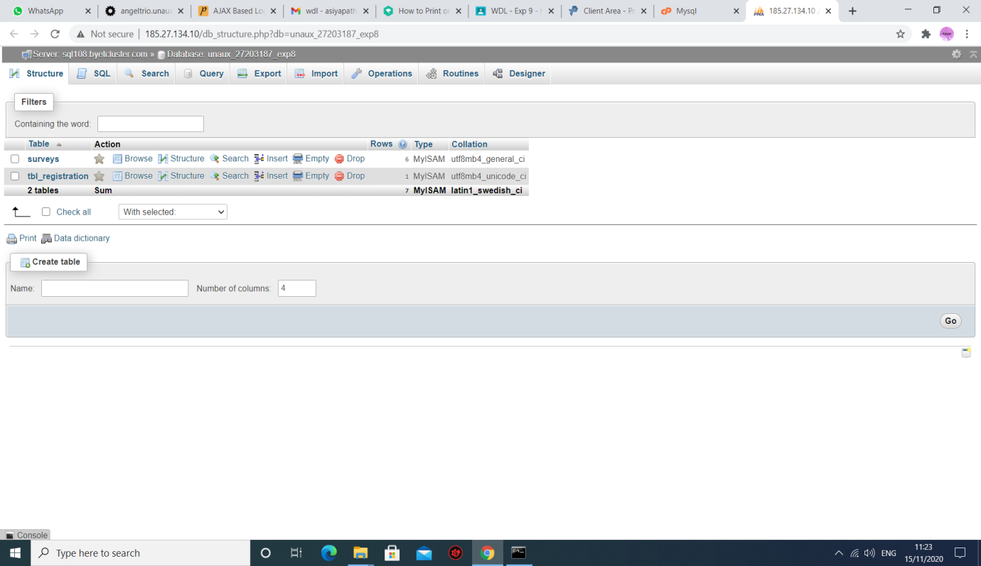

Step 11: To Upload files Go To Online File Manager

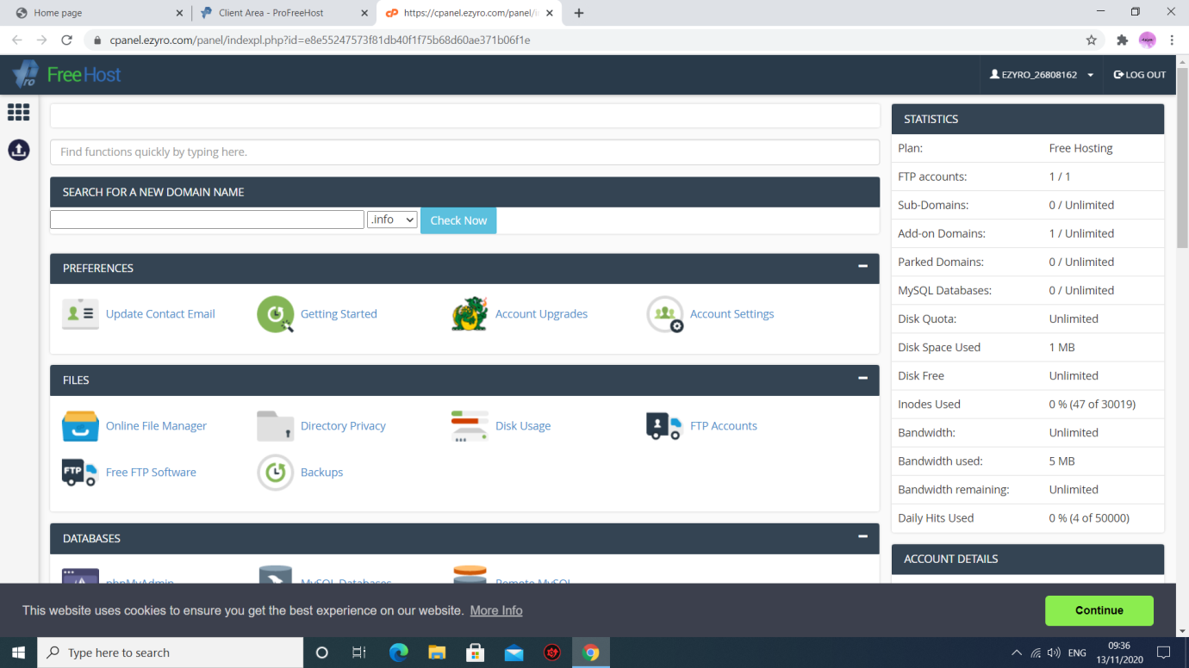

Step 12: Upload folder or files by clicking on the upward arrow.

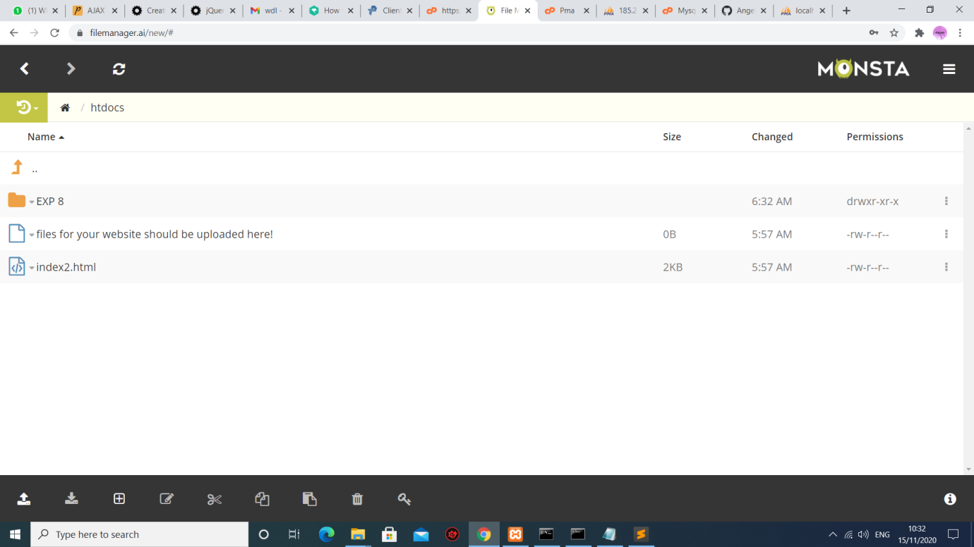

Step 13: Website is hosted successfully. Check it by pasting the domain name on google chrome.

