**Full name:** Angel Martín González García  
**NAO ID:** 3313  
**Date:** 08/09/2025  
**Pathway:** IN-MEXICO PROGRAM BACKEND DEVELOPER CERTIFICATION

GitHub and Digital Repository Management Sprint 1: Roadmap

Roadmap  
  
Title

Project: GitHub and Digital Repository Management

## Objectives

**General Objective**

Master Git/GitHub practices to set up environments, collaborate via PRs, manage branches/conflicts, and document decisions with clear versioning.

**Specific Objectives**

Configure a working environment (Git, GitHub, SSH) and document evidence.

Implement a repo workflow: branches, PRs, reviews, access.

Practice conflict resolution and reverts safely on branches A/B.

Produce concise deliverables that illustrate process and outcomes.

## Deliverables & Deadlines

**Sprint 1 deliverables (due Sep 8, 2025):**

Initialized repo and configurations completed

README with versioning guidelines

Sprint-1 PDF with screenshots & summary

**Sprint 2 deliverables (due Sep 10, 2025):**

Project uploaded, branch workflow, PR opened/reviewed/merged

Access granted to reviewers

**Sprint 3 deliverables (due Sep 12, 2025):**

Branches A & B, conflicts resolved

Revert demonstrated, PRs merged

## Processes & Roles

Developer (Myself): Executes tasks, documents decisions, opens PRs.

Maintainer/Reviewer (Digital NAO Team): Reviews PRs, verifies access, provides feedback.

PM (Myself): Plans sprints, tracks progress, updates roadmap/backlog.

## Timeline (made in Miro) — Planned Activities

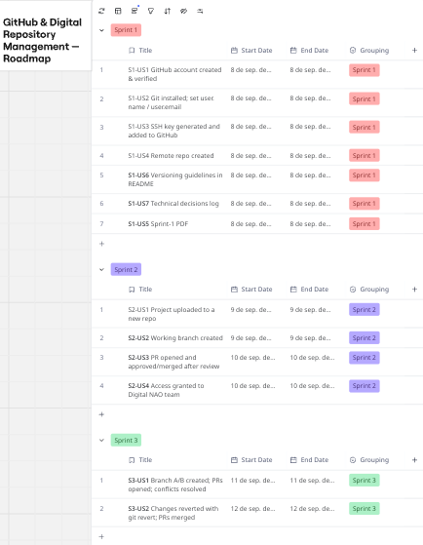

## Dependencies

S1-US3 depends on S1-US1 (account) and S1-US2 (Git installed).

S1-US4 depends on S1-US3 (SSH ok).

S1-US6/S1-US7 depend on S1-US4 (repo exists).

S1-US5 depends on S1-US1 🡪 S1-US7 evidence.

S2-US2 depends on S2-US1; S2-US3 depends on S2-US2; S2-US4 after S2-US3.

S3-US1 depends on a stable main (after S2-US3); S3-US2 depends on S3-US1.