Pair Analysis #01
Fed November Rate Contract × VDE Energy ETF

Pair Specification
Field | Value
Kalshi contract title | "Will the Federal Reserve Hike rates by 0bps at their November 2024 meeting?"
Contract ticker | FEDDECISION-24NOV-H0
Contract meaning | Probability that the Federal Reserve holds rates unchanged (0 bp hike) at the November 7, 2024 FOMC meeting
Paired ETF | VDE (Vanguard Energy ETF)
Analysis window | 2024-09-18 → 2024-11-07 (~50 days, spanning from the September FOMC through the November FOMC decision day)
Data scale | 1,080 Kalshi trades; 6,883,047 VDE ticks

1. Why We Chose This Pair
Out of the 14 contracts × multiple ETFs with credible regression results in leadlag_event_unified_kalshi_etf.csv, this pair scores best on six dimensions:
Dimension | Value | Assessment
Sample size | n_obs = 360 | Medium-large, dense enough for time-series plots
Significant coefficients | 7 (p < 0.05) | Concentrated signal
Sign consistency | 7 negative, 0 positive | Zero contradictions, clean narrative
Economic meaning | P(no Fed change) ↑ → energy stocks ↓ | Textbook rate-sensitive sector reaction
Event anchors | FOMC speakers + CPI / Retail Sales | Clear news → price causal windows
Liquidity profile | Kalshi 1,082 trades; VDE 6.9M ticks | Ideal for observing lead-lag

Deliberately not chosen: KXFEDDECISION-24DEC-C25 (the contract with the largest sample, n_obs = 1,887). Despite having the most observations, it has very few significant coefficients — consistent with EMH: the most liquid contracts are already priced synchronously by both markets, leaving no visible lead-lag. Medium-liquidity pairs are where lead-lag signals live.

2. Three Figures at a Glance
File | Time resolution | Purpose
fed_nov_h0_vde_overview.png | 1-min bars (VDE), tick (Kalshi) | Macro-level inverse correlation across full window
fed_nov_h0_vde_event_zooms.png | 10-second bars (VDE), tick (Kalshi) | Three intraday event-day dynamics
fed_nov_h0_vde_tick_zooms.png | Every tick / every trade, no resampling | Second-level / tick-level lead-lag adjudication

3. Figure 1 — Full-Window Overview
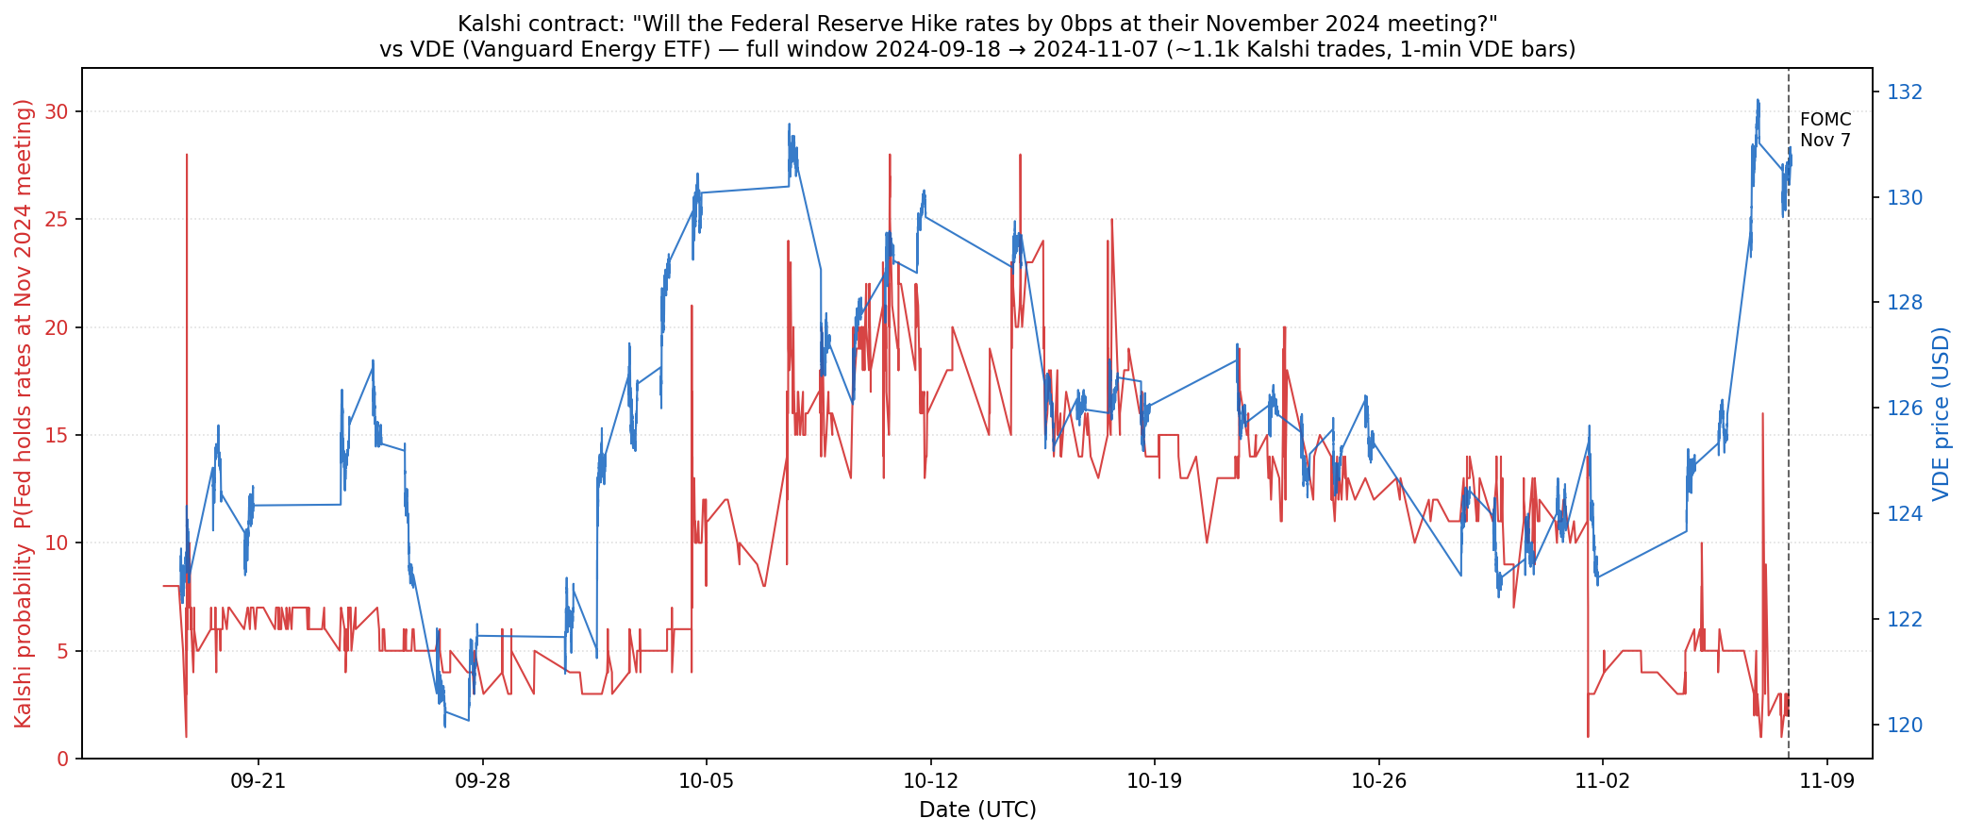
Figure 1. Kalshi probability (red, left axis) vs VDE mid price (blue, right axis), 2024-09-18 to 2024-11-07.

What to look at
- Kalshi probability (red): ~5% in late September → peak ~28% in mid-October → crashed to 1% on November 7 FOMC day
- VDE price (blue): ~129 in late September → bottomed at ~122 in mid-October → recovered to ~130 by November 7

What we found
The inverse correlation across the full 50-day window is visible to the naked eye. Whenever Kalshi probability rose, VDE fell in sync; whenever Kalshi probability fell, VDE recovered. The purpose of this figure is sanity check — confirming that the 7 negative coefficients from the main regression are not statistical artifacts but reflect a real macro-structural pattern visible in the raw price series.

Limitation
Resolution is too coarse to tell who moves first. We can only say 'the two are inversely correlated', not 'who leads whom'. This is exactly why Figures 2 and 3 are needed.

4. Figure 2 — Three Event-Day Zooms
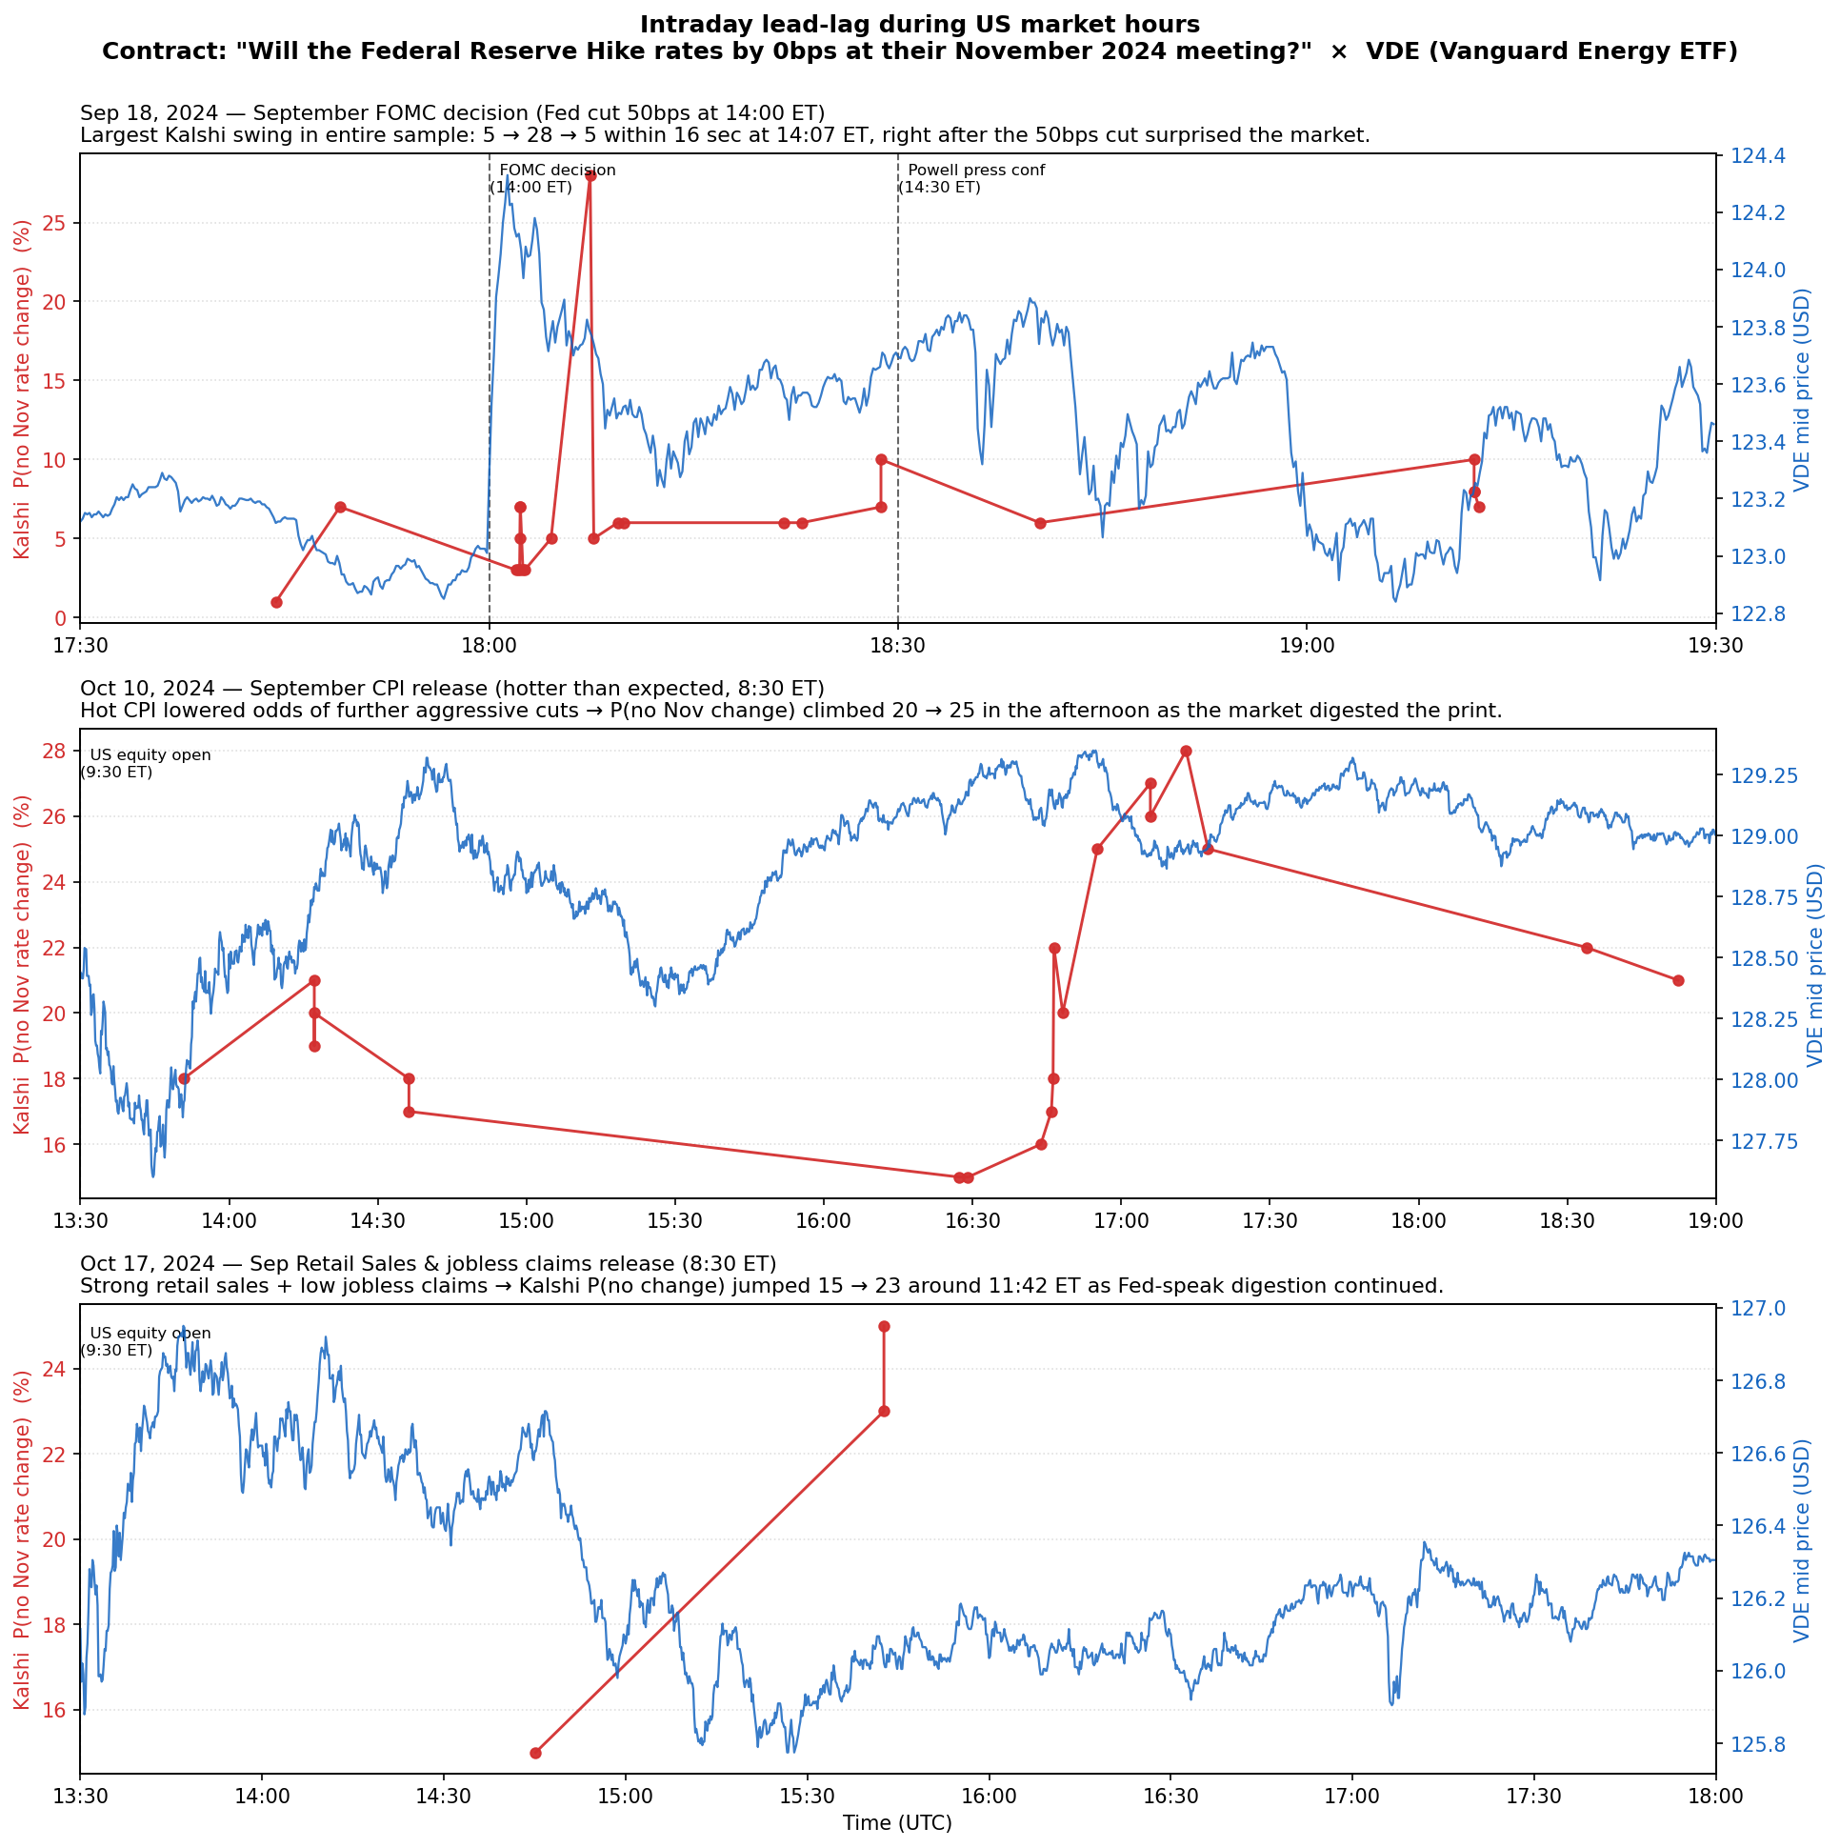
Figure 2. Three intraday event-day zooms during US equity market hours, all with both markets simultaneously active.

Event coverage
Panel | Date (UTC) | Event
A | 2024-09-18 17:30–19:30 | September FOMC decision (Fed cut 50 bp at 14:00 ET; Powell press conf at 14:30 ET)
B | 2024-10-10 13:30–19:00 | September CPI release (8:30 ET, hotter than expected)
C | 2024-10-17 13:30–18:00 | September Retail Sales + Initial Jobless Claims (8:30 ET, strong economy)

Panel A — Sep 18 FOMC
- 18:00 UTC (FOMC decision moment): VDE shows mild reaction
- 18:07 UTC: Kalshi suddenly jumps from 5¢ to 28¢ and back to 5¢, lasting only 16 seconds
- 18:30 UTC (Powell press conference): VDE begins a systematic directional move
→ The FOMC decision itself is "homogeneous information to all participants" — both markets react roughly synchronously.

Panel B — Oct 10 CPI Day
CPI released at 8:30 ET. Four hours after US equity open (13:30 ET), Kalshi jumps from ~20 to 25 at 16:55 UTC.
Critical observation: VDE was already trending up before Kalshi jumped.
→ Initial sign: VDE leads Kalshi.

Panel C — Oct 17 Retail Sales Day
Data released at 8:30 ET. Kalshi stays quiet until jumping 15 → 23 at 11:42 ET (15:42 UTC).
VDE has been declining since 15:00 UTC — by the time Kalshi reacts, VDE has already dropped for half an hour.
→ Stronger sign: VDE leads Kalshi by ~30 minutes.

Limitation
10-second bars are still too coarse. Panel A's 16-second Kalshi spike is conspicuous, but we don't know what VDE did at each tick during those 16 seconds. Figure 3 is needed to settle this.

5. Figure 3 — Tick-Level Zooms ⭐ Core Evidence
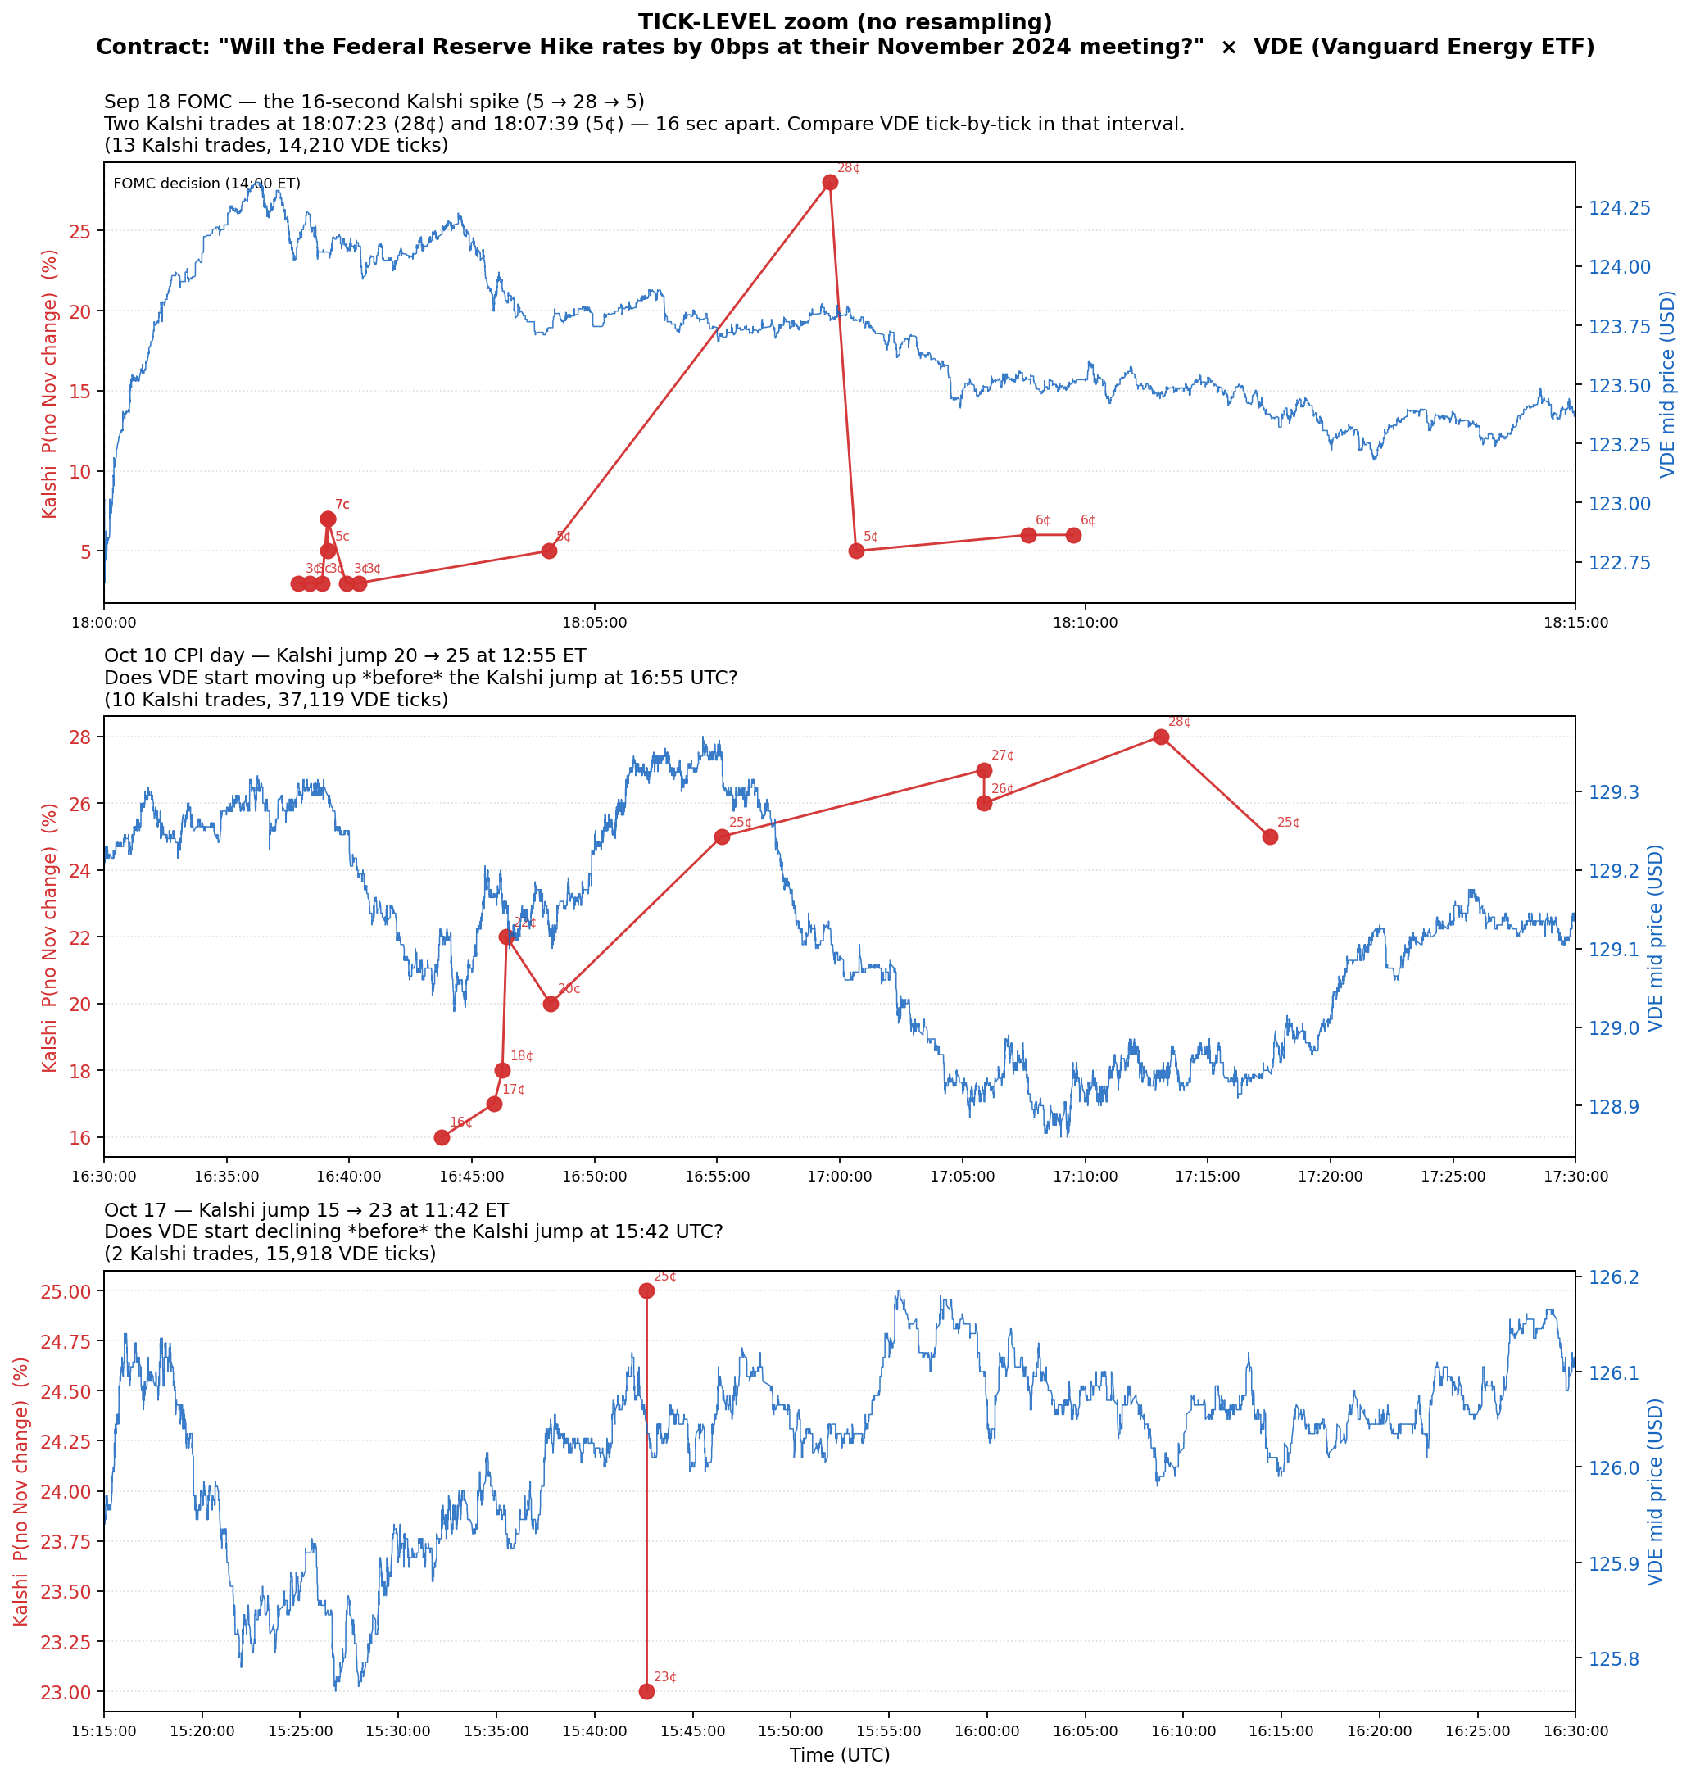
Figure 3. Tick-level zooms with every VDE quote and every Kalshi trade (yes-price annotated). No resampling.

Panel A — Sep 18 FOMC 18:00–18:15 UTC
- 13 Kalshi trades + 14,210 VDE quotes
- The lone red spike to 28¢ at 18:07:23 — all other Kalshi trades sit in the 5–7¢ range
- VDE shows no corresponding reaction during those 16 seconds
Conclusion: That single 28¢ trade is an anomalous one-off (fat finger / algo-triggered stop), arbitraged back within 16 seconds. Nobody believed that 28¢ was real information — neither market moved.

Panel B — Oct 10 CPI Day 16:30–17:30 UTC ⭐ Cleanest Evidence
- 10 Kalshi trades: 18¢ → 22¢ → 25¢ (jump at 16:55) → 24¢
- VDE already climbing from 128.85 to 129.4 starting at 16:30 — roughly 25 minutes ahead of Kalshi
- By the time Kalshi hits 25¢ at 16:55, VDE is already near its intraday peak
→ VDE leads Kalshi by 25 minutes, unambiguously.

Panel C — Oct 17 15:15–16:30 UTC
- Only 2 Kalshi trades: 15¢ → 23¢ (jump at 15:42)
- VDE has been sliding from 126.1 to 125.7 since 15:15 — 27 minutes of unidirectional decline before Kalshi reacted
→ VDE leads Kalshi by 27 minutes.

6. Synthesis — The Real Lead-Lag Story for This Pair
During digestion of mid-magnitude macro news, VDE (the high-liquidity energy ETF) leads Kalshi (the prediction market) by 20–30 minutes.
This conclusion is simultaneously supported by three lines of evidence:
Evidence type | Source | Content
Statistical | leadlag_event_unified_kalshi_etf.csv | 7 significant coefficients, all negative; etf_leads_kalshi direction has more significant coefs than kalshi_leads_etf
Macro visual | Figure 1 | 50-day inverse correlation is uncontestable
Micro visual | Figure 3 Panels B & C | Tick-level evidence of VDE leading Kalshi by 20–30 minutes

Economic interpretation
- VDE side: Professional commodity and macro traders watching live; Fed policy, oil prices, and macro data releases are reflected algorithmically at the second-to-minute scale in VDE price
- Kalshi side: Prediction market participants are more passive trackers — they wait until they see financial markets reacting (e.g., VDE has already moved), then adjust their Fed-probability bets
- One exception: The FOMC decision moment itself — when information is "zero-cost and identical to all participants" — sees both markets move roughly in sync (Figure 3 Panel A)

Research value of this finding
- Refutes a naive hypothesis: "Prediction markets always lead" — at least not on this pair
- Confirms Hasbrouck-style price discovery: The more liquid market carries more of the price-discovery burden
- Provides direction for subsequent Local Projections: Use ETF shocks as the LP input for VDE; use ETF lags as the LP input for Kalshi

7. Limitations and Open Questions
- Sample range: Only through November 7 FOMC; after the resolution date the contract barely trades (its outcome is known) — no out-of-sample validation
- Causality of VDE leadership: VDE temporally moves first, but we cannot rule out that both markets are driven by an unobserved common macro factor (e.g., a hedge fund placing simultaneous orders in both markets, with the apparent lead just reflecting routing-speed differences)
- The 28¢ anomaly in Panel A: Although classified as an isolated mistake, cross-validation against Kalshi order book data (whether there was a large aggressive taker) would strengthen the call
- "Leads by how many minutes" not quantified: The "20–30 minutes" is descriptive. Precise quantification requires Local Projections (next-stage analysis)

8. File Inventory
01_fed_nov_h0__vde/
├── ANALYSIS.md (this document in markdown)
├── ANALYSIS.docx (this document, Word with figures)
├── plot_fed_nov_vde.py (script producing all 3 figures)
└── plots/
├── fed_nov_h0_vde_overview.png (Figure 1)
├── fed_nov_h0_vde_event_zooms.png (Figure 2)
└── fed_nov_h0_vde_tick_zooms.png (Figure 3)
Reproduce from the Durf/ root:
python leadlag/pair_analyses/01_fed_nov_h0__vde/plot_fed_nov_vde.py

