Pair Analysis #02 (Corrected)
Trump 281-257 Contract × VCR Consumer Discretionary ETF

⭐ Correction Notice
This pair analysis originally focused on tick/minute scale and found "intraday synchronization, no Kalshi lead". After identifying Type A (spike) vs Type B (compressed real adjustment) Kalshi moves and re-examining at multi-day scale, we now also recognize that Kalshi-281's overnight peak leads VCR's full Trump-trade adjustment by ~6 days. The lead is structural (closure asymmetry + slow integration), not informational. This document includes Figure 5 capturing this multi-day pattern.

Pair Specification
Field | Value
Kalshi contract title | "Will Trump win 281-257 - AZ, GA, NC, PA?"
Contract ticker | KXECDJT281
Contract meaning | Probability Trump wins by 281-257 (specific state combination). Actual result was 312-226 (didn't match).
Paired ETF | VCR (Vanguard Consumer Discretionary ETF)
Analysis window | 2024-11-04 → 2024-11-15
Data scale | 907 Kalshi trades; 770,422 VCR ticks

1. Why We Chose This Pair
Chosen as methodological complement to Pair #01 (Fed × VDE). Hypothesis: for election information, Kalshi might lead VCR. Reality: intraday synchronous; only multi-day Kalshi lead via overnight + slow integration.

2. Five Figures at a Glance (Figure 5 added in correction pass)
File | Time resolution | Purpose
ecdjt281_vcr_overview.png | 1-min bars (VCR), tick (Kalshi) | Macro-level co-movement
ecdjt281_vcr_event_zooms.png | 10-sec bars (VCR), tick (Kalshi) | Three intraday event-day dynamics
ecdjt281_vcr_tick_zooms.png | Every tick / every trade | Second-level lead-lag adjudication
ecdjt281_vcr_election_night.png | 1-min bars (VCR), tick (Kalshi) | Election-night structural pattern
ecdjt281_vcr_multiday_compression.png | Hourly resample | ★ Multi-day Type B compression — Kalshi peak leads VCR by ~6 days

3. Figure 1 — Full-Window Overview
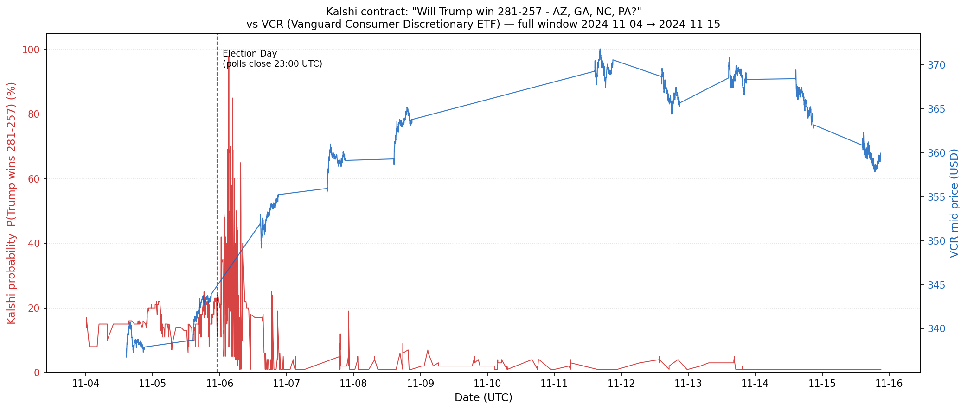
Figure 1. Kalshi probability (red) vs VCR mid price (blue), 2024-11-04 → 2024-11-15.
Kalshi: ~12% (11/4) → 98% overnight peak (11/6 03:00 UTC) → falls to single digits (specific 281-257 path didn't happen). VCR: ~340 (11/4) → gap up to ~353 at 11/6 open → steady step-wise climb to ~370 over the following week.

4. Figure 2 — Three Event-Day Zooms
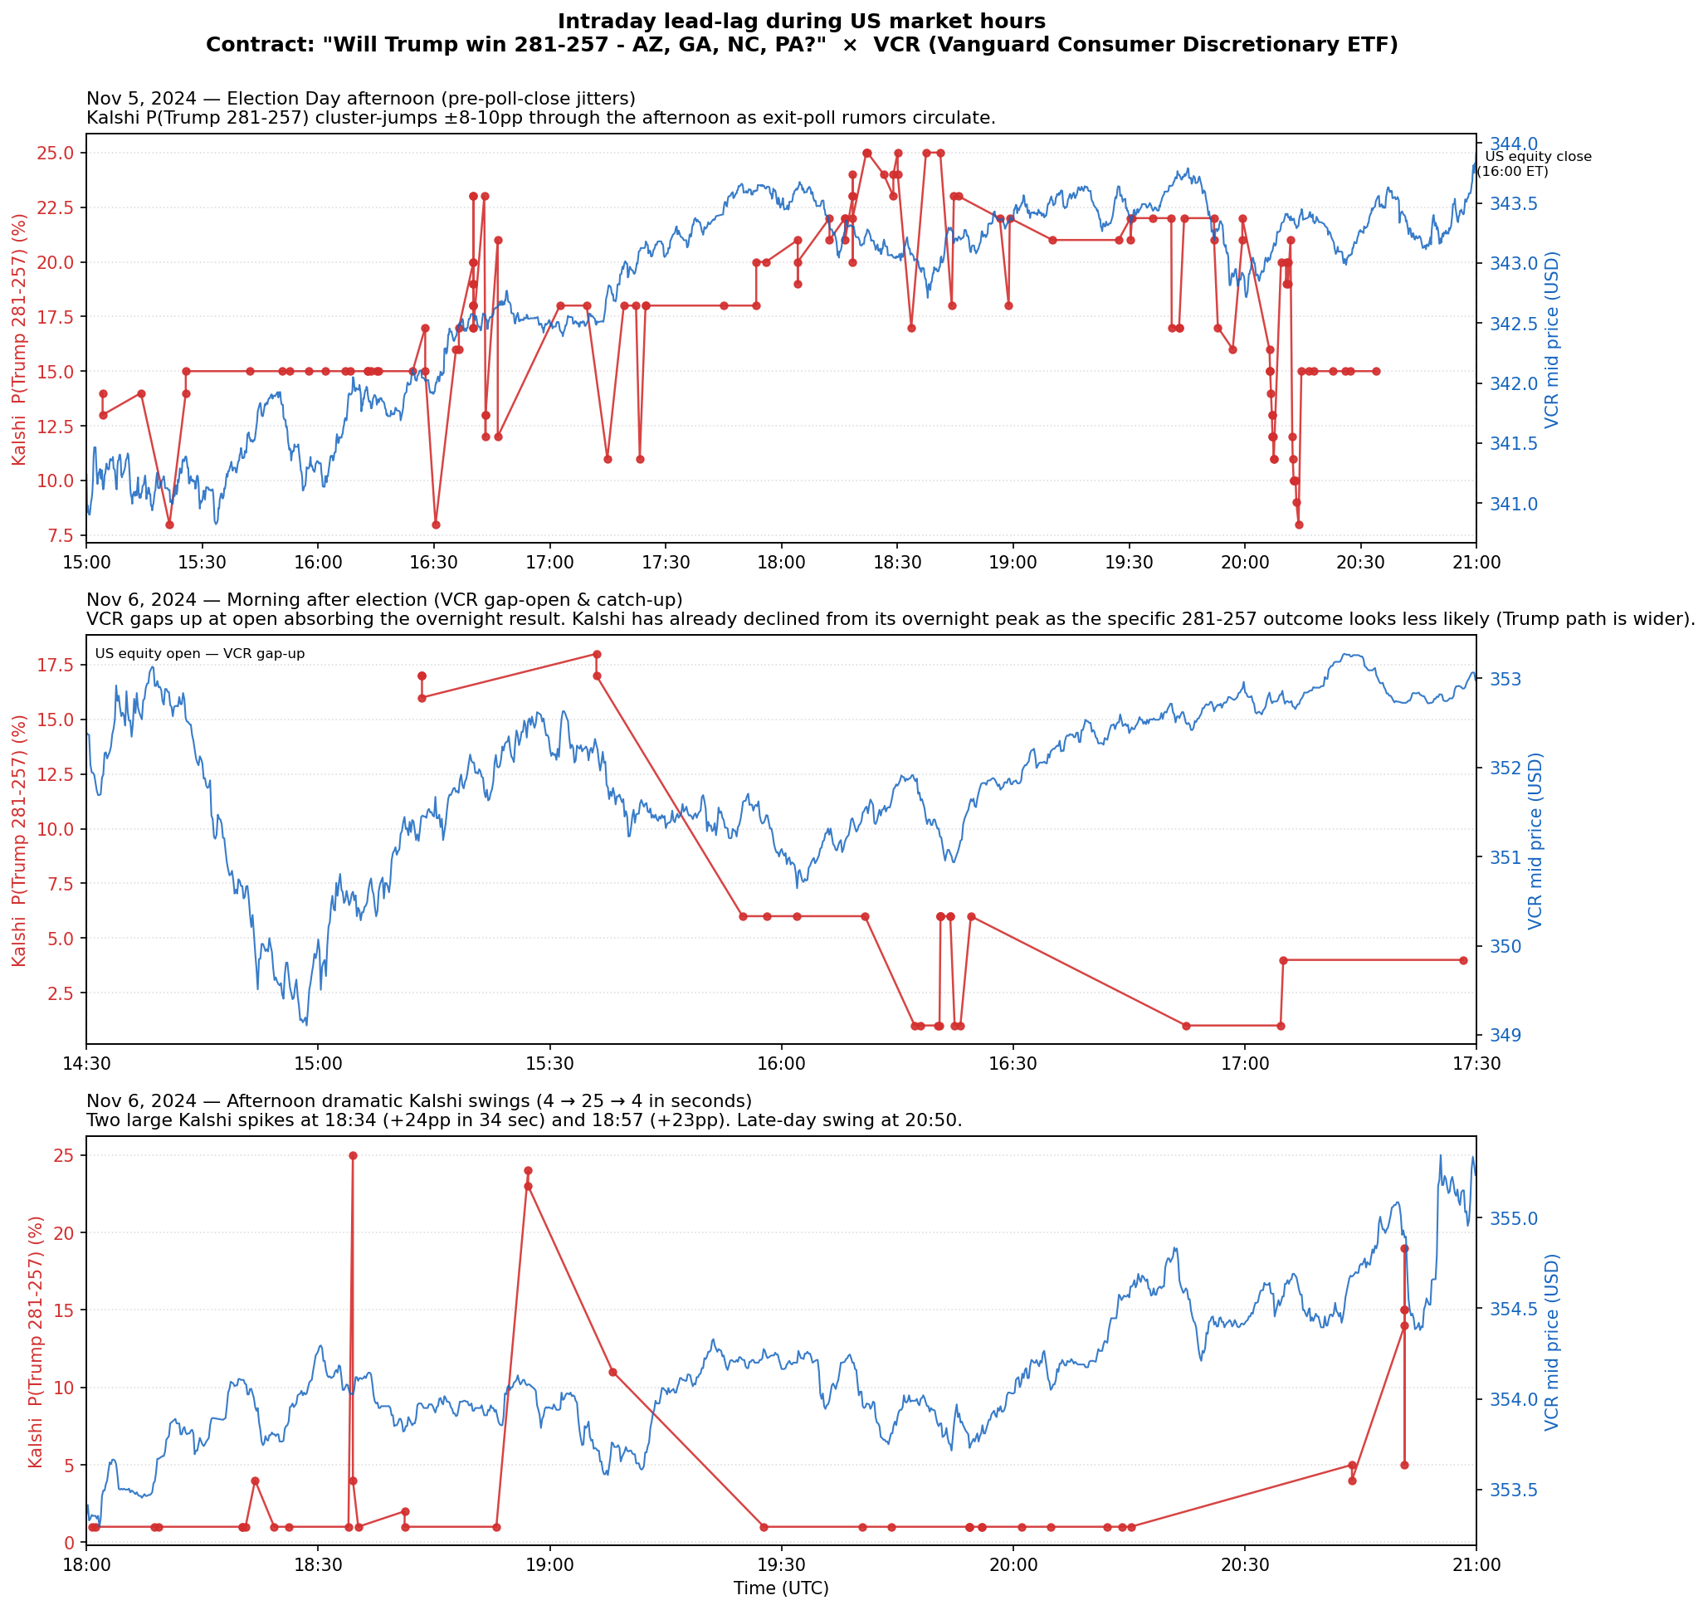
Figure 2. Three intraday event-day zooms during US equity market hours.
Panel A (Nov 5 afternoon): election day exit-poll jitters. Panel B (Nov 6 morning): VCR gap-open; Kalshi has already declined from overnight peak. Panel C (Nov 6 afternoon): anomalous Kalshi spikes (25¢, 24¢, 19¢) with no VCR response.

5. Figure 3 — Tick-Level Zooms
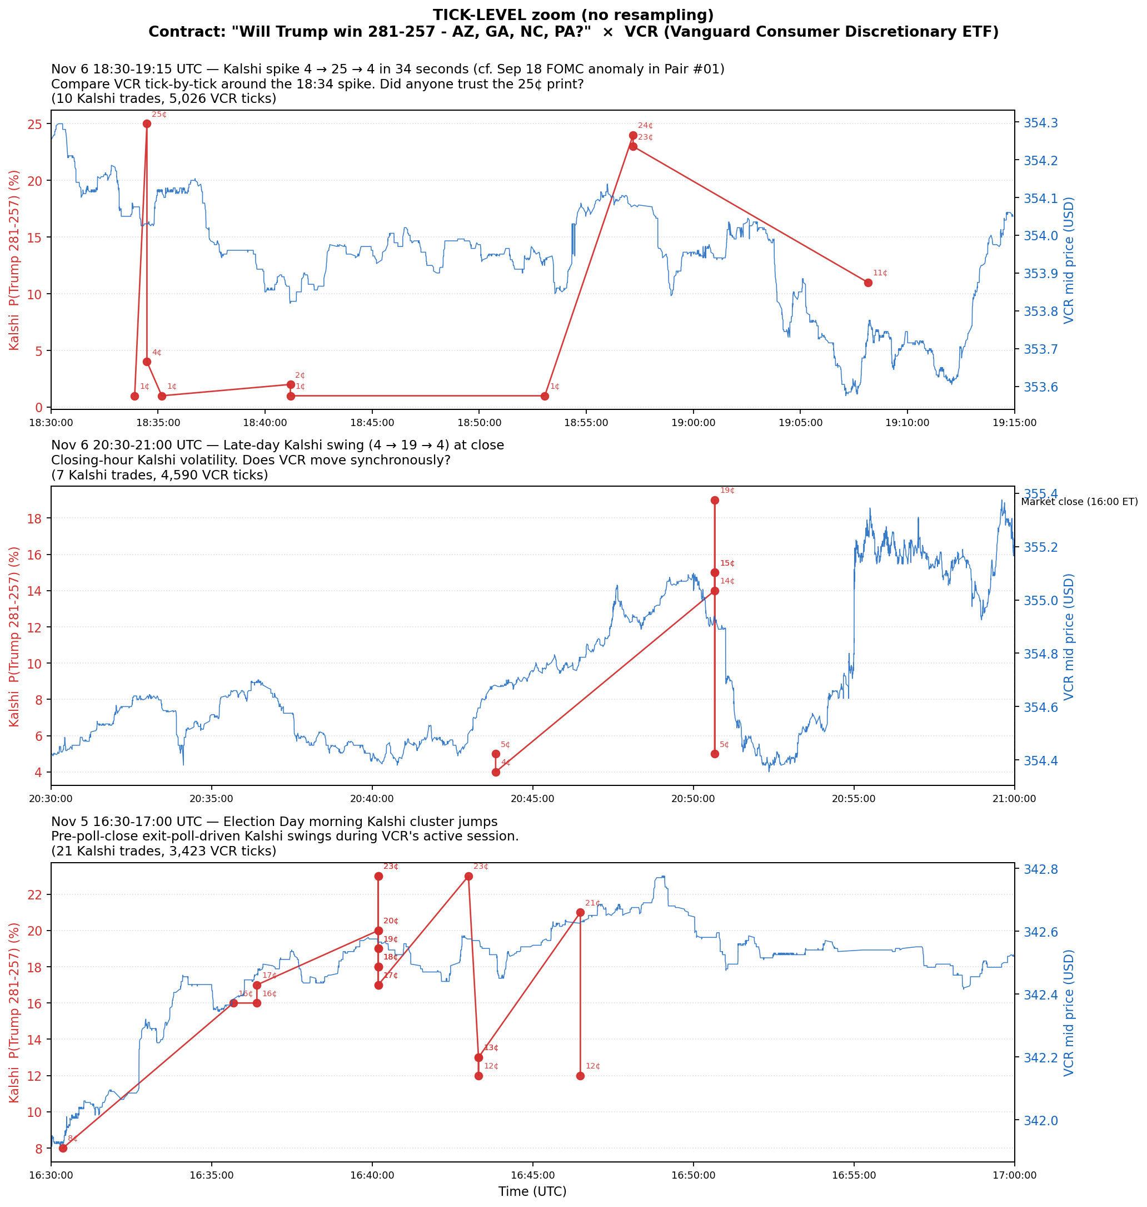
Figure 3. Tick-level zooms with every VCR quote and every Kalshi trade. No resampling.
Verdict at tick scale: Synchronous co-movement. No consistent Kalshi-leads or VCR-leads pattern detectable. Anomalous Kalshi spikes at 25¢/24¢/19¢ are isolated trades that don't elicit VCR response.

6. Figure 4 — Election-Night Special ⭐ Original Core Finding
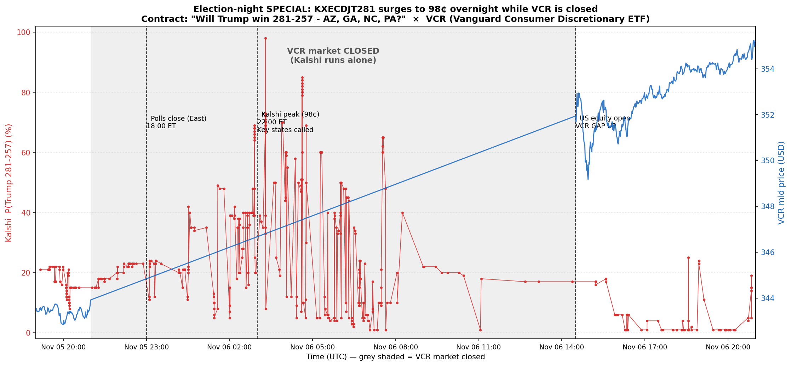
Figure 4. Election-night special: Nov 5 19:00 UTC → Nov 6 21:00 UTC. Grey band = VCR closed.
Kalshi monopolizes price discovery for ~17.5 hours while VCR is closed. VCR opens with gap-up to absorb overnight consensus. This is a STRUCTURAL pattern, not a tick-level lead-lag.

6b. Figure 5 — Multi-day Type B Compression ⭐ Added in correction pass
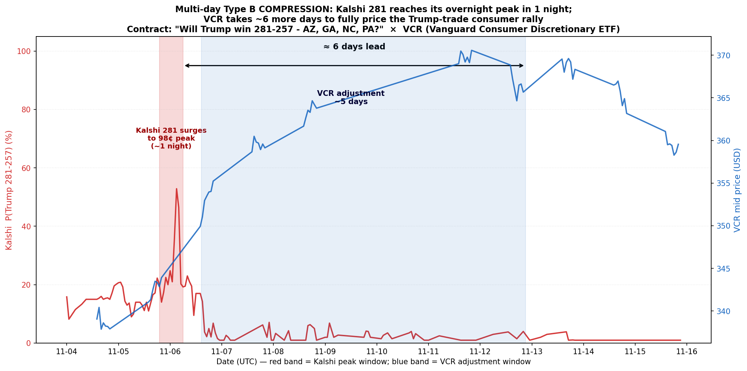
Figure 5. Multi-day Type B compression: Kalshi-281 peak (red band) precedes VCR full integration (blue band) by ~6 days.

What it shows
- Red band: Kalshi 281 surges from ~22% to 98% peak overnight (11/5 19:00 → 11/6 06:00 UTC). After peak, Kalshi 281 FALLS because the specific 281-257 path didn't happen.
- Blue band: VCR price climbs from ~340 to ~370 over 5 trading days (11/6 14:30 → 11/12 21:00 UTC).
- Black arrow: ~6-day lead from Kalshi-281 peak to VCR completion.

Important nuance — noisier than Pair #03
Unlike Pair #03 where Kalshi 312 was the actual outcome, Pair #02's Kalshi 281 is for a SPECIFIC path that didn't happen. So Kalshi-281 surges to 98¢ then falls. The underlying signal both markets respond to is 'Trump won'. Kalshi-281 reflects this via noisy peak; VCR reflects via smooth rise. The compression is still present — Kalshi's full info about Trump winning visible overnight; VCR took 5 more days to fully price the consumer-rally implications.

Why VCR takes 5 days (3 mechanisms)
- Closure asymmetry: VCR closed ~17.5h overnight; Kalshi was open and priced in result immediately
- Signal complexity asymmetry: Kalshi tracks one probability; VCR must integrate 'Trump → tax cuts → consumer confidence → discretionary spending'
- Order book thickness: VCR's deep book requires many trades to drift
Caveat: The 6-day lead is STRUCTURAL (closure + slow integration), NOT informational. Kalshi traders are not smarter than VCR traders.

7. Synthesis — Corrected Conclusions

Finding 1 — Intraday synchronization (tick scale)
When both markets are open, Kalshi and VCR move roughly synchronously. No consistent tick-level lead-lag. Regression direction (8 etf_leads / 5 kalshi_leads) confirms.

Finding 2 — Anomalous Kalshi trades are universal
Isolated 25¢/24¢/19¢ spikes revert within seconds and elicit zero VCR response. Robust microstructure finding, replicated across all pairs.

Finding 3 — Election night structural monopoly
Kalshi monopolizes price discovery for ~17.5 hours when VCR is closed. VCR gaps at open to absorb overnight consensus. Structural, not informational.

Finding 4 — Multi-day Kalshi leadership ⭐ Added in correction pass
At multi-day scale, Kalshi-281's overnight peak leads VCR's full adjustment by ~6 days. Clean (though noisier than Pair #03) Type B compression. The lead is structural (closure + slow integration), not informational.

Comparison table (Pair #01 vs Pair #02, with multi-day scale added)
 | Pair #01: Fed × VDE | Pair #02: Election × VCR
Statistical signature | 7 neg coefs, etf_leads dominant | 14 pos coefs, etf_leads slightly favored
Tick-level verdict | VDE leads Kalshi 20–30 min | Roughly synchronous
Multi-day verdict | No multi-day compression | Kalshi leads VCR by ~6 days
Anomalous spike pattern | Sep 18 28¢ | Nov 6 25¢, 24¢, 19¢
Unique structural pattern | None | Overnight monopoly during election night
Sign of co-movement | Negative | Positive

Revised 2×2 framework (with timescale dimension)
 | Tick scale (markets simultaneously active) | Multi-day scale (closure + slow integration)
Macro/policy info (Pair #01) | ETF leads Kalshi 20–30 min | No multi-day compression
Event-revelation info (Pair #02) | Synchronous | Kalshi leads VCR ~6 days

8. Limitations and Open Questions
- Anomalous trades: 25¢/24¢/19¢ pattern needs cross-validation against order book data
- Gap quantification: Nov 6 gap of ~1% reflects overnight Kalshi integration. Need quantification.
- Sample size: Only one election. Generalization limited.
- Confounding news flow: 5-day VCR rise also reflects ongoing news (cabinet picks). Cleaner identification would use ~3 days post-election only.

9. File Inventory
02_ecdjt281__vcr/
├── ANALYSIS.md
├── ANALYSIS.docx
├── plot_ecdjt281_vcr.py
└── plots/
├── ecdjt281_vcr_overview.png (Figure 1)
├── ecdjt281_vcr_event_zooms.png (Figure 2)
├── ecdjt281_vcr_tick_zooms.png (Figure 3)
├── ecdjt281_vcr_election_night.png (Figure 4)
└── ecdjt281_vcr_multiday_compression.png (Figure 5 — added in correction pass)

