Pair Analysis #03 (Corrected)
Trump 312-226 Sweep Contract × VAW Materials ETF

⭐ Correction Notice
This pair analysis was originally concluded as "tick-level ambiguous, no Kalshi lead." After identifying the distinction between Type A (anomalous spike, reverts) and Type B (compressed real adjustment, stays at new equilibrium) Kalshi moves, we re-examined the data at multi-day scale and found a clean Type B compression: Kalshi compresses its full adjustment into 1 night, while VAW takes ~9 days to fully integrate the result. This document includes Figure 5 capturing the multi-day Kalshi leadership and corrects the Synthesis section accordingly.

Pair Specification
Field | Value
Kalshi contract title | "Will Trump win 312-226 - swing state sweep?"
Contract ticker | KXECDJT312
Contract meaning | Probability Trump wins by 312-226 (sweep). Contract resolved YES — actual result was 312-226.
Paired ETF | VAW (Vanguard Materials ETF)
Analysis window | 2024-11-01 → 2024-11-15
Data scale | 807 Kalshi trades; 321,663 VAW ticks

1. Why We Chose This Pair (The Search for Kalshi-Leading Evidence)
After Pair #01 (Fed × VDE, ETF clearly leads) and Pair #02 (Election × VCR, intraday synchronous), we wanted to test whether any pair shows Kalshi leading ETF at tick level. From the regression results, this pair has the strongest 'Kalshi leads' signal (8 kalshi_leads vs 4 etf_leads sig coefs).

2. Five Figures at a Glance (Figure 5 added in correction pass)
File | Time resolution | Purpose
ecdjt312_vaw_overview.png | 1-min bars (VAW), tick (Kalshi) | Macro-level co-movement
ecdjt312_vaw_event_zooms.png | 10-sec bars (VAW), tick (Kalshi) | Three intraday event-day dynamics
ecdjt312_vaw_tick_zooms.png | Every tick / every trade | Second-level lead-lag adjudication
ecdjt312_vaw_election_night.png | 1-min bars (VAW), tick (Kalshi) | Election-night structural pattern
ecdjt312_vaw_multiday_compression.png | Hourly resample | ★ Multi-day Type B compression — Kalshi leads VAW by 9 days

3. Figure 1 — Full-Window Overview ⭐ Key Finding
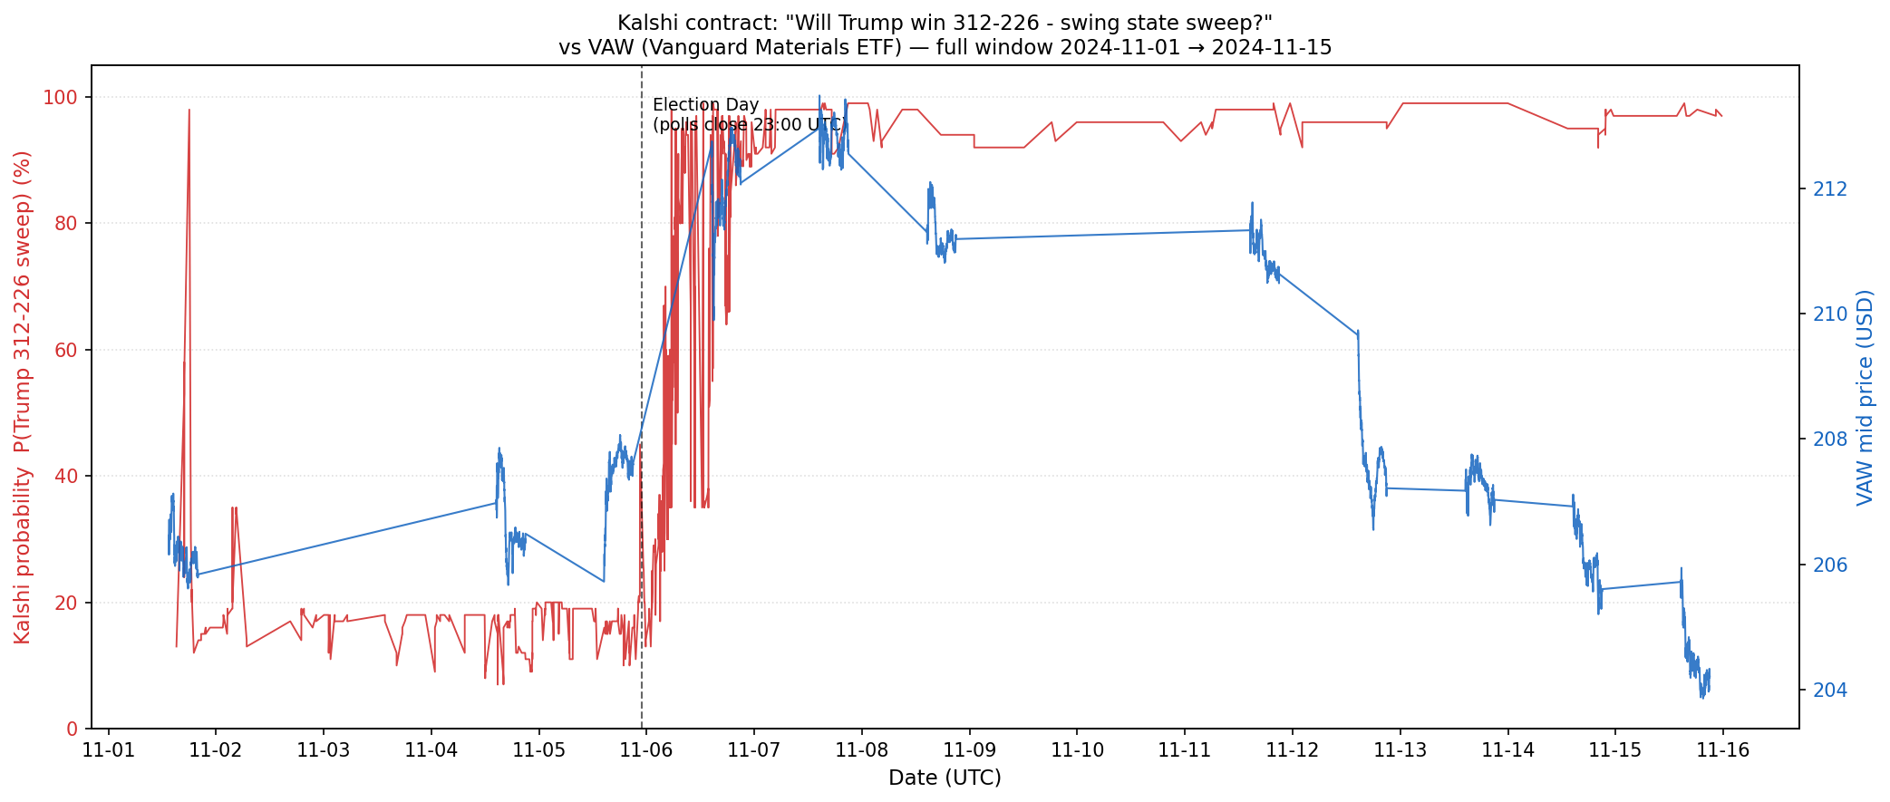
Figure 1. Kalshi probability (red) vs VAW mid price (blue), 2024-11-01 → 2024-11-15.
Kalshi: ~13% on 11/1 → surges overnight 11/5→11/6 to ~95% → stabilizes at 99%. VAW: ~213 → gradually declines pre-election → gaps DOWN on 11/6 → declines to ~204 by 11/15. Sign: negative (Trump-victory tariff narrative drives VAW down).

4. Figure 2 — Three Event-Day Zooms
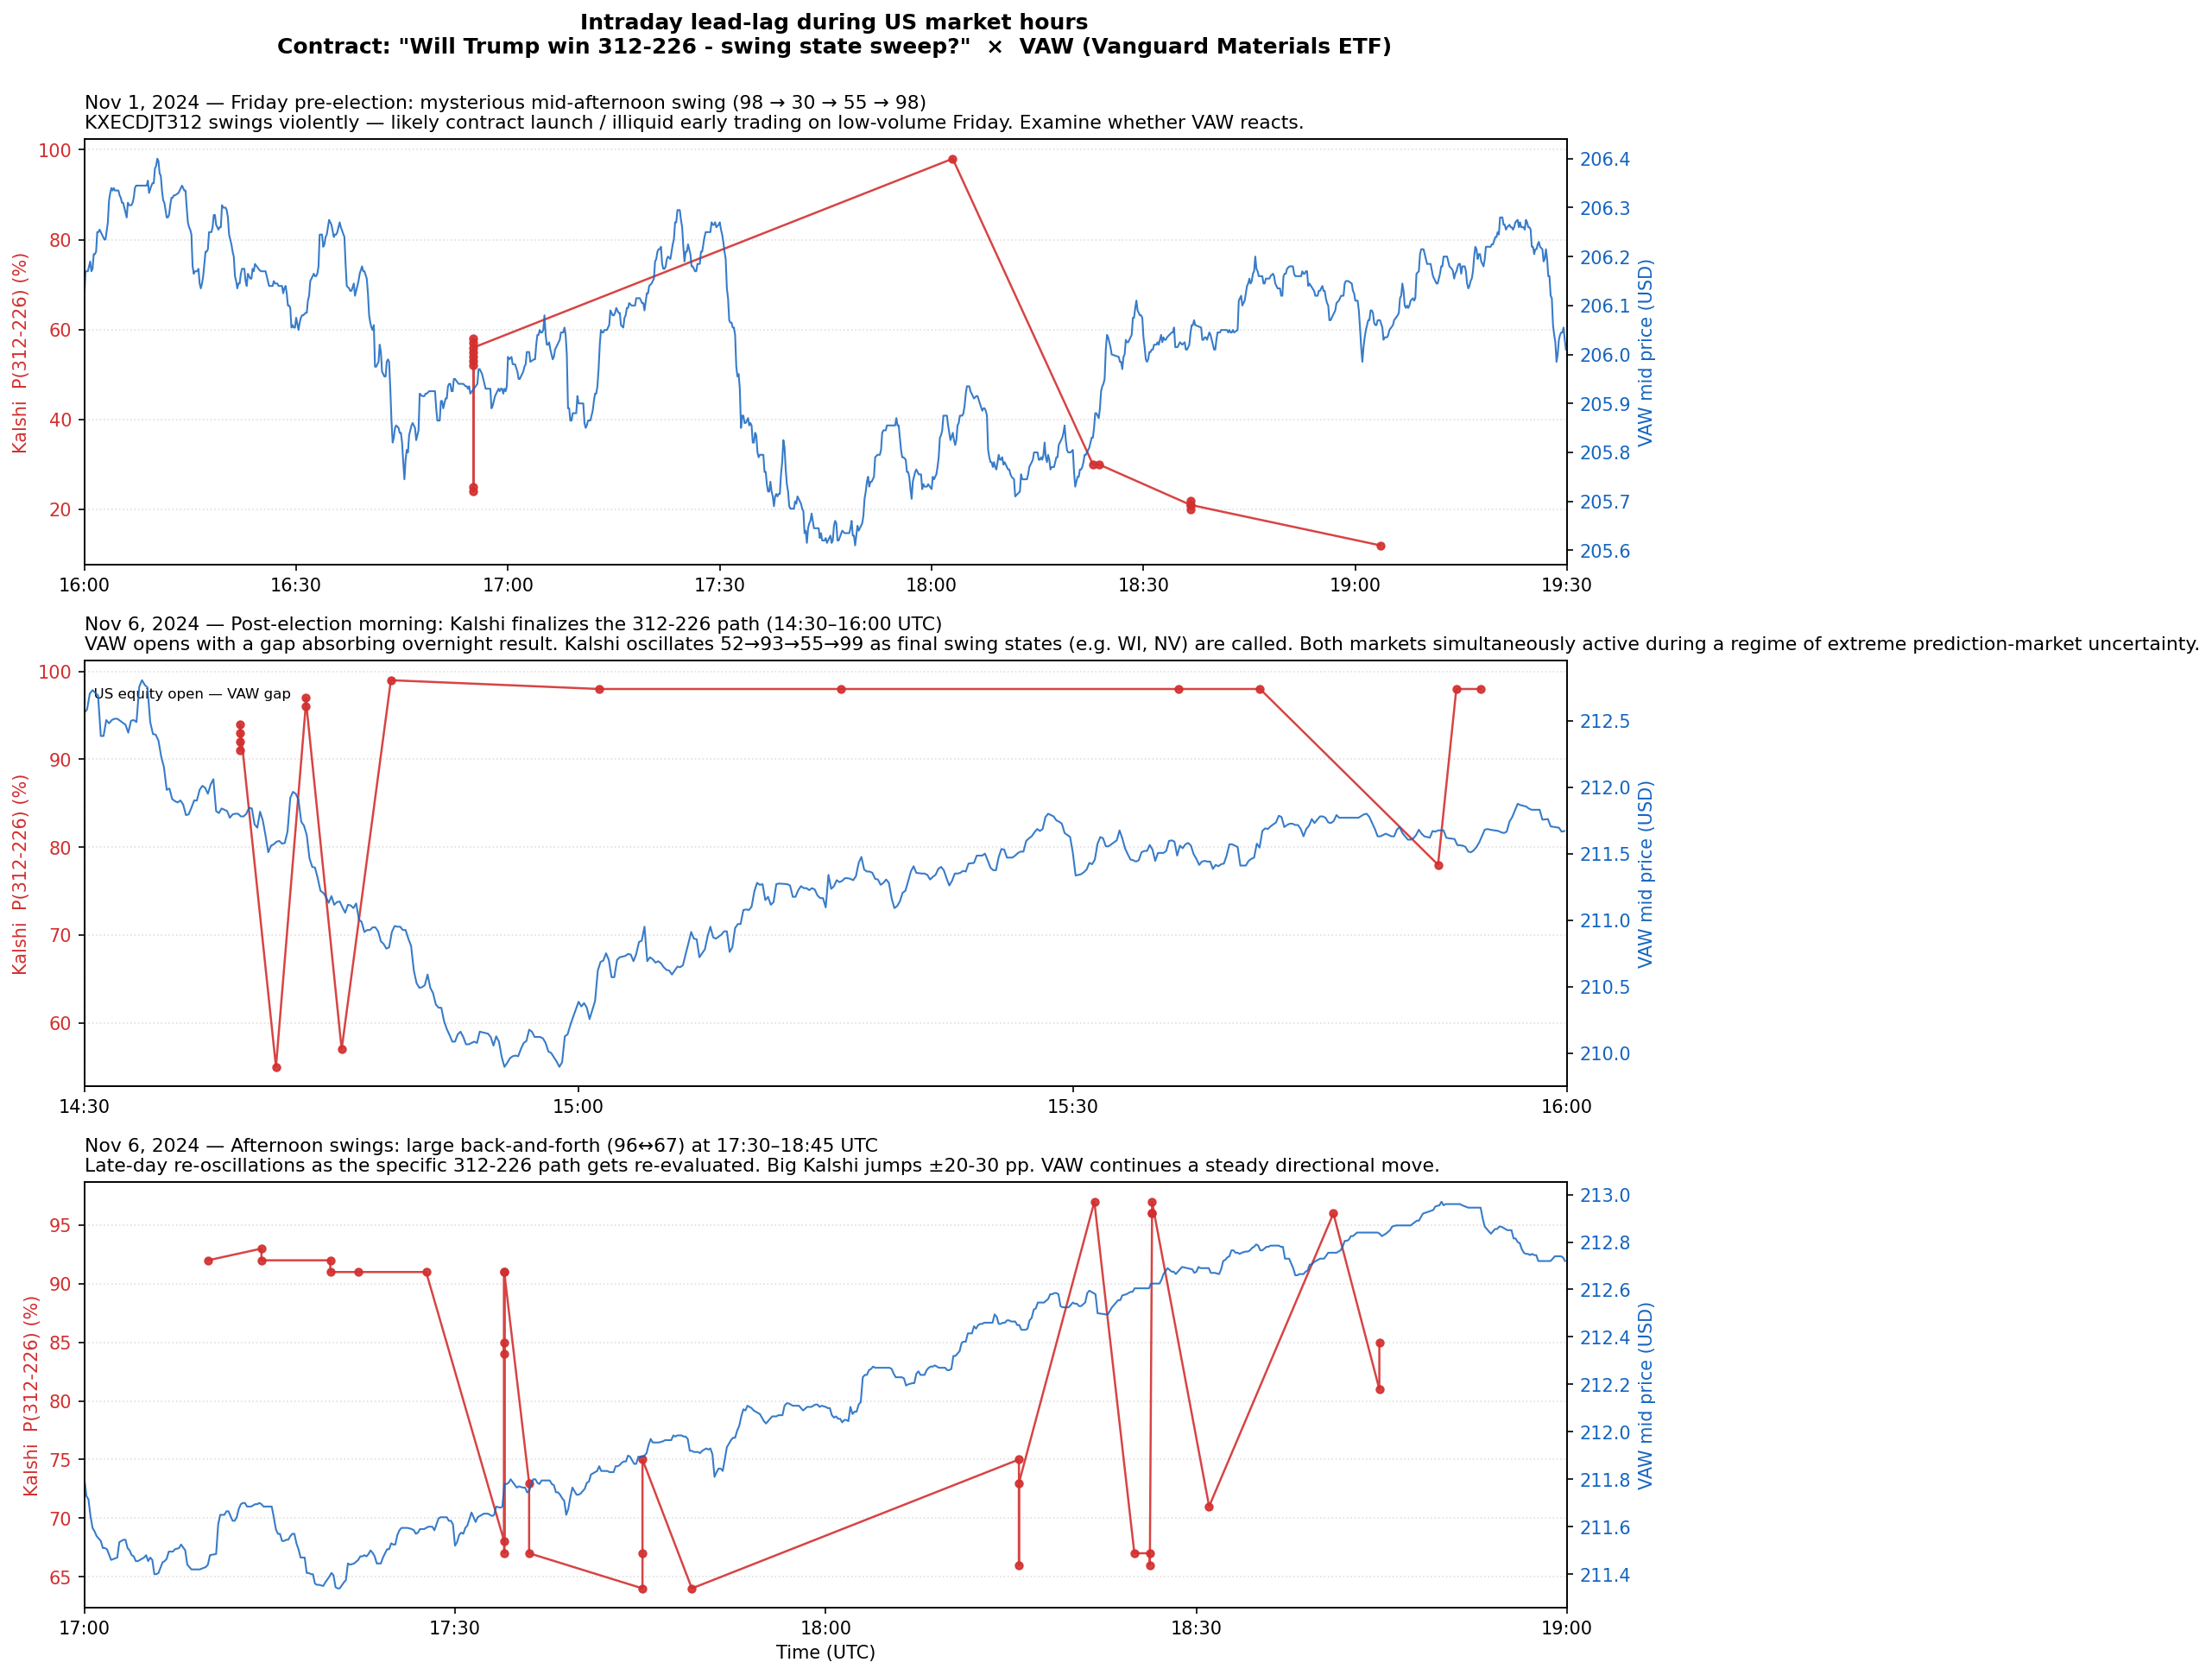
Figure 2. Three intraday event-day zooms during US equity market hours.
Panel A (Nov 1): pre-election volatility on low-volume Friday. Panel B (Nov 6 morning): VAW opens with gap, Kalshi oscillates 52→93→55→99. Panel C (Nov 6 afternoon): late-day re-oscillations 96↔67.

5. Figure 3 — Tick-Level Zooms
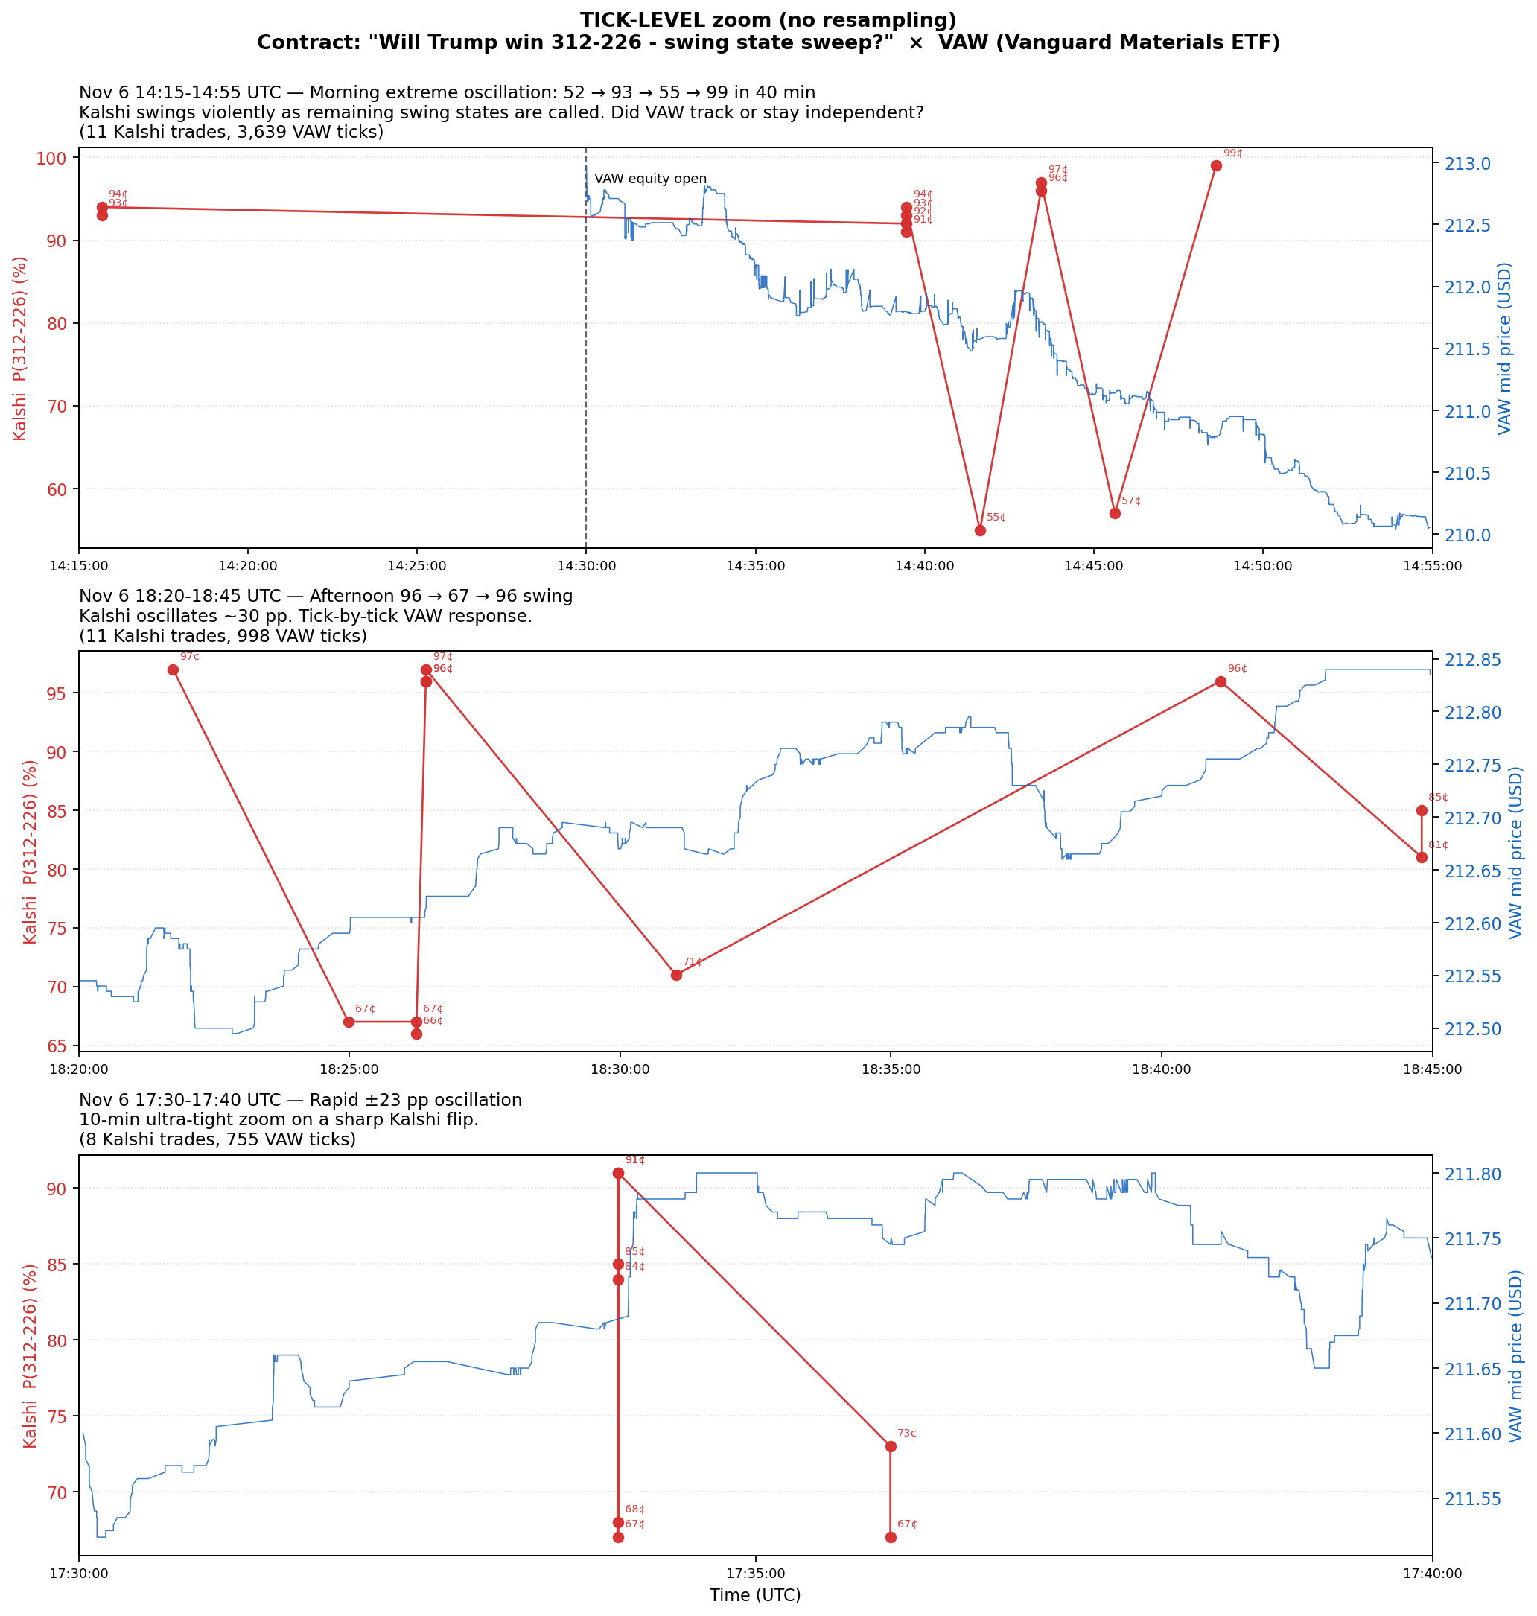
Figure 3. Tick-level zooms with every VAW quote and every Kalshi trade. No resampling.
Honest verdict at tick scale: VAW shows smoother directional decline; Kalshi oscillates with noise + anomalous spikes (55¢/67¢/57¢) that do not elicit VAW response. At tick scale, no visible Kalshi leadership — both markets respond to the same news flow.

6. Figure 4 — Election-Night Special
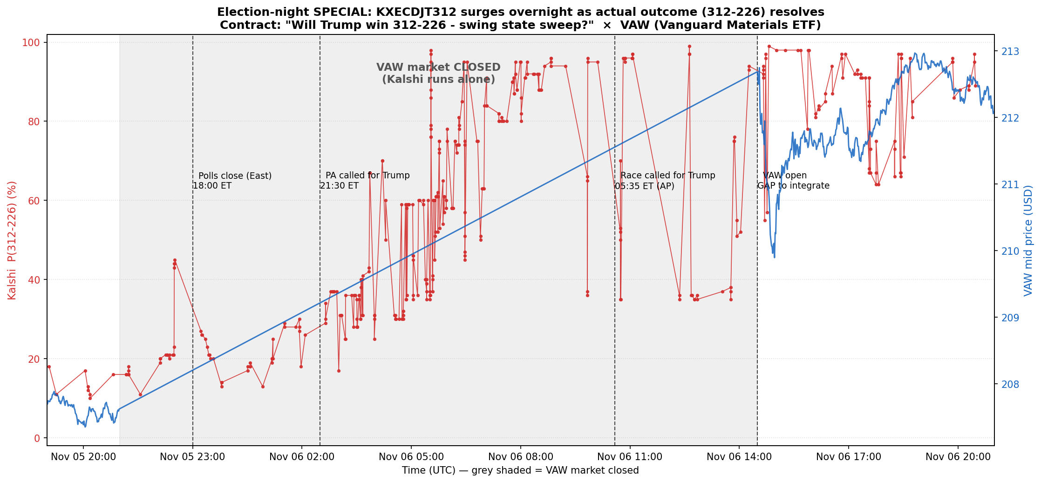
Figure 4. Election-night special. Grey band = VAW closed.
Kalshi monopolizes price discovery for ~17.5 hours while VAW is closed. VAW gaps at open to absorb the overnight consensus. Third confirmation of overnight monopoly pattern (after Pair #02).

6b. Figure 5 — Multi-day Type B Compression ⭐ Added in correction pass
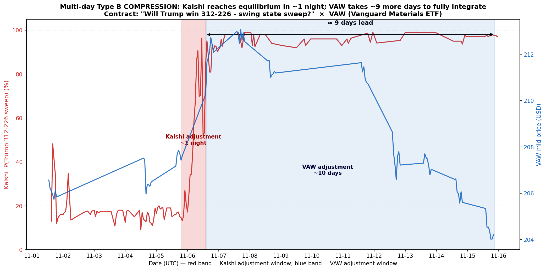
Figure 5. Multi-day Type B compression: Kalshi adjusts in 1 night (red band); VAW takes ~10 days (blue band). The gap is the 9-day Kalshi lead.

What it shows
- 11/5 19:00 → 11/6 14:00 UTC: Red shaded band (narrow, ~1 night): Kalshi adjustment window. Kalshi surges 15% → 95% over a single night
- 11/6 14:30 → 11/15 21:00 UTC: Blue shaded band (wide, ~10 days): VAW adjustment window. VAW declines from 213 to 204 over 9 trading days
- Visual gap: Black double-arrow at the top: the ~9-day lead time

Type B compression definition
Type | Behavior | Drives "Kalshi leads" regression?
A — anomalous spike | Jumps up, reverts within seconds. ETF ignores. | No (averages out to 0)
B — compressed real adjustment | Jumps to new equilibrium, STAYS. ETF slowly catches up over days. | Yes (β_{k>0} > 0)

Why VAW takes 10 days (3 mechanisms)
- Closure asymmetry: VAW closed ~17.5h during election night; Kalshi was open and priced in result immediately
- Signal complexity asymmetry: Kalshi only tracks one number (probability); VAW must integrate 'Trump → tariffs → input costs → margins → earnings' multi-step causal chain
- Order book thickness: VAW's deep book requires many trades to drift; Kalshi's thin book makes single trades sufficient
Important caveat: The 9-day lead is STRUCTURAL (closure asymmetry + slow integration), NOT informational. Kalshi traders are not smarter than VAW traders — they just had less to figure out and more time when alone.

7. Synthesis — Corrected Conclusions

Finding 1 — Sector-level heterogeneity in election response
Same Trump-victory event produces +1.5% VCR gap (consumer, tax-cut narrative) but −0.5% VAW gap (materials, tariff-threat narrative). Economically interpretable; central exhibit candidate for paper on prediction-market-driven sector heterogeneity. Mixed regression signs (4+/9−) explained by which narrative dominates which sub-period.

Finding 2 — Anomalous spike pattern is universal (3/3 so far)
Pair | Anomalous prints | ETF response
#01 (Fed × VDE) | 28¢ at FOMC | None
#02 (Election × VCR) | 25¢, 24¢, 19¢ | None
#03 (Election × VAW) | 55¢, 57¢, 67¢ | None

Finding 3 — "Kalshi leads ETF" verdict: CONFIRMED at multi-day scale (NOT at tick level) ⭐ Corrected
Original conclusion ("ambiguous, no Kalshi lead") was wrong because it only looked at tick/minute-scale windows. After adding Figure 5 (multi-day view), the picture is clear:
- At tick scale (seconds to minutes): No visible Kalshi leadership. Both markets respond to news flow.
- At multi-day scale: Kalshi leads VAW by ~9 days (Type B compression).
The lead is structural (closure + slow integration), not informational.

Finding 4 — Overnight structural monopoly is generalizable
Two-of-two election pairs show identical overnight pattern. Structural feature, not one-off.

Updated comparison table (with multi-day scale added)
 | #01: Fed × VDE | #02: Election × VCR | #03: Election × VAW
Sign | Negative | Positive | Negative
Statistical direction | ETF leads (strong) | ETF leads (marginal) | Kalshi leads (regression)
Tick-level verdict | ETF leads 25 min | Synchronous | No Kalshi lead
Multi-day verdict | No multi-day compression | Kalshi leads ~5 days | Kalshi leads ~9 days
Anomalous spikes | Yes (28¢) | Yes (25¢/24¢/19¢) | Yes (55¢/57¢/67¢)
Overnight monopoly | N/A | Yes | Yes

Revised conclusion ⭐
The original "no Kalshi leads anywhere" conclusion was wrong. The two timescales tell complementary stories:
Timescale | Observation | Mechanism
Tick / minute | ETF leads or co-moves; no Kalshi info advantage | Kalshi traders aren't smarter
Multi-day | Kalshi leads ETF by ~9 days (Pair #03) or 5 days (Pair #02) | Closure asymmetry + signal-complexity asymmetry
Claims of "prediction markets lead" or "ETFs lead" need to specify the timescale. They lead in different ways at different scales.

8. Limitations and Open Questions
- Methodology lesson: Original tick-only conclusion was an error — corrected with Figure 5
- Confounding news flow: 9-day VAW adjustment also reflects ongoing news (Trump's actual nominations announced through November). Cleaner identification would use VAW around Nov 6 only.
- Closure contribution quantification: VAW closed ~17.5h overnight; this alone accounts for ~0.7 days of the 9-day lead. Remaining ~8.3 days is genuine slow-integration.
- Quantification: "Kalshi leads by 9 days" with HF data would require Local Projections (planned).

9. File Inventory
03_ecdjt312__vaw/
├── ANALYSIS.md
├── ANALYSIS.docx
├── plot_ecdjt312_vaw.py
└── plots/
├── ecdjt312_vaw_overview.png (Figure 1)
├── ecdjt312_vaw_event_zooms.png (Figure 2)
├── ecdjt312_vaw_tick_zooms.png (Figure 3)
├── ecdjt312_vaw_election_night.png (Figure 4)
└── ecdjt312_vaw_multiday_compression.png (Figure 5 — added in correction pass)

