Angela Corcino

Wells international college  [Company address]

Evaluate and communicate business requirements

|  |  |  |  |
| --- | --- | --- | --- |
| Name of Student | ANGELA A. G. MOURAO CORCINO | ID | 17485 |

**Assessment – Research and Questioning**

Contents

Instructions: 1

Business Scenario 1

Website content………………………………………………………………………………………………………………………………………………..1

Task 1: Determine support areas 4

Task 2: Identify stakeholders 4

Task 3: Develop support procedures 5

Task 4: Assign Support Personnel 5

Task 5: Short Answer Questions 6

Task 6: Multiple Choice Questions 7

Search Index 15

# Instructions:

This is an individual assessment. Answer all the questions on the document provided by your Trainer.

***Duration:***

Trainer will set the duration of the assessment.

# Business Scenario

D&K Books Pty Ltd is a bookstore owned by Mr. Dean Kerr. The business occupies two levels of an office building connected by escalators and lifts. D&K Books employs approximately six sales staff, one operation manager, two administrative officers, a bookkeeper and a marketing manager. They have an Ethernet network consisting of ten PCs (Intel I3 Desktop cloned), two switches, a router and three printers. They use the QuickBooks software to manage their entire business, including sales, inventory, ordering, accounts receivable, accounts payable, payroll and employee management. They also have two EFTPOS terminals one on each floor.

D&K Books has a Linux server that stores all of the data including the QuickBooks database. The server is backed up to tape regularly. They also have a website (hosted on an Australian ISP’s server, dynamic and static pages using asp.net) on which customers can browse the product catalogue and view current specials. They also lease a telephone system from Live Telecoms. The PABX (phone system) consists of a main switchboard and five remote phones with three incoming lines and a message-on-hold queue system.

Please check my website support:

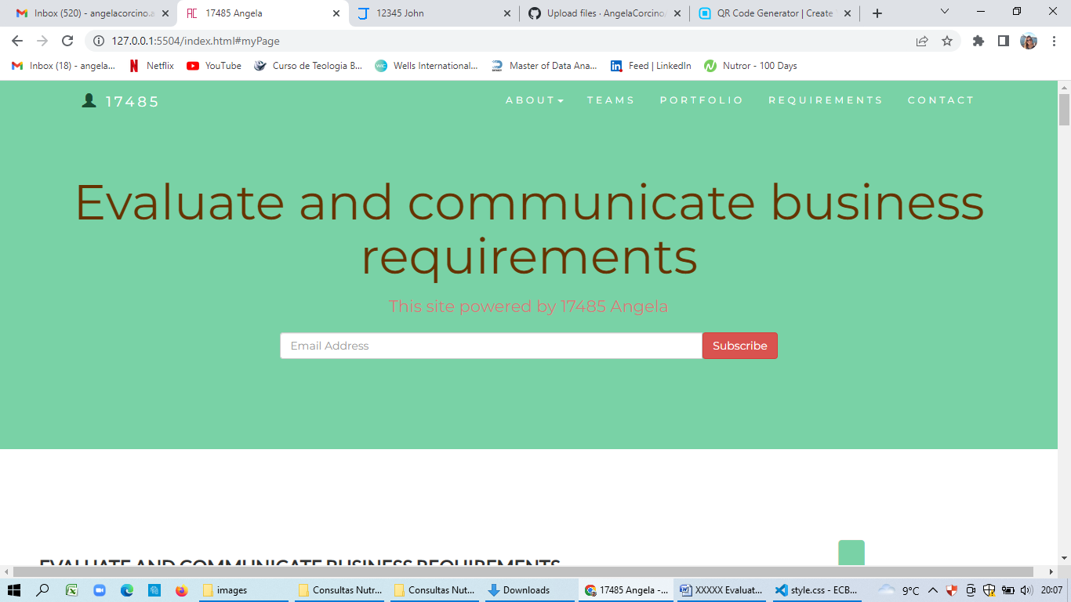

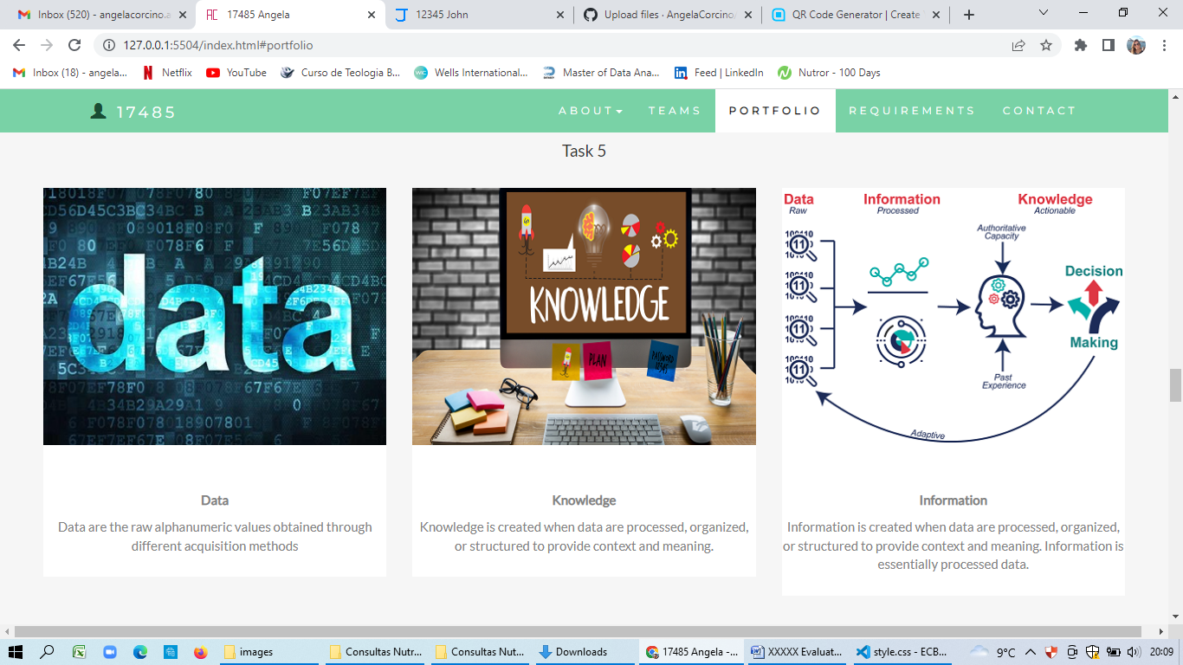

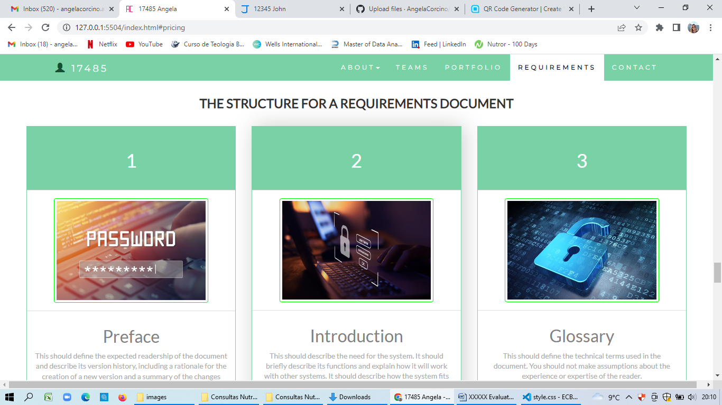

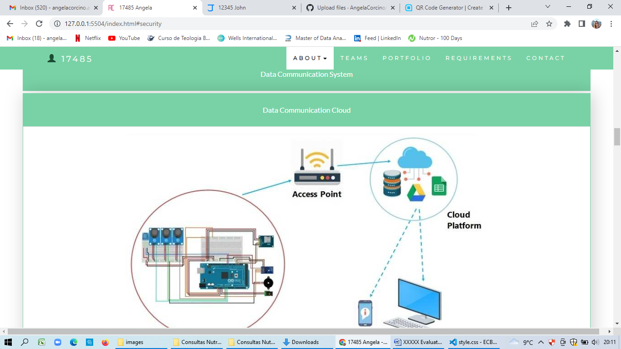

# Task 1: Determine support areas

Identify information technology (HW and SW) and list the technology in use in D&K Books and consider the following:

* What sort of support does the technology require?
* Who is likely to provide this support?
* Does the support arrangement already exist?

Present your answer in a table such as the one below:

|  |  |  |  |  |
| --- | --- | --- | --- | --- |
| **Technology** | **Description** | **Support Required** | **Provider** | **Support Already exists? (Yes/No)** |
| QuickBooks Software | Software to manage their entire business | customisation, training, upgrades, bug fixes (patching), user support | [www.intuit.com.au](http://www.intuit.com.au)  online to find more | No |
| PC’s | Intel I3 Desktop | upgrades, repairs, troubleshooting, maintenance, backup, customisation, network to link | Microsoft | No. Need find one person to do this job |
| Server | Linux | User account management, security policy implementation, home folder management, permissions management, backup and restore, operating system patching, software installation | Shop | No |
| EFTPOS | For payments | No need | shop | Yes |
| Telephone system | Main switchboard and five remote phones with three incoming lines and a message-on-hold queue system. | Phone company | Telstra | Yes |
| Website | Used for customers to browse the product catalogue and view current specials | Yes | Godaddy | no |

# Task 2: Identify stakeholders

Identify stakeholders related in D&K Book’s system

**Internal: Project manager, team such as data analyst, developer full stack, assistant administrative, data engineer, sponsor.**

**External: Customers, Intel Company, Australian ISP’s server company.**

# Task 3: Develop support procedures

1. Describe one positive and one negative experience you have had when seeking assistance from a telecommunications company, an ISP or a computer supplier. Your experience may be via telephone, email or even voice recognition.

**Positive experience was when I called to a telecommunications company to get a internet provider and the company was clear on the phone e give all instructions to install the wifi router.**

**Negative experience was when I tried to cancel one invoice and they could not find and and I was being charged every month.**

1. Using the experiences described above please answer the following questions.
   1. What support aspects were professional and/or unprofessional?

**The experience and guide through the process was great and unprofessional was when they had not experience enough to solve my problem.**

* 1. How long did the support process take?

**Less than 10 minutes (Internet provider)**

**More than 1 hour (Vodafone provider)**

* 1. Were the steps logical?

**Yes, I followed up all instructions to install the router**

* 1. Did they solve your problem?

**Yes**

* 1. Was the call deflected to another area?

**Yes, I did not waste my time and I recommended to others that company**

# Task 4: Assign Support Personnel

Classify the following into soft skills and technical skills. Your answer should take the form of a table shown below.

|  |  |  |
| --- | --- | --- |
| **Skill** | **Soft skill** | **Technical skill** |
| A knowledge of Linux |  | x |
| The ability to work under pressure | x |  |
| The administration of Windows 2008 Server |  | x |
| The ability to formulate network and IT policies | x | x |
| The ability to write network documentation | x | x |
| The ability to give presentations | x |  |

# Task 5: Short Answer Questions

1. 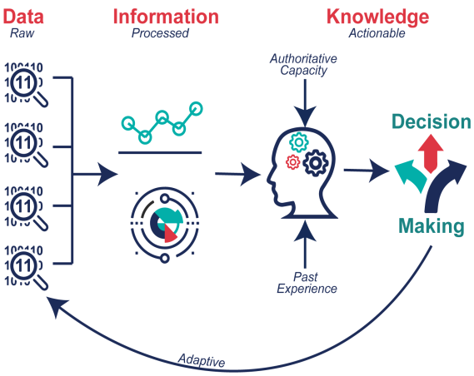Explain the relationship between data, information and knowledge.

**Data are the basic facts; information is data with context; knowledge is processed information with meaning**.

<https://internetofwater.org/valuing-data/what-are-data-information-and-knowledge/#:~:text=Data%20in%20their%20simplest%20form,Knowledge%20is%20what%20we%20know>.

1. What is quantitative data and how can you use it.

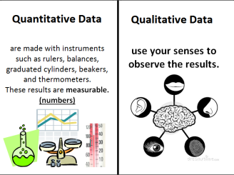**Quantitative data are used when a researcher is trying to quantify a problem, or address the "what" or "how many" aspects of a research question. It is data that can either be counted or compared on a numeric scale.**

<https://libguides.macalester.edu/c.php?g=527786&p=3608639>

1. What is qualitative data and how can you use it.

**Qualitative data describes qualities or characteristics. It is collected using questionnaires, interviews, or observation, and frequently appears in narrative form**

1. Give an example of how quantitative and qualitative data can be used in conjunction with each other.

**Hybrid research is a combination of two market research techniques whether it be qualitative and quantitative, or a mixture of qualitative methods, to deliver the perfect solution.**

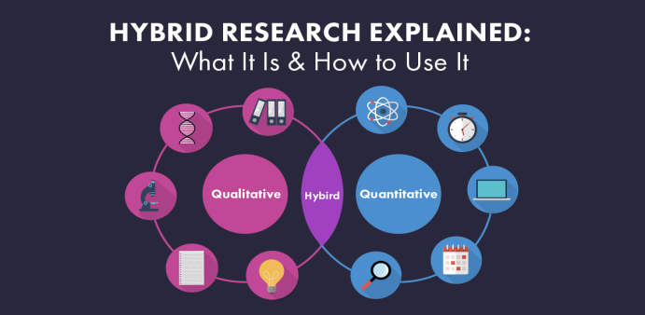

<https://www.driveresearch.com/market-research-company-blog/hybrid-research-combining-qualitative-and-quantitative-methods-for-better-results/>

1. What sort of methods could you use to determine client requirements for a website design and key information sources?

**Goal identification, Scope definition, Sitemap and wireframe creation, Content creation, Visual elements, Testing**

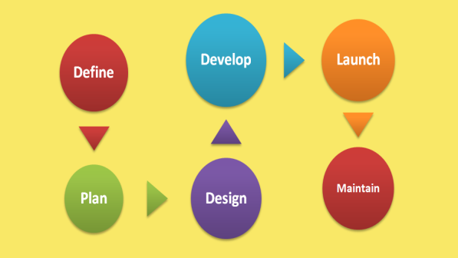**Launch.**

<https://webflow.com/blog/the-web-design-process-in-7-simple-steps>

1. Give some examples of client requirements for a website design

**Website Content Requirements, Images, Mock-ups, Access to your Domain and Hosting, Google Drive Access, Shortlist.**

<https://www.webdesigninnerwest.com.au/?gclid=CjwKCAjwx7GYBhB7EiwA0d8oe5xJpZYtnELqzRnsWmgXlpsY8KEoEOO0anebCfEIAPlWMZsFLxYWfRoCqD0QAvD_BwE>

# 2 Survey Rating Scale for the Walking Experience Survey | Download Scientific DiagramTask 6: Multiple Choice Questions

1. Generally, how many points should a rating scale have?
   1. Five
   2. Four
   3. Ten
   4. Somewhere from 4 to 11 points

**A rating scale is one of the most commonly used questionnaire types for online as well as offline surveys.**

<https://www.voxco.com/blog/rating-scale/#:~:text=What%20is%20a%20Rating%20Scale,the%20qualitative%20and%20quantitative%20attributes>.

1. 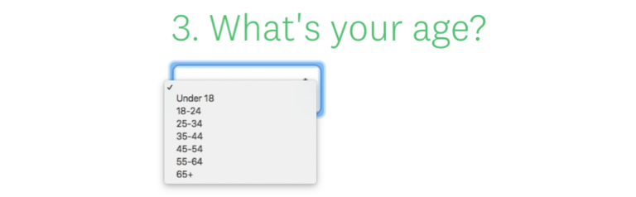What is the problem(s) with this set of response categories to the question “What is your current age?” o 1-5 o 5-10 o 10-20 o 20-30 o 30-40
   1. The categories are not mutually exclusive
   2. The categories are not exhaustive
   3. Both a and b are problems
   4. There is no problem with the above set of response categories

**First, the categories (response options) must be mutually exclusive, which means they do not overlap with one another. Second, survey response options must be collectively exhaustive, meaning they provide all possible options that could comprise a response list.**

<https://www.cvent.com/en/blog/events/survey-response-design-mutually-exclusive-collectively-exhaustive-categories>

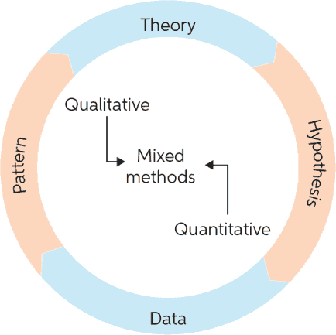

1. You should mix methods in a way that provides complementary strengths and no overlapping weaknesses. This is known as the fundamental principle of mixed research.

a) True

b) False

**Mixed methods research, also known as hybrid methods research, is an evolving research methodology that involves the methodical integration or combination of quantitative and qualitative research approaches within a single research study.**

<https://www.chegg.com/writing/guides/research/mixed-methods-research/>

1. According to the text, questionnaires can address events and characteristics taking place when?
   1. In the past (retrospective questions)
   2. In the present (current time questions)
   3. 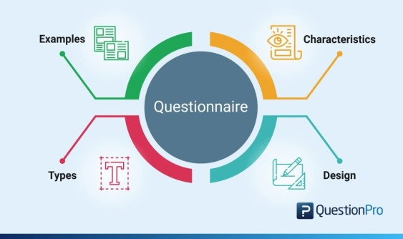In the future (prospective questions)
   4. All of the above

**A research questionnaire is typically a mix of close-ended questions and open-ended questions.**

<https://www.questionpro.com/blog/what-is-a-questionnaire/>

1. Which of the following are principles of questionnaire construction?
   1. Consider using multiple methods when measuring abstract constructs
   2. Use multiple items to measure abstract constructs
   3. Avoid double-barrelled questions
   4. All of the above
   5. Only b and c

**There are at least nine distinct steps: decide on the information required; define the target respondents, select the method(s) of reaching the respondents; determine question content; word the questions; sequence the questions; check questionnaire length; pre-test the questionnaire and develop the final questionnaire**

<https://www.fao.org/3/w3241e/w3241e05.htm>

1. 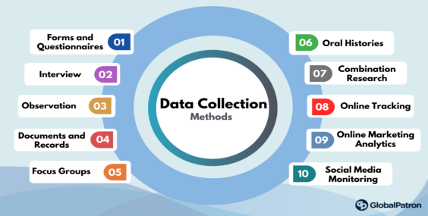Which of these is not a method of data collection?
   1. Questionnaires
   2. Interviews
   3. Experiments
   4. Observations

**Data are the information gained from observing and testing an experiment.**

<https://www.albert.io/blog/data-collection-methods-statistics/>

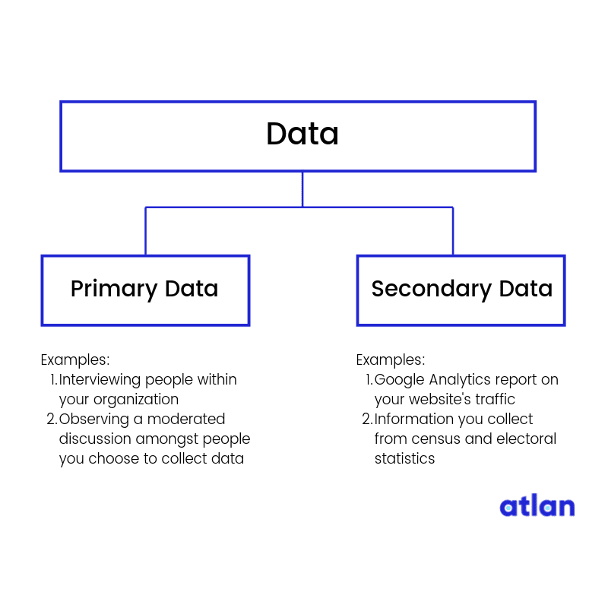

1. Secondary/existing data may include which of the following?
   1. Official documents
   2. Personal documents
   3. Archived research data
   4. All of the above

**Secondary data is the data that has already been collected through primary sources and made readily available for researchers to use for their own research. It is a type of data that has already been collected in the past.**

<https://www.formpl.us/blog/secondary-data>

1. 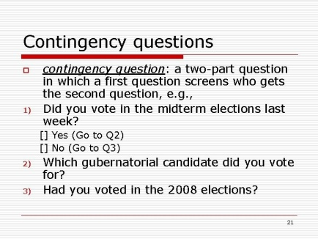An item that directs participants to different follow-up questions depending on their response is called a ____________.
   1. Response set
   2. Probe
   3. Semantic differential
   4. Contingency question

**Contingency questions are questions that are only to be answered by some subgroup(s) of respondents**.

<https://home.csulb.edu/~msaintg/ppa696/696qstin.htm>

1. Which of the following terms best describes data that were originally collected at an earlier time by a different person for a different purpose?

a) Primary data

* 1. Secondary data
  2. Experimental data
  3. Field notes

**Secondary data is the data that has already been collected through primary sources and made readily available for researchers to use for their own research. It is a type of data that has already been collected in the past.**

<https://www.formpl.us/blog/secondary-data>

1. 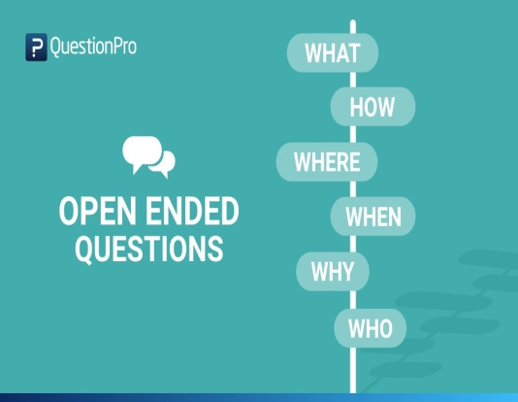Researchers use both open-ended and closed-ended questions to collect data. Which of the following statements is true?
   1. Open-ended questions directly provide quantitative data based on the researcher’s predetermined response categories
   2. Closed-ended questions provide quantitative data in the participant’s own words
   3. Open-ended questions provide qualitative data in the participant’s own words
   4. Closed-ended questions directly provide qualitative data in the participants’ own words

**Open-ended questions are broad and can be answered in detail (e.g. "What do you think about this product?"**

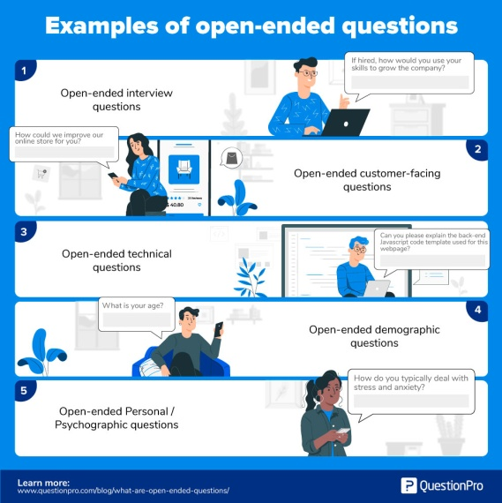<https://www.hotjar.com/blog/open-ended-questions/>

1. Open-ended questions provide primarily ______ data.
   1. Confirmatory data
   2. Qualitative data
   3. Predictive data
   4. None of the above

**Open-ended questions motivate the respondents to put their feedback into words without restricting their thoughts.**

<https://www.questionpro.com/blog/what-are-open-ended-questions/>

1. 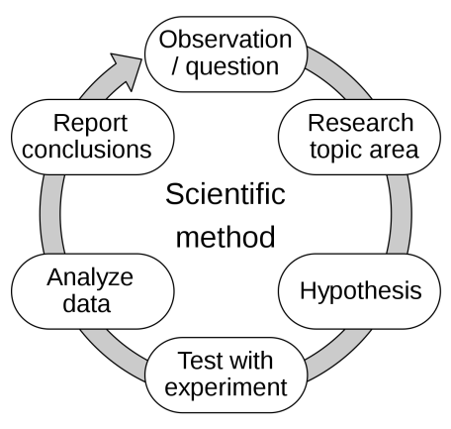Which of the following is true concerning observation?
   1. It takes less time than self-report approaches
   2. It costs less money than self-report approaches
   3. It is often not possible to determine exactly why the people behave as they do
   4. All of the above

**Observation is way of gathering data by watching behavior, events, or noting physical characteristics in their natural setting. Observations can be overt (everyone knows they are being observed) or covert (no one knows they are being observed and the observer is concealed).**

<https://www.cdc.gov/healthyyouth/evaluation/pdf/brief16.pdf>

1. 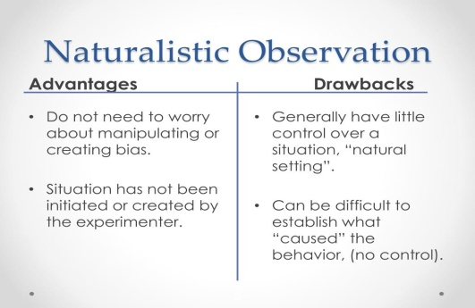Qualitative observation is usually done for exploratory purposes; it is also called ___________ observation.
   1. Structured
   2. Naturalistic
   3. Complete
   4. Probed

**Naturalistic observation is a method that involves observing subjects in their natural environment.**

<https://www.sciencedirect.com/topics/psychology/naturalistic-observation#:~:text=Naturalistic%20observation%20is%20a%20method,a%20natural%20setting%20without%20intervention>.

1. When constructing a questionnaire, it is important to do each of the following except ______.
   1. 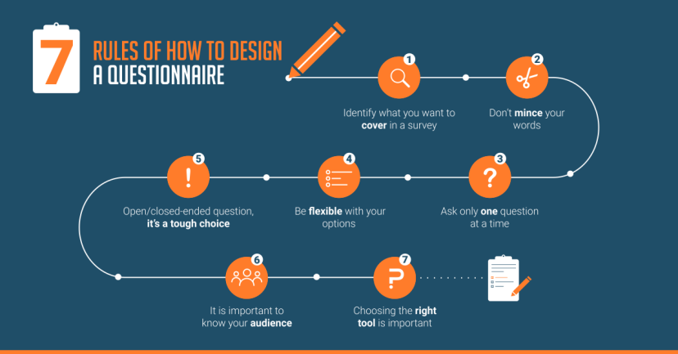Use "leading" or "loaded" questions
   2. Use natural language
   3. Understand your research participants
   4. Pilot your test questionnaire

**There are nine steps involved in the development of a questionnaire: Decide the information required, Define the target respondents, Choose the method(s) of reaching your target respondents, Decide on question content, Develop the question wording, Put questions into a meaningful order and format, Check the length of the questionnaire, Pre-test the questionnaire, Develop the final survey form.**

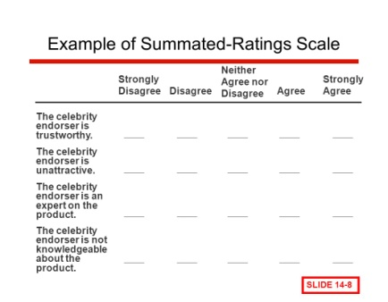<https://www.fao.org/3/w3241e/w3241e05.htm>

1. Another name for a Likert Scale is a(n):
   1. Interview protocol
   2. Event sampling
   3. Summated rating scale
   4. Ranking

**Summated rating scale is a type of assessment instrument comprising a series of statements measuring the same construct or variable to which respondents indicate their degree of agreement or disagreement.**

<https://dictionary.apa.org/summated-rating-scale>

1. 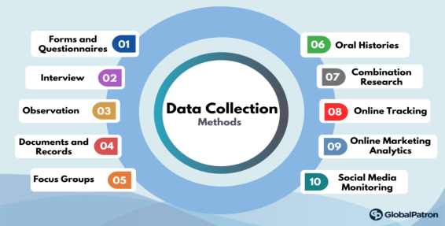Which of the following is not one of the six major methods of data collection that are used by educational researchers?
   1. Observation
   2. Interviews
   3. Questionnaires
   4. Checklists

**Tests, questionnaires, interviews, and observations are some of the methods of data collection that you might use in carrying out this evaluation task.**

<https://us.sagepub.com/sites/default/files/upm-assets/106363_book_item_106363.pdf>

1. 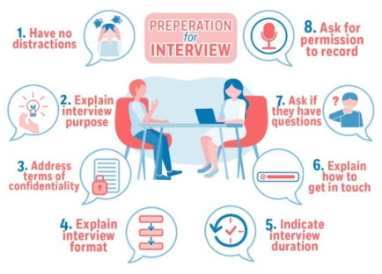The type of interview in which the specific topics are decided in advance but the sequence and wording can be modified during the interview is called:

a) The interview guide approach

* 1. The informal conversational interview
  2. A closed quantitative interview
  3. The standardized open-ended interview

**This provides more focus than the conversational approach, but still allows a degree of freedom and adaptability in getting information from the interviewee.**

<https://managementhelp.org/businessresearch/interviews.htm>

1. Which one of the following in is not a major method of data collection?
   1. 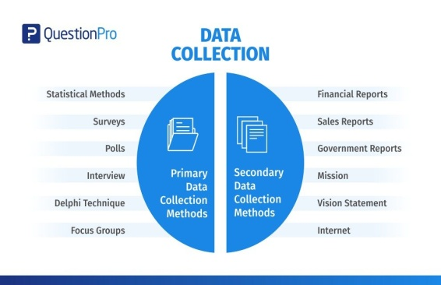Questionnaires
   2. Interviews
   3. Secondary data
   4. Focus groups
   5. All of the above are methods of data collection

**The secondary data collection methods, too, can involve both quantitative and qualitative techniques. Secondary data is easily available and hence, less time-consuming and expensive as compared to the primary data. However, with the secondary data collection methods, the authenticity of the data gathered cannot be verified.**

<https://www.questionpro.com/blog/data-collection-methods/>

1. 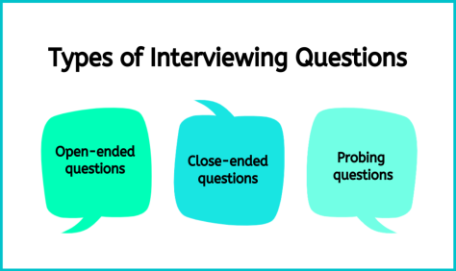A question during an interview such as “Why do you feel that way?” is known as

a) Probe

* 1. Filter question
  2. Response
  3. Pilot

**A probing question sparks deep thought and detailed responses. An open-ended question supports deeper comprehension for both the person asking and the one answering. By asking a probing question, you encourage the receiver to explore their personal feelings and ideas about a specific topic.**

<https://ca.indeed.com/career-advice/career-development/probing-questions>

1. 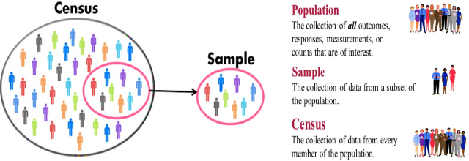A census taker often collects data through which of the following?
   1. Standardized tests
   2. Interviews
   3. Secondary data
   4. Observations

**A census is a survey conducted on the full set of observation objects belonging to a given population or universe.**

<https://ec.europa.eu/eurostat/statistics-explained/index.php?title=Glossary:Census>

1. The researcher has secretly placed him or herself (as a member) in the group that is being studied. This researcher may be which of the following?

a) A complete participant

* 1. An observer-as-participant
  2. A participant-as-observer
  3. None of the above

**Researchers can be subjects in their own studies. However, MSU policy regards this type of research (investigator self-experimentation) as research with human participants, and generally requires the same review and approval as research that recruits other people as subjects.**

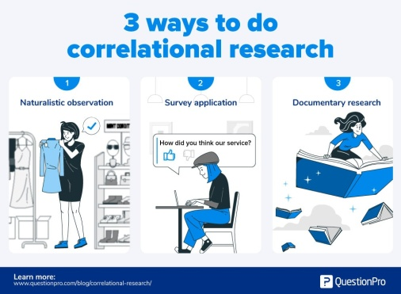<https://www.montana.edu/orc/irb/researchers_as_own_subjects.html>

1. Which of the following is not a major method of data collection?
   1. Questionnaires
   2. Focus groups
   3. Correlational method
   4. Secondary data

**The correlational method involves looking for relationships between variables. For example, a researcher might be interested in knowing if users' privacy settings in a social networking application are related to their personality, IQ, level of education, employment status, age, gender, income, and so on.**

<https://www.sciencedirect.com/topics/computer-science/correlational-method>

1. 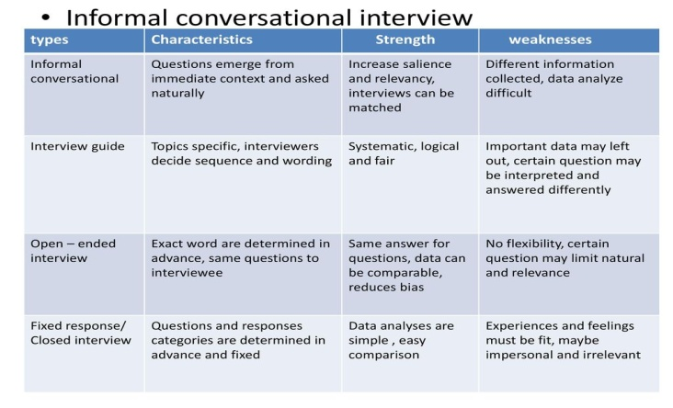Which type of interview allows the questions to emerge from the immediate context or course of things?

a) Interview guide approach

* 1. Informal conversational interview
  2. Closed quantitative interview
  3. Standardized open-ended interview

**An informal interview, also known as a conversational or informal chat interview, is a non-formal job interview, often held in a neutral setting such as a café, usually over food or drink. Informal interviews can also be virtual.**

<https://targetjobs.co.uk/careers-advice/interviews-and-assessment-centres/what-informal-interview-and-how-can-you-succeed-one>

1. When conducting an interview, asking "Anything else? What do you mean? Why do you feel that way?," etc, are all forms of:
   1. Contingency questions
   2. Probes
   3. Protocols
   4. Response categories

**A probing question sparks deep thought and detailed responses. An open-ended question supports deeper comprehension for both the person asking and the one answering. By asking a probing question, you encourage the receiver to explore their personal feelings and ideas about a specific topic.**

<https://ca.indeed.com/career-advice/career-development/probing-questions>

1. When constructing a questionnaire, there are 15 principles to which you should adhere. Which of the following is not one of those principles?
   1. Do not use "leading" or "loaded" questions
   2. Avoid double-barrelled questions
   3. Avoid double negatives
   4. Avoid using multiple items to measure a single construct

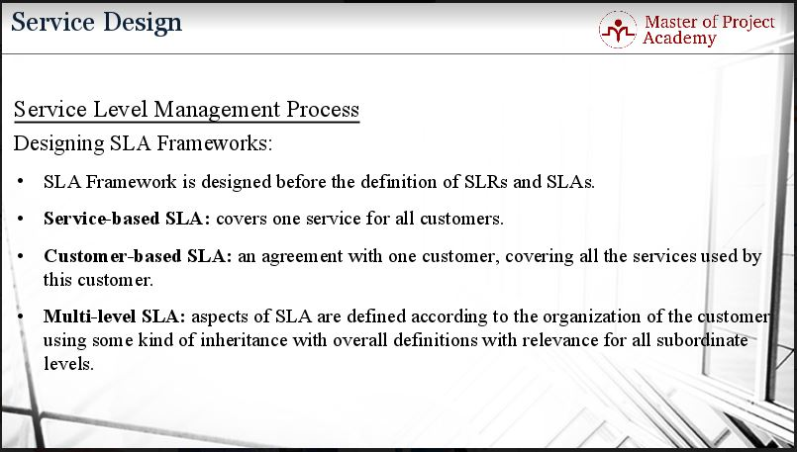

1. A customer-based Service Level Agreement structure includes:
   1. An SLA covering all Customer groups and all the services they use
   2. SLAs for each service that are Customer-focused and written in business language
   3. An SLA for each service type, covering all those Customer groups that use that Service
   4. An SLA with each individual Customer group, covering all of the services they use

**A customer-based SLA is a contract with one customer, covering all the services used by this customer.**

<https://blog.masterofproject.com/3-types-sla/#:~:text=The%20second%20type%20of%20service,services%20used%20by%20this%20customer>.

1. 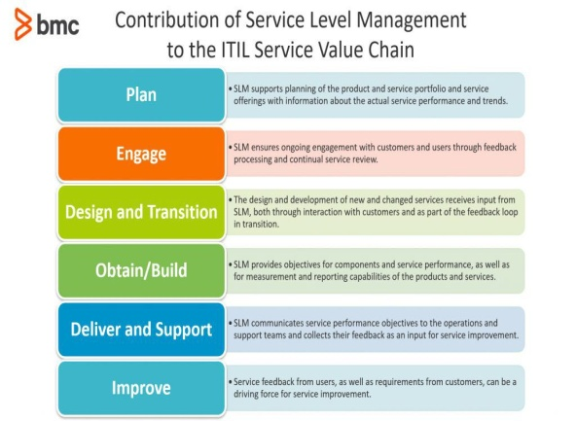Which of the following best describes the goal of Service Level Management?
   1. To maintain and improve IT service quality in line with business requirements
   2. To provide IT services at the lowest possible cost by agreeing with Customers their minimum requirements for service availability and ensuring performance does not exceed these targets
   3. To provide the highest possible level of service to Customers and continuously improve on this through ensuring all services operate at maximum availability
   4. To ensure that IT delivers the same standard of service at the least cost

**The purpose of Service Level Management is to ensure that all current and planned IT services are delivered to agreed achievable targets.**

[**https://www.alaska.edu/files/oit/PinkSCAN_slm.pdf**](https://www.alaska.edu/files/oit/PinkSCAN_slm.pdf)

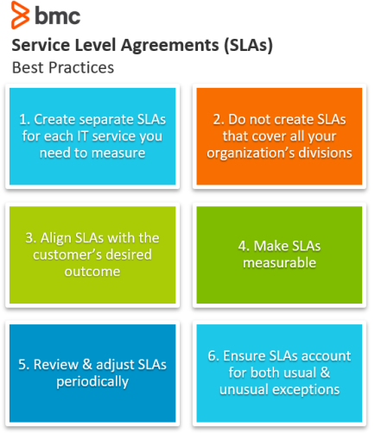

1. The process to implement SLAs comprises of the following activities in sequence:
   1. Draft SLAs, catalogue services, review underpinning contracts and OLAs, draft SLRs, negotiate, agree

SLAs

* 1. Draft SLAs, review underpinning contracts and OLAs, negotiate, catalogue services,
  2. Review underpinning contracts and OLAs, draft SLAs, catalogue services, negotiate, agree SLAs
  3. Catalogue services, establish SLRs, review underpinning contracts and OLAs, negotiate service levels, agree SLAs

1. 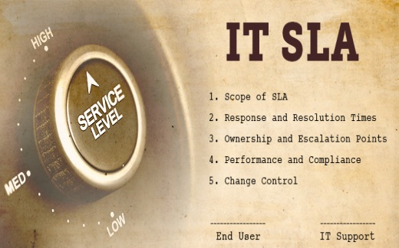Which of the following is an example of a service level agreement (SLA) between an information systems support unit and a research unit in the laboratories of a large company?
   1. The maximum response time to get the system operational should it fail.
   2. The minimum ‘up-time’.
   3. The types of information that will be provided as standard.
   4. All of the above.

1. 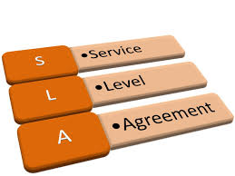Some organisations bring a degree of formality to the internal customer concept by encouraging (or requiring) different parts of the operation to agree on:

a) Internal service agreements

* 1. Service level agreements
  2. Formal provision agreements
  3. Delivery agreements

**A service level agreement is designed to create alignment between two parties by setting clear expectations and mitigating any issues before they happen. With that in mind, there are multiple types of SLA depending on your use case.**

<https://blog.hubspot.com/blog/tabid/6307/bid/34212/how-to-create-a-service-level-agreement-sla-for-better-sales-marketing-alignment.aspx>

# Search Index