User manual

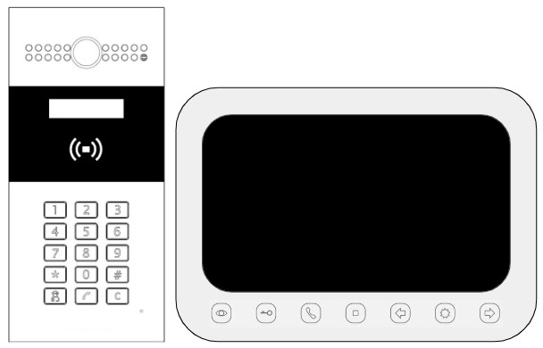

**ZOOM 2100**

**INTERCOM SYSTEM**

**TERMS AND CONDITIONS OF SAFE USE:**

The device is suitable only installed in living buildings.

**Caution**

* **Do not drop the device** or subject it to physical shock, and do not expose it to high electromagnetism radiation.
* **Do not install the device:**
  + near heat sources (heaters, radiators, etc.);
  + in dusty and dirty places;
  + in magnetic fields range.
* **Please, use a soft and dry cloth** when clean inside and outside surfaces of the device cover, do not use alkaline detergents.
* **Do not open, disassemble, or repair** the device by yourself**.**
* **Do not apply paint** to the device.

**Attention!**

To avoid injury, do not use the device if the case is damaged, broken, or cracked.

**TERMS AND CONDITIONS OF STORAGE AND TRANSPORTATION**

* Observe the temperature conditions of the device.
* Use the original packaging to protect the device from dirt, bumps, scratches and damages during transportation.

Contents

Overview 4

Features 4

Connecting an Apartment 5

Door opening 6

Incoming call answer 7

# Overview

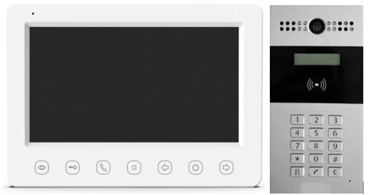

The ZOOM 2100 is an intercom system that is used to make two-way audio/video calls with visitors without any physical interaction.

The intercom system has an outdoor panel for visitors and indoor monitor for residents. Featuring convenient installation and easy use, it is mainly applied in the residential buildings for improving the living security.

# Features

**Indoor Station Features**

* Hands-free video intercom communication
* Supports monitoring the door station and the external analog camera
* Remote unlocking

**Outdoor Station Features**

* Hands-free video intercom communication
* Self-adaptive IR supplement
* Pinhole camera with 720 x 576 @ 25 fps
* Unlock controlling
* Anti-oxidant aluminum alloy

# Connecting an Apartment

On the outdoor panel, press  , then enter the apartment number.

**Note**

The maximum intercom call duration is 60 seconds. If there is no answer within 60 seconds, the call will be "reset".

If you make a mistake in entering, press 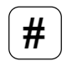 and re-enter. If you press , the number will be completely "reset".

If the apartment number is entered incorrectly or the indoor monitor is missing/not working, a signal 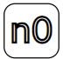 will appear on the panel.

To call the concierge, press .

# Door opening

**Opening by code**: Residents can use personal codes to unlock a door. To unlock the door, press  button and dial the code. On the panel you will see **“DOOR UNLOCKED”**. If you enter an incorrect code, a signal  will appear on the panel.

**Opening by e-key:** Put the e-key to the door reader to unlock the door. On the panel you will see **“DOOR UNLOCKED”**.

# Incoming call answer

When a visitor presses the call button of the outdoor panel, the visitor’s image automatically appears on the indoor monitor.

Press  button to talk with the visitor, or press  button to decline the call.

During the speaking duration, you can unlock the door. Press  button to unlock the door for the visitor, and the monitor will show **“DOOR UNLOCKED”**.

**Note**

The unlocking status can be maintained 5 seconds after pressing  button.