LAB4 Input, Output & Decision Making

Learning objects:

1. Understand input and output and decision making.
2. Debug your programs and hand in the screenshots of the results.

Tasks:

1. Understand the format characters and modifier characters. Edit programs, try to use the different format characters and modifier characters in printf and scanf functions. Run your programs and explain the results.

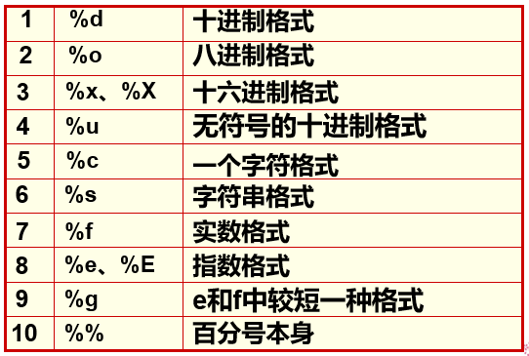

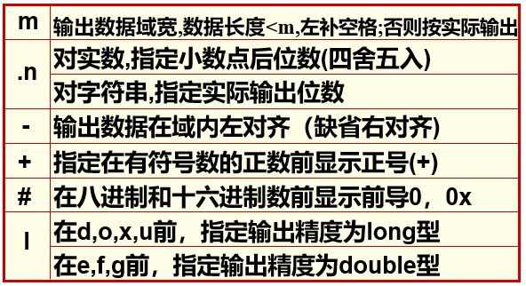

For example:

**#include <stdio.h>**

**int main()**

**{**

**float f=123.456;**

**printf(“%f,%10.2f,%0.2f, %-10.2f,%10.2e,%10.2g\n”,f, f, f, f, f, f, f);**

**return 0;**

**}**

1. If your name is John Smith, edit a program, use scanf and printf functions to input your name and output your name.
2. If your name is John Smith, edit a program, use gets and puts functions to input your name and output your name.
3. Edit a program, input a year, output if it’s a leap year.
4. Edit a program, input a character, output if it’s a lower case letter, and if it’s a lower case letter, convert it to an upper case letter. For example:

Input: a

Output: a is a lower case letter. a->A

Input: 3

Output: 3 is not a lower case letter.

6.Edit a program, input a 5-digit integer, output if it’s a palindrome number（回文数）, such as 12321. If the input number is not a 5-digit integer, then output “Error!”.

Optional tasks:

1. 找零计算器需要用户做两个操作：输入购买的金额，输入支付的票面，而找零计算器则根据用户的输入做出相应的动作：计算并打印找零，或告知用户余额不足以购买。（从计算机程序的角度看，这就是意味着程序需要读用户的两个输入，然后进行一些计算和判断，最后输出结果。）

输入样例1：

20 50

输出样例1：

30

输入样例2：

50 20

输出样例2：

余额不足

1. 模拟交通警察的雷达测速仪。输入汽车速度，如果速度超出60 mph，则显示“Speeding”，否则显示“OK”。

输入样例1：

40

输出样例1：

Speed: 40 – OK

输入样例2：

75

输出样例2：

Speed: 75 - Speeding