### 

### **UNIVERSIDAD TECNOLÓGICA DE AGUASCALIENTES**

Topic:

*“Topic.”*

Student name:

Talamantes Castañeda Ángela María.

Enrollment:

191243.

Carrier/Classroom/Grade/Group:

IDGS ~ Aulas2, 9°A.

Teacher:

Teacher.

Subject:

Subject.

Is it created the repository and add to the Visual:



Is it created the branch pages/netlify:





Creation the new branch called dev:





### The creation of the index with a nav, also a commit has been created on the branch dev:

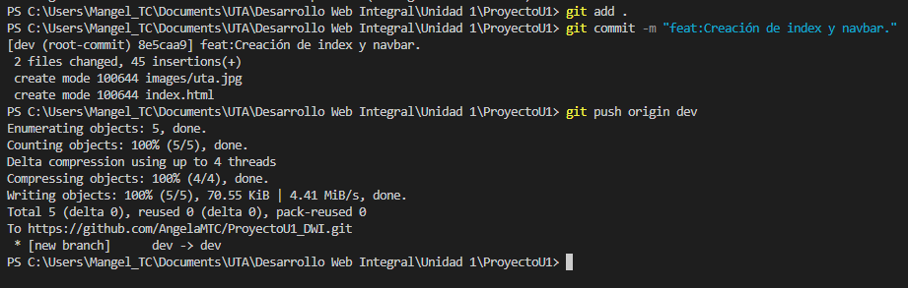

Aggregate an icons and committed it on the branch pages/netlify:



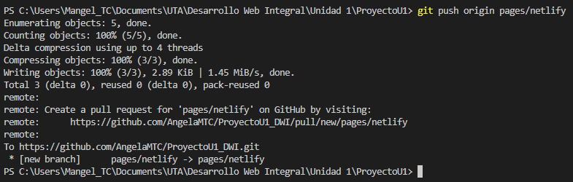

Another commit adding the carpet and file styles:

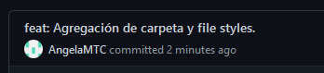

Another commit with changes on the style:

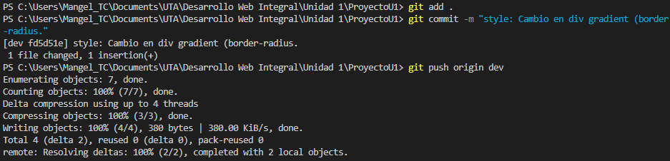

Another commit with changes on the style:

