A SOLAR-POWERED IOT-BASED WATER QUALITY MONITORING SYSTEM WITH REAL-TIME CLOUD VISUALIZATION FOR DIVERSE AQUATIC ENVIRONMENTS: DESIGN, DEVELOPMENT, AND PERFORMANCE EVALUATION

A CAPSTONE PROJECT CONCEPT

Presented to the
the Graduate Faculty of
College of Technology
University of Science and Technology of Southern Philippines
Cagayan de Oro City



In Partial Fulfilment
of the Requirements for the Degree
MASTERS IN INDUSTRIAL TECHNOLOGY AND OPERATIONS

PHILIP JAMES B. SOLANA
MITO-II

NOVEMBER 2025
- Background of the Study
Water quality plays a vital role in maintaining ecological balance and protecting public health. Ensuring that water resources remain clean and safe is crucial for both human consumption and the survival of aquatic life. In the Philippines, this responsibility is underscored by the Philippine Clean Water Act of 2004 (Republic Act No. 9275), which mandates the protection, preservation, and revival of the country’s freshwater and marine environments. The law emphasizes the sustainable management of water resources to prevent pollution, safeguard biodiversity, and ensure that all Filipinos have access to safe and clean water for domestic, agricultural, and industrial use.
Water quality monitoring is an essential component of sustainable water management, as it enables the identification of contaminants and pollution sources to ensure compliance with quality standards (Shende et al., 2025; Nurlaila et al., 2024). Traditional water monitoring methods, however, rely heavily on manual sampling and laboratory analysis, which are often time-consuming, labor-intensive, and incapable of providing real-time feedback (Chow et al., 2014; Wahjono, 2016). To address these limitations, various IoT-based and automated monitoring technologies have emerged. For instance, Dayaday and Namoco (2021) developed a real-time IoT-based water quality monitoring system for aquaculture applications capable of maintaining optimal pond conditions. Similarly, Abrajano et al. (2024) designed an IoT-based monitoring system for off-grid communities in the Philippines to provide real-time data on pH, turbidity, and temperature, demonstrating its applicability in remote settings. On a larger scale, Gao (2024) utilized remote sensing technologies to monitor water pollution across extensive river and lake basins, highlighting the potential of macro-scale environmental surveillance. The Environmental Management Bureau of the Department of Environment and Natural Resources (EMB–DENR, 2008) also established national baseline protocols for water quality monitoring in rivers, lakes, and coastal waters through its Water Quality Monitoring Manual. These studies collectively emphasize the growing use of IoT and remote technologies across diverse aquatic environments but also reveal common challenges: high system costs, dependence on stable connectivity, and the need for skilled personnel to operate and maintain the equipment.
For example, the Agusan–Cugman Cluster of Watersheds Management Council (ACCWMC) meeting in CY 2024 held on May 30, 2025 in Deluxe Hotel, Cagayan de Oro City, have several advanced instruments such as the CTD and AWLS devices have been used to monitor local watershed conditions. While effective, these instruments are bulky, expensive, and require specialized training for operation and maintenance. Device failures often result in downtime that reverts monitoring to manual methods. Furthermore, the need for frequent battery replacement and poor signal coverage in remote areas disrupts continuous data transmission. Due to their high cost, monitoring efforts are limited to specific sites, making it challenging to scale operations across multiple areas. During the same meeting, the council also recommended capacity-building initiatives and technical training for local monitoring teams to reduce dependency on external experts and improve system operation and maintenance efficiency. However, such efforts remain constrained by the lack of accessible and user-friendly equipment, underscoring the need for a more practical and low-cost monitoring solution.
To address these challenges, this study aims to design, develop, and evaluate a low-cost IoT-based water quality monitoring system that is compact, robust, and easily deployable across various types of water bodies. The proposed system will employ inexpensive yet reliable components to reduce maintenance costs and simplify repair processes. It will be scalable, allowing multiple sensor nodes to operate simultaneously in different locations for broader coverage. Communication between nodes will utilize LoRa technology, ensuring reliable data transmission even in remote or low-signal environments. The device will also be properly sealed to prevent fouling and sustain long-term operation in diverse aquatic settings. To further improve its sustainability and reduce maintenance frequency, the system will incorporate an energy-efficient power management design that minimizes consumption through optimized sleep–wake cycles and low-power components. In addition, solar charging modules will be integrated to support autonomous recharging and prolong battery life, effectively addressing the issue of frequent battery replacement during long-term field deployments.
Beyond its technical outcomes, the study contributes directly to the attainment of Sustainable Development Goal (SDG) 6: Clean Water and Sanitation, and indirectly supports SDG 9: Industry, Innovation and Infrastructure, SDG 11: Sustainable Cities and Communities, SDG 13: Climate Action, and SDG 14: Life Below Water by promoting affordable environmental monitoring, protecting aquatic ecosystems, and enhancing community resilience through accessible technology (United Nations, n.d.).

- Statement of the Problem
The Philippine Clean Water Act of 2004 (Republic Act No. 9275) mandates the protection and preservation of the country’s water bodies through the establishment of effective monitoring and management systems. Despite these legislative efforts, water pollution continues to pose a persistent environmental challenge due to the lack of reliable, continuous, and real-time monitoring technologies. Traditional water quality assessment methods rely heavily on manual sampling and laboratory analysis, which are time-consuming, labor-intensive, and inadequate for providing early detection of sudden pollution events.
In recent years, technological advancements have enabled the development of online and IoT-based water quality monitoring systems. However, most commercially available equipment—such as Conductivity, Temperature, and Depth (CTD) profilers and multi-parameter sondes—remain expensive and require specialized personnel for installation and maintenance. These limitations restrict their accessibility, particularly in rural or resource-constrained communities, resulting in significant data gaps that hinder evidence-based decision-making and effective water resource management. IoT-based systems have demonstrated potential for continuous, real-time water monitoring and remote data access (Sathio et al., 2025; GJ et al., 2024), facilitating the early identification of pollution sources and supporting environmental management (Gao, 2024). Nevertheless, the high cost, energy demand, and limited adaptability of existing systems impede large-scale or long-term deployment in diverse aquatic environments.
To address these constraints, this study proposes the design, development, and evaluation of a low-cost IoT-based water quality monitoring system that can be deployed across various types of water bodies. The system will emphasize affordability, modularity, and energy efficiency—integrating long-range wireless communication, low-power operation, and potential renewable power sources to minimize maintenance requirements. Its prototype will be tested and evaluated in a controlled environment to validate functionality, data reliability, and operational performance under simulated field conditions. Controlled testing allows precise manipulation of input variables for reproducibility and consistency (Bapiraju et al., 2017), while also serving as a foundation for future deployment in real-world aquatic settings where environmental variability affects sensor performance and reliability (Persona et al., 2016).
Ultimately, this study seeks to establish a sustainable and scalable alternative to existing high-cost monitoring systems. The resulting device aims to support the implementation of Republic Act No. 9275 by improving local capacity for water quality monitoring and contributing to data-driven environmental management and policy development in the Philippines.
- Objectives of the Study
3.1 General Objective
This study aims to build a functional prototype of a low-cost, solar-powered IoT-based water quality monitoring system that enables reliable, continuous, and accessible assessment of water conditions through real-time web visualization and remote data access for environmental management and protection.
3.2 Specific Objectives
- To design a cost-effective IoT-based water quality monitoring system that utilizes a solar-powered power supply.
- To develop and integrate the designed system—comprising hardware, software, and mechanical components—into a functional prototype capable of real-time monitoring, data transmission, and alert generation.
- To evaluate the accuracy, reliability, and operational performance of the developed prototype by comparing its readings and functionality with those of a commercial water quality monitoring device.
- Significance of the Study
This study holds significant value in addressing one of the most pressing environmental issues of modern times—water pollution and degradation of aquatic ecosystems. Anchored on Republic Act No. 9275, otherwise known as the Philippine Clean Water Act of 2004, this research supports the national framework for maintaining, protecting, and restoring the country’s water quality through the integration of modern technology in environmental monitoring. The proposed IoT-based water quality monitoring system aims to offer an efficient, scalable, and cost-effective alternative to conventional laboratory-based testing methods, which are often time-consuming, labor-intensive, and require specialized personnel and equipment (Mohammed, 2023).
By employing sensors that measure key physicochemical parameters such as pH, temperature, turbidity, and dissolved oxygen, the system enables real-time data collection and transmission to a cloud-based platform. This capability provides an opportunity for continuous and remote monitoring of various aquatic environments, including rivers, coastal waters, and groundwater sources. The integration of LoRa communication technology and cloud-based data visualization ensures that water quality data can be accessed, analyzed, and interpreted easily, thereby enhancing decision-making among environmental management bodies, local government units, and community stakeholders.
Technologically, the study advances the application of Internet of Things (IoT) in environmental systems by demonstrating a modular and scalable framework that can be expanded into multi-nodal deployments in the future. It also introduces a web-based visualization platform that allows users to monitor water quality trends, detect anomalies, and receive automated alerts when critical thresholds are exceeded. Such features transform traditional monitoring into a proactive and preventive system, capable of providing early warnings for pollution events and supporting sustainable resource management (Sathio et al., 2025).
Academically, the project contributes to the growing body of research in environmental informatics, automation, and sensor-based monitoring (Nandhini et al., 2023). It serves as a reference for students and researchers seeking to explore the convergence of IoT, cloud computing, and environmental science. Furthermore, the project provides a hands-on educational tool that demonstrates how modern technology can be utilized to address environmental challenges in developing regions like the Philippines.
At the community and industrial level, the system offers a practical and deployable solution for sectors that rely heavily on water quality, such as aquaculture, agriculture, and water treatment facilities. By enabling accessible and continuous monitoring, the system supports public health protection, ecosystem conservation, and resource efficiency, aligning with the country’s broader goals of sustainable development and environmental resilience.
In essence, this study not only showcases the integration of technology in environmental management but also reinforces the principle that sustainability is achievable when scientific innovation, policy direction, and community participation converge (Aditya, 2025; Schilirò, 2019). Through this project, water quality monitoring becomes more inclusive, data-driven, and responsive—empowering stakeholders to safeguard one of the nation’s most vital natural resources.
V. Scope and Limitations
This study focuses on the design, development, and evaluation of an IoT-based water quality monitoring system capable of periodically measuring and transmitting environmental data for continuous assessment and management. The system will utilize an ESP32 LilyGO microcontroller integrated with appropriate sensors for data acquisition. The gathered readings will be transmitted via LoRa communication to a packet receiver, which then relays the data to a cloud-based backend hosted on Vercel. While LoRa enables long-range, low-power communication between the sensor unit and the packet receiver, the system's ultimate ability to achieve remote data management and web visualization is dependent on the internet accessibility and connectivity of that packet receiver. Data will be stored and managed through a database. A web interface will visualize the results in graphical, tabular, and timeline formats, with automated alerts when measured conditions exceed predefined thresholds.
The system will be designed to be architecturally scalable, supporting future multi-node deployment under a unified data management framework. However, the current study will focus on the deployment of a single LoRa sensory unit to validate its core functionality and communication stability. To optimize energy consumption and data efficiency, the study will implement a periodic sampling strategy, with data collected and transmitted at fixed intervals under normal conditions. The system will also explore adaptive sampling intervals based on environmental stability and observed variability. For example, when monitored conditions remain stable over time, the system may automatically lengthen the interval between readings, while more dynamic environmental behavior may trigger shorter intervals. This adaptive approach may also account for seasonal variations, where environmental stability differs between dry and wet conditions (Bua et al., 2025).
To enhance sustainability and operational independence, the system will incorporate a compact solar power module consisting of a small solar panel, a solar charge controller (SCC), and a rechargeable battery. This setup will allow the prototype to operate autonomously and support the evaluation of its energy efficiency and low-power performance under typical outdoor conditions.
The scope of the study primarily includes hardware and software design, prototype fabrication, and controlled-environment testing of the system. Evaluation will focus on the system’s accuracy, reliability, energy sustainability, and communication stability by comparing readings against reference instruments. While the proposed framework supports future multi-node scalability, only one sensor unit prototype will be fabricated for this phase due to financial and logistical constraints.
Several limitations are recognized in the study. The prototype will be tested in a controlled aquatic environment rather than in open or natural bodies of water; therefore, external factors such as strong currents, sedimentation, biofouling, and long-term exposure will not yet be considered. The solar power setup will be evaluated primarily for prototype-level energy performance and may not fully represent large-scale or long-term operation. Additionally, due to the limited deployment size (one sensor unit), network performance will be assessed on a small scale and may not fully reflect wide-area communication behavior.
Despite these limitations, the study aims to provide a cost-effective, energy-sustainable, and adaptable water quality monitoring solution that integrates IoT technology with modern data visualization and communication systems. The incorporation of adaptive sampling and solar-based power support strengthens the system’s efficiency, resilience, and responsiveness—contributing to more intelligent and sustainable environmental monitoring frameworks that can be expanded for real-world applications in the future.

  - Contributions to the Sustainable Development Goals (SDGs)
This study contributes directly to the attainment of Sustainable Development Goal (SDG) 6: Clean Water and Sanitation, which aims to improve water quality by reducing pollution and minimizing the release of harmful substances, and also focuses on protecting and restoring water-related ecosystems. By developing a low-cost and energy-sustainable IoT-based monitoring system, the study enables continuous assessment of water conditions, early detection of pollution, and timely intervention to prevent further environmental degradation. This study also contributes directly to SDG 14: Life Below Water, which aims to prevent and significantly reduce marine pollution from land-based activities. The system’s potential application in estuarine and coastal monitoring can help identify pollutant sources and support long-term aquatic ecosystem protection.
It also indirectly supports SDG 9: Industry, Innovation and Infrastructure, which encourages scientific research and the development of local technological capabilities. The project promotes innovation in environmental monitoring by integrating IoT, cloud computing, and renewable energy technologies into a scalable, community-oriented solution. Similarly, the study aligns with SDG 11: Sustainable Cities and Communities, by providing data that can guide local government units in managing water resources and reducing the environmental impact of urban areas.
Furthermore, the study contributes to SDG 13: Climate Action, strengthening resilience and adaptive capacity to climate-related hazards. Continuous monitoring of water systems supports early warning and adaptive management against pollution events and climate-induced variations in water quality.
Through these contributions, the study not only advances sustainable environmental management but also reinforces the country’s commitment to integrating innovation, sustainability, and community engagement in support of the United Nations’ 2030 Agenda for Sustainable Development (United Nations, n.d.).
  - Methodology
7.1 Design of the IoT-Based Water Quality Monitoring System
A. Design Considerations
The IoT-based water quality monitoring system is built on four key considerations addressing current monitoring gaps:
- Real-Time Monitoring and Data Efficiency- A dual-mode data architecture enables both continuous real-time monitoring and efficient data logging. The MQTT protocol ensures low-latency data transmission, while interval-based database logging provides validated records for long-term analysis.
- User Interface and Data Accessibility (UI/UX)- A web dashboard presents data in clear graphical and tabular formats with automated alerts when parameters exceed thresholds. This design supports quick responses and data-driven environmental management.

- Portability of Device - The system is designed to be compact and lightweight, allowing easy transport and installation in various locations. Its modular structure enables quick setup and relocation, making it suitable for both field and laboratory applications.
- Ease of Maintenance - A custom-designed PCB enhances serviceability by organizing all major components on a single accessible board, reducing wiring complexity and potential points of failure. The layout allows quick identification and replacement of modules, streamlining inspection, calibration, and troubleshooting. This design consideration minimizes downtime and ensures reliable operation over extended periods.
- Energy Sustainability - An integrated solar power module with charge control and battery storage ensures autonomous operation in remote areas, maintaining continuous monitoring without dependence on the power grid.
B. Selection of Water Quality Parameters
In this part, the key parameters chosen were crucial in identifying the state of water quality based on studies:
- Temperature: Palatability, viscosity, solubility, odors, and chemical reactions are influenced by temperature (APHA, 2005).
- Dissolved Oxygen: considered to be one of the most important parameters of water quality in streams, rivers, and lakes. It is a key test of water pollution (APHA, 2005). The higher the concentration of dissolved oxygen, the better the water quality.
- pH: is one of the most important parameters of water quality. It is defined as the negative logarithm of the hydrogen ion concentration (Spellman, 2017; Edzwald JK, 2010). It is a dimensionless number indicating the strength of an acidic or a basic solution (Hammer MJ, 2011).
- Turbidity: Turbidity in water is aesthetically undesirable and indicates potential contamination. High turbidity increases water treatment costs (Davis, 2010) and reduces disinfection efficiency because suspended particles can shield microorganisms from treatment (Edzwald, 2010). It also harms aquatic life by clogging fish gills, hindering growth, and affecting reproduction (Tarras-Wahlberg et al., 2003; Kiprono, 2017). Moreover, suspended particles can adsorb toxic substances such as heavy metals and organic pollutants (Cole et al., 1999). Elevated turbidity further raises water temperature and lowers dissolved oxygen levels, leading to reduced food availability and degraded aquatic conditions (Cole et al., 1999).
- Ammonia (NH₃): Agricultural runoff and industrial processes, which contribute to increased nitrogen levels in water bodies (Edwards et al., 2023).
C. System Operation Overview
This phase focuses on conceptualizing the system architecture and defining both the hardware and software components necessary for monitoring key water quality parameters.
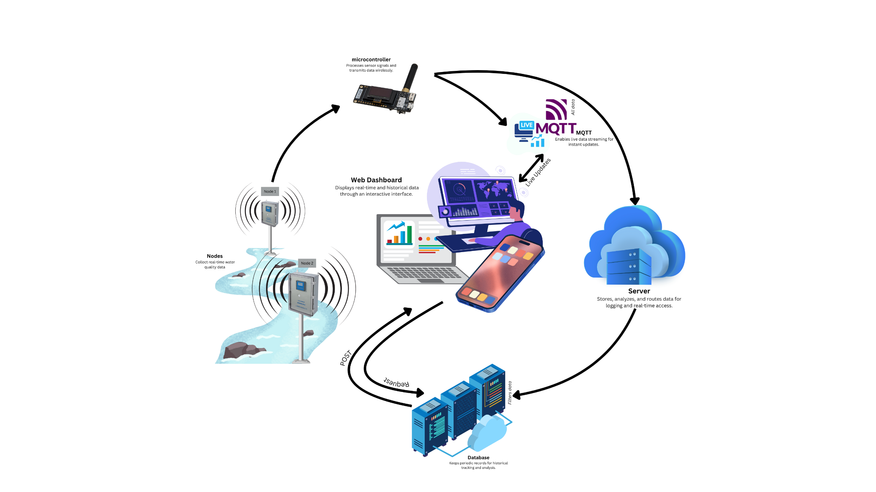
Figure 7.1.1 shows the overall system architecture of the IoT-based water monitoring system. Sensor nodes equipped with water level and environmental sensors are deployed along the river to gather real-time data. These nodes transmit the collected information wirelessly to an ESP32 microcontroller, which serves as the main packet forwarder. The forwarder connects to the internet via a Wi-Fi or data and communicates with a cloud-based MQTT broker. The MQTT broker acts as an intermediary, ensuring reliable data transmission between the IoT devices and the web application. Data are periodically stored in a cloud database every 30 minutes to conserve memory and bandwidth, while the web application displays real-time and historical data for monitoring and analysis.
Figure 7.1.1. Schematic Diagram of the IoT-Based Water Monitoring System
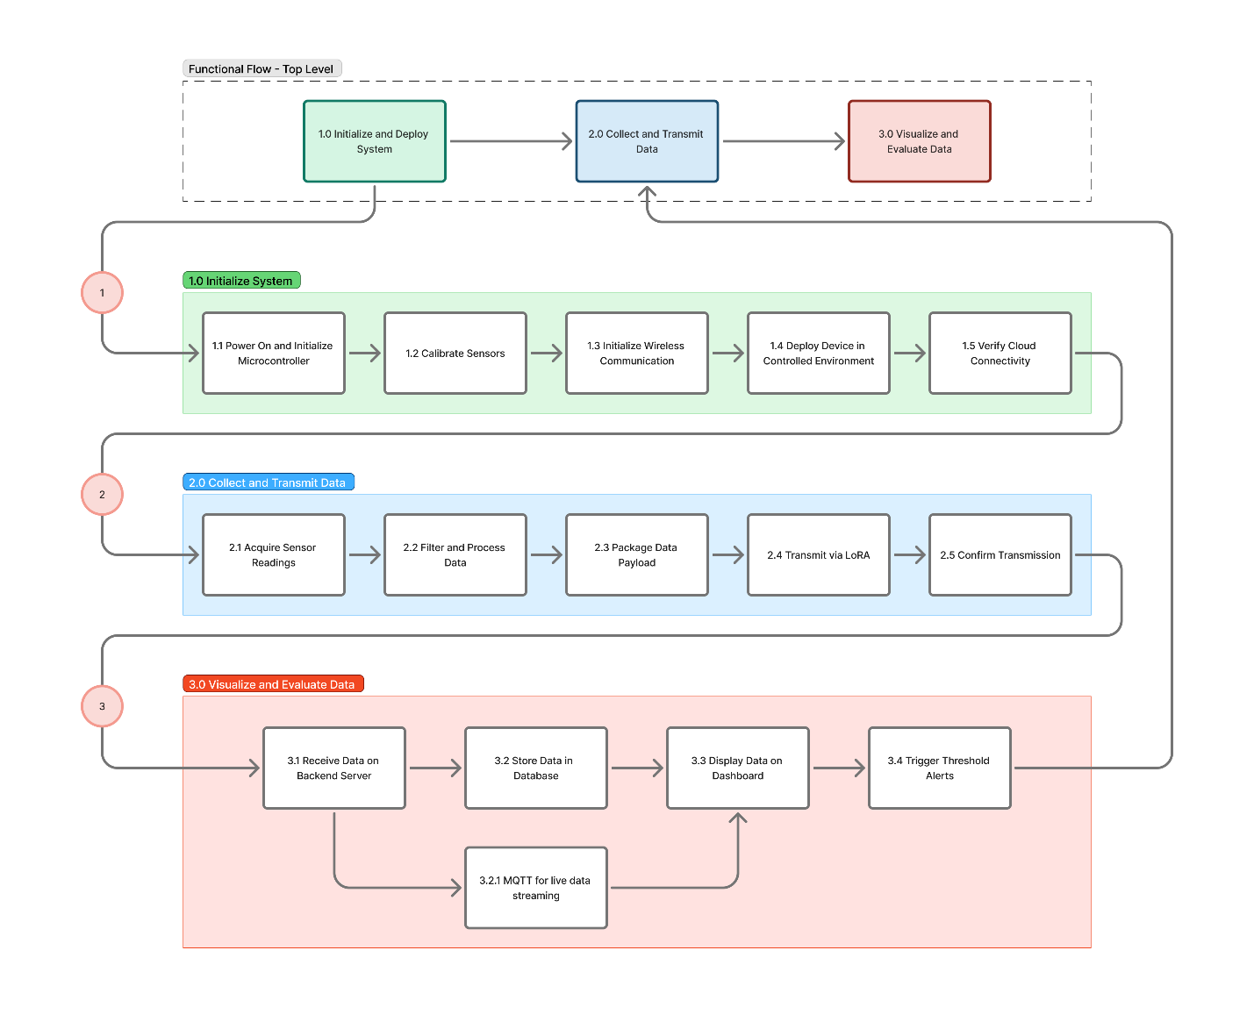
This architecture enables efficient, continuous, and remote observation of water parameters in the monitoring area.

Fig 7.1.2 Functional Flow Block Diagram of the IoT-Based Water Quality Monitoring System.
The overall operation of the IoT-based water quality monitoring system follows a structured process designed to ensure accurate data collection, efficient transmission, and clear visualization. The system begins with the initialization of the microcontroller and sensors, proceeds to real-time data acquisition and wireless transmission through a peer-to-peer network, and concludes with data storage and visualization on a cloud-based dashboard. The functional flow of these operations as presented in Figure 7.1.2.
7.1.2 Design of Monitoring Devices
A. Data Acquisition and Control Unit
The Data Acquisition and Control Unit is composed of two primary subsystems that enable localized sensing and wireless data transmission through a peer-to-peer network configuration.
- Sensor Node
The sensor node, based on an ESP32 LilyGo microcontroller, is responsible for collecting data from connected water quality sensors such as pH, turbidity, temperature, and dissolved oxygen. The node processes and formats the sensor readings before transmitting them to the packet forwarder. The use of the ESP32 platform allows efficient multitasking, analog/digital data handling, and integration with IoT communication protocols.
- Packet Forwarder
A second ESP32 LilyGo module functions as the packet forwarder, receiving data from the sensor node via a peer-to-peer (P2P) communication link. This forwarder acts as the bridge between the local sensing unit and the central server or dashboard. It packages and forwards data using lightweight IoT protocols (e.g., MQTT) for cloud upload or local storage.

C. Core Sensing Unit
- pH Sensor
The pH sensor, such as the DFRobot Gravity Analog pH Sensor Kit V2, measures the acidity or alkalinity of the water. It operates within a range of 0 to 14 pH with an accuracy of ±0.1 pH at 25 °C, providing an analog output to the ESP32’s ADC through appropriate signal conditioning.
- Dissolved Oxygen (DO) Sensor
The dissolved oxygen (DO) sensor, exemplified by the DFRobot SEN0237 analog probe, monitors the concentration of dissolved oxygen in the water. It functions within a range of 0 to 20 mg/L and maintains an accuracy of ±0.3 mg/L.
- Turbidity Sensor
The turbidity sensor, such as the DFRobot SEN0189 module, detects the number of suspended solids or cloudiness in the water. It covers a measurement range of 0 to 1000 NTU with an accuracy of ±5% of full scale.
- Temperature Sensor
the temperature sensor typically the DS18B20 waterproof digital probe, measures water temperature within a range of −55 °C to +125 °C and an accuracy of ±0.5 °C. This sensor also provides temperature compensation for the pH and DO readings, ensuring more accurate measurements.

- Analog-to-Digital Converter
To ensure stable and precise analog signal conversion, an external analog-to-digital converter may be used instead of relying solely on the ESP32’s built-in ADC, which can exhibit noise and nonlinearity during high-frequency sampling. This external ADC enhances measurement accuracy and overall system reliability in continuous monitoring applications.
D. Customized PCB
The customized PCB will use standardized keyed connectors for sensors, power, and communication modules to prevent incorrect wiring. Clear labels will identify each port (e.g., “pH Sensor,” “ESP32”) to ensure easy setup, maintenance, and component replacement.
E. Power Supply Unit (Solar-Powered)
The Power Supply Unit provides reliable and sustainable energy for system operation. It consists of a rechargeable battery that powers the sensing and control components, and a small solar panel that serves as a renewable charging source for extended or remote use. This setup ensures continuous operation and reduces dependence on external power sources, making the system suitable for both laboratory testing and potential field applications.

7.1.3 Design of Software System
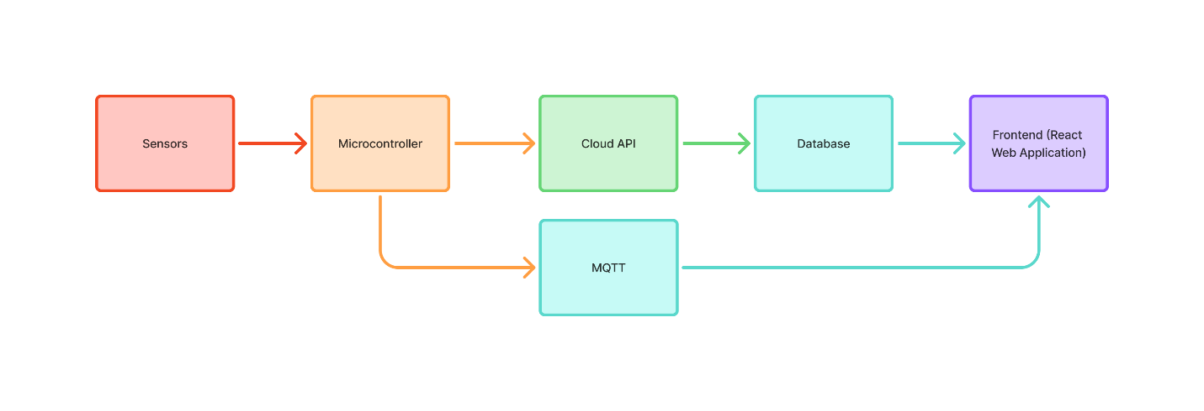
The software design defines how the system’s components—firmware, backend, and user interface—work together to collect, process, and visualize data from the IoT network as seen in the figure below.

Fig7.1.3 Flow Chart of the IoT-Based Water Quality Monitoring System
The diagram illustrates the end-to-end operation of the system, beginning with sensor data acquisition and proceeding through data transmission, cloud processing, and storage, culminating in web-based visualization. It outlines the flow of information from the sensing modules to the microcontroller, which interfaces with the cloud infrastructure for data handling, and subsequently to the web platform for real-time monitoring and user interaction
- Firmware Development
The firmware will be developed using both the Arduino IDE and the PlatformIO environment. The microcontroller will be programmed to acquire data from multiple sensors, including pH, turbidity, temperature, and dissolved oxygen sensors. In addition, the system will estimate ammonia (NH₃) concentration by utilizing pH and temperature readings. The estimation will be based on the ammonia equilibrium relationship proposed by Emerson et al. (1975), expressed as:
$$NH_{3}(mg/L)=\frac{TAN}{1+{10}^{(pK_{a}-pH)}}$$
where $pK_{a}$is the dissociation constant of ammonium, calculated as:
$$pK_{a}=0.09018+\frac{2729.92}{T+273.15}$$
This equation determines the un-ionized ammonia fraction from the total ammonia nitrogen (TAN) concentration, where $pK_{a}$is temperature-dependent. The estimated NH₃ values will later be validated against laboratory test results to verify consistency and accuracy.
The collected sensor data will undergo averaging and calibration to improve measurement accuracy before being formatted into JavaScript Object Notation (JSON) for transmission. The system will adopt a uniform 30-minute baseline sampling interval for all parameters, providing a practical compromise between data resolution and power efficiency while maintaining synchronization across measurements. Although Bua et al. (2025) proposed adaptive sampling intervals with mean values ranging from approximately 41.75 to 48.42 minutes for temperature and 42.24 to 46.06 minutes for humidity, a fixed 30-minute interval will be selected as the midpoint strategy to ensure higher temporal resolution and consistent monitoring.
The firmware’s core architecture will also employ a dual-mode data transmission logic designed to balance real-time responsiveness and storage efficiency. In Logging Mode, the system will operate on the 30-minute baseline sampling interval for database storage. To improve data reliability, the microcontroller will collect readings once per minute during the 10-minute window preceding the scheduled log, compute the average, maximum, and minimum values, and transmit the summarized statistics in JSON format to the cloud for long-term storage. In Live Stream Mode, a concurrent routine will publish lightweight, instantaneous updates at higher frequency through an MQTT-based communication channel. This approach enables real-time dashboard visualization while minimizing database load and optimizing network bandwidth usage.
- Backend Programming
The backend software manages the exchange of data between the microcontroller and the cloud database. Incoming sensor readings are formatted as JSON objects for standardized communication and easier parsing. Upon receipt, the backend validates and processes these data packets before forwarding them for storage and visualization. Security mechanisms, such as encrypted data transmission and authentication tokens, help ensure the integrity and confidentiality of all transmitted information.
- Database.Integration
Validated JSON data are stored in a structured cloud database designed for scalability, reliability, and efficient retrieval. Each record is automatically time-stamped and associated with its respective sensor node, supporting both real-time monitoring and historical data analysis. The system architecture allows seamless interaction between the backend services and the visualization platform.
- Frontend and Visualization
The web-based dashboard provides an intuitive interface for visualizing processed data. It retrieves JSON-formatted records from the backend and presents them using graphical and tabular components to illustrate trends, variations, and anomalies. The system also includes alert functionality that notifies users when measurements exceed predefined limits, supporting proactive environmental management.
- Visualization Tools and Libraries
Data visualization is achieved through tools capable of handling dynamic updates and multi-parameter display. Interactive features—such as filtering by date range, sensor node, or measured parameter—enable users to perform comparative and temporal analyses effectively.
7.1.4 Design of Cloud Infrastructure
A. Data Transmission Layer
This layer handles the communication between the IoT devices and the cloud. A lightweight messaging protocol, such as MQTT, is used to transmit sensor readings from the packet forwarder to the cloud server. The broker manages message exchange between devices and subscribed services, ensuring efficient and reliable data delivery.
B. Data Storage Layer
At the cloud level, received data are processed and stored in a managed database service. The database organizes the records based on sensor node identifiers and timestamps, enabling both real-time access and historical data retrieval. This structure supports data integrity and scalability for long-term monitoring applications.
C. Data Visualization Layer
The web-based dashboard serves as the main user interface of the system. Hosted on a cloud platform, it allows users to view and interpret live and historical water quality data through visual elements such as graphs and tables. It may also include alert features to notify users when measured parameters exceed defined thresholds.
7.1.5 Design of Web Dashboard
The user interface (UI) will serve as the bridge between the sensor network and the end-user. Initial wireframes will be developed to outline essential components such as the live dashboard, sensor trend graphs, and alert notifications. The final interface will feature a multi-graph visualization panel capable of displaying either line or bar charts for each water quality parameter, depending on the user’s preference. Since the system adopts a uniform 30-minute sampling interval, the dashboard will visualize hourly data in daily mode, providing sufficient granularity to observe short-term fluctuations. In weekly or extended views, the system will compute and display the highest, lowest, or average value for each day, depending on user selection. This ensures clear long-term trend visualization without overwhelming the interface with excessive data points.
Interactive controls will allow users to toggle between hourly, daily, and weekly views, as well as switch between line and bar graph modes, enabling flexible data interpretation. The dashboard will also include an alert section that highlights both current and historical threshold breaches, supporting proactive water quality management. All visual and navigational elements will be designed with simplicity, accessibility, and usability in mind, ensuring responsiveness across various devices.
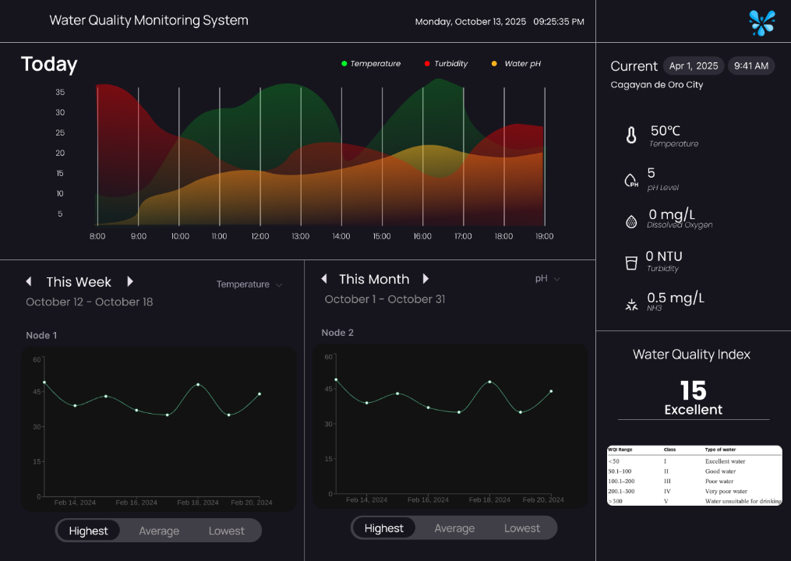
This visualization strategy will provide an optimal balance between data resolution, interpretability, and performance. By summarizing data into highest, lowest, and average readings and allowing flexible visualization modes, the system will deliver insightful, responsive, and user-friendly monitoring. This design approach ensures that users can quickly evaluate overall water quality, detect anomalies, and make informed decisions based on reliable, time-synchronized data.

Figure 7.1.5 Proposed Web Dashboard Interface of the IoT-Based Water Quality Monitoring System
The dashboard presents real-time and historical visualizations of water quality parameters (temperature, turbidity, pH, dissolved oxygen, and NH₃) across monitoring nodes. It also features a computed Water Quality Index (WQI), alert indicators, and parameter trends over time for decision-making and analysis.
7.1.6 Enclosure Unit
The enclosure unit serves as the primary protective housing for the sensing and control components. It employs an IP65-rated waterproof casing, offering protection against dust ingress and low-pressure water exposure. The housing is 3D-printed possibly using PETG (Polyethylene Terephthalate Glycol), selected for its mechanical durability, UV resistance, and moisture tolerance compared to standard PLA. These design considerations ensure that the prototype remains structurally reliable and resistant to wear during operation.
Although the initial prototype will be tested in a controlled or semi-controlled environment, the enclosure incorporates IP65 protection as a forward-looking measure for potential future outdoor or field deployment. This approach balances environmental resistance with accessibility for testing, calibration, and maintenance while ensuring scalability for real-world applications.
7.2 Development of the IoT-Based Water Quality Monitoring System

The development phase systematically translates the theoretical design into a functional, low-cost prototype ready for evaluation. It encompasses the procurement of components, the fabrication of two complete monitoring nodes, the programming of the firmware, cloud infrastructure, and initial testing to confirm system functionality.

7.2.1 Electronic Components Sourcing and Preparation
This stage involves procuring and preparing all required electronic, mechanical, and power components.
7.2.2 Hardware Fabrication and Assembly
The hardware components, including sensors, power modules, and the ESP32 microcontroller, will be carefully integrated to ensure stable and reliable operation. The power system combined a rechargeable battery and solar panel managed by a solar charge controller to maintain continuous power supply. All components were enclosed within a custom 3D-printed PETG housing, selected for its durability, UV resistance, and water resistance—properties that make it well-suited for devices exposed to prolonged sunlight and aquatic environments (Rabinovitch & Summers, 2002). The enclosure will be sealed to achieve an IP65 waterproof rating, ensuring protection against moisture ingress and environmental degradation.
7.2.3 Software Development
The software development phase focuses on implementing, coding, and integrating all software components required for the operation of the IoT-based monitoring system. This includes the development of the sensing unit firmware, the web application, backend services, and database configuration to enable seamless real-time monitoring, logging, and user interaction.
- Sensing Unit

The firmware for the sensing unit will be developed using the Arduino IDE, programmed on the ESP32 LilyGO microcontroller. It will handle sensor initialization, data acquisition, calibration, and wireless data transmission to the cloud server. Communication protocols such as MQTT will be integrated to ensure reliable and low-latency transmission. The code will also include error handling routines and data validation to maintain measurement accuracy.
- Web Development
The web application will be developed to serve as the main platform for data visualization, monitoring, and management. Using modern web technologies, the development will focus on achieving both real-time data streaming and accessible historical data retrieval. The web system will be hosted on a cloud platform to ensure availability and scalability.
- Web Design
The frontend will be implemented using React.js to create a responsive and dynamic user interface. Data from the sensors will be visualized through charts, tables, and status indicators. Alert functions will be added to notify users when readings exceed threshold values. CSS frameworks and UI libraries will be used to improve the visual layout and ensure cross-device compatibility.
- Backend Development
The backend will be developed to handle communication between the sensing unit, database, and web interface. It will manage data flow, system logic, and cloud interactions to ensure that data is properly processed and stored.
- Database Development
A database system will be developed to store and organize sensor data for both real-time and historical use. It will support secure data retrieval and serve as the foundation for analysis and reporting within the web application.

7.2.4 Hardware and Software Interfacing
This phase ensures the seamless integration between the hardware components and the developed software systems to achieve synchronized operation of the IoT-based water quality monitoring device. The interfacing process involves establishing reliable communication between the ESP32 microcontroller, connected sensors, and the cloud infrastructure.
The ESP32 LilyGO microcontroller serves as the central processing unit, managing both data acquisition from sensors and wireless data transmission. The firmware will be tested to verify accurate sensor readings, proper calibration, and real-time data delivery via the MQTT protocol. Each sensor’s output will be validated through comparison with known reference values to ensure consistency and accuracy.
Data transmitted from the sensing unit will be received and processed by the backend service, which forwards validated readings to the database and web application. The communication between hardware and cloud services will undergo latency and reliability testing to confirm efficient data flow and synchronization.
Debugging and logging tools will be employed to monitor performance, detect errors, and refine both hardware and software configurations for optimal functionality.
The successful completion of this phase confirms the full interoperability of hardware and software systems, enabling continuous, real-time monitoring and user feedback through the web interface.

7.2.5 Cloud and Web Application Development
The cloud infrastructure will support a web-based application for managing and visualizing collected data. A central database will serve as a secure repository for validated periodic data, including summary statistics. The backend will handle receiving, validating, and storing incoming data, while the frontend will provide an interactive interface to present the information.
The web interface will offer two main views:
- Historical Data: Displays long-term trends and summaries of past data.
- Live Stream: Provides near real-time updates to show current conditions.
An automated alert system will be integrated to notify users when readings exceed predefined thresholds, enabling prompt action and monitoring.
7.2.5 Functional Testing
This phase focuses on verifying that the entire IoT-based water quality monitoring system performs according to its intended design and functional requirements. All subsystems—sensing, communication, power management, and data visualization—will be evaluated under controlled conditions to ensure coordinated and reliable operation.
Functional testing will begin with validating sensor performance and calibration accuracy. Each sensing unit will be exposed to known reference standards to confirm correct response, precision, and repeatability. Communication pathways between the ESP32 microcontroller, cloud server, and web dashboard will be tested to ensure consistent real-time data transmission and minimal latency.
The system’s data handling process will also be verified, including data acquisition, logging, and retrieval. Tests will confirm that both real-time and stored datasets maintain integrity and that the backend properly distinguishes between live visualization and historical storage functions.
Power stability tests will be performed to ensure uninterrupted operation during variable environmental and load conditions. Additionally, alert and notification mechanisms will be triggered under simulated threshold exceedances to confirm appropriate and timely system responses.
Overall, this testing phase ensures that the integrated system operates efficiently, delivers accurate measurements, and provides dependable feedback through the cloud-based monitoring platform.
7.3 Evaluation of the Water Quality Monitoring System
The Evaluation Phase is designed to rigorously test and validate the developed prototype against the project's core objectives: accuracy, reliability, power efficiency, and cost-effectiveness. This phase will be conducted in a controlled environment before any potential field deployment to ensure the system's readiness and performance metrics are met.
7.3.1 Performance Evaluation and Calibration for Quality Monitoring Device based on identified parameters
This evaluation assesses the measurement integrity of the custom-built sensor nodes.
- Calibration (Comparison vs Commercial): The two device nodes will be deployed alongside a commercial-grade, calibrated multi-parameter water quality meter in a laboratory setting or a controlled water reservoir. Simultaneous readings for pH, Dissolved Oxygen DO, and Turbidity. The prototype’s sensor readings will be compared to the commercial device's readings. The Mean Absolute Error and Root Mean Square Error will be calculated for each parameter. The goal is to achieve an MAE within 5% of the commercial readings (Bayotas et al., 2025).
- Ammonia Estimation Validation: The estimated Ammonia concentration, derived from the pH and Temperature readings via the implemented algorithm, will be chemically validated using standard laboratory Ammonia test kits for a range of controlled water samples.
7.3.2 Software Reliability Evaluation
The reliability of this software will be assessed in terms of communication data integrity, stability, and system responsiveness under controlled environmental conditions.
- Data Integrity and LoRa Reliability: A stress test will be performed over a period of time to measure the data packet success rate from the sensor nodes to the Packet Forwarder. The test will track the total number of expected 30-minute logging payloads versus the number successfully logged into the database. A success rate 95 % is targeted.
- MQTT Latency Assessment: The responsiveness of the Live Stream Mode will be evaluated by measuring the time delay between a sensor reading on the MCU and its corresponding update on the web dashboard via the MQTT Broker. This assessment will help characterize the real-time performance of the system.
- Alert System Responsiveness: The adaptive sampling logic and the automated alert system will be tested by simulating threshold violations. The time taken for the system to detect the anomaly, increase the sampling rate, and trigger an alert notification on the dashboard will be recorded.
7.3.3 Evaluation of the User Interface and Experience (UI/UX)
The user interface and user experience (UI/UX) of the web dashboard will be evaluated through end-user feedback using a 5-point Likert scale. The evaluation will focus on usability, clarity of data visualization, responsiveness, and overall satisfaction with the system’s functionality and design. Respondents will consist of intended users or individuals familiar with environmental monitoring systems.
Participants will rate each statement according to the following scale:
1 – Strongly Disagree
2 – Disagree
3 – Neutral
4 – Agree
5 – Strongly Agree
Key evaluation criteria include:
- Ease of Navigation: The dashboard layout is intuitive and easy to use.
- Clarity of Information: Data is clearly presented in charts, tables, and indicators.
- Responsiveness: The interface updates and loads data smoothly.
- Aesthetic Appeal: The color scheme and design are visually appealing.
- System Usefulness: The system helps users easily interpret data and take appropriate actions.
Collected responses will be statistically analyzed to determine overall user satisfaction and identify potential areas for improvement in the UI/UX design.

References
Aditya, A. (2025). A Systems-Based Framework for Sustainable Environmental Solutions: Integrating Science, Technology, and Policy for Resilience and Resource Efficiency. International Journal of Environmental Sciences, 229–240. https://doi.org/10.64252/3tfhs542
Bayotas, R., Maghanoy, M. J., Saumat, M., & Demecillo, G. (2025). Development of a Real-Time Household Energy Monitoring System. International Journal For Multidisciplinary Research, 7(4). https://doi.org/10.36948/ijfmr.2025.v07i04.47404
Davis ML.Water and Wastewater Engineering—Design Principles and Practice. New York: McGraw-Hill; 2010
Tarras-Wahlberg H, Harper D, Tarras-Wahlberg N.A first limnological description of Lake Kichiritith, Kenya: A possible reference site for the freshwater lakes of the Gregory Rift valley. South African Journal of Science. 2003;99:494-496
Kiprono SW.Fish Parasites and Fisheries Productivity in Relation to Extreme Flooding of Lake Baringo, Kenya [PhD]. Nairobi: Kenyatta University; 2017
Cole S, Codling I, Parr W, Zabel T, Nature E, Heritage SN. Guidelines for Managing Water Quality Impacts within UK European Marine Sites; 1999
Hammer MJ. Water and Wastewater Technology. 7th ed. Upper Saddle River: Pearson education; 2011
Edzwald JK. Water Quality and Treatment a Handbook on Drinking Water. New York: McGraw-Hill; 2010
Edwards, T. M., Puglis, H. J., Kent, D. B., López Durán, J., Bradshaw, L. M., & Farag, A. M. (2023). Ammonia and aquatic ecosystems - A review of global sources, biogeochemical cycling, and effects on fish. Science of The Total Environment, 167911. https://doi.org/10.1016/j.scitotenv.2023.167911
Mohammed, S. S. (2023). Drawbacks of traditional environmental monitoring systems. TMP Universal Journal of Research and Review Archives., 2(2). https://doi.org/10.69557/ujrra.v2i2.47
Spellman FR. The Drinking Water Handbook. 3rd ed. Boca Raton: CRC Press; 2017
Schilirò, D. (2019). Sustainability, Innovation, and Efficiency: A Key Relationship (pp. 83–102). Palgrave Macmillan, Cham. https://doi.org/10.1007/978-3-030-16522-2_4
APHA. Standard Methods for the Examination of Water and Wastewater. 21st ed. Washington, DC: American Public Health Association; 2005
Bapiraju, J., Lukka, A., Shanthibhushan, B., & Shriram, S. (2017). Reliability testing of real-time medium voltage drive simulation by benchmarking with field data. IEEE International Advance Computing Conference, 250–254. https://doi.org/10.1109/IACC.2017.0062
Botangen, K. A., Abrajano, J., Nabua, J., Apanay, J., & Peña, C. (2024). IoT-based water quality monitoring system in Philippine off-grid communities. In Proceedings of the 2024 International Conference on Business and Industrial Research (ICBIR). https://doi.org/10.1109/ICBIR61386.2024.10875694
Chow, C. W. K., Saint, C. P., Zappia, L., Henderson, R. K., Roeszler, G., Dexter, R., Nguyen, T., Stuetz, R. M., Byrne, A. J., Trolio, R., Lucas, J., Williamson, S., & Wilson, S. (2014). Online water quality monitoring: The voice of experience. Water, 41(2), 60. http://search.informit.com.au/documentSummary;dn=604849010428161;res=IELAPA
Environmental Management Bureau – Department of Environment and Natural Resources. (2008). Water quality monitoring manual (Vol. 1: Ambient). Department of Environment and Natural Resources.
Gao, H. (2024). Application and effect evaluation of remote sensing technology in the monitoring of water pollution. Deleted Journal, 3, 186–191. https://doi.org/10.62051/ge6a5h55
GJ, P., T, S., P, V., Muzammil, S. D., & Karthikeya, N. R. (2024). Smart water pollution management: IoT for automatic detection and prevention. International Journal of Advanced Research in Science, Communication and Technology. https://doi.org/10.48175/ijarsct-18484
Lakshmikantha, V., Hiriyannagowda, A., Manjunath, A., Patted, A., Basavaiah, J., & Anthony, A. A. (2021). IoT-based smart water quality monitoring system. Global Transitions Proceedings, 2(2), 181–186. https://doi.org/10.1016/j.gltp.2021.08.062
Maricel, G. D., & Namoco, C. S. (2021). An innovative real-time water quality monitoring system for aquaculture application. Journal of Engineering and Applied Sciences, 16(24), 2737–2740. https://hal.science/hal-04171323
Meza-Solis, F., Cespedes-Ramos, J., Sotomayor-Beltran, C., & Briones-Zuñiga, J. (2025). Automated water quality control system for aquaculture. International Journal of Engineering Trends and Technology, 73(2), 200–213. https://doi.org/10.14445/22315381/IJETT-V73I2P117
Nandhini, B., S, Karthika., S, Karthiyayini., & K, Krishnaveni. (2023). Sensor Fusion Techniques for Enhanced Environmental Monitoring in IoT. 445–450. https://doi.org/10.1109/icscna58489.2023.10370221
Nurlaila, N., Asiah, A., & Elfidasari, D. (2024). Water quality monitoring using ONLIMO automatic water monitoring device in water pollution monitoring efforts. BIO Journal, 4(3), 133–141. https://doi.org/10.59689/bio.v4i3.233
Persona, A., Sgarbossa, F., & Pham, H. (2016). Systemability: A new reliability function for different environments (pp. 145–193). Springer. https://doi.org/10.1007/978-1-4471-6778-5_6
Rabinovitch, E. B., & Summers, J. W. (2002). Weather resistant plastic composites capped with polyethylene terephthalate glycol (PETG) for outdoor exposures. https://patents.google.com/patent/US6855402B2/en

Republic Act No. 9275. (2004). An Act providing for a comprehensive water quality management and for other purposes (Philippine Clean Water Act of 2004). Official Gazette of the Republic of the Philippines. https://www.officialgazette.gov.ph/2004/03/22/republic-act-no-9275/
Sathio, A. A., Singh, V. K., Anwar, S., & Vavekanand, R. (2025). Real-time industrial water pollution evaluation using edge–cloud IoT architecture and multi-parameter sensing. NDT, 3(3), 21. https://doi.org/10.3390/ndt3030021
Shende, A. D., Tekade, S. A., Deshmukh, A., Tembhurkar, S., & Selvakumar, P. (2025). Water quality monitoring and control with AI. In Handbook of Smart Water Systems (pp. 51–80). https://doi.org/10.4018/979-8-3693-8074-1.ch003
Wahjono, H. D. (2016). Penerapan teknologi online monitoring kualitas air untuk DAS prioritas di Sungai Ciliwung dan Sungai Cisadane. Jurnal Air Indonesia, 9(1), 1–10.
Bua, C., Adami, D., & Giordano, S. (2025). What Is the Optimal Sampling Time of Environmental Parameters? Fourier Analysis and Energy Harvesting to Reduce Sensors Consumption in Smart Greenhouses. AgriEngineering, 7(3), 82. https://doi.org/10.3390/agriengineering7030082
Emerson, K., Russo, R. C., Lund, R. E., & Thurston, R. V. (1975). Aqueous ammonia equilibrium calculations: Effect of pH and temperature. Journal of the Fisheries Research Board of Canada, 32(12), 2379–2383. https://doi.org/10.1139/f75-274

