# Peace and Governance Achievements

|  |  |  |  |  |  |
| --- | --- | --- | --- | --- | --- |
| **Name of project** | **Where we have worked (project location)** | **Our beneficiaries (at each location)**  **Males**  **Females** | **Year of implementation** | **Achievements (what was done)**  **-Quantify it** | **Name of Donors** |
| Advocacy on inclusive Dialogue, Reconciliation, Healing and Social Cohesion | Maridi  Nzara  Yambio | 512 females  598 males | 2020-2021 | * 5 sessions conducted on Commission for Truth, Reconciliation and Healing (CTRH) * 8 sessions conducted on women participation in Peace and Governance processes * 5 sessions conducted on intergeneration dialogue * 5 sessions of dialogue conducted between security forces and civilians * 9 sessions on community mobilization and reconciliation initiative | UNDP-Peace and Community Cohesion Unit |
| Access to Justice, Security and Human Rights Strengthening Program | Yambio | 369 females  409 males | 2021 | * 1 day state public lecture on R-ARCSS conducted * 12 Community awareness-raising campaigns * 6 Radio Talk shows on various topics relating to transitional Justice * 2 Community dialogues on the processes, understanding and Community views | UNDP-Rule of Law Unit |

# Annex 1: Pictures

**Project tittle:** “Advocacy on inclusive Dialogue, Reconciliation, Healing and Social Cohesion” 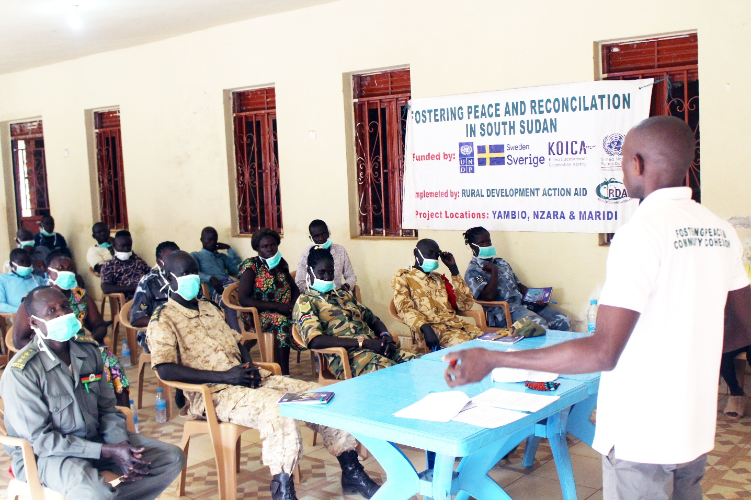

**Project tittle:** “Access to Justice, Security and Human Rights Strengthening Program” 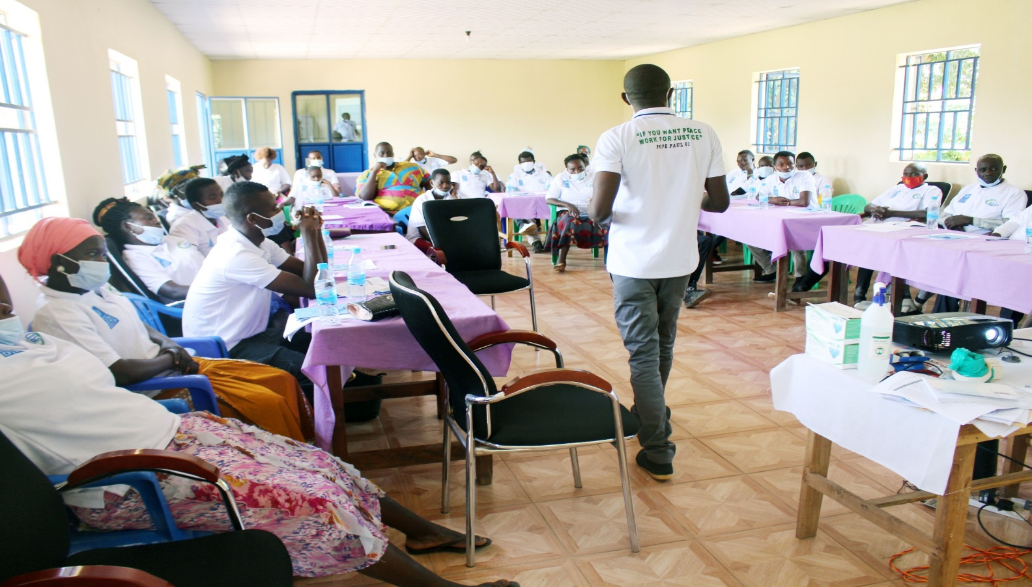

# Annex 2: video clips?

# Annex 3: Testimonials

**Project tittle:** “Access to Justice, Security and Human Rights Strengthening Program”

***Mrs. Rhoda Samuel women leader in Bazungua*** “Much thanksto RDAA for bringing such a program to Bazungua, it will be better that the formation of the three commissions should not delay because I am one of the victims who lost 8 people as members of the entire family at spot from gun shoot, all the house property was also looted and houses were destroyed, I will be the happiest if transitional justice materialize in the nearest future”

***Mr. John Dasio of Gangura Payam*** *“I* appreciate the program and let this awareness cover the state so that all should be aware of traditional justice, I also want to ask a question will the hybrid court truly judge all what happened like the mass killing, destruction of homes, rapping and so on because since the signing of the revitalized peace agreement there is still killing of innocent people by known men in uniform and unknown gun men, and government know about it and no action taken”

***Mr. Baraka Isaac a youth leader in Kuzee residential area*** “I thank RDAA for bringing such awareness to make people understand and know about transitional justice which explained about the rights of people, the formation of the three commissions if is really true will end conflict and bring everlasting peace to South Sudan”

***Mr. Samuel Baaki of Tindoka in Tindoka Boma Yambio County*** “I am very delighted to express my happiness and feelings to the participants, why is it so long to form this commissions? I strongly emphasize that government should hurry up with formation of the commissions to let people’s hearts cool down because people are still in great sorrow for many that affected them, how will the anger cool down? People need peace and continue development”