# Overview of Research Tutorials and Surveys

Research Tutorials and Surveys (RETS) is a local company based in Nairobi, Kenya. We focus on providing Research Capacity and data analytics. We use the research data for adaptive Business Intelligence (BI), Performance Improvement and development of interactive dashboards in various industries. Our unique client-focused methodology ensures our projects are successful because all the requirements of the client have been met.

**Mission**

We develop data analytics and machine learning solutions by aggregating disparate data sources to

**Vision**

To become the most valuable and authentic data analytics partner in Africa and beyond.

## Our Products

* Rets Tutorials
* Rets Analytics

## What we do

* Research capacity building
* Market research surveys and data analysis
* Interactive Dashboards development

# **RETS TUTORIALS**

|  |  |  |  |
| --- | --- | --- | --- |
| **Who we are**  **(about us, our purpose, our philosophy)** | **What we do** | **Our Modules (Drop Down)** | **Contact Us** |

## **About RETS Tutorials**

There is evidence of many graduate students not finishing their theses on time; students taking many years to graduate; and shortage of available supervisors in some university departments. It is in line with these challenges that we initiated *RETS Tutorials*. Our tutors are University Professors with research supervision experience, hence understand the needs of graduate research, and  provide extra academic direction to graduate students struggling with thesis writing. Whatever your current stage of thesis writing is, there are benefits for anyone who wishes to attend our Tutorials. We have packaged the thesis writing stages as modules, which we guide you step by step as a developmental process. The RETS Tutorials are open to individuals interested in learning relevant research methodologies for business research.

## Purpose of Rets Tutorials

*RETS Tutorials* focus on a holistic, but not strictly academic approach to finishing your degree by tutoring and coaching. We offer academic support to supplement your university supervisor by helping you complete important tasks and provide the skills you need to achieve your academic goals. The tutors guide you to:

***Get Focused* :** Clarify your research interests and articulate your ideas

***Stay Focused***: Use a logical progression of ideas; Use sources judiciously; and avoid plagiarism

***Survive the Process***: Create roadmaps to guide you through the process

## RETS Tutorials Philosophy

**Integrity**-We DO NOT write the thesis for you.

**Honesty**-We DO NOT plagiarize other works on your behalf.

**Professional**-We DO NOT replace your university supervisor, but we supplement the guidance.

## **What we do**

The writing tutorials are dedicated solely to getting words down on paper (or a computer screen) and designed to help you get over that final hurdle or to kick-start your writing progress if it has stalled. Introductory sessions will include motivational talks, goal setting and strategies for writing quickly and well. Not for the faint hearted, the writing tutorial participants will battle through writer’s block and thesis fatigue to achieve significant progress on their manuscript. The content in the *RETS* Tutorials is delivered in 7 modules organized in progressive order. In these online tutorials, you will meet candidates around the same candidature stage of thesis writing in a no-excuses and no-time-for-procrastination mode. We help you successfully structure the thesis writing process;  create realistic work plans and increase accountability.

|  |  |  |
| --- | --- | --- |
|  | **What we address** | **Expected Audience** |
| Module 1: Research Onboarding | Academic Thinking  Research Ethics  Citation Techniques  General Dissertation Structure |  |
| Module 2: Introduction to the study | Idea development  Variable selection and the mind-map  Research objectives, questions and hypotheses  Background information and problem statement |  |
| Module 3: The literature Review | Introduction to literature review  Theoretical review  Empirical review  The conceptual framework |  |
| Module 4: Research Methodology | Research designs  Population and sampling  Types of data and collection process  Data collection instruments  Research quality and analysis  Compiling the research proposal |  |
| Module 5: Data analysis and Interpretation | Data presentation techniques  Descriptive data presentation  Inferential data presentation  Qualitative data presentation |  |
| Module 6: Discussions, Conclusions and Recommendations | Summary of findings and discussions  Conclusions and recommendations  The final write-up |  |
| Module 7: Thesis Examination, Defense and Publishing | Thesis examination points  Preparing for the defense  Publishing after defense |  |

**Module 1 objectives**

By the end of the module workshop, you should be able to:

1. Identify a specific research paradigm for your study area of interest.
2. Identify quality journals or publishers related to your research area of interest.
3. Improve communication and academic writing skills
4. Describe various ethical issues in research to consider before selecting a specific research area
5. Develop skills on how to provide, receive and respond to constructive criticism from peers.

## **Why Attend Our Online Research Tutorials?**

* We make you comfortable having Online Interactive discussions with tutors and peers at the same academic writing stage.
* We have a global outlook in our approach. So, no matter where you live in the world, there is a seat for you in one of our online classes.
* Hands on learning and progress follow-up
* We give you summary notes for each session
* Tutorial presentations and reading assignments are all available through the online classroom.
* Recorded tutorials on demand and refresher sessions at an additional cost
* Additional resources on academic research writing.

## **Expected Outcomes**

* Successfully complete your thesis once and for all;
* Identify and change beliefs and behaviors that interfere with your motivation and productivity.
* Improve your academic writing skills through individual or group sessions
* Have an idea of a completed chapter after each session.
* Complete thesis/dissertation within 2 months.
* Publish your academic research findings!
* Appreciate the value for money of your investment.

## **The Graduate student challenges we address**

We help you deal with the following Graduate challenges:

1. Negative thinking;
2. Procrastination;
3. Fear of failure,
4. Obsession with perfection;
5. Low motivation to proceed,
6. Lack of self-discipline to keep writing
7. Writer's block; anxiety and Stresses of delayed  progress,
8. Lack of faculty support;
9. Managing multiple roles and responsibilities,
10. Difficulty managing time effectively.

**Mode of Delivery**

* The 7 modules are delivered as 4-Hour interactive live sessions in 2 sessions using **Zoom**/**Google Meet or** other media as appropriate**.**
* The Thesis Tutorials are offered weekly on **Saturdays** or may vary when necessary .
* Students post their drafts during class; Coaching is done to give direction and receive feedback within the online classroom.
* Expect to finish your Thesis is 8 weeks (2 months).

Package

At only kshs. 8000 ($ 80) per Module, you get Value for your money

Or whole Package with all the 7 modules @ kshs. 50,000 ($ 500)

|  |  |  |  |
| --- | --- | --- | --- |
| **Module** | **Price (kshs.)** | **Price ($)** | **Session Bonus** |
| Module 1: Research Onboarding | 8,000 | 80 |  |
| Module 2: Introduction to the study | 10,000 | 100 |  |
| Module 3: The literature Review | 7,000 | 70 |  |
| Module 4: Research Methodology | 8,000 | 80 |  |
| Module 5: Data analysis and Interpretation | 10,000 | 100 |  |
| Module 6: Discussions, Conclusions and Recommendations | 5,000 | 50 |  |
| Module 7: Thesis Examination, Defense and Publishing | 7000 | 70 |  |
| **Total** | **55, 000** | **550** |  |
| **Discount for enrolling for all seven modules** | **45,000** | **450** |  |
| **Early Bird registration** |  |  |  |
| **Referral Perks** |  |  |  |

|  |  |  |
| --- | --- | --- |
|  | **Duration** | **Activity** |
| **Session 1** | **90 minutes** | * Tutorials are given on basic research principles of  a given module. * Presentations and typical case scenarios are discussed * Practical assignments are all done through the online classroom. |
| **BREAK** | **20 Minutes** |  |
| **Session 2** | **90 minutes** | * Interactive discussions with instructor and peers at the same writing stage. * Students post their drafts during class; * Coaching is done to give direction and receive feedback within the online classroom. |

iPay

Mpesa PayBill: **838363**

Paypal: [**vipro.education2@gmail.com**](mailto:vipro.education2@gmail.com)

Research Tutorials Blog

* To share articles on tips, technics and emerging trends on academic research writing. Important for building presence, networking and displaying expertise & enhances credibility and confidence.
* For client feedback

Events/Announcement

Create space for events and announcements

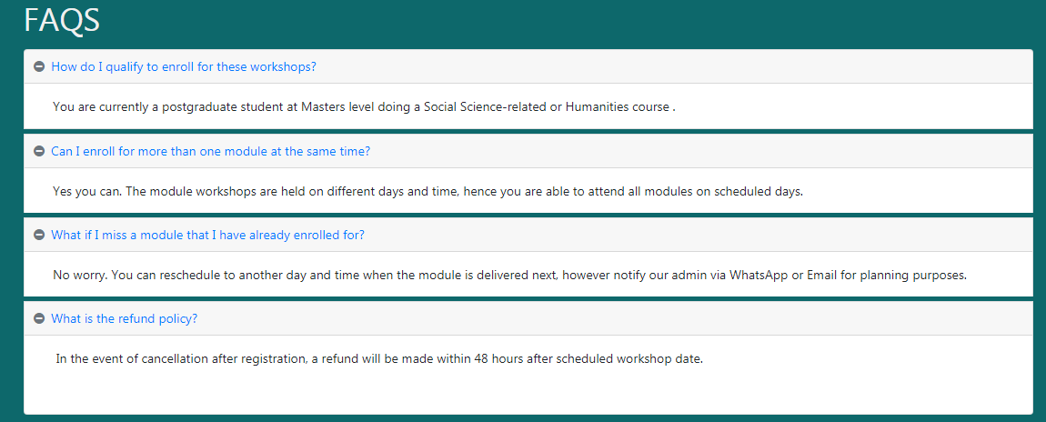

# **RETS ANALTYTICS**

## **About Rets Analytics**

RETS Analytics consists of experienced data analysts who are ready to get the most out of your **business analytics.** We start with research data which we then develop interactive dashboards for client’s visualization of company data metrics and make informed decisions from data. At Rets Analytics, our vision is to be the leading business intelligence solution provider in Eastern Africa. With the advent of technology, we pride in application of Power BI and Tableau in advanced analytics and development of interactive dashboards. We offer data analytics services using a unique methodology that realizes data efficiency, data transparency, automated reporting, information sharing, predictive modelling to realize data driven decision-making.

## **Purpose of RETS analytics**

* 1. **Development of Dashboards**

Our dashboards give company executives a better view of critical performance indicators and metrics. The Dashboards replace text and tables with easy-to-use interactive dashboards, the data becomes more meaningful, more engaging and more powerful. The Dashboards also provide Business Executives and decision makers with a snapshot view of how their business is performing based on critical business measures.

* 1. **Customized Operational Reporting**

At RETS Analytics, we believe every business has data which when collected, stored, cleaned, organized, consolidated, analyzed and interpreted can enable informed decision making. We deliver customized reports to address specific needs of customers. Customized Operational Reporting helps to offer functionality that is more focused on client needs; Ability to build reports using data from more than one system involvement of our consultancy team in interpreting analyzed data.

## **What we do**

Consultancy Report

Interactive Dashboard

1. **Brand portfolio analysis**

1. **Customer Capital analysis**

Analysis of current and potential customers concerning satisfaction, requirements, socio-demographic criteria.

1. **Governance Surveys**

Our team uses tested international metrics for evaluating and generating report cards for your company’s overall governance performance. We do survey reports for:

1. **Human Resource Analytics**
2. **Competitive Analysis**

Our experienced team uses 5 Competitive Analysis Frameworks for evaluating your company’s competitive position in the market. These frameworks include:

## **RETS Analytics Values**

At RETS analytics, we’re guided by the following values:

* Integrity
* Transparency
* Teamwork
* Professionalism

# THE TEAM

1. Experienced university professors
2. Data scientists and engineers
3. Computer scientists
4. Advocate

# CONTACT US

Email: [info@researchtutorials.org/](mailto:info@researchtutorials.org/) [Vipro.education@gmail.com](mailto:Vipro.education@gmail.com)

WhatsApp and call: +254 780 722 722

Telegram: 0776 046 196

**Social Media channels (twitter, Instagram)**

**Twitter**:  @rets2020 **Instagram**: @Re_tutor

**Telegram**: @Re_tutor

**Website:** <https://researchtutorials.org>