CMPEN 331 sec 002

LAB 1

Yiming Ren

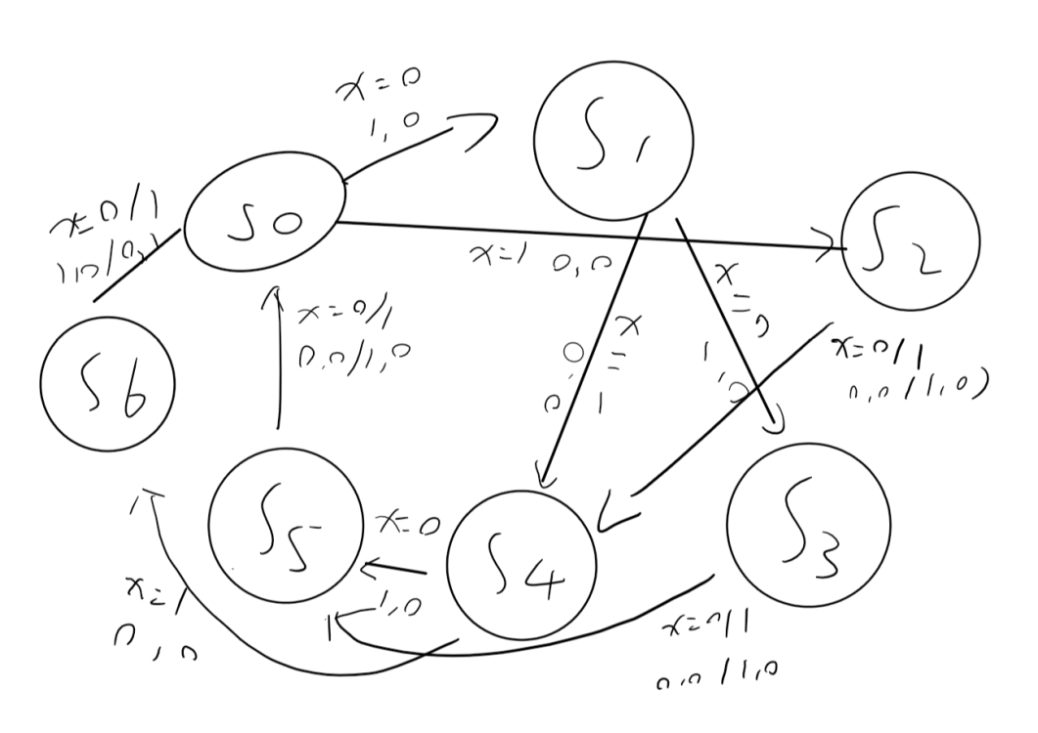

Source Code

`timescale 1ns / 1ns

module lab_1(clk, X,S,V);

input clk;

input X;

output reg S,V;

localparam s0=3'b000,s1=3'b010,s2=3'b001,s3=3'b101,s4=3'b011,s5=3'b100,s6=3'b111;

reg[2:0] state;

initial begin

S =0;

V =0;

end

always@(negedge clk) begin

case(state)

default: begin

state=s0;

end

s0: begin

if(X==0) begin

state=s1;

S=1;

V=0;

end

else begin

state=s2;

S=0;

V=0;

end

end

s1: begin

if (X==0) begin

state=s3;

S=1;

V=0;

end

else begin

state=s4;

S=0;

V=0;

end

end

s2: begin

if(X==0) begin

state=s4;

S=0;

V=0;

end

else begin

state=s4;

S=1;

V=0;

end

end

s3: begin

if(X==0) begin

state=s5;

S=0;

V=0;

end

else begin

state=s5;

S=1;

V=0;

end

end

s4: begin

if(X==0) begin

state=s5;

S=1;

V=0;

end

else begin

state=s6;

S=0;

V=0;

end

end

s5: begin

if(X==0)begin

state=s0;

S=0;

V=0;

end

else begin

state=s0;

S=1;

V=0;

end

end

s6: begin

if(X==0) begin

state=s0;

S=1;

V=0;

end

else begin

state=s0;

S=0;

V=1;

end

end

endcase

end

endmodule

Test Bench

`timescale 1ns / 1ns

module tester( );

reg x;

reg y;

wire S,V;

lab_1 lab1(y,x,S,V);

initial begin

x=0;

y=0;

#5 y=1;

#2.5 x=1;

#2.5 y=0;

#5 y=1;

#2.5 x=0;

#2.5 y=0;

#5 y=1;

#2.5 x=1;

#2.5 y=0;

#5 y=1;

#2.5x=1;

#2.5 y=0;

#5 y=1;

#2.5 x=0;

#2.5 y=0;

#5 y=1;

#2.5 x=0;

#2.5 y=0;

#5 y=1;

#2.5 x=1;

#2.5 y=0;

#5 y=1;

#2.5 x=1;

#2.5 y=0;

#5 y=1;

#2.5 x=1;

#2.5 y=0;

#5 y=1;

#2.5 x=1;

#2.5 y=0;

#5 y=1;

#2.5 x=0;

#2.5 y=0;

#5 y=1;

#2.5 x=1;

#2.5 y=0;

$finish;

end

endmodule

Schematic

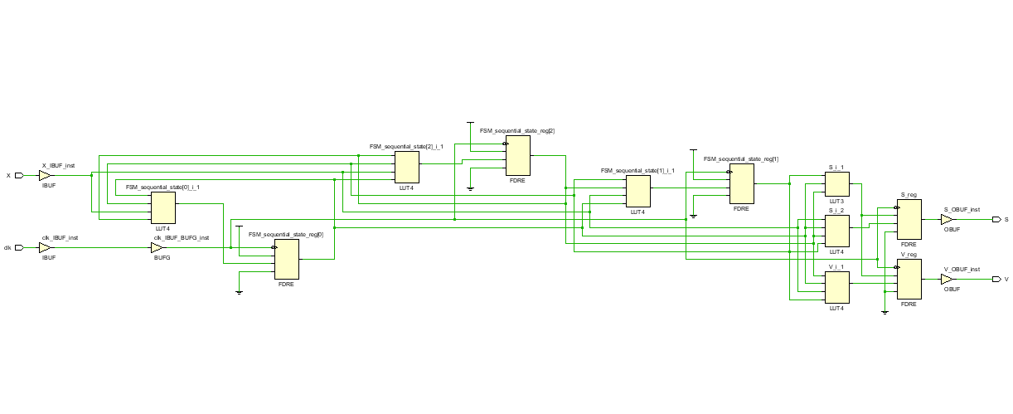Floor planning

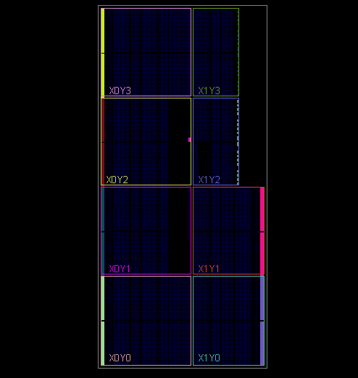

I/o planning

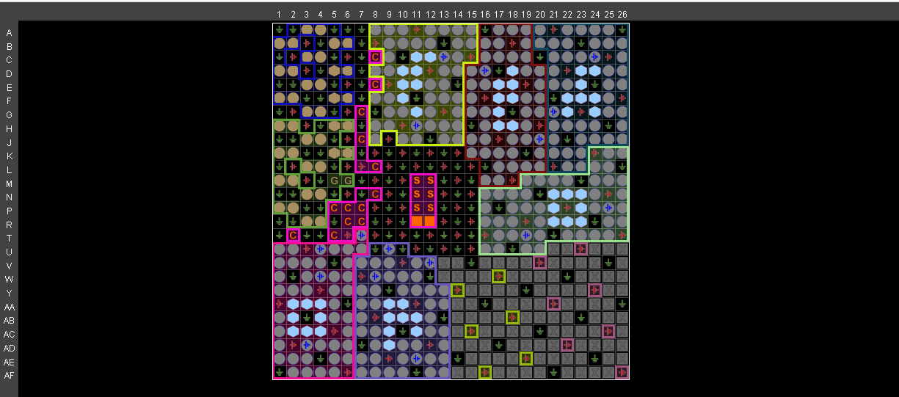

Waveform

