Recovering the risk-neutral probability distribution from call option prices

First try:

1. 02/06/2018 S&P 500 Option Price; add midpoint to each two neighboring striking price;

2. Use cubic spline interpolation to add “prices” for the midpoints;

3. Optimization

Objective function:

Subject to

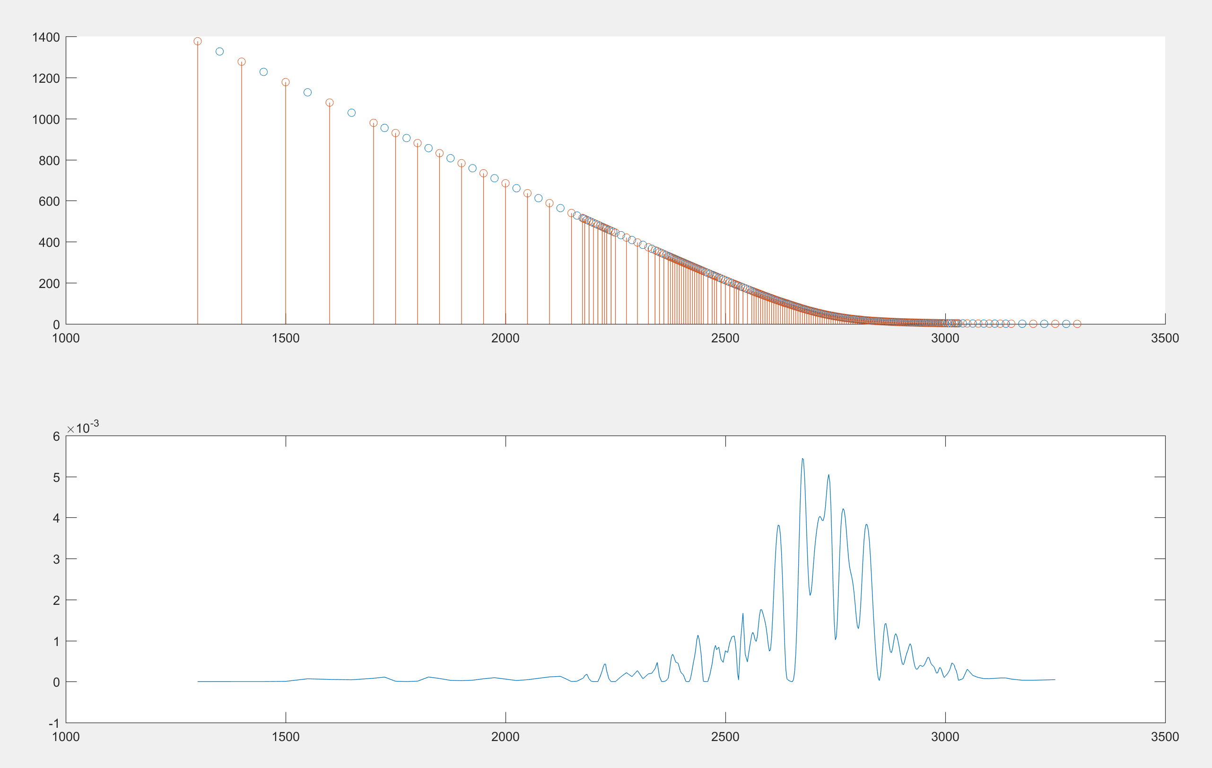

Prices seem good, but too much jaggedness of Probability distribution.

Second try: The jaggedness of P is caused by unstable values of 3rd-order derivatives.

4. Change the objective function to limit the 3rd-order derivatives.

5. Used quadratic function as the test function to test the optimization. I found that the initial value matters for the function **fmincon.** So I used Lowess function to smooth the strike price (uniform 2.5-grid), then used the smoothed prices as initial value.

**Problem: Used Matlab to replicate the previous method used in Stata, the results are different.**

Smoothed price data:

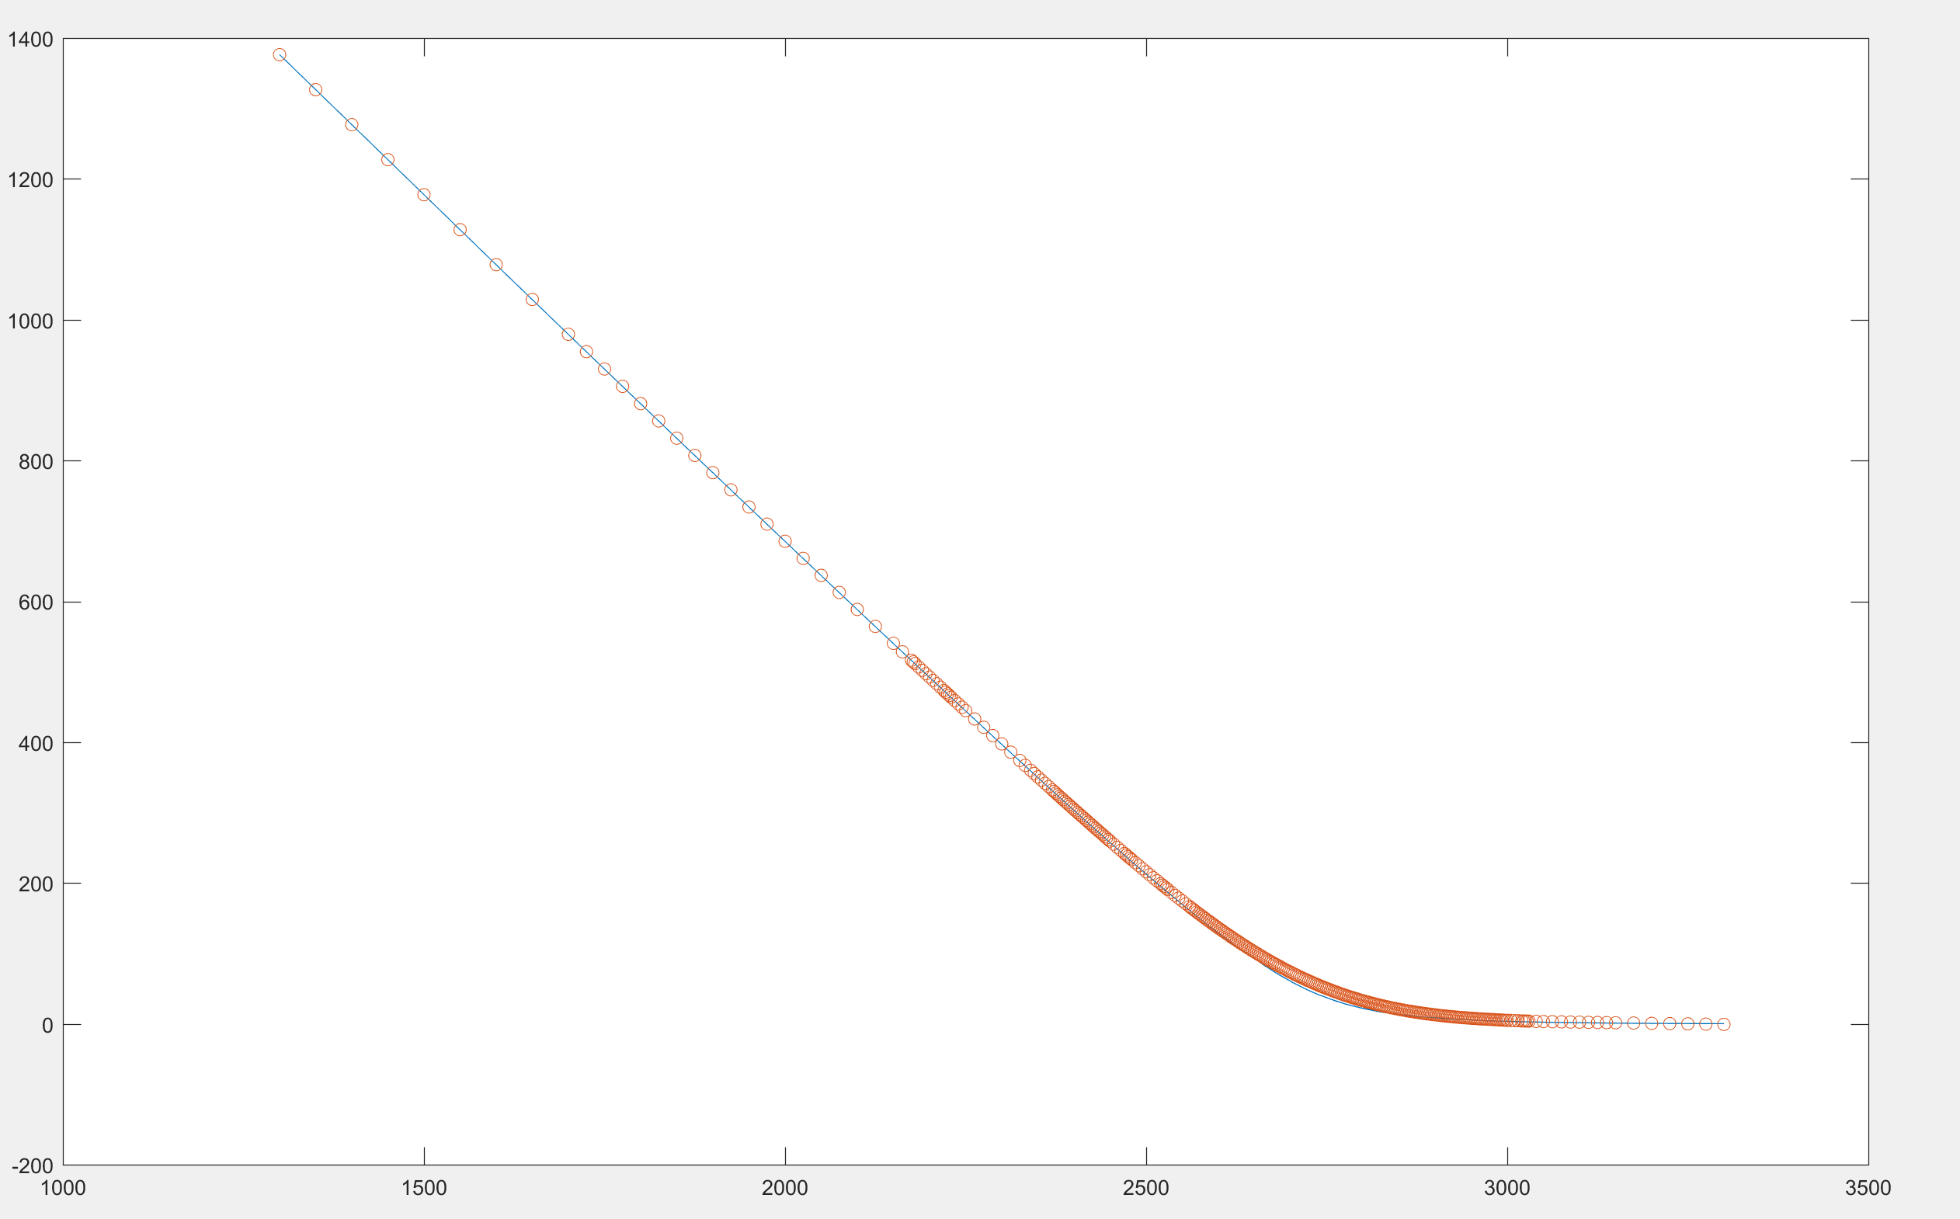

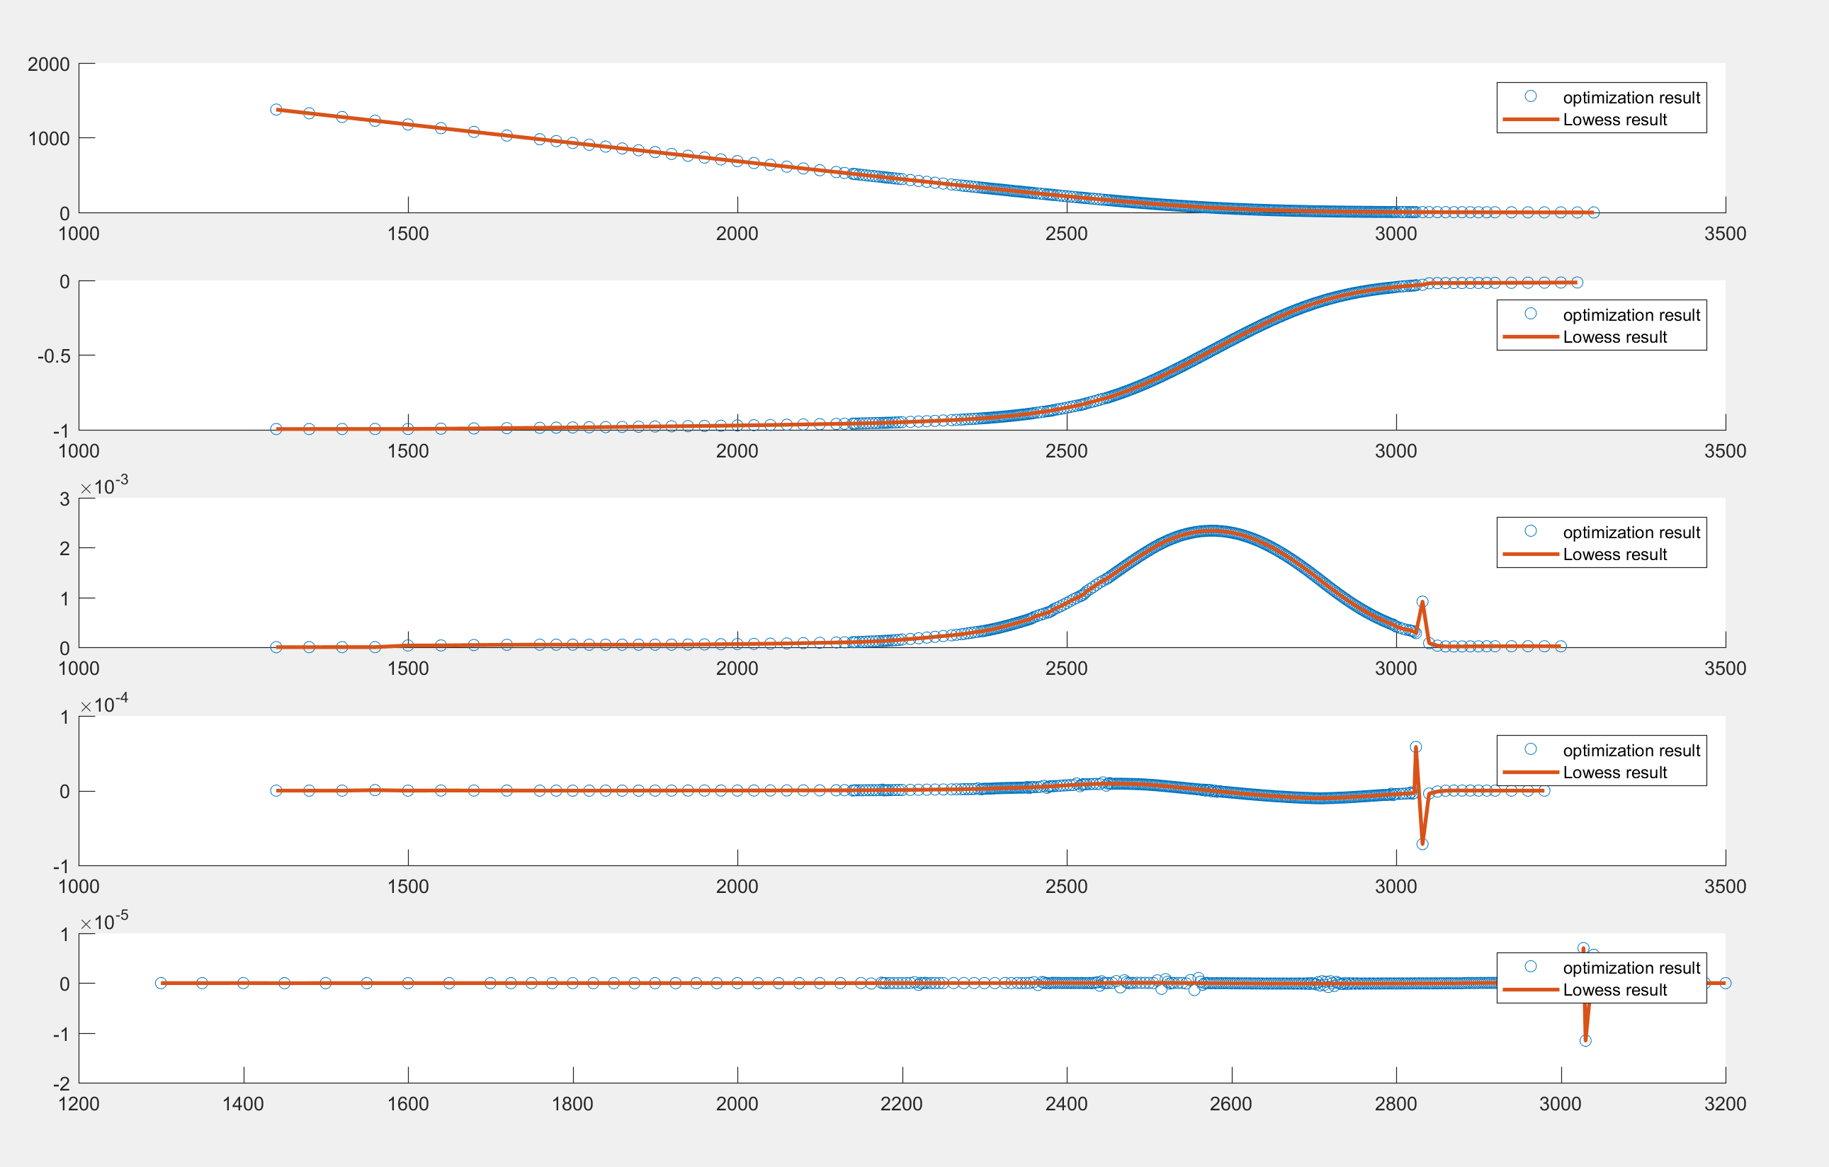

For 01/25/2018 & 04/17/2018, the results are much worse:

Date 01/25/2018

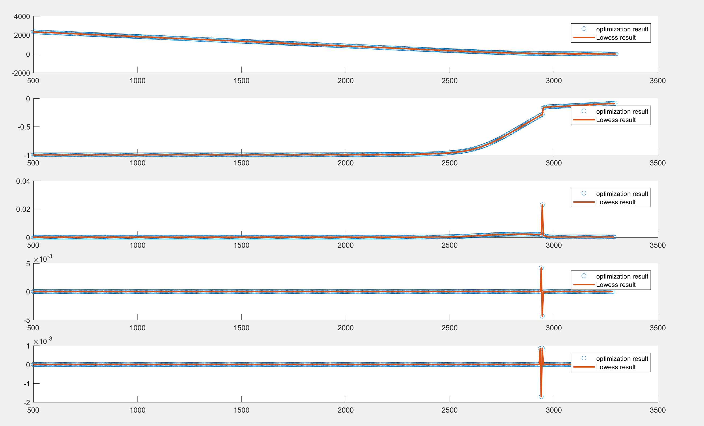

Matlab optimization is sensitive to the initial values, and the results have too much jaggedness.

Tried to use Python – the results are worse…

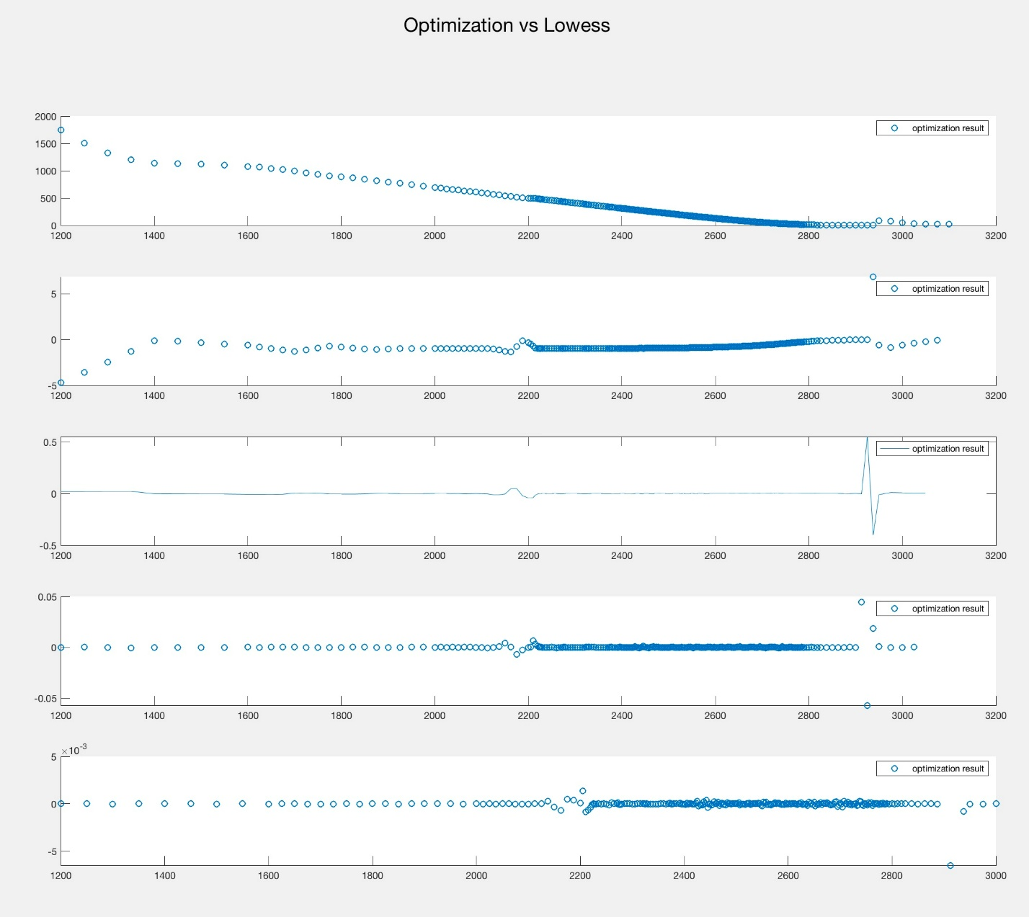

Finally

Objective function:

