### Upon opening the application you immediately come across the “Login” screen.

### Login:

Login interface was designed as follows:

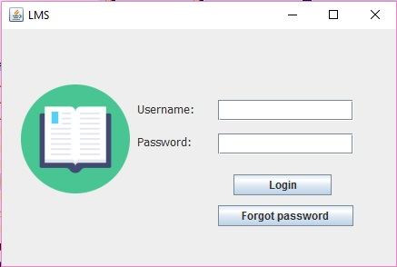

* If the logged-in user is not found then the following message will be shown:

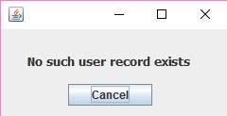

* If the fields are empty then the following message will be shown:

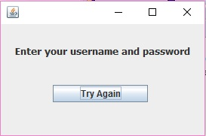

* If the password is entered incorrectly then the following message will be shown:

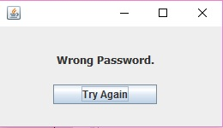

According to the login interface, users are asked their username and password. If they forget their password then they will be directed to the “New Password” interface.

* New Password:

Interface for new password was designed as follows:

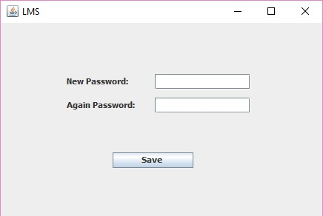

After the new password is saved, return to the “Login” interface.

If the user isn’t a member of the system, then they have to go a librarian to be registered into the system.

The user entering the system is checked whether he is a librarian or a member. If he is a librarian then he is directed to the “Librarian” interface. If he is a member then he is directed to the “User” interface.

* User:

The following interface is designed for the member:

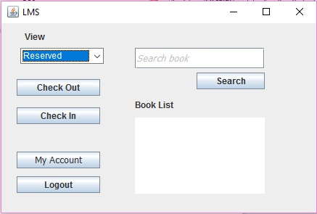

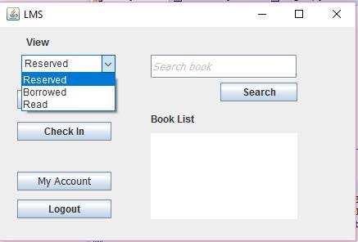

The member can search a book by its name and see whether or not the book is available. The books availability is determined by its station. The member can also see his reserved, borrowed and read books. He can logout with the “Logout” button. Also the member can go to his “Account” screen through here.

Members borrow a book with its barcode and give it back with the same barcode. To do this they can use the “Check In” and “Check Out” buttons to direct them to the “Check In” and “Check Out” pages.

* Check Out:

When the members wish to get books with their barcodes, they use the following interface:

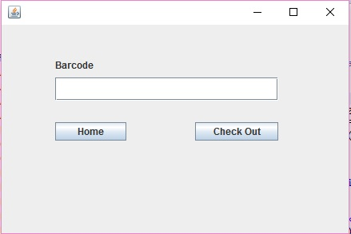

* Check In:

Members use the following interface when they wish to return a book with its bar code:

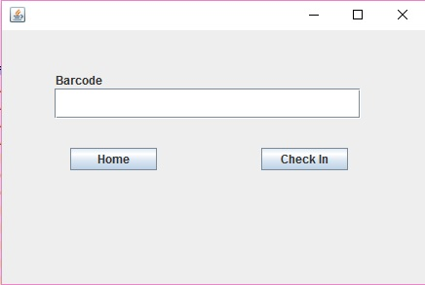

* If the check in, check out or adding book to waiting list was successful then the following message will be shown:

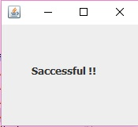

* Account:

Both members and librarians can access this page. Members can see their account information and fines they’ve been given, if any, here. Members can pay said fines with the “Pay” button. This button is inactive for librarians. “Edit” and “Delete” buttons aren’t active for members in the system. Only librarians can edit or delete member information. With the “Home” button, the members can return to the “User” interface and librarians can return to the “Librarian” interface.

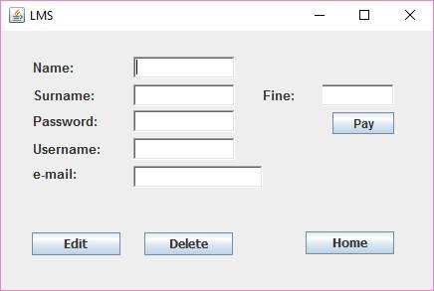

* Librarian:

The following interface is designed for the librarian:

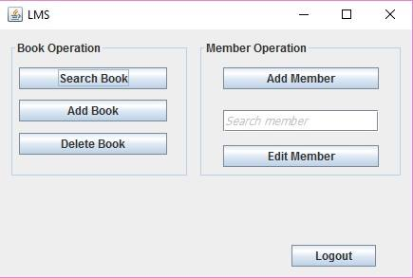

The librarian can add, delete and search books with the Book Operations panel. Clicking the “Search Book” button will open the “Books” interface. The librarian can access the “Add Book” page by clicking on “Add Book” button located here or they may also access it through the identically named button on the “Books” page. Clicking on the “Delete Book” button will direct the librarian to the “Delete Book” page.

* Books:

The interface designed for librarians for searching books is as follows:

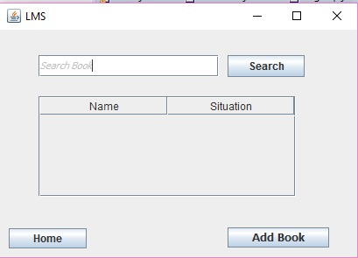

After the librarian has clicked “Search”, he can see the books and their station on the table. The librarian can return to main “Librarian” page with the “Home” button. As a quality of life feature, the librarian can easily access the “Add Book” page from here, in case he is searching for a book he wishes to add to see whether or not it was already added.

* Delete Book:

The interface shown below is the screen for deleting books:

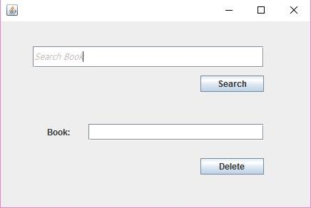

* If the entered name of the book is not found then the following message will be shown:

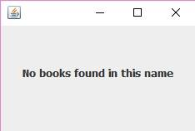

* Add Book:

The interface designed for adding books is as follows:

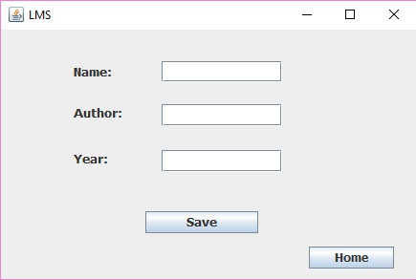

The librarians are asked information about the book they wish to add, like its name, author and year. Then the librarians can save this book with the “Save” button. Doing so they will stay in the same interface (faster book adding). The librarians can return to the “Librarian” page with the “Home” button.

Through the “Librarian” page, the librarian can sign up new members or edit existing ones with the Member Operation panel. Clicking “Add Member” will direct the librarian to the “Sign Up” page. While clicking the “Edit Member” button will direct him to the “Account” page. To do this the librarian must enter a valid member name.

* Sign Up:

The interface that is designed to add a member is as follows:

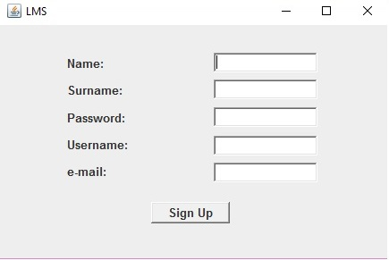

* If the all fields are empty then the following message will be shown:

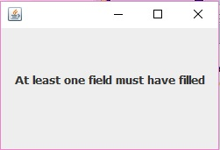

The user is asked their name, surname, username, e-mail and password by the librarian. After the user is a member, the user can log into the system anytime.

After the librarian is finished making the new member, he is directed to the “Librarian” page.

* Admin:

Admins can only add or delete librarians. The interface designed for admins is as follows:

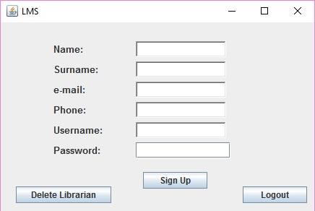

The librarians are asked their name, surname, e-mail, username, phone, username and password by an admin. When an admin signs up the librarians with “Sign Up” button, the admin won’t be directed to any page. Admins can click the “Delete Librarian” button to go to the “Delete Librarian” page.

* Delete Librarian:

Admins can delete librarians. The interface designed for this is as follows:

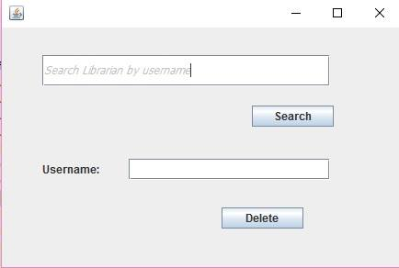

* If the librarian trying to be deleted does not exist then the following message will be shown:



* If the search fields are empty then the following message will be shown:

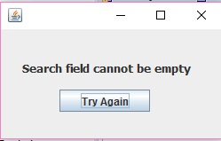

* If the registration was successful then the following message will be shown:
* If a reserved book is available the following message will be shown:

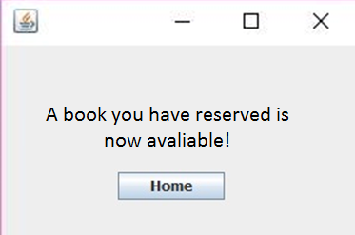

* If a book you wish to check out is unavailable you can add it to your waitlist with the following message:

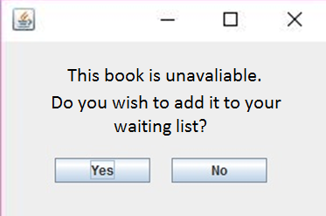

* If the member or librarian username already exists while making new users, the following message will pop up:

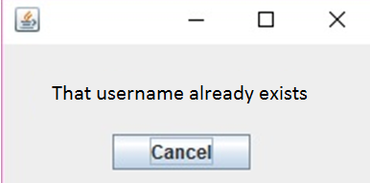

* If the system is closed without logging out then the following message will be shown:

