<Library Management System>

System-Wide Requirements Specification

Apdx - C

Entity Relationship Diagram

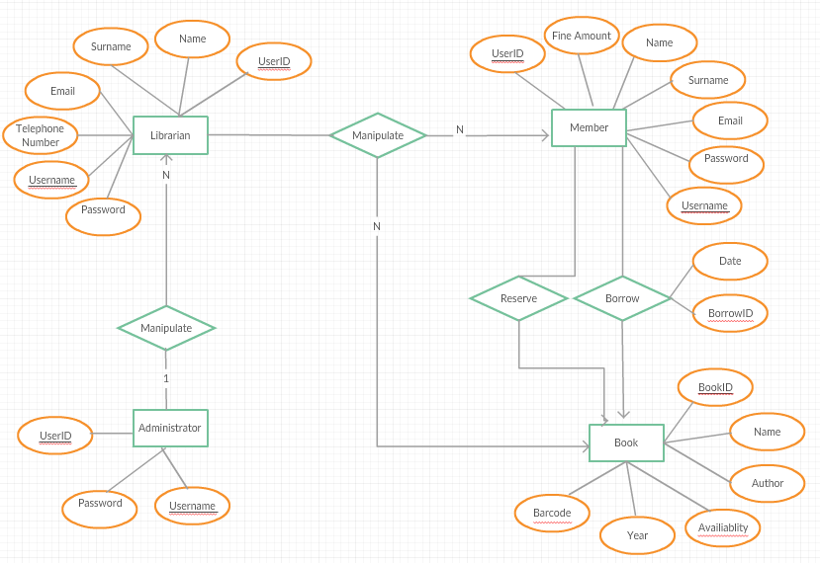

ReserveID