<Library Management System>

System-Wide Requirements Specification

# Introduction

Library management system is software to manage the catalog of the local government libraries. This helps to keep the records of member’s transaction and librarian’s transactions. Members can search a book, check-in, check-out, pay fine and look at self-information and books. Librarians can manipulate book and members information. Admins can manipulate librarians and the system itself issues fines and notifies waitlisted books becoming available.

# System-Wide Functional Requirements

It is important who uses the system. There is a difference in authority between people. Access to the system will be controlled. However, it will not be tracked when the system is used except check-in and check-out operations. System won’t be licensed and doesn’t need any printing and reporting. User’s information will be secure. Members other than the members themselves and the librarians cannot access the personal information of the member.

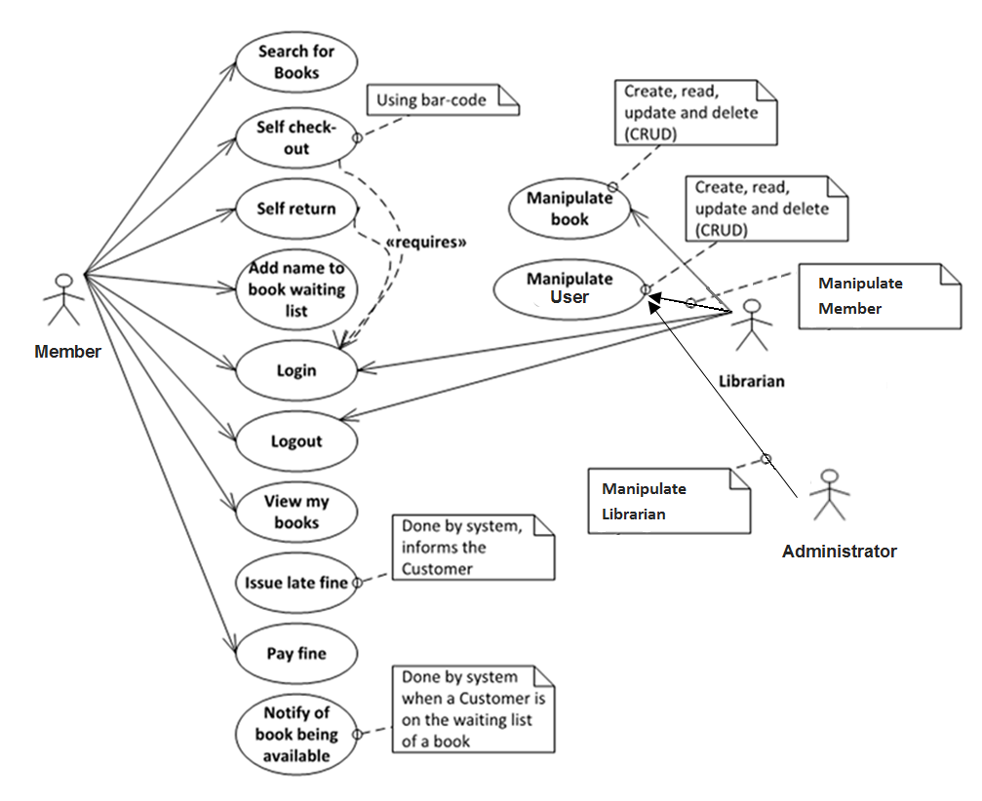

Use-case details in tabular structure are shown in Apdx-A.

ER Diagram is shown in Apdx-C.

# System Qualities

## Usability

Members should be able to handle the main operations with two or three clicks when they enter the system. A warning should be given if there is a problem during operation. The system warnings should be short and straightforward. It is expected that 80 percent of the users will be satisfied with the system.

## Reliability

It is expected that the operations will be realized with 95% success. The system should not wait more than 5 seconds. There are no restriction on the operation of the system, such as hours of use. Book entries in the system should not be deleted as an error result.

## Performance

On average, the system should answers the calls in 2 second. Respond time should be maximum 5 seconds. Since this version of the system cannot use the database, there is no criterion for the number of users to use the program at the same time. The system should be able to record at least 500,000 members and 200,000 books in this version. The time for the system to start up and shut down should be maximum 2 minute.

## Supportability

In the second version of the project, database system will be added. With this update, the system can be active on multiple computers. The second version is not compatible with the previous one. The data is transferred to the second version by the project team. For the installation of the system, the computer must have windows 7/8/10 operating system and the monitor, keyboard and mouse hardware. (All information given here is to fit the status quo on documentation; realistically speaking a second version of the project will not be worked on)

The system is restarted when the system fails. In case of continuation of the fault, technical support is provided by telephone from the project team. If the problem cannot be solved, the project team sends a responsible person for support.

Initially the project will support a certain number of books and member registrations. In the second version we will be eliminating restrictions.

# System Interfaces

The Java Graphics API was used to develop the interface of the software. Interfaces were developed with Eclipse Neon. The required interfaces supported by the LMS are specified as follows:

* Login
* New Password
* User
* Check Out
* Check In
* Account
* Librarian
* Books
* Delete Book
* Add Book
* Sign Up
* Admin
* Delete Librarian

## User Interfaces

GUI’s are shown in Apdx-B.

### Look & Feel

The interface must be simple. The main operations must be on the main page. The customer did not have any requests related to the color and page placement of the system interfaces.

### Layout and Navigation Requirements

The capture requirements are shown on major screen areas with diagrams. The requirements are grouped according to who they are for and what they are needed.

### Consistency

The size of system does not resize. Contains’ size in the window does not change when the size of window is increased. The system window opens on the right side of the screen.

### User Personalization & Customization Requirements

The users cannot personalize their screens.

## Interfaces to External Systems or Devices

There aren’t any external systems with which this system must interface. So there isn’t any consistency.

### Software Interfaces

There isn’t any other used unit of software for the system, especially paid ones. Because the system was developed in java it will be universally usable.

### Hardware Interfaces

Special hardware device was not used for the system. The system runs on an every computer.

### Communications Interfaces

# The system doesn’t depend on internet or bank system. The system only works with the computer on which it is installed

# Business Rules

## <Check Out/ Check In Rules>

### <Number of book, #1>

A member can hold 5 books at the same time and can reserve 3 books. There is no restriction on the number of books that members can borrow during membership.

### <Loan Period, #2>

A member can hold books for 20 days. If this time is exceeded 1 Turkish lira penalty cut every day.

### <Fine, #3>

If the member has a fine on 20 Turkish lira, he cannot loan a new book. He should pay first.

## <User Rules>

### <Same information, #4>

### Users can not have the same user name, telephone number or mail address.

# System Constraints

* The system does not use any 3rd party component.
* The program will be in English only. There is no need to add other languages.
* The system must be running Windows 7/8/10 operating system.
* The system footprint (with the data) should not exceed 100 MB.

# System Compliance

## Licensing Requirements

There isn’t any licensing enforcement requirement or other usage restriction requirement that are to be exhibited by the software.

## Legal, Copyright, and Other Notices

There isn’t any necessary legal disclaimer or warranty. Because it is a student project, there are no standards like corporate logos or watermarks.

## Applicable Standards

There is no standard followed in the project. Eclipse OpenUp standards are followed in the documentation.

# System Documentation

User Manuals and Installation Guides will created by project team. User Manuals will be written by the project manager and analyst. Installation guides will be written by developer. (Given the circumstance that the project does not require an installation guide then one will not be written, this will be determined closer to launch)

The documentation process in the Eclipse open up is followed for the documents in the project process. Documents completed by the project team in accordance with their responsibilities. This distribution is clearly stated in the project plan.