<Library Management System>
Software Design Description

Revision History

Version | Date | Author | Change Description
1.0 | 21.03.2017 |  | Initial Version Description
1.1 | 25.04.2017 |  | Second Version Description

INTRODUCTION

Purpose and Scope
The SSD is a written description of a software product written by the software project to provide general guidance to the architecture.

Document Overview

This document describes the design constraints and decisions, the project's uml diagrams, and the user interface.

System Overview
[Give a general description of the complete system here; preferably in form of a commented drawing.]

Definitions, Acronyms, and Abbreviations
All non-standard terms, acronyms and abbreviations that are unique to this document should be included in this section. References to other appendices or reference documents may be included. Index information should be in bold.
- IEEE – Institute of Electrical and Electronics Engineers
- SRS – System Requirements Specification
Also see IEEE Std 1002-1987, IEEE Standard Taxonomy for Software Engineering Standards.
Term/Acronym | Definition

References
[Provide references for any pertinent document including reference number, version number, release date, and version name.]

Design Constraints and Decisions
- The Library Management System does not use internet. The system needs to be installed on the computer.
- Members, librarians and books are registered in the array list temporarily.
- Admin must be registered in the LMS.
- Admin can add librarians to the LMS or delete them from the LMS or search them in the system.
- Admin cannot add member to the LMS and delete them from the LMS.
- Admin cannot update member or librarians in the system.
- Users must be a member of the system.
- Librarians cannot add themselves to the LMS or delete themselves from the LMS.
- Librarians can add books to the system, delete them from the system or update them in the system.
- Librarians can borrow books from system or return them back to the system.
- Librarian can search books or members.
- Librarians can add members to the system delete them from the system or update them in the system.
- Members cannot add themselves to the system or delete themselves from the system or update themselves in the system.
- Members cannot add books to the system, delete them from the system or update them in the system.
- Members can search books from system.
- Members can borrow books from system or return them back to the system.
- Members can reserve books in the system.
- Members can check books out with barcode from system or check books in with barcode to the system.

Design Details
In this section project design uml diagrams and user interfaces are shown

Software Components
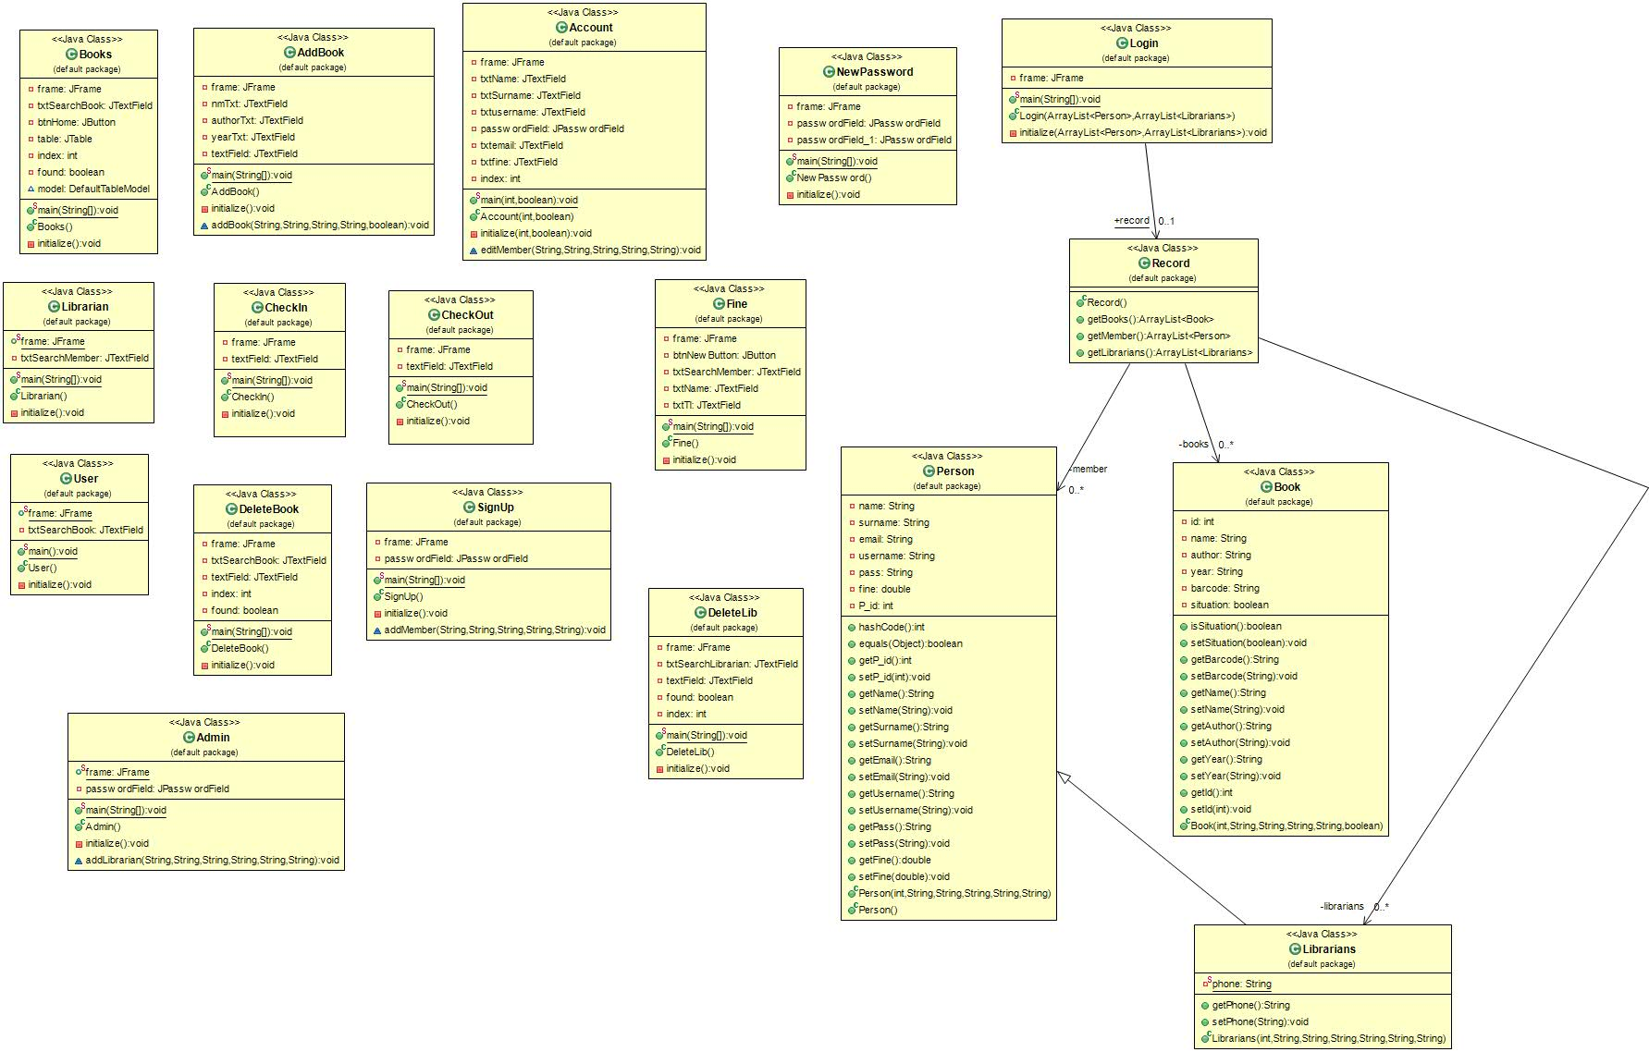
The Class Diagram For The System:

Software Behavior
[ Draw sequence diagrams for use-cases specified on System-Wide Requirements Specification Document.
Identify a class in this system for which state-driven behavior is important and interesting, and then draw the state
diagram for it, with full details (events and guard conditions).]

Data Model (E-R Diagram)
[Detail the elements that make up the data model and the relationships between them.]

User Interface Design

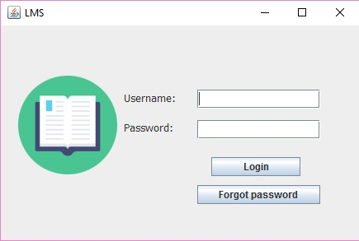
- Login:

- Librarian:
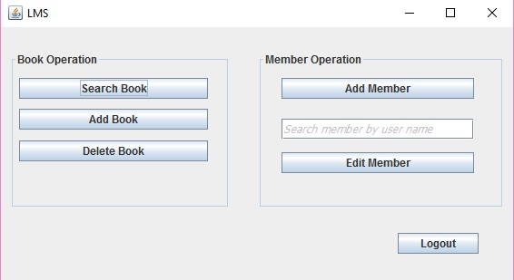

- User
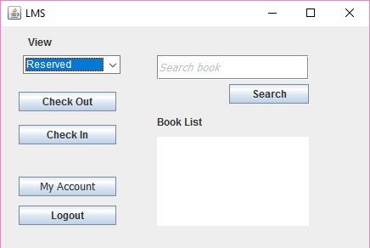
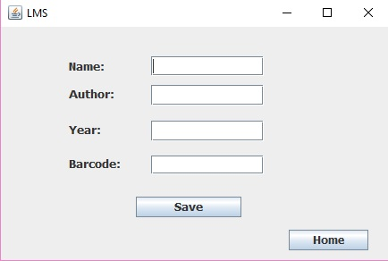
- Add Book

- Add User
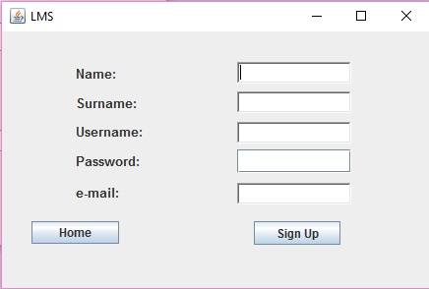

- Delete Book
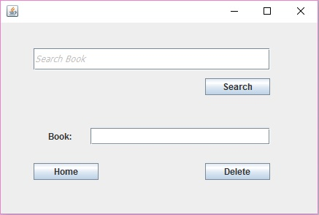

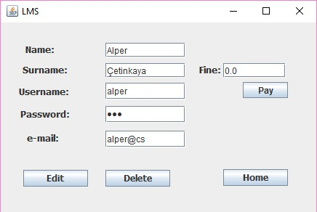
- Edit and Delete User

- Delete Librarian
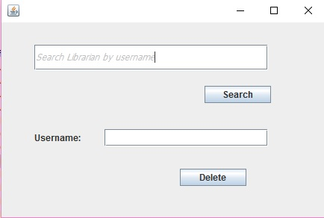

- Check In
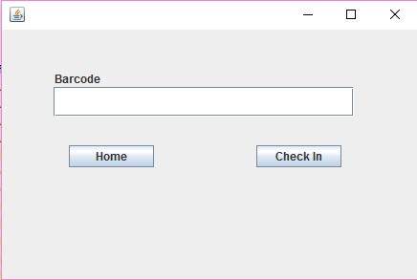
- Check Out
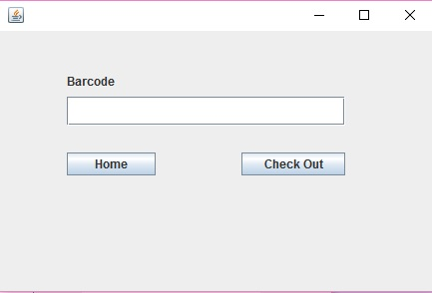
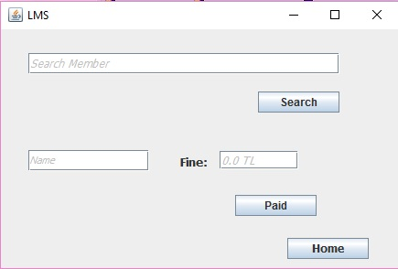
- Fine

- Search Book
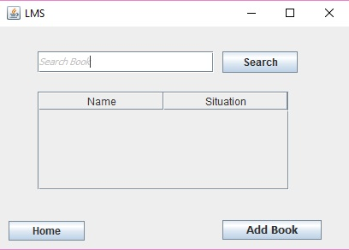

- Search User

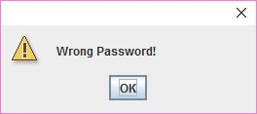
- Wrong Password

- Empty Field for user name and password
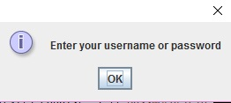
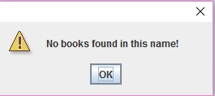
- No Book

- No User
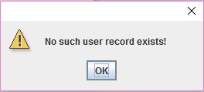
- Borrowed
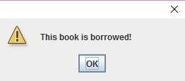

- Not Borrowed
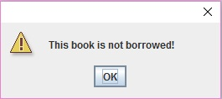

- New Password

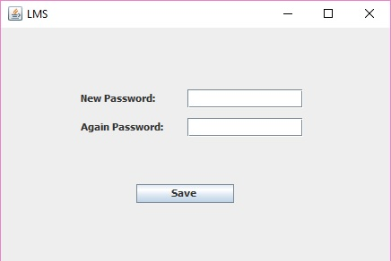

- Successful

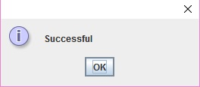

- Logout
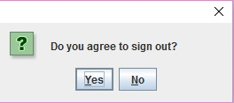

Requirements Traceability
Requirement | Software Design
Login | X
Manipulate Book | X
Manipulate Users | X
Check In | X
Check Out | X
Logout | X

