INCLUDES
Challenge: Includes
Category: Web Exploitation
Difficulty: Easy

Step 1: Open the Website
I opened the challenge URL and checked the webpage. It looked normal and did not show the flag.

STEP2: INSPECT PAGE
I right click then inspect then I explore I found half of the flag in the source

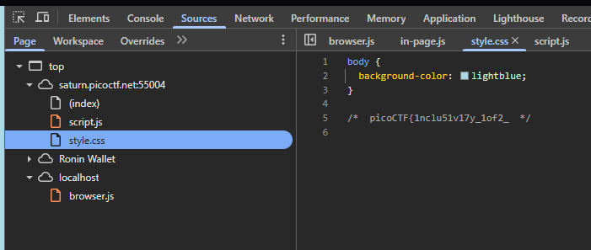
STEP 3: find and combine the flag
Then I go to script.js 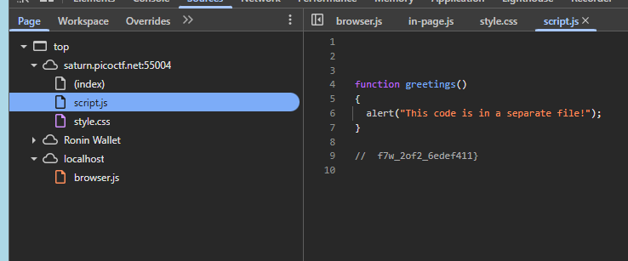
The other flag was there
Now combine picoCTF{1nclu51v17y_1of2_ + f7w_2of2_6edef411}
FLAG: picoCTF{1nclu51v17y_1of2_f7w_2of2_6edef411}

picoCTF{1nclu51v17y_1of2_ f7w_2of2_6edef411}

