Logon
Challenge: logon
Category: Web Exploitation
Difficulty: Easy

In the picoCTF "logon" challenge, the gate is guarded by a classic web vulnerability: Insecure Cookie Handling.
The website claims that only the "admin" can see the flag. However, it lets you log in with any username and password. The trick is that once you are logged in, the server doesn't check its own database to see if you are an admin; it checks a Cookie that it just gave to your browser.

The Situation
- Go to the challenge website.
- Try logging in with admin and a random password. It will likely fail.
- Log in with a random username like guest and password guest. You'll get in, but the page says: "No flag for you!"
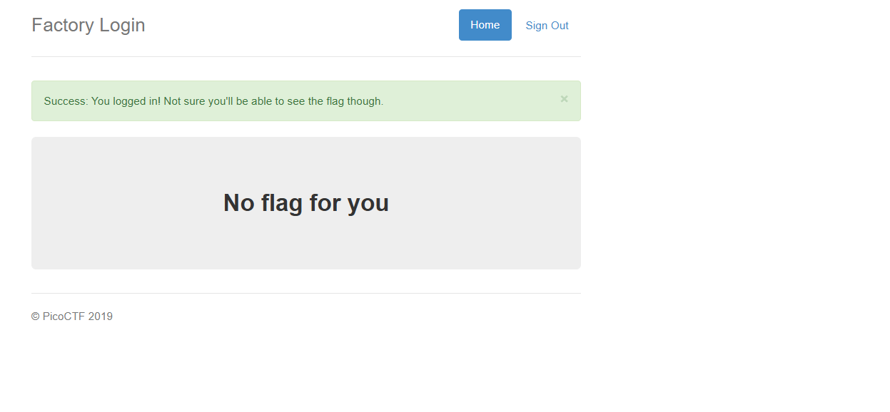
The Exploit: Cookie Tampering
Since the server trusts the browser to identify itself, we can simply tell the server we are the admin by editing our session data.
Step-by-Step:
- While logged in as guest, open your browser's Developer Tools (Press F12 or Right-Click > Inspect).
- Navigate to the Application tab (Chrome/Edge) or the Storage tab (Firefox).
- On the left sidebar, click on Cookies and select the challenge URL.
- Look for a cookie named admin.
  - You will notice its value is set to False.
- Double-click the value False and change it to True.
- Refresh the page.

