Unminify
Category: Web Exploitation
Description: I don't like scrolling down to read the code of my website, so I've squished it. As a bonus, my pages load faster!

The Concept: What is Minification?
Minification is the process of removing all unnecessary characters (whitespace, newlines, comments) from source code to reduce file size and improve page load speeds. While it makes the code "ugly" to humans, it doesn't actually encrypt or hide anything.
2. The Method: "View Source"
When you launch the challenge instance and open the URL, the page looks like a very basic, unstyled site. To find the flag:
- Right-click anywhere on the page.
- Select View Page Source (or press Ctrl + U).
- You will see a single, long line of HTML. This is the "minified" code.
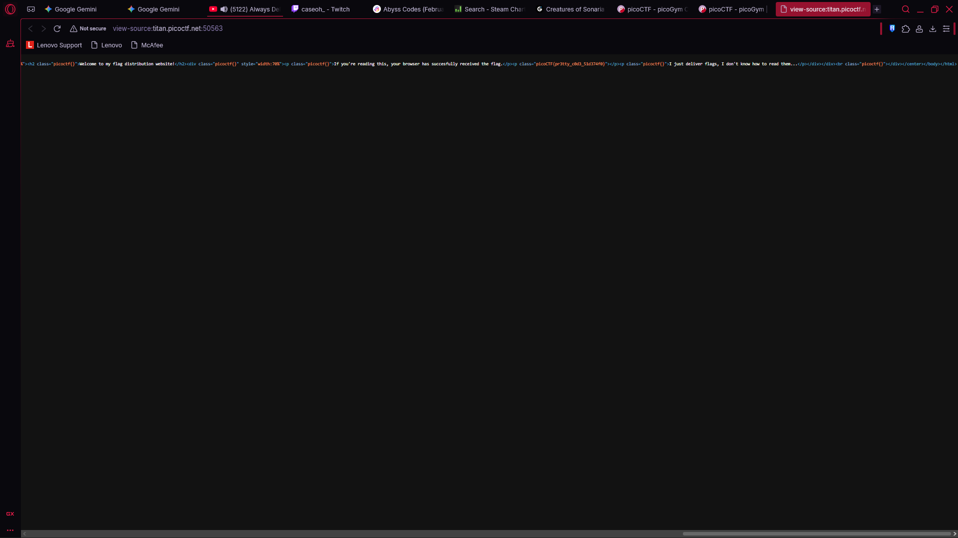
3. Finding the Flag
Because the code is all on one line, it can be hard to read. You have two options:
- The Manual Search: Scroll to the right until you see the picoCTF{...} format.
- The Shortcut: Press Ctrl + F (Find) and type picoCTF.
The browser will highlight the flag sitting inside a <span> or <div> tag that was squished during the minification process.
4. Solution
The flag is typically found in a block that looks like this: <div><p>Welcome to my website!</p><span>picoCTF{pr3tty_c0d3_51d374f0}</span></div>

Flag: picoCTF{pr3tty_c0d3_51d374f0}

