WEBDECODE

Category: Web Exploitation
Description: "Do you know how to use the web inspector? Start searching here to find the flag."

1.Initial Reconnaissance
Upon launching the instance and opening the provided URL, we are greeted with a simple multi-page website (Home, About, Contact).
The challenge hint suggests using the Web Inspector. My first step was to explore the different pages and inspect the source code of each to look for hidden comments, unusual attributes, or hardcoded strings.
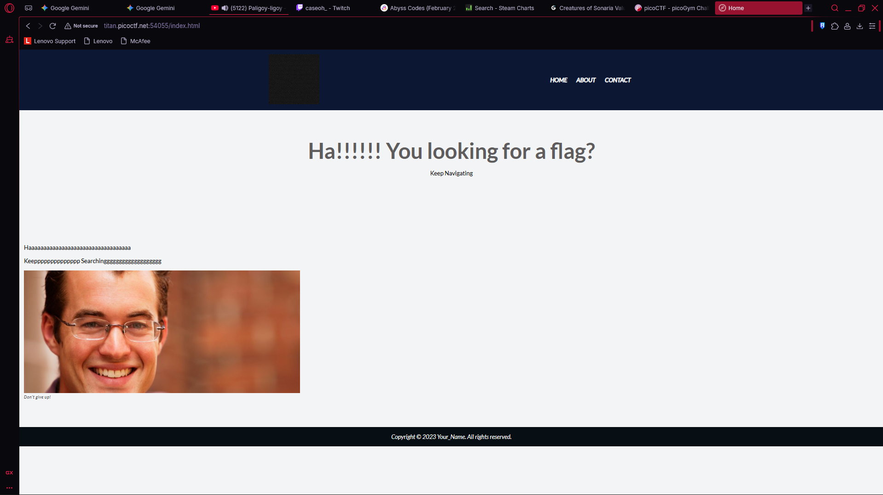
2. Finding the Clue
I navigated through the pages:
- Home: No obvious clues in the text or source.
- Contact: Displays a "Keep searching" message.
- About: This page includes a message: "Try inspecting the page!! You might find it there".
By right-clicking and selecting Inspect (or Ctrl+Shift+I), I examined the HTML elements. Under the <section> tag for the "About" content, I found a suspicious custom attribute:
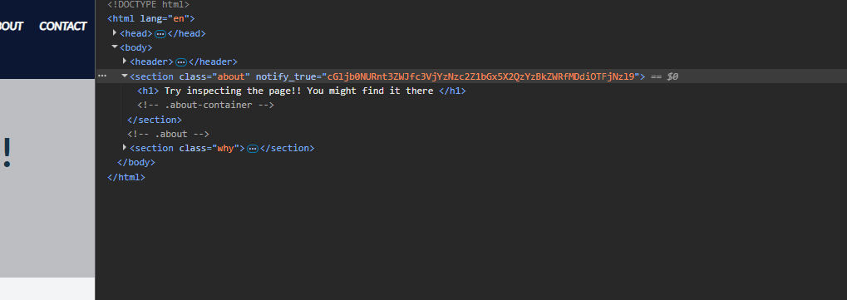
3. Analysis & Decoding
The string cGljb0NURnt3ZWJfc3VjYzNzc2Z1bGx5X2QzYzBkZWRfMDdiOTFjNzl9has the classic hallmarks of Base64 encoding:
- It uses alphanumeric characters (A-Z, a-z, 0-9).
- It looks like a random string but follows a specific character set.
To retrieve the flag, I used a Base64 decoder.
Using the Terminal:
Bash
echo "cGljb0NURnt3ZWJfc3VjYzNzc2Z1bGx5X2QzYzBkZWRfMDdiOTFjNzl9" | base64 -d

4. Result
The decoded string reveals the flag:
Flag: picoCTF{web_succ3ssfully_d3c0ded_07b91c79}

