dont-use-client-side
Challenge: dont-use-client-side
Category: Web Exploitation
Difficulty: Easy

The Situation
You are presented with a login portal. If you type a password and hit "Verify," it either tells you "Correct" or "Incorrect." Since the title says "don't use client-side," we know the check isn't happening on a secure server—it's happening right in your browser.

The Exploit: Inspecting the Logic
- Right-click the page and select View Page Source (or press Ctrl+U).
- Look for a <script> tag. You will find a function called verify().
The code usually looks something like this (obfuscated by splitting the string):
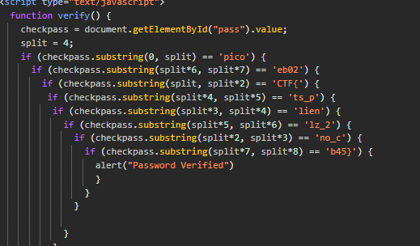

The Breakdown
The script sets a variable split = 4. It then uses the substring(start, end) method to check your password in chunks of 4 characters.
The fragments are checked out of order in the code, so we need to map the mathematical expressions (e.g., split*6) to their actual numerical positions.
The Reassembly Table
Based on the image provided, here is the reconstruction of the flag piece by piece:
Index Range | Math Expression | String Fragment
0 - 4 | (0, split) | pico
4 - 8 | (split, split*2) | CTF{
8 - 12 | (split*2, split*3) | no_c
12 - 16 | (split*3, split*4) | lien
16 - 20 | (split*4, split*5) | ts_p
20 - 24 | (split*5, split*6) | lz_2
24 - 28 | (split*6, split*7) | eb02
28 - 32 | (split*7, split*8) | b45}

FLAG: picoCTF{no_clients_plz_2eb02b45}

