**SET A**

**Classified as acceptable in Physionet:**

**1**. **1002867_acceptable (lead 2)**

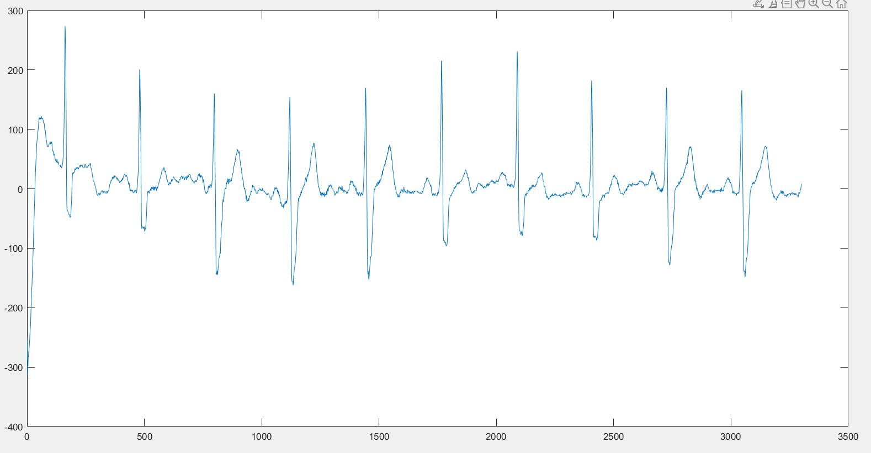

kSQI: 1

sSQI: 0

pSQI: 0.8453

SQI_rel_powerLine_01: 0.9976

cSQI: 1

basSQI: 0.1

dSQI: 0.8571

mean: 0

**2. 1015620_acceptable (lead 2)**

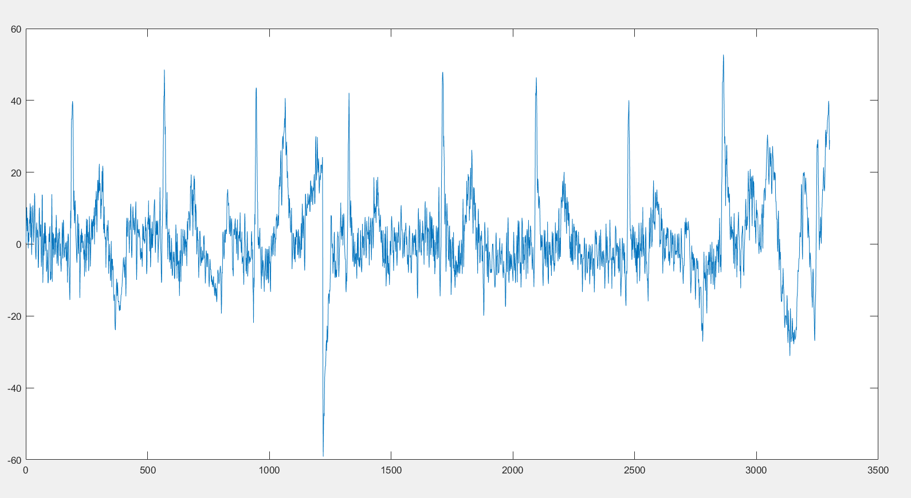

kSQI: 1

sSQI: 0.3381

pSQI: 1

SQI_rel_powerLine_01: 0.8431

cSQI: 0.8856

basSQI: 0.1

dSQI: 0.5

mean: 0.5355

**3. 1045434 (lead 2)**

kSQI: 1

sSQI: 1

pSQI: 1

SQI_rel_powerLine_01: 0.9856

cSQI: 1

basSQI: 0.1

dSQI: 1

mean: 0.7182

**4. 1179983_acceptable (lead 2)**

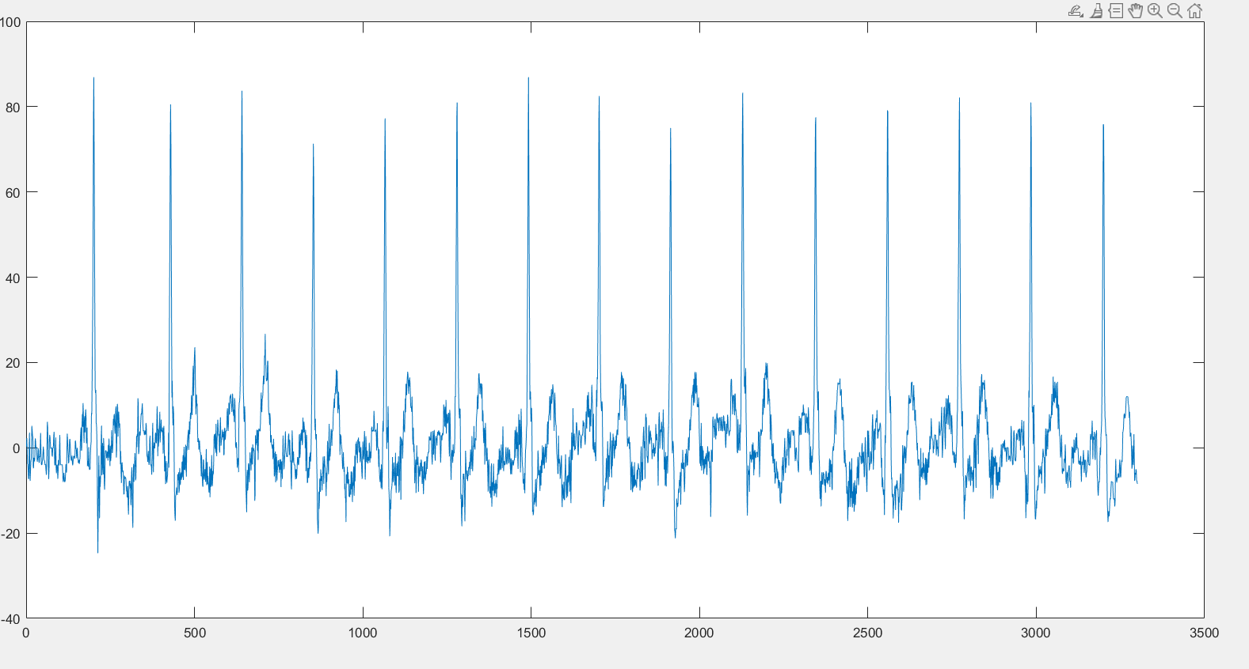

kSQI: 1

sSQI: 1

pSQI: 1

SQI_rel_powerLine_01: 0.9537

cSQI: 1

basSQI: 0.1

dSQI: 1

mean: 0.7148

**Classified as unacceptable in Physionet**:

**1. 1002603_unacceptable (lead 2)**

kSQI: 1

sSQI: 1

pSQI: 0.3058

SQI_rel_powerLine_01: 0.1

cSQI: NaN

basSQI: 0.1

dSQI: 0.1

mean: NaN

**2. 1063073_unacceptable (lead 2)**

kSQI: 1

sSQI: 1

pSQI: 1

SQI_rel_powerLine_01: 0.9942

cSQI: 0.5575

basSQI: 0.1

dSQI: 0.1

mean: 0.4761

**3. 1180858_unacceptable (lead 2)**

kSQI: 1

sSQI: 0.9075

pSQI: 0

SQI_rel_powerLine_01: 0.999

cSQI: 1

basSQI: 0.1

dSQI: 1

mean: 0 (si lower limit fuese 0.01🡪 mean = 0.3676)

**4. 1354265_unacceptable (lead 2)**

kSQI: 1

sSQI: 0.9075

pSQI: 0

SQI_rel_powerLine_01: 0.9224

cSQI: 1

basSQI: 0.1

dSQI: 0.1

mean: 0.5120

**SET B**

**1. 1002036_setB (lead 2)**

kSQI: 1

sSQI: 1

pSQI: 1

SQI_rel_powerLine_01: 0.9979

cSQI: 1

basSQI: 0.1

dSQI: 1

mean: 0.7195

**2. 1000066_setB (lead 2)**

kSQI: 1

sSQI: 1

pSQI: 0.8022

SQI_rel_powerLine_01: 0.9936

cSQI: 1

basSQI: 0.1

dSQI: 1

mean: 0.6967

**3. 1007003_setB (lead 2)**

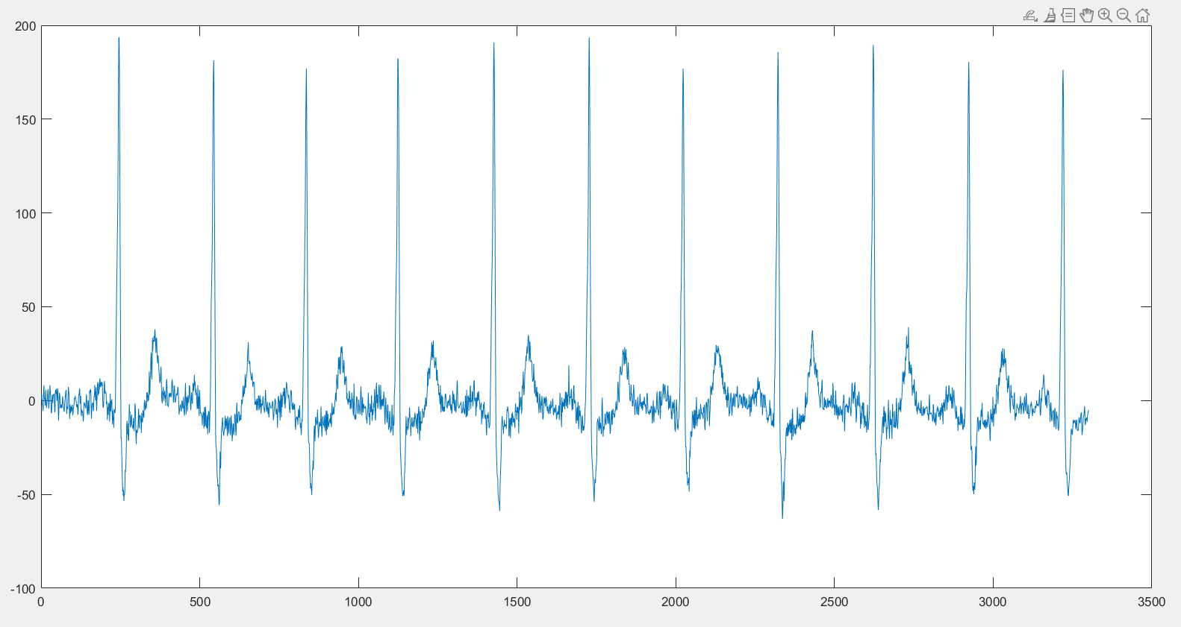

kSQI: 1

sSQI: 1

pSQI: 0.6489

SQI_rel_powerLine_01: 0.9908

cSQI: 1

basSQI: 0.1

dSQI: 1

mean: 0.6757

**4. 1032637_setB (lead 2)**

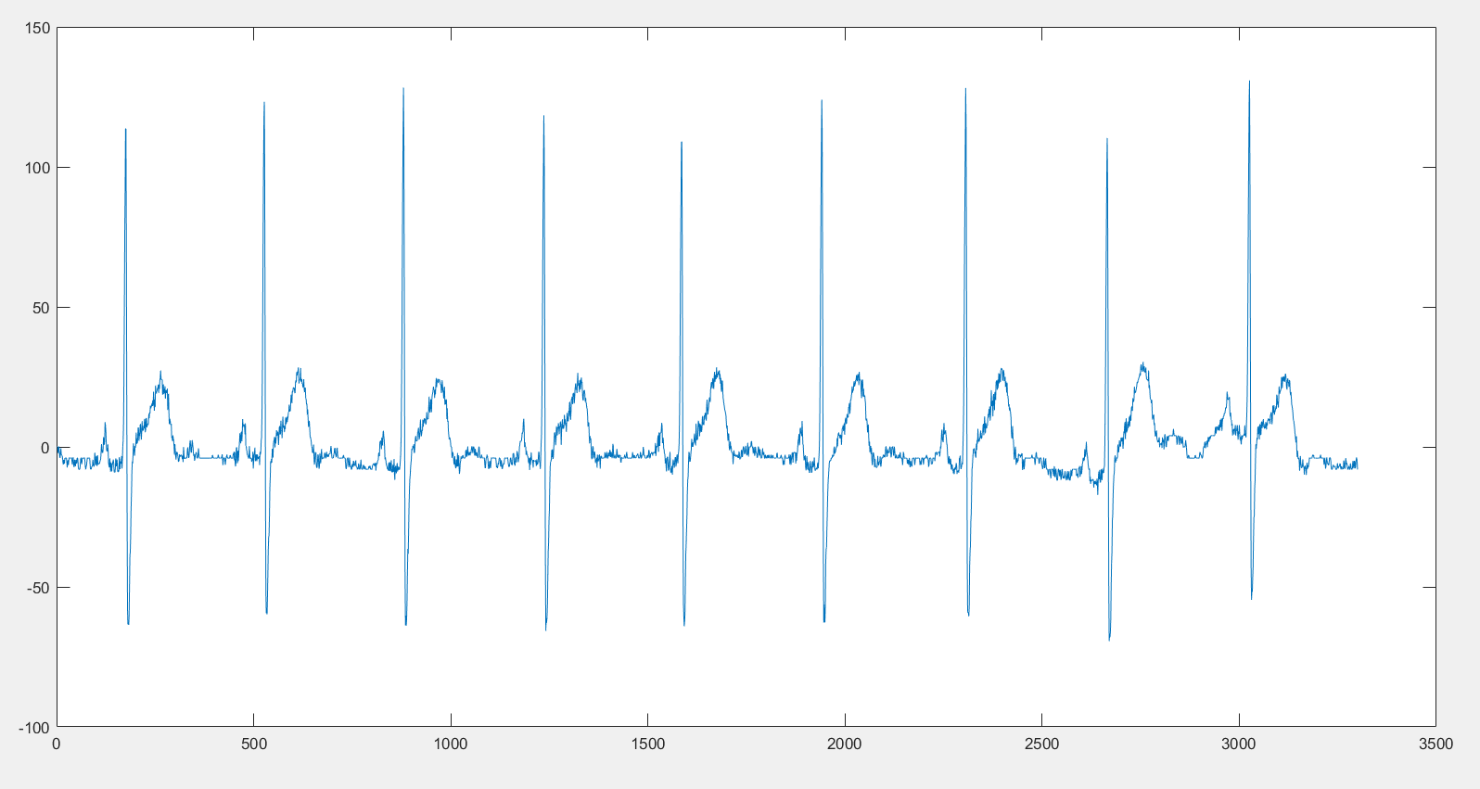

kSQI: 1

sSQI: 1

pSQI: 0.9690

SQI_rel_powerLine_01: 0.9839

cSQI: 1

basSQI: 0.1

dSQI: 1

mean: 0.7148