Llama 3 chat + ViMMRC: 0.8421 (step 90)

Mistral inst + ViMMRC: 0.7495 (step 80)

Gemma it + ViMMRC: 0.849364 (step 70)

Translation

Fine tune Envit5:

* 44.877 bleu en-vi on PhoMT test, 41.1204 bleu vi-en
* 38.5858 bleu en-vi on IWSLT15, 38.1521 vi-en

Finetune envit5-translation on MedEV:

* Bleu: 47.903 on MedEV test set (en - vi), 40.1578 vi-en

Llama 3 – 2M:

* 41.2638 bleu en-vi on PhoMT test, 38.8982 vi-en
* 34.6314 bleu en-vi on IWSLT15, 35.4172 vi-en

Llama 3 – 2M further finetune on MedEV:

* 47.7973 en – vi on MedEV, 40.8097 vi – en

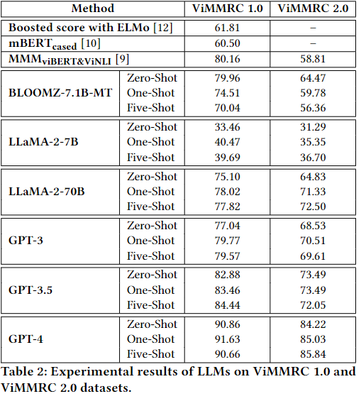

[paper](https://arxiv.org/pdf/2310.12059v3)

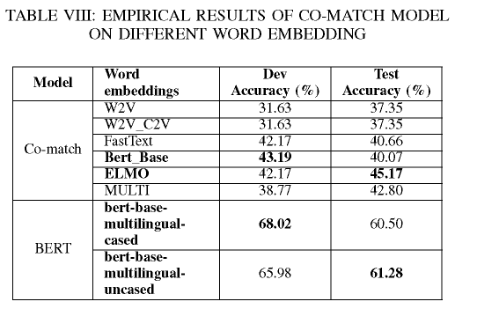

[paper](https://sci-hub.se/10.1109/ICCE48956.2021.9352127)